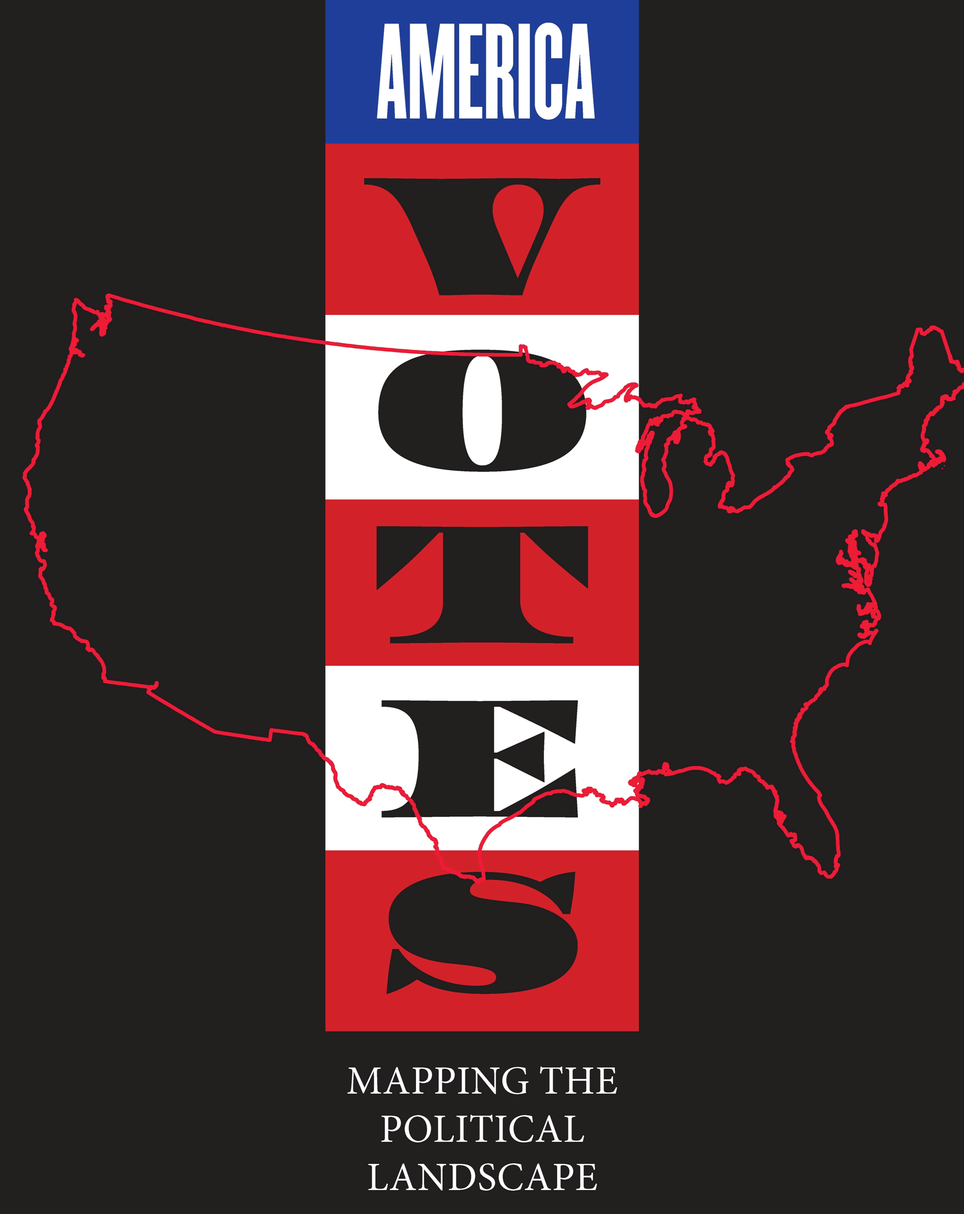

Elementary School Curriculum Guide
maps.bpl.org


Massachusetts Electoral Districts

Location: Massachusetts Time Period: 1900-Present Grades: 3-5
Essential Question:
How has Massachusetts’ representation in Congress changed over time?

Objectives:
Students will compare Congressional maps of the State, one current and one from history.
Students will consider the number of representatives from each district in terms of both numbers and land mass.
Students will reflect upon the nature of representative democracy for the people of Massachusetts.

Curriculum Standards:
Common Core
Grades 3, 4 and 5: English/Language Arts
Reading Informational Text: Integration of Knowledge and Ideas
RI.3.7. Use information gained from illustrations (e.g., maps, photographs) and the words in a text to demonstrate understanding of the text (e.g., where, when, why, and how key events occur).
RI.4.7. Interpret information presented visually, orally, or quantitatively (e.g., in charts, graphs, diagrams, time lines, animations, or interactive elements on Web pages) and explain how the information contributes to an understanding of the text in which it appears.

Range of Reading and Level of Text Complexity
RI.3.10. By the end of the year, read and comprehend informational texts, including history/social studies, science, and technical texts, at the high end of the grades 2–3 text complexity band independently and proficiently.
RI.4.10. and RI.5.10.
By the end of year, read and comprehend informational texts, including history/social studies, science, and technical texts, in the grades 4–5 text complexity band proficiently, with scaffolding as needed at the high end of the range.

National Geography Standards
Standard 1: How to Use Maps and Other Geographic Representations, Tools, and Technologies to Acquire, Process, and Report Information From a Spatial Perspective
Standard 17: How to Apply Geography to Interpret the Past

Massachusetts
Grade 3
History and Geography
The Difference between a contemporary map and a historical map
Civic and Government
Why it is necessary for communities to have governments
Cities and Towns of Massachusetts
Grade 4
History and Geography
Maps Skills; Interpret a Map
Grade 5
History and Geography
Map skills; Interpret a Map; Compare contemporary and historical map
Civics and Government
The Principles and Institutions of American Constitutional Government
5.24 Principles of American Democracy
5.27 Participation of American citizens in government

America is not a direct democracy but a representative republic. To that end, we take a census every ten years to determine the number of representatives we send to Congress in Washington and how many electors we have for Presidential elections. Yet Congressional districts are organized by both number and space and have changed often. This is a very complicated process to understand and explain to anyone. Maps are a good way to show this process.

Procedure:

- Explore the basic nature of representative democracy with your students. Perhaps begin with groups within your classroom or school. How might they have a voice? Consider creating a student government. Suppose one grade had 20 children and another grade had 50 children. Should they send the same number of representatives to the student government? Should they receive the same benefits from government? Does the number of students in each grade remain the same every year? How could they find out?
- Have Students Complete Part I of the Student Sheet. They may work individually, in small groups or as a class.
- Explain that the men who first began the government of the United States had to solve these problems as well, but for the whole country. Instead of classes, they decided that people would vote by states, but they still needed to keep track of two things:
a) How many people were in each state, and
b) If those numbers remained the same
- The result was a system where we counted the population every ten years, called the CENSUS and then decided how many people each state would get to send to Washington to try to solve the problems of the country.
- Problems arose as the country grew and in 1929, the total number of representatives was limited to 435, so even some big states had to give back some representation, because each state gets at least one representative.
- Have them complete Part II of the Student Sheet

Time Allocation:

Part I: 10-15 minutes
Part II: 15-20 minutes

Materials Needed:
1901 Map of Massachusetts Congressional Districts, included below and also located at http://maps.bpl.org/id/12688
2011 Map of Massachusetts Congressional Districts, included below and also located at http://www.malegislature.gov/District/ProposedDistrictMaps
Graph of Massachusetts Population and Electors, 1790-2010, included below and also located at http://maps.bpl.org/sites/default/files/Massachusetts_Population_and_Electoral_College.jpg

Assessment Criteria:
Did the students compare Congressional maps of the State, one current and one from history?

Did the students consider the number of representatives from each district in terms of both numbers and land mass?

Did the students reflect upon the nature of representative democracy for the people of Massachusetts?

Enrichment Activities:
- Compare Massachusetts’ history to the history of another State, using http://www.270towin.com/states/
- Look at the text of the Constitution Article 1, Section 2 with your Students
Section 2.
The House of Representatives shall be composed of Members chosen every second Year by the People of the several States, and the Electors in each State shall have the Qualifications requisite for Electors of the most numerous Branch of the State Legislature.
No Person shall be a Representative who shall not have attained to the Age of twenty five Years, and been seven Years a Citizen of the United States, and who shall not, when elected, be an Inhabitant of that State in which he shall be chosen.
Representatives and direct Taxes shall be apportioned among the several States which may be included within this Union, according to their respective Numbers, which shall be determined by adding to the whole Number of free Persons, including those bound to Service for a Term of Years, and excluding Indians not taxed, three fifths of all other Persons. The actual Enumeration shall be made within three Years after the first Meeting of the Congress of the United States, and within every subsequent Term of ten Years, in such Manner as they shall by Law direct. The Number of Representatives shall not exceed one for every thirty Thousand, but each State shall have at Least one Representative; and until such enumeration shall be made, the State of New Hampshire shall be entitled to choose three, Massachusetts eight, Rhode-Island and Providence Plantations one, Connecticut five, New-York six, New Jersey four, Pennsylvania eight, Delaware one, Maryland six, Virginia ten, North Carolina five, South Carolina five, and Georgia three.

What was the actual plan? How has it changed? Why? What has stayed the same?

- Compare the 2011 Massachusetts map to the previous Congressional map, and have students explore the changes made. http://www.iqrealestate.com/CongressionalMaps/MA2.gif

If you have lots of people and want to try to solve everyone’s problem, it can get pretty messy to let everyone try to get involved. What are some possible solutions?

Part I

- You go to The Little Red, White and Blue School. There are 5 grades in your school, with a total number of 1000 students. How would you create a student government that would be both FAIR and still be able to get things done?

- Suppose that there is not the same number of children in each grade. Here is the school’s population:
Grade 1: 100
Grade 2: 200
Grade 3: 20
Grade 4: 480
Grade 5: 200

Would this change the student government you made in Question 1? What might the student government look like for this population?

- If you were a student in Grade 4, how many people do you think your grade should have in the Student Government? How many people should Grade 2 send? If you were a student in Grade 2, do you think you would feel the same way? Why or why not?

- Should the children in Grade 4 get more classrooms, pencils and books than the children in Grade 3 do? Why or why not?

- Would you have to do anything the next year, as each student moves up to the next grade, the children in Grade 5 go to a new school and new students (number not known) enter Grade 1?

Part II

These were the problems the Founding Fathers had when they wrote the Constitution. States had different numbers of people, new states were coming into the country and states were growing. Their solution was called the CENSUS and they decided to count the number of people every 10 years. At some point, the country got so big, and had so many people, they decided that there could only be a total of 435 people allowed to go to Washington, so some states, even if they got really big, had to give up some of their representatives because every state had to have at least ONE.

Look at the Map of Massachusetts from 1901 and answer the following questions:

- How many districts were there in Massachusetts?

- How many people lived in the 10th district? The 14th?

- Do these two districts take up the same about of land in the state? Which is bigger?

- What conclusions can you drawn about the size of the district and the number of people who live there? Which is more important in terms of making sure people can get their voices heard in government—its size or the number of people who live there?

Now look at the Current Map of Congressional Districts of Massachusetts and answer the following questions:

- How many districts does Massachusetts have in 2011?

- According to the 2010 Census, there are 6,547,629 people living in Massachusetts. Approximately how many people are represented in each district? Has this gone up or down since 1900?

- Which district has changed the most since 1901?

- Which has stayed the same?

- Do you think it is easier or harder for the people of Massachusetts to influence the government in Washington than it was in 1900? What other information do you need to know to answer this question?

MASSACHUSETTS CONGRESSIONAL DISTRICTS, 1901

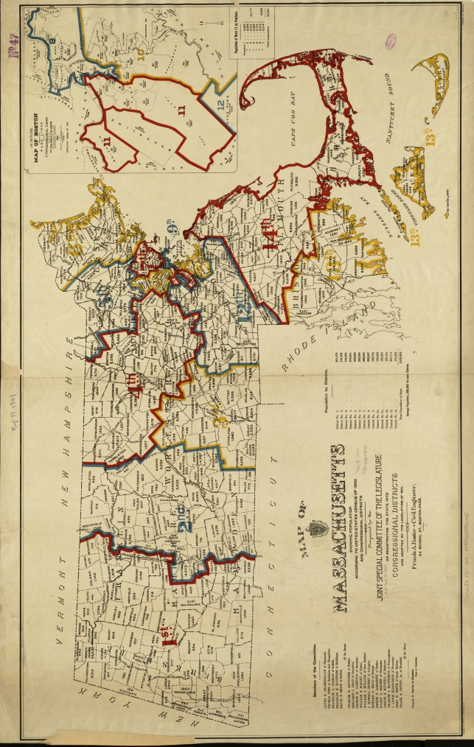

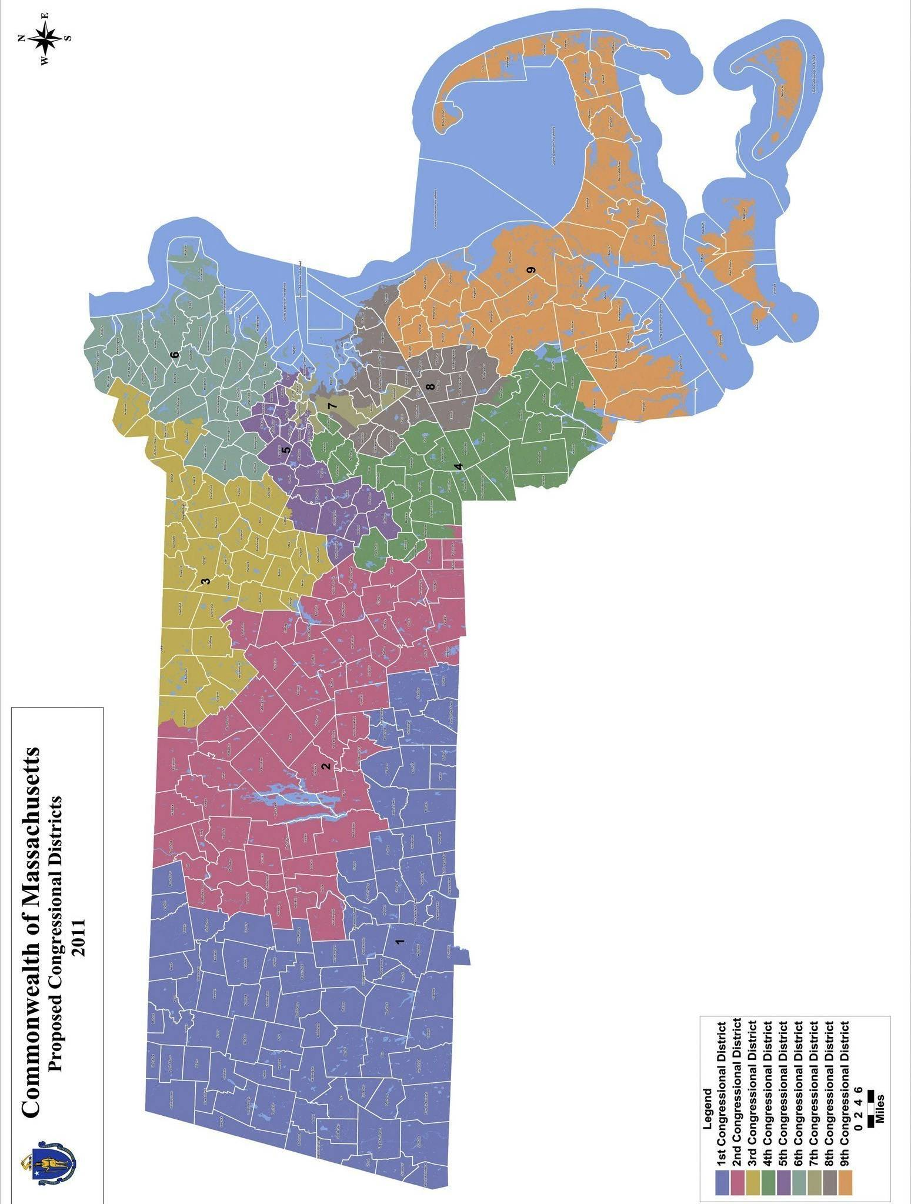

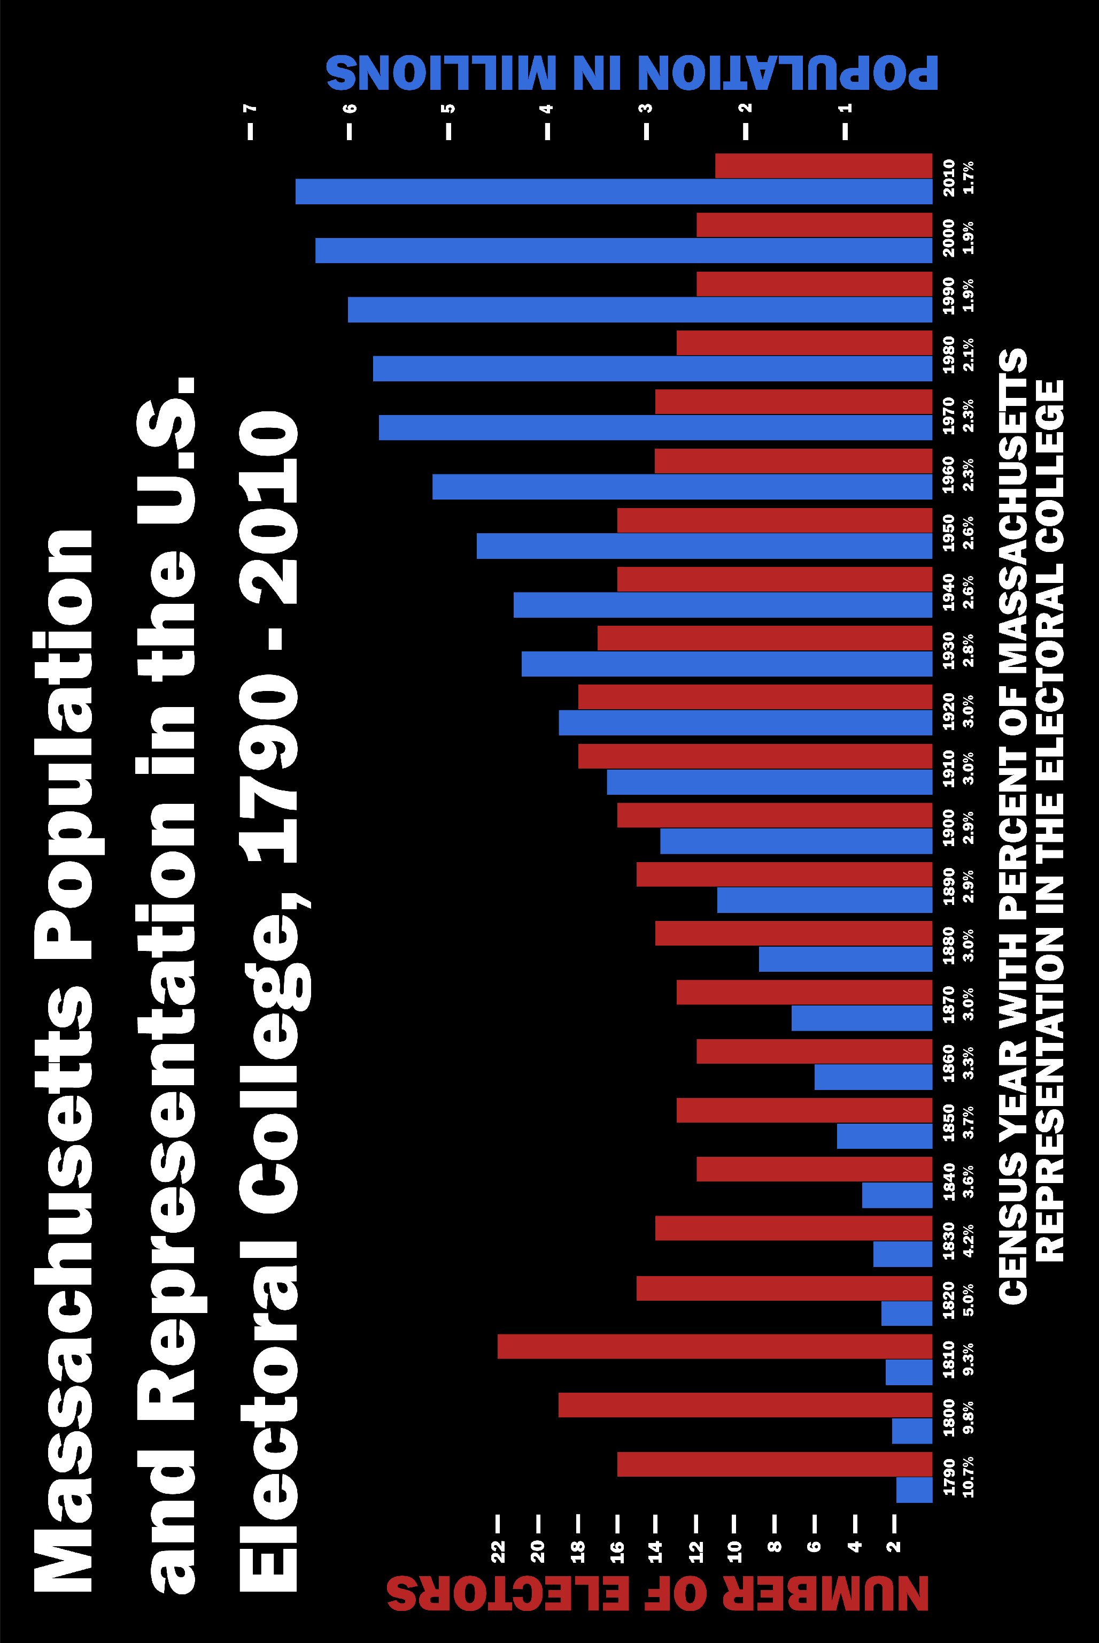


Massachusetts: Population and Electoral Power

Location: Massachusetts Time Period: 1790-Present Grades: 3-5

Essential Question:
What is the connection between a state’s population and its relative power in electing a president?

Objectives:
Students will read a bar graph and identify Massachusetts’ population for the period from 1790 to 2010.
Students will read a bar graph and identify the number of electors Massachusetts has had from 1790 to 2010.
Students will consider the connection between these two data points, both in absolute and relative terms.

Curriculum Standards:
Common Core
Mathematics, Grade 3
Measurement and Data: Represent and Interpret Data
3.MD.3. Solve one- and two-step “how many more” and “how many less” problems using information presented in scaled bar graphs.
Grades 4: English/Language Arts
Reading Informational Text: Integration of Knowledge and Ideas
RI.4.7. Interpret information presented visually, orally, or quantitatively (e.g., in charts, graphs, diagrams, time lines, animations, or interactive elements on Web pages) and explain how the information contributes to an understanding of the text in which it appears.

National Geography Standards
Standard 1: How to Use Maps and Other Geographic Representations, Tools, and Technologies to Acquire, Process, and Report Information From a Spatial Perspective

Massachusetts Curriculum Frameworks
Grade 3
History and Geography: Time Periods
Civic and Government
Massachusetts History
Grade 4
History and Geography: Maps Skills; Interpret a Map
Grade 5
History and Geography
Civics and Government
The Principles and Institutions of American Constitutional Government
5.24 Principles of American Democracy
5.27 Participation of American citizens in government
The Growth of the Republic

How America elects a president is a very complex process. The goal in this lesson is to show the absolute and relative electoral power of a single state over the course of the last 220 years through the use of a single bar graph. You may take your students as far in this process as their skills and interest levels allow.

Procedure:
- Introduce the term ELECTORS to your students. Explain that each state gets at least three electors and the rest is determined by a state’s population.
- Have them complete Part I of the Student Sheet and discuss their results.
- Now explore the notion that each state does not exist by itself and the number of Electors is also based on how many Electors the other states have too.
- Show them a 2012 Presidential election map, or use the Chart of State Population and Electors.
- Ask them what they notice. Be sure to point out that each of the 50 states plus the District of Columbia gets at least 3 Electoral Votes. Any additional Electoral votes are determined by a state’s population. To become president in 2012, a candidate must receive at least 270 electoral votes. We count the population of the state every 10 years in the Census. After 1929, the government said the total number of electors would be 535 (the District of Columbia was added by Constitutional amendment in 1961), so even if a state’s population kept growing, it would get no more electors and some states have even had to give up some as other states got really big. One more thing that is really confusing—it doesn’t matter how much land a state has—only how many people live there.
- Have them complete Part II of the Student Sheet

Time Allocation:
Part I: 15 to 20 Minutes Part II: 15 to 20 Minutes

Materials Needed:
Massachusetts Population and Elector Graph, included below
Chart of State Population and Electors, included below, and also located at:
http://maps.bpl.org/sites/default/files/Massachusetts_Population_and_Electoral_College.jpg

2012 Electoral College Map, http://www.270towin.com/

Assessment Criteria:
Did students read a bar graph and identify Massachusetts’ population for the period from 1790 to 2010?

Did students read a bar graph and identify the number of electors Massachusetts has had from 1790 to 2010?

Did students consider the connection between these two data points, both in absolute and relative terms?

Enrichment Activities:
- Have them construct a graph for another state. This information can be found
State Population Over Time: http://www.thirty-thousand.org/pages/MA.htm
Number of Electoral Votes Over Time http://www.270towin.com/states/

- Explore Massachusetts’ comparative power in presidential electoral power by look at past elections. Use information at Electoral College Maps of Presidential
Elections, http://campaign2012.c-span.org/electoral-college-map

America chooses a President in a pretty complicated way. Each State picks ELECTORS first. Look at the Bar Graph your teacher gives you and answer the following questions:

Part I

- What do the Blue Lines show?
- How many people lived in Massachusetts in
- 1790
- 1890
- 1990
- What do the Red Lines Show?
- How many Electors did Massachusetts have in
- 1790
- 1890
- 1990
- What has happened to the number of Electors compared to the Population? Would you have expected the state to get more electors as they got more people?

Part II

Look at the white numbers below the dates on the Bar Graph and answer the following questions:

What information do they give you?

How does it help you answer Question 5 above?

Look at the State Population Chart and find Massachusetts.
- What percentage of the overall population of the nation is MA in 2010?

- What percentage of the Electoral College is MA in 2010?

- Does this seem fair to you?

- Look At California. What percentage of the Electoral College is it? Of the nation’s population? How about Wyoming?

- How many states are like Wyoming (a higher percentage of electors than population)?

- How many states are like California (a higher percentage of population than electors)?

- Does this system seem fair to you? How would you fix it if you had the power to do so?

STATE POPULATION AND ELECTORAL VOTES CHART, BASED ON 2010 CENSUS

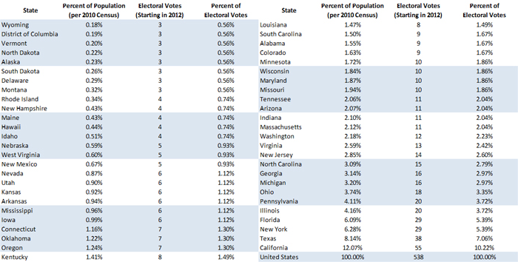

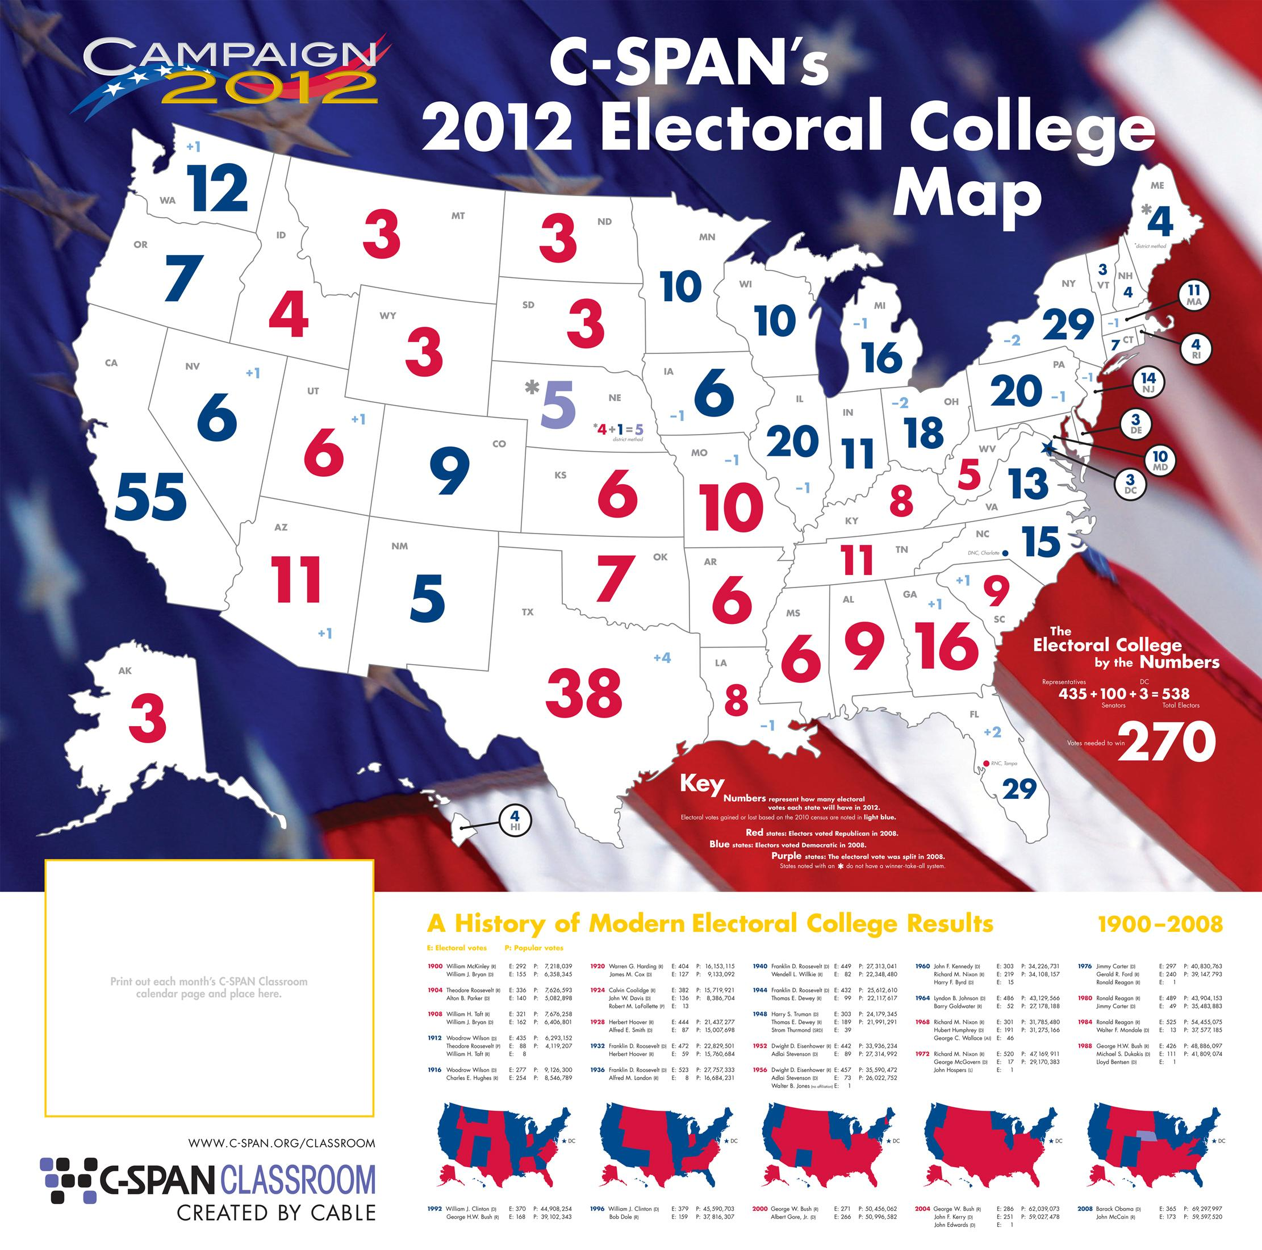


How America Elects a President: Political Parties

Location: US Time Period: 1789-Present Grades: 2-5

Essential Question: What roles do political parties play in the election of a president?

Objectives:
Students will learn to identify the major political parties.
Studies will read election maps that identify election result by party using colors.
Students will note party variation within state results.

Curriculum Standards:
Common Core
Grades 3, 4 and 5: English/Language Arts
Reading Informational Text: Integration of Knowledge and Ideas
RI.3.7. Use information gained from illustrations (e.g., maps, photographs) and the words in a text to demonstrate understanding of the text (e.g., where, when, why, and how key events occur).
RI.4.7. Interpret information presented visually, orally, or quantitatively (e.g., in charts, graphs, diagrams, time lines, animations, or interactive elements on Web pages) and explain how the information contributes to an understanding of the text in which it appears.

Range of Reading and Level of Text Complexity
RI.3.10. By the end of the year, read and comprehend informational texts, including history/social studies, science, and technical texts, at the high end of the grades 2–3 text complexity band independently and proficiently.
RI.4.10. and RI.5.10.
By the end of year, read and comprehend informational texts, including history/social studies, science, and technical texts, in the grades 4–5 text complexity band proficiently, with scaffolding as needed at the high end of the range.

National Geography Standards
Standard 1: How to Use Maps and Other Geographic Representations, Tools, and Technologies to Acquire, Process, and Report Information From a Spatial Perspective
Standard 17: How to Apply Geography to Interpret the Past

Massachusetts Curriculum Frameworks
Grade 2: History and Geography:
American citizenship, political principles and system of government
Different ways that maps convey information, generate narrative accounts
from maps
Grade 4: North American Geography
US Political geography

Grade 5: US History, Geography, Economics and Government
Development of democratic institutions and ideas
Identify specialized maps
Powers and responsibilities of government officials

When the Constitution was adopted in 1789, there were no political parties. The framers were wary of political parties but somehow they have become one of the permanent fixtures of the political landscape. For a while, politics has been simplified into voter results as shown on maps, i.e. Red States and Blue States. The reality of both election results and party adherence is much more complicated.

Procedure:

- Introduce/remind students that our country will be electing a new president in November. Ask what they know about the candidates. Write their responses on the board. Prompt for party affiliation, identification. Ask if they know which party each candidate represents.

- Write Democrat and Republican on the board. Ask what they know about either party. There are no correct answers here. What you are looking for are impressions and the simple reality that there are two parties and each one runs a candidate for president.

- Look at the 2004 Election Map, State results only. Have them complete Part I of the Student Sheet. Discuss their results.

- Explain to the students there were parties before the Democrats and the Republicans, such as the Whigs, the Federalists, even the Know-Nothings!!
Look at the map of the 1792 Presidential Election. Ask them why it is all one color. You want to prompt them to understand that when our country began there were no political parties and everyone voted for George Washington.

5. Look at the Presidential Election Map from 1836. Have them complete Part II of the Student Sheet and discuss their results.

Time Allocation:

Part I: 15 minutes
Part II: 10 minutes

Materials Needed:

Presidential Election Map, 1792
Presidential Election Map, 1836
2004 Election Map, State results only
2004 Election Map, State and County results

Assessment Criteria:

Did the students learn to identify the major political parties on election maps?
Did the students read election results by party using colors on maps?
Did the students note party variation within states in election results?

Enrichment:

- What happens when three parties run candidates? Look at election results from 1912, 1968 and 1992. http://www.nationalatlas.gov/printable.html#elections

- Party influence has changed over historic time. Look at the election results from 1960 and 2000. Which states did the Democrats win in 1960? In 2000? What might explain this change?

- What is each Party’s position in 2012? Have students check their websites for an overview.
http://www.democrats.org/
http://www.rnc.org/

The United States will elect a new president on November 6th. The two candidates represent two different groups, called political parties. The two major parties in our country are the Democrats and the Republicans.

Part I

Look at the map of the presidential election from 2004. President Bush, a Republican, ran against John Kerry, a Democrat.

- What color are the states that President Bush won?

- What color are the states that John Kerry won?

- President Bush is from Texas. Did he win that state? Do you think he got every vote in Texas? John Kerry is from Massachusetts. How did he do there? Do you think he got every vote in Massachusetts?

- When you are done with Question 3, ask your teacher for the other map of the 2004 Presidential election. Find Texas on that map. Why do you think there is both red and blue there? In Massachusetts?

Part II

- Look at the map of the 1836 presidential election. How many different candidates ran?

- How many different parties can you see on the map? What are their names?

- Are any of those parties still around today?

- Why does each state have more than one color?

2004 PRESIDENTIAL ELECTION RESULTS BY STATE

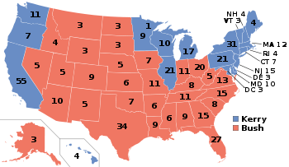

2004 PRESIDENTIAL ELECTION, STATE AND COUNTY RESULTS
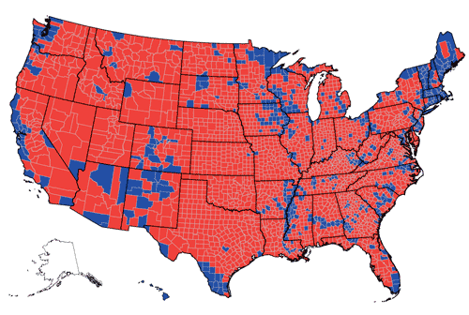

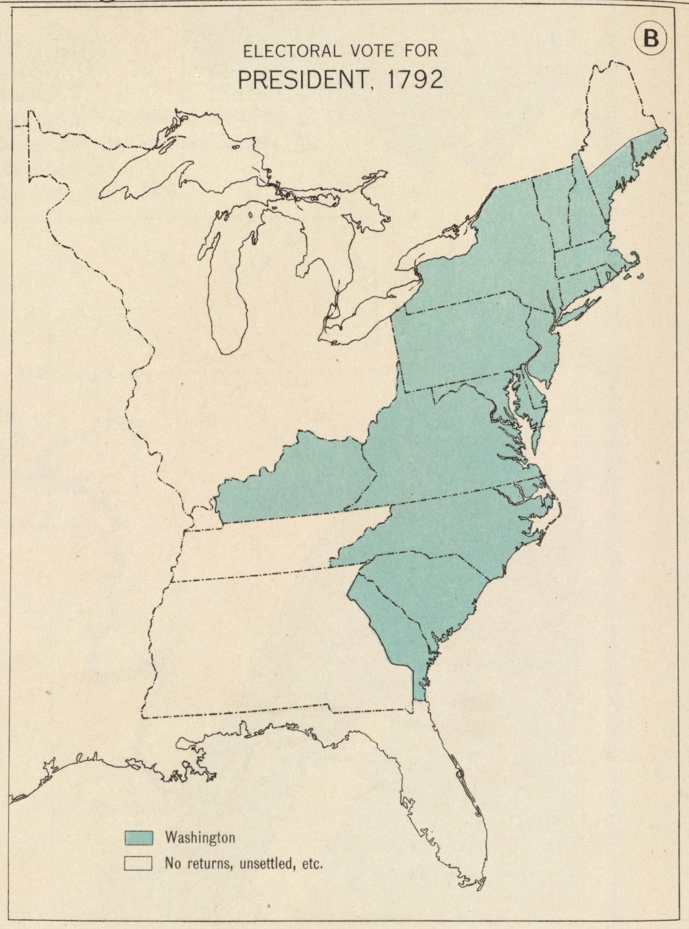

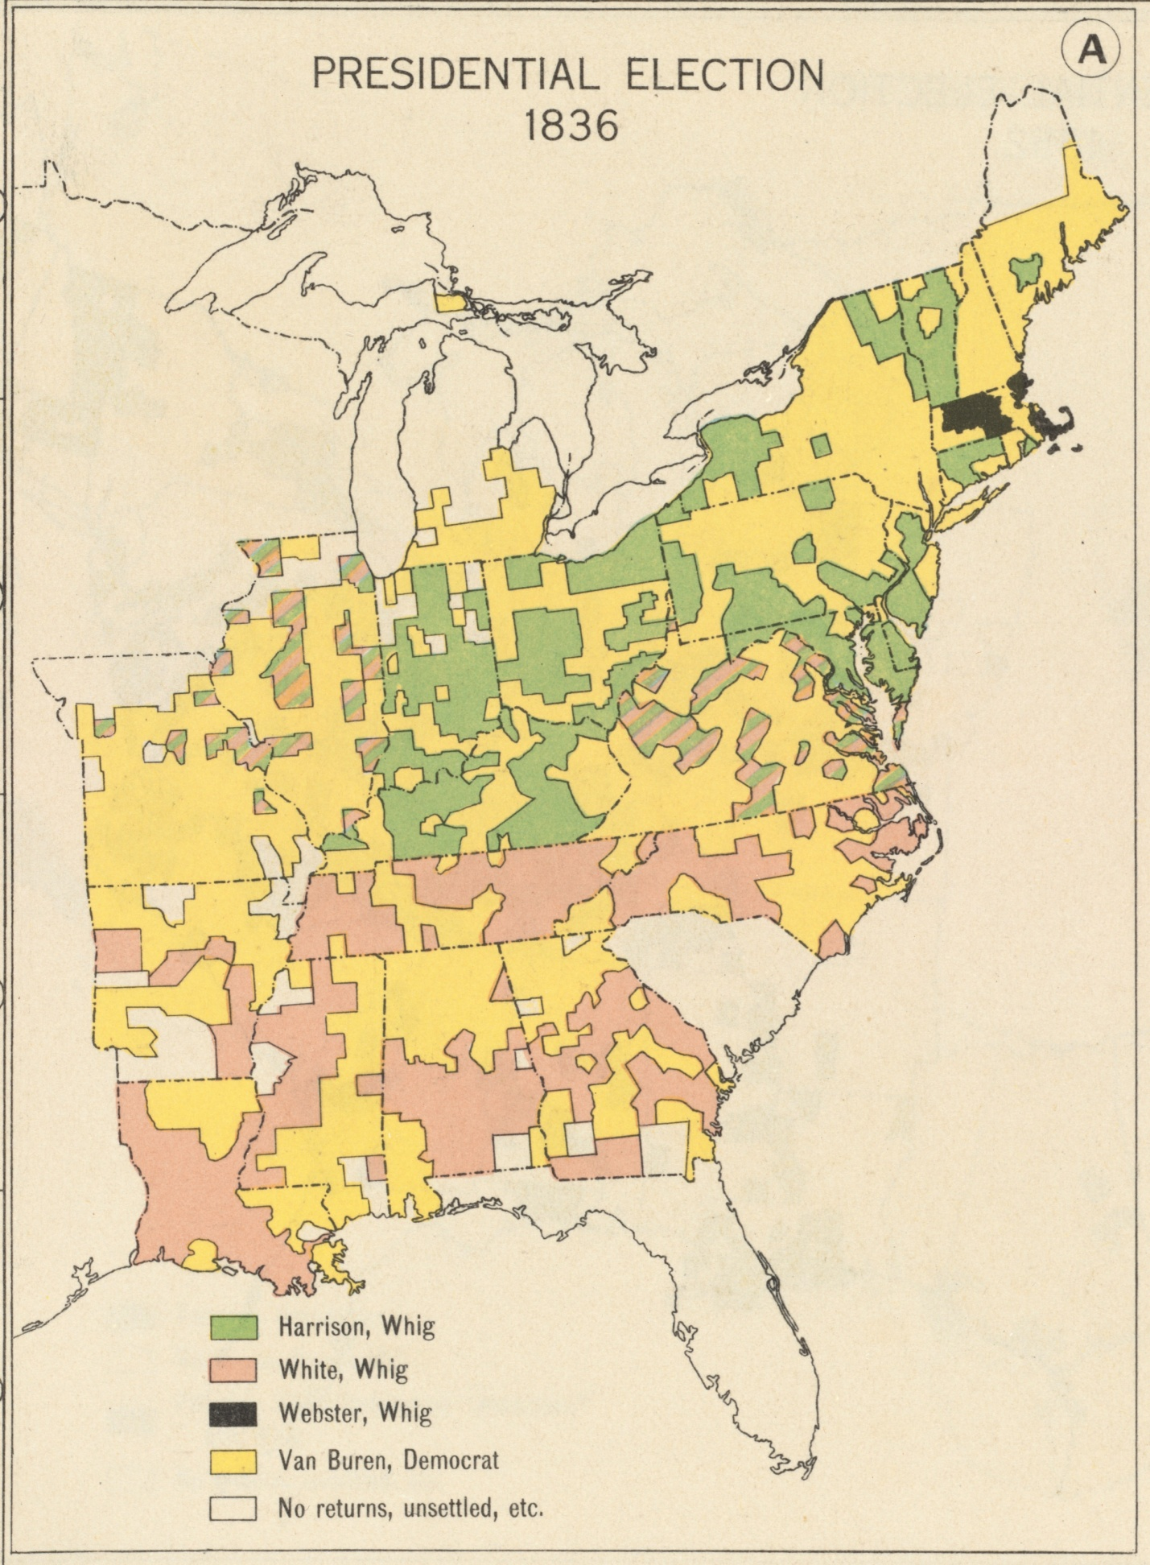



Who Gets To Vote

Location: US Time Period: 1789-Present Grades: 2-5

Essential Question: How has the right to vote evolved over the course of the nation’s history?

Objectives:
Students will learn when different groups in America got the vote.
Students will construct a timeline to identify when each group got the vote.
Students will understand property qualifications as a criterion for voting.

Curriculum Standards:
Common Core
Grades 3, 4 and 5: English/Language Arts
Reading Informational Text: Integration of Knowledge and Ideas
RI.3.7. Use information gained from illustrations (e.g., maps, photographs) and the words in a text to demonstrate understanding of the text (e.g., where, when, why, and how key events occur).
RI.4.7. Interpret information presented visually, orally, or quantitatively (e.g., in charts, graphs, diagrams, time lines, animations, or interactive elements on Web pages) and explain how the information contributes to an understanding of the text in which it appears.

Range of Reading and Level of Text Complexity
RI.3.10. By the end of the year, read and comprehend informational texts, including history/social studies, science, and technical texts, at the high end of the grades 2–3 text complexity band independently and proficiently.
RI.4.10. and RI.5.10.
By the end of year, read and comprehend informational texts, including history/social studies, science, and technical texts, in the grades 4–5 text complexity band proficiently, with scaffolding as needed at the high end of the range.

National Geography Standards
Standard 1: How to Use Maps and Other Geographic Representations, Tools, and Technologies to Acquire, Process, and Report Information From a Spatial Perspective
Standard 17: How to Apply Geography to Interpret the Past

Massachusetts Curriculum Frameworks
Grade 2: US History and Government
American Citizenship
Political Principles
Explain Information in Historical Timelines
Read Maps and follow narrative accounts using them

Grade 5: US History, Geography, Economics and Government
Democratic Institutions and Ideas
Responsibilities and Powers associated with federal officials


Voting is both a right and a privilege in the United States. Who gets to vote has been one of the most important parts of our nation’s story. Originally, only white men who owned property were allowed to vote. The struggle to include everyone else has reflected the best and worst of our history.

Procedure:

- Ask students what it means to vote. Prompt responses that include making choices, expressing an opinion. Extend the discussion to voting for a president and encourage them to see how voting is a way to influence their society.
- Write the words RIGHT and RESPONSIBILITY on the board. Ask the students to define each word. Try to prompt responses that include “I have the right to say what I want as long as it doesn’t hurt someone else” or “I have a responsibility to help others”. A RIGHT is something you want the freedom to do. A RESPONSIBILITY is something you must do. Help them to see that being a good member of a society means having certain rights and responsibilities.
- Tell class that even though Americans have been voting since 1789, not every one got to vote. Ask them what might have prevented some people from voting.
- Give class Student Sheet and have them complete Part I independently or in small groups. Discuss their results.
- Explain what property is. When the Constitution was first written, only people with property were allowed to vote. Ask the students why that might have been the case. Look for answers that focus on being able to trust who was voting, being afraid of how some people might vote. Show the students the following 3 maps:
Property Qualifications for Suffrage, 1775
Property Qualifications for Suffrage, 1800
Property Qualifications for Suffrage, 1830
Explain that Suffrage means voting. Have them complete Part II of the Student Sheet independently or in small groups. Discuss their results.

Time Allocation: 20 minutes

Materials Needed:

Property Qualifications for Suffrage Map, 1775
Property Qualifications for Suffrage Map, 1800
Property Qualifications for Suffrage Map, 1830

Assessment Criteria:

Did the students learn when different groups in America got the vote?
Did the students construct a timeline to identify when each group got the vote?
Did the students understand property qualifications as a criterion for voting?

Enrichment Activities:

- States determine voter eligibility. Have the students see what the requirements are in their state to vote. Voter eligibility is usually under the state Secretary of State. This information is on the state’s website.

- Have students read the actual text of the 15th, 19th and 26th Amendments. What is actually guaranteed? What opportunities still existed to deny people the vote?

- The 24th Amendment was ratified (passed) in 1964. Have students read the Amendment and brainstorm about why it was necessary to make this the law of the land.

Amendment 24:

1. The right of citizens of the United States to vote in any primary or other election for President or Vice President, for electors for President or Vice President, or for Senator or Representative in Congress, shall not be denied or abridged by the United States or any State by reason of failure to pay any poll tax or other tax.
2. The Congress shall have power to enforce this article by appropriate legislation.


Voting is about making choices. Americans have been voting in Presidential elections since 1789. But everyone has not always been allowed to vote. The rules for voting are listed in the United States Constitution.

Part I

1789: The Constitution becomes the rule book for America.
1870: The States add the 15th Amendment to the Constitution. It says that you can’t stop someone from voting because of their race.
1920: The States add the 19th Amendment to the Constitution. It says that you can’t stop someone from voting because of their gender.
1971: The States add the 26th Amendment to the Constitution. It says that you can’t stop someone over 18 from voting.

1. Construct a timeline of voting based on this information.

2. The language in all three Amendments says that you can’t stop (prevent) someone from voting because of their race, gender or age. Might there be some other way to stop someone from voting even with these new rules in place?

Part II

Look at the three Property Qualification maps that your teacher gives you and answer the following questions:
- What do the yellow states represent? The blue states? The green states?

- A ‘T’ on a state means that even if you do not own property, you can still vote if you pay money called a POLL TAX . Do you think that let more people vote? Did it let all people vote? Who still was not allowed to vote in those states?

- Do the voting rules seem fair to you? Why or why not?




