THE ANTEBELLUM NORTH AND SOUTH: DIFFERENT BUT CONNECTED
The climate and topography of the North and South led to important differences from the beginning of our nation’s founding. The types of crops and economy resulted in part from these geographic differences. But as different as the regions were, they were also connected. Raw materials from the South provided the supplies for the growing manufacturing of the factories of the North. Planters in the South often purchased items manufactured in the North.

Procedure

- Show your students the Photograph of the Slaves on Hilton Head Island and the Map of Lowell, MA. What connections might there be between these two images? Have them brainstorm about raw materials and finished goods for textile factories.
- Now return to the basics of geography. Discuss the connection between geography and economy with your students. Show students the Crop and Climate Maps and have them complete the Student Sheet. Have them fill out the Regional Economic Chart on their own and then fill in whatever they might have missed. Discuss their results.

Time Allocation: 20-30 minutes

Materials Needed

Photograph of slaves picking cotton on Hilton Head (http://www.flickr.com/photos/59843331@N03/5468267625/in/photostream)
Map of Lowell (http://maps.bpl.org/details_11051/?dl_pp=1&srch_query=1850&srch_fields=all&srch_style=exact&srch_fa=save)
1860 United States Crop Map, located in Supporting Materials
Climate Map (http://www.eduplace.com/ss/maps/usa.html)

Assessment Criteria

Did students learn about the geography and resulting economy of the North?
Did students learn about the geography and resulting economy of the South?
Did students learn about the differences and connections between the North and South?

Enrichment Activities

- Look at this map of cotton production, http://www.flickr.com/photos/59843331@N03/5492480326/
What impact did the war have on the supply of cotton?
- Look at this map entitled, "A map of the cotton kingdom and its dependencies in Amhttp://maps.bpl.org/details_14677/?dl_pp=1&srch_query=civil+war&srch_fields=all&srch_style=exact&srch_fa=saveerica."
What information does it give you about agricultural production in the South?

Common Core Curriculum Standards
English/Language Arts: Anchor Standards: CCSR for Reading
Integration of Knowledge and Ideas
CCSS.ELA-Literacy.CCRA.R.7 Integrate and evaluate content presented in diverse media and formats, including visually and quantitatively, as well as in words
CCSS.ELA-Literacy.CCRA.R.9 Analyze how two or more texts address similar themes or topics in order to build knowledge or to compare the approaches the authors take.

English/Language Arts: History and Social Studies
Integration of Knowledge and Ideas
CCSS.ELA-Literacy.RH.6-8.7 Integrate visual information (e.g., in charts, graphs, photographs, videos, or maps) with other information in print and digital texts.

The type of land in a place has a big impact on what happens there. The land in the United States was very different in the North and South and the result was different types of ways to earn a living.

Assignment

Look at the Climate and Crop Maps your teacher gives you and answer the following questions:
- What types of crops grow in the North? The Mid-Atlantic States? The South?
- What climate differences are there in these three areas?
- What other ways did people earn their living in those places in the decades before the Civil War?
- Fill out the Regional Economic Chart as best as you are able.
- Imagine a meeting of farmers from the original 13 colonies. What topics might they discuss? What common concerns might they have?
- Now think back to the photograph of the slaves and the map of the textile factories. Can you think of any connections that you did not think of before?

Regional Economic Chart

 | NEW ENGLAND | MID-ATLANTIC | SOUTH
CROPS

INDUSTRY
CONNECTIONS

Photographs of slaves picking cotton on Hilton Head

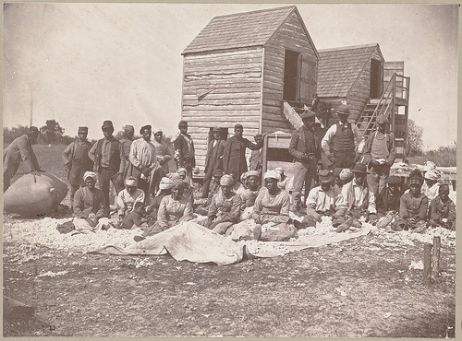

Map of Lowell, Massachusetts

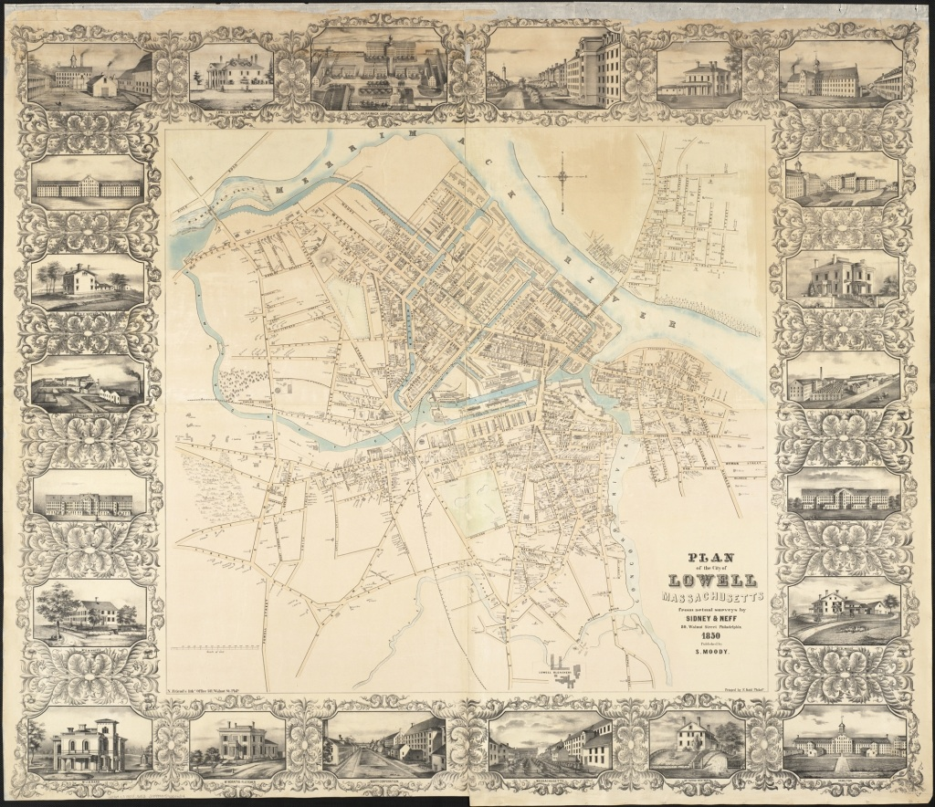

Crop Map United States 1861

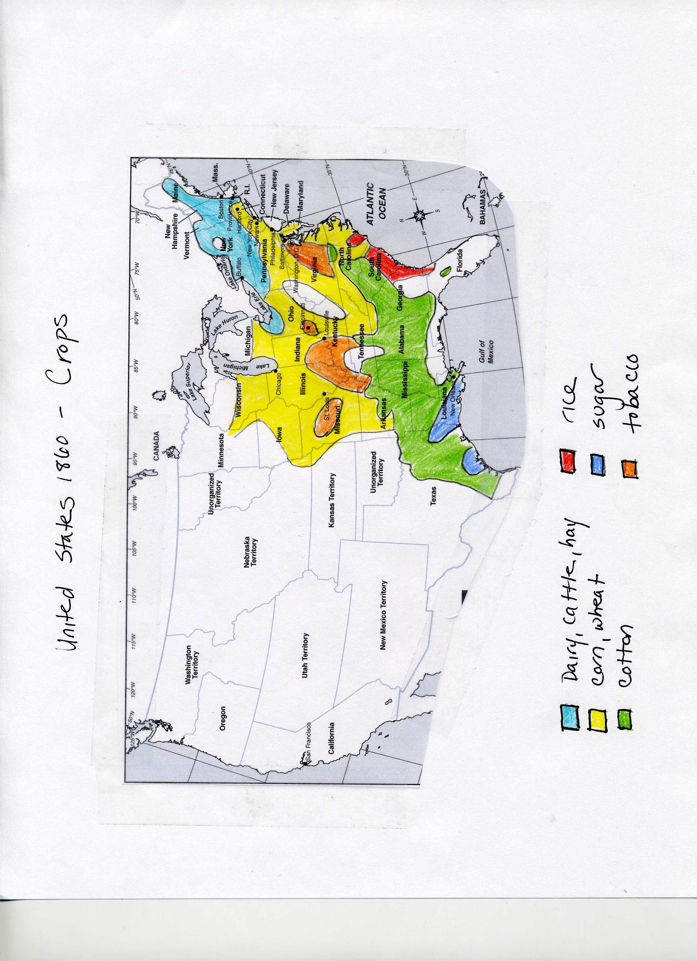

Climate Map

