CIVIL WAR BATTLE PLANS
In his Second Inaugural Address, President Lincoln observed about the war: “Both parties deprecated war, but one of them would make war rather than let the nation survive, and the other would accept war rather than let it perish, and the war came.”

Much the same may be said about the geographic knowledge of the terrain upon which the war was fought. The North had few accurate maps of the areas of the South. This early advantage helped the South greatly because the battles were fought on its home turf. Most battle maps were drawn after the actual conflict. Maps, like other primary sources, also reflect a perspective, often in a literal sense. Students will explore how both location and historic time tempered what people saw and placed on maps.

Procedure

- Show Students the Map of the Battle of Greenbriar River. Although this was not a major battle of the war, how can they tell from whose point of view this map was drawn? What clues do they have that this was drawn from a Southern point of view?
- Now show them the three maps on Bull Run/Manassas and have them complete Part I of the Student Sheet. You may do this as a class, in small groups or individually. Discuss their results.
- Now look at the Map of Richmond, Charleston Harbor, Scott’s Great Snake and the Historical Sketch of the Rebellion. How do they show the overall Union strategy for capturing the South?
- Maps made after the battles were important to establishing the historic record. Have Students look at the 3 maps of the Gettysburg battle, completed over a decade after the war. Using these maps, how could they reconstruct the key events of that turning point in the war? Have them note the key events of each day on the Student Sheet. Discuss their results.

Time Allocation:
Part I: 20-30 minutes
Union Strategy: 20-30 minutes
Gettysburg Reconstruction: 45 Minutes

Materials Needed

Map of Battle of Greenbriar River, http://maps.bpl.org/details_14356/?dl_pp=1&srch_query=civil+war&srch_fields=all&srch_style=exact&srch_fa=save
3 Maps on Manassas/Bull Run
http://maps.bpl.org/details_14362/?dl_pp=1&srch_query=civil+war&srch_fields=all&srch_style=exact&srch_fa=save
http://maps.bpl.org/details_14360/?dl_pp=1&srch_query=civil+war&srch_fields=all&srch_style=exact&srch_fa=save
http://maps.bpl.org/details_14551/?dl_pp=4&srch_query=civil+war&srch_fields=all&srch_style=exact&srch_fa=sav
Map of Richmond, http://maps.bpl.org/details_14378/?dl_pp=2&srch_query=civil+war&srch_fields=all&srch_style=exact&srch_fa=save
Map of Charleston harbor, http://maps.bpl.org/details_14549/?dl_pp=2&srch_query=civil+war&srch_fields=all&srch_style=exact&srch_fa=save
Scott’s Great Snake, http://maps.bpl.org/details_14551/?dl_pp=4&srch_query=civil+war&srch_fields=all&srch_style=exact&srch_fa=sav
historical sketch of rebellion, http://maps.bpl.org/details_14546/?dl_pp=3&srch_query=civil+war&srch_fields=all&srch_style=exact&srch_fa=save
Gettysburg, Day 1, http://maps.bpl.org/details_14684/?dl_pp=4&srch_query=civil+war&srch_fields=all&srch_style=exact&srch_fa=save
Gettysburg, Day 2
http://maps.bpl.org/details_14685/?dl_pp=4&srch_query=civil+war&srch_fields=all&srch_style=exact&srch_fa=save
Gettysburg, Day 3, http://maps.bpl.org/details_14686/?dl_pp=4&srch_query=civil+war&srch_fields=all&srch_style=exact&srch_fa=save

Assessment Criteria

Did students recognize how maps convey bias?
Did students learn about maps made after significant battles?
Did students learn about the major Union battle strategies in the Civil War?

Common Core Curriculum Standards
English/Language Arts: History/Social Studies. 9-12
Integration of Knowledge and Ideas
- CCSS.ELA-Literacy.RH.9-10.7 Integrate quantitative or technical analysis (e.g., charts, research data) with qualitative analysis in print or digital text.
- CCSS.ELA-Literacy.RH.9-10.9 Compare and contrast treatments of the same topic in several primary and secondary sources.
- CCSS.ELA-Literacy.RH.11-12.7 Integrate and evaluate multiple sources of information presented in diverse formats and media (e.g., visually, quantitatively, as well as in words) in order to address a question or solve a problem.
- CCSS.ELA-Literacy.RH.11-12.9 Integrate information from diverse sources, both primary and secondary, into a coherent understanding of an idea or event, noting discrepancies among sources.

Maps are useful devices to help chart unfamiliar territory. This function is especially true for a battle but amazingly enough, the North had very few accurate maps of the places they fought before they went to war in 1861.

Part I
Look at these 3 Maps of the same battle and answer the following questions:
- What are the dates and titles of the three maps?
- On what do they agree?
- How do they differ?
- Are any of the three completely accurate?
- Are any of the three completely wrong?
- Which map would you have wanted to have before the battle?

Gettysburg Reconstruction
Day 1

Day 2

Day 3
Map of the Greenbriar River

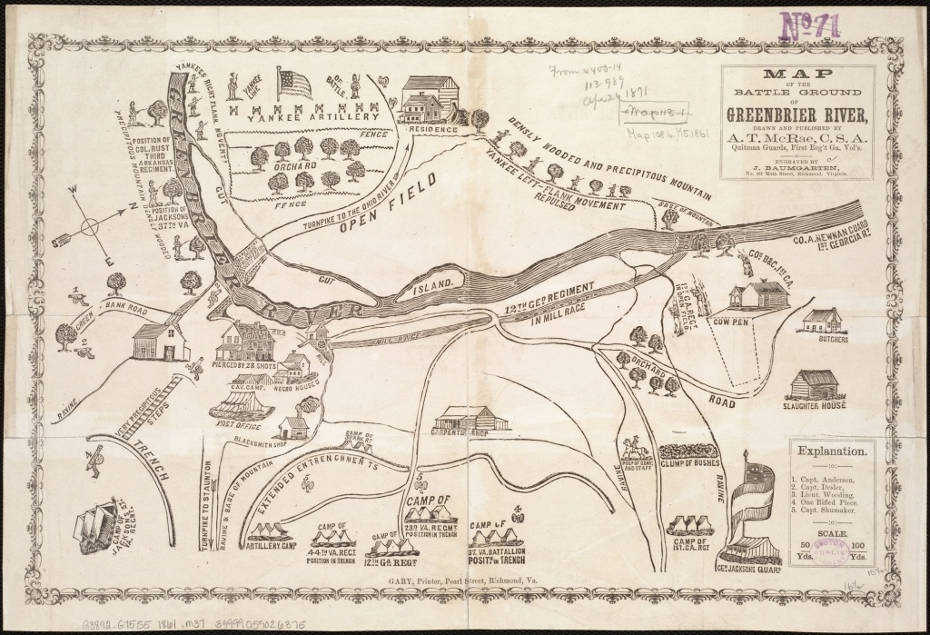

Map of Manassas/Bull Run 1

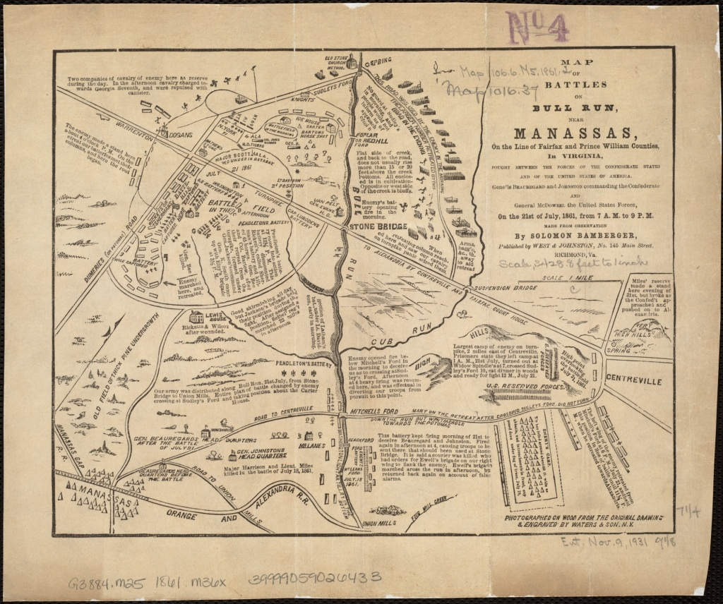

Map of Manassas/Bull Run 2

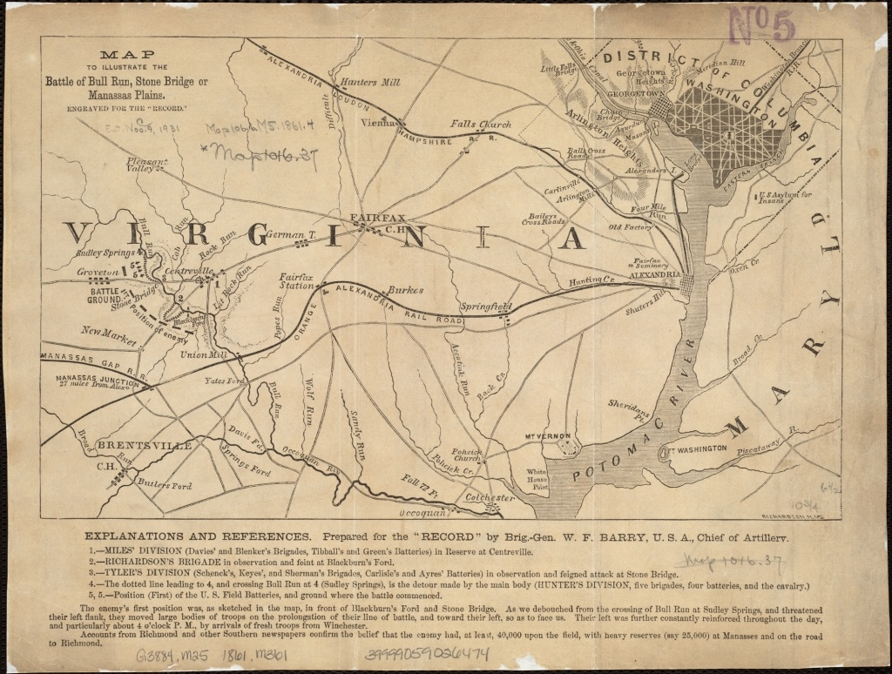

Map of Manassas/Bull Run 3

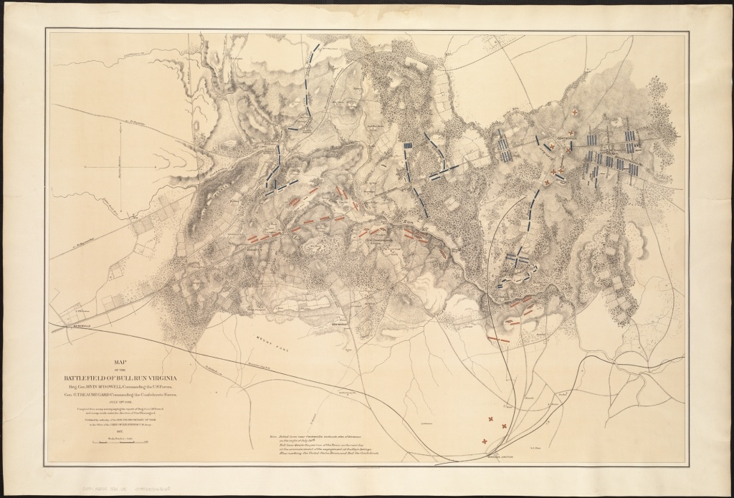

Map of Richmond

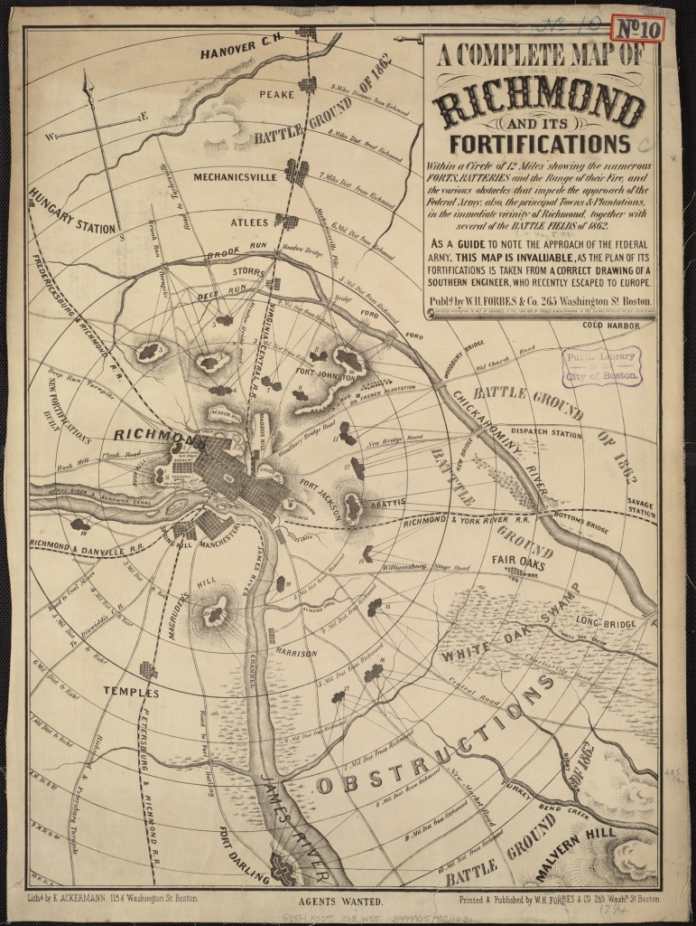

Map of Charleston Harbor

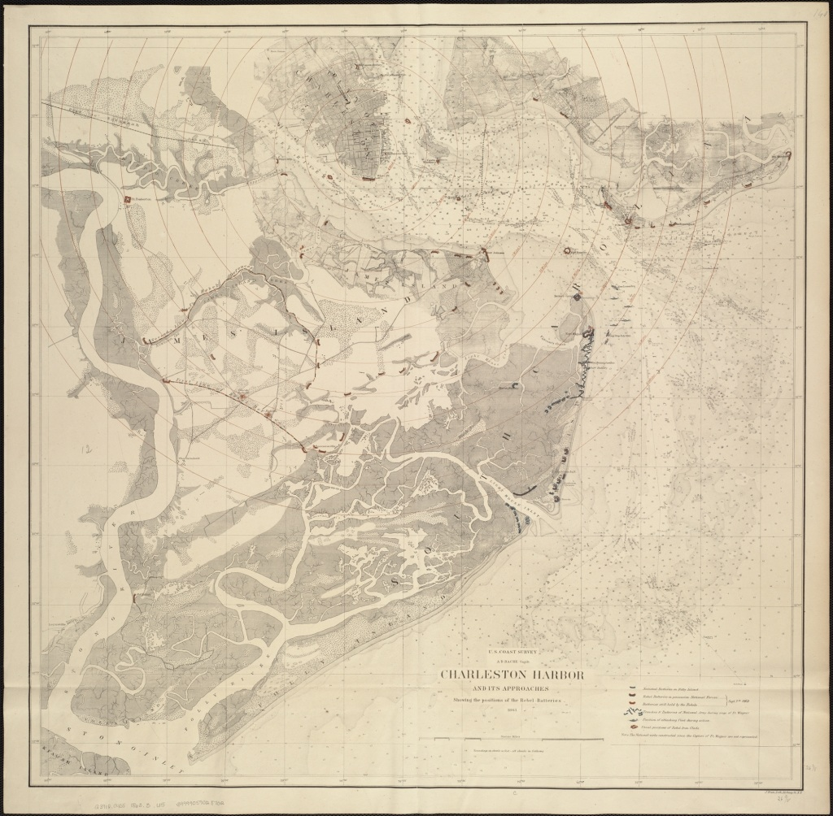

Scott’s Great Snake

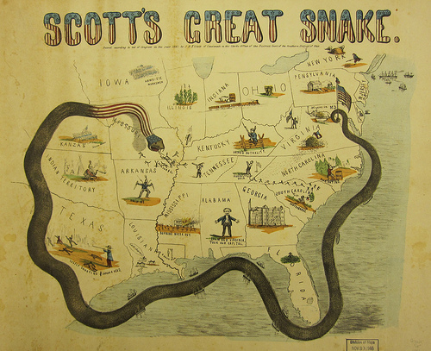

Historical Sketch of Rebellion

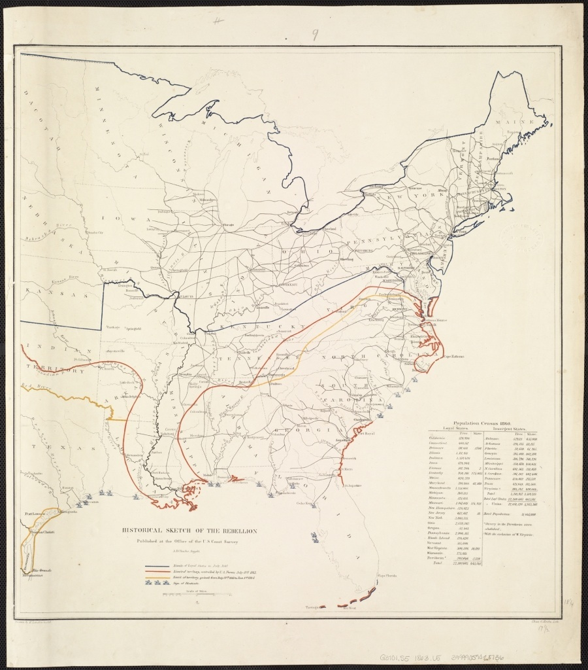

Battle of Gettysburg Day 1

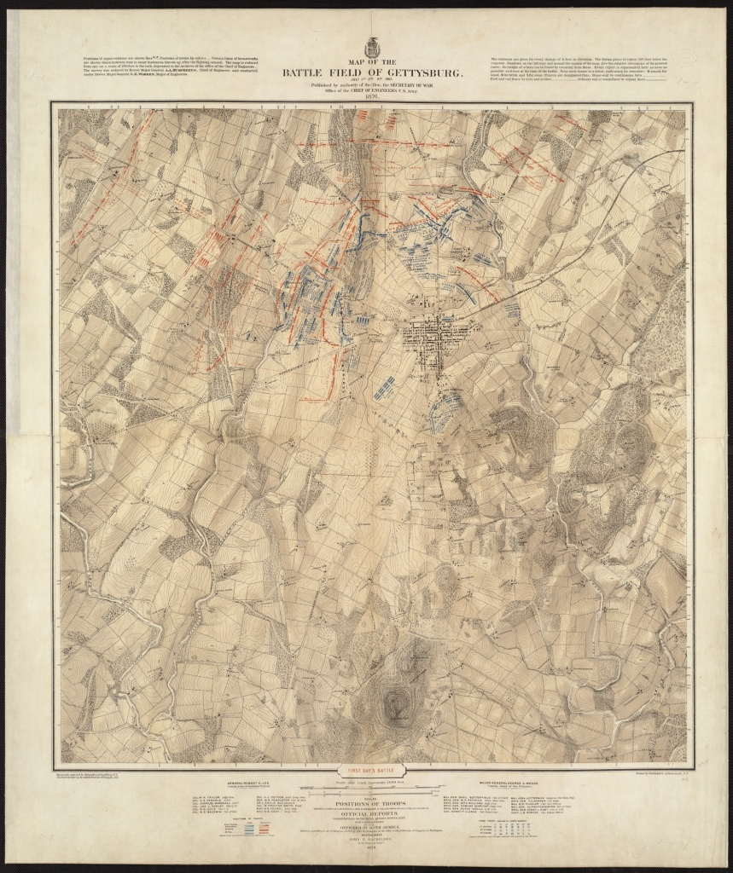

Battle of Gettysburg Day 2

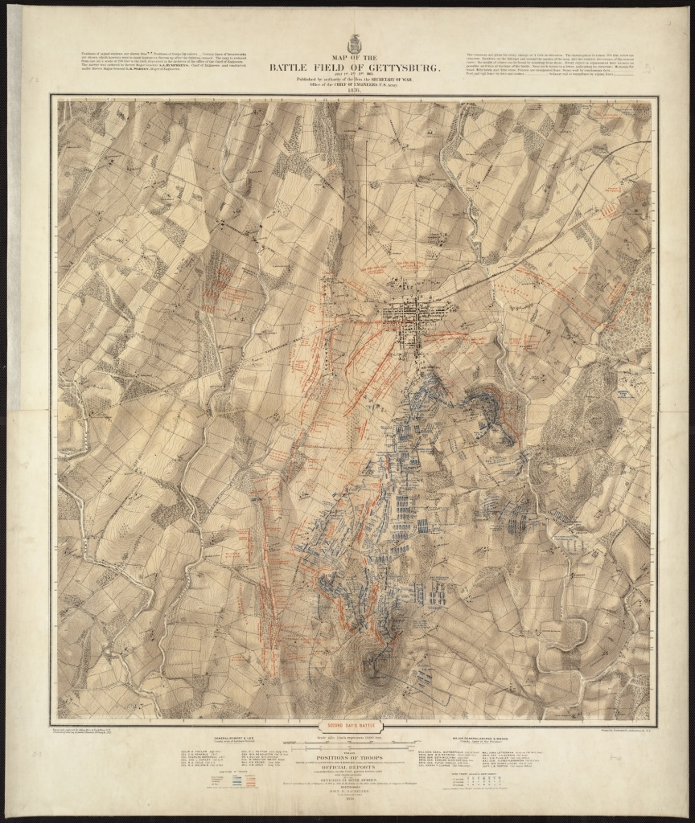

Battle of Gettysburg Day 3

