CONSTITUTION AND COMPROMISE
The Constitution of the United States is an extraordinary document, and it had provided a blueprint for governing our country for over 230 years. Its strength is its flexibility but at times this absence of clarity has created more confusion than guidance. In this lesson, students will analyze the text and context of this seminal document.

Procedure

- Begin the discussion with your students about government. What is its job? Explore notions of freedom and order, allowing people to walk the paths they wish without bumping into one another. But what happens when two people arrive at an intersection at the same time. Who gets to go first? Turn this into a conversation about COMPROMISE. What do they think this word means? Do they make compromises in their own lives?
- Now identify the big issues the people writing the Constitution had in front of them, i.e. what big intersections did they have to cross? Have Students Complete Part I of the Student Sheet. You may do this as a class or they may work in small groups using their textbooks or other materials. Discuss their results.
- The language of the Constitution was often vague ON PURPOSE. The framers wanted future generations to have to figure things out, to be able to adapt the document to changing circumstances. Read the two parts from the Constitution together, making sure everyone understands the language—it is quite complicated. Have Students complete Part II of the Student Sheet. You may do this as a class, in small groups or individually. Discuss their results.
- To explore one political compromise, have students look at Missouri Compromise Map and Information from the Materials Needed section. They may also use their text if it is covered there. Have them complete Part III of the Student Sheet. Discuss their results.

Time Allocation:

Part I: 30-45 minutes
Part II: 15-20 minutes
Part III: 20-30 minutes

Materials Needed

Missouri Compromise Map http://maps.bpl.org/details_12419/?srch_query=paullin&srch_fields=all&srch_style=exact&srch_fa=save
Missouri Compromise Information 1, http://www.loc.gov/rr/program/bib/ourdocs/Missouri.htm
Missouri Compromise Information 2, http://www.infoplease.com/ce6/history/A0833427.html

Assessment Criteria

Did students learn about the specific compromises reached in writing the Constitution?
Did students explore the language of the Constitution when the document does not provide exact guidance?
Did students learn about one political compromise prior to the Civil War?

Enrichment Activities

1. Have Students use the Checks and Balance sheet to see learn more about the nature of political compromise, Checks and Balances Image, http://www.ndstudies.org/images/checks.gif
2. Have students learn about the ways the 15th Amendment was circumvented in the Jim Crow South.
3. Have Students learn more about antebellum political compromise, http://www.loc.gov/rr/program/bib/ourdocs/Compromise1850.html

Common Core Curriculum Standards
English/Language Arts: Anchor Standards: CCSR for Reading
Key Ideas and Details
• CCSS.ELA-Literacy.CCRA.R.1 Read closely to determine what the text says explicitly and to make logical inferences from it; cite specific textual evidence when writing or speaking to support conclusions drawn from the text.
• CCSS.ELA-Literacy.CCRA.R.2 Determine central ideas or themes of a text and analyze their development; summarize the key supporting details and ideas.
Integration of Knowledge and Ideas
CCSS.ELA-Literacy.CCRA.R.7 Integrate and evaluate content presented in diverse media and formats, including visually and quantitatively, as well as in words
CCSS.ELA-Literacy.CCRA.R.9 Analyze how two or more texts address similar themes or topics in order to build knowledge or to compare the approaches the authors take.

English/Language Arts: History and Social Studies
Key Ideas and Details
• CCSS.ELA-Literacy.RH.6-8.1 Cite specific textual evidence to support analysis of primary and secondary sources.
• CCSS.ELA-Literacy.RH.6-8.2 Determine the central ideas or information of a primary or secondary source; provide an accurate summary of the source distinct from prior knowledge or opinions.
Integration of Knowledge and Ideas
CCSS.ELA-Literacy.RH.6-8.7 Integrate visual information (e.g., in charts, graphs, photographs, videos, or maps) with other information in print and digital texts.

The 13 colonies had gotten their independence from England but how would they rule themselves? They had tried the Articles of Confederation but needed something that gave them more rules but didn’t want too much power in a central government. They needed to figure out how to balance some big issues.

Part I
There were three big issues facing the men who wrote the Constitution:

BIG STATES versus SMALL STATES
One Side
The Other Side
Compromise Reached:

POWER OF STATES versus POWER OF CENTRAL (FEDERAL) GOVERNMENT
One Side
The Other Side
Compromise Reached:

SLAVERY
One Side
The Other Side
Compromise Reached:

Questions to consider:
- Does compromise mean that everyone is happy with the solution to the problem?
- What happens when a compromise does not provide a final answer to a problem?
- Did everyone in the new country benefit equally from the solution to the problem?
- Which groups in particular did not do well with the compromises that were made?

Part II
- Look at the following from the Constitution:

Article I, Section 8 (the powers of Congress)
To make all Laws which shall be necessary and proper for carrying into Execution for foregoing Powers, and all other Powers vest by this Constitution in the Government of the United States , or in any Department or Officer thereof.

Amendment Ten (part of the original Bill of Rights)
The powers not delegated to the United States of the Constitution, nor prohibited by it to the States, are reserved to the States respectively, or to the people.

- Suppose you wanted to build a road between New York and New Jersey. Who should make the laws about the road—the States or the Congress? How would you decide? Does the Constitution, based on what is above, help answer your question?
- How about a tax on a machine that is made in England but brought into the port of Charleston, South Carolina? Who should set the tax? Collect the tax?
- Do you think these two pieces of the Constitution were part of a compromise? If so, what questions were not settled by this compromise?
- The Fifteenth Amendment to the Constitution States
Section. 1. The right of citizens of the United States to vote shall not be denied or abridged by the United States or by any State on account of race, color, or previous condition of servitude.
Section. 2. The Congress shall have power to enforce this article by appropriate legislation.

- What is promised in this Amendment? Is anything promised?
- Why do you think the amendment was written the way it was?
- What might still be done to prevent people from voting, even with this Amendment?
- Do you think it was the result of a compromise?

Part III
Look at the Map and read the Materials your teacher gives you about the Missouri Compromise. Answer the following questions:
- What was the big problem that needed to be addressed in 1818?
- In what way was this problem similar to those faced by those who wrote the Constitution? In other words,
  - What did one side want?
  - What did the other side want?
  - What was the compromise?
  - Were there any people affected who were not consulted?

Missouri Compromise Map

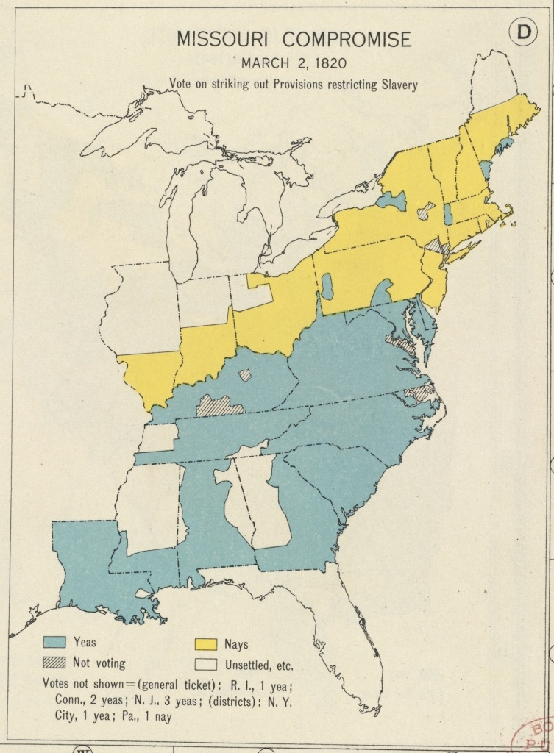

Missouri Compromise
Missouri Compromise, 1820–21, measures passed by the U.S. Congress to end the first of a series of crises concerning the extension of slavery.
By 1818, Missouri Territory had gained sufficient population to warrant its admission into the Union as a state. Its settlers came largely from the South, and it was expected that Missouri would be a slave state. To a statehood bill brought before the House of Representatives, James Tallmadge of New York proposed an amendment that would forbid importation of slaves and would bring about the ultimate emancipation of all slaves born in Missouri. This amendment passed the House (Feb., 1819), but not the Senate. The bitterness of the debates sharply emphasized the sectional division of the United States.
In Jan., 1820, a bill to admit Maine as a state passed the House. The admission of Alabama as a slave state in 1819 had brought the slave states and free states to equal representation in the Senate, and it was seen that by pairing Maine (certain to be a free state) and Missouri, this equality would be maintained. The two bills were joined as one in the Senate, with the clause forbidding slavery in Missouri replaced by a measure prohibiting slavery in the remainder of the Louisiana Purchase north of 36°30'N lat. (the southern boundary of Missouri). The House rejected this compromise bill, but after a conference committee of members of both houses was appointed, the bills were treated separately, and in Mar., 1820, Maine was made a state and Missouri was authorized to adopt a constitution having no restrictions on slavery.
A provision in the Missouri constitution barring the immigration of free blacks to the state was objectionable to many Northern Congressmen, and necessitated another congressional compromise. Not until the Missouri legislature pledged that nothing in its constitution would be interpreted to abridge the rights of citizens of the United States was the charter approved and Missouri admitted to the Union (Aug., 1821). Henry Clay, as speaker of the House, did much to secure passage of the compromise—so much, in fact, that he is generally regarded as its author, even though Senator Jesse B. Thomas of Illinois was far more responsible for the first bill. The 36°30' proviso held until 1854, when the Kansas-Nebraska Act repealed the Missouri Compromise.
See studies by G. Moore (1953, repr. 1967) and R. H. Brown (1964).
The Columbia Electronic Encyclopedia, 6th ed. Copyright © 2007, Columbia University Press. All rights reserved.

