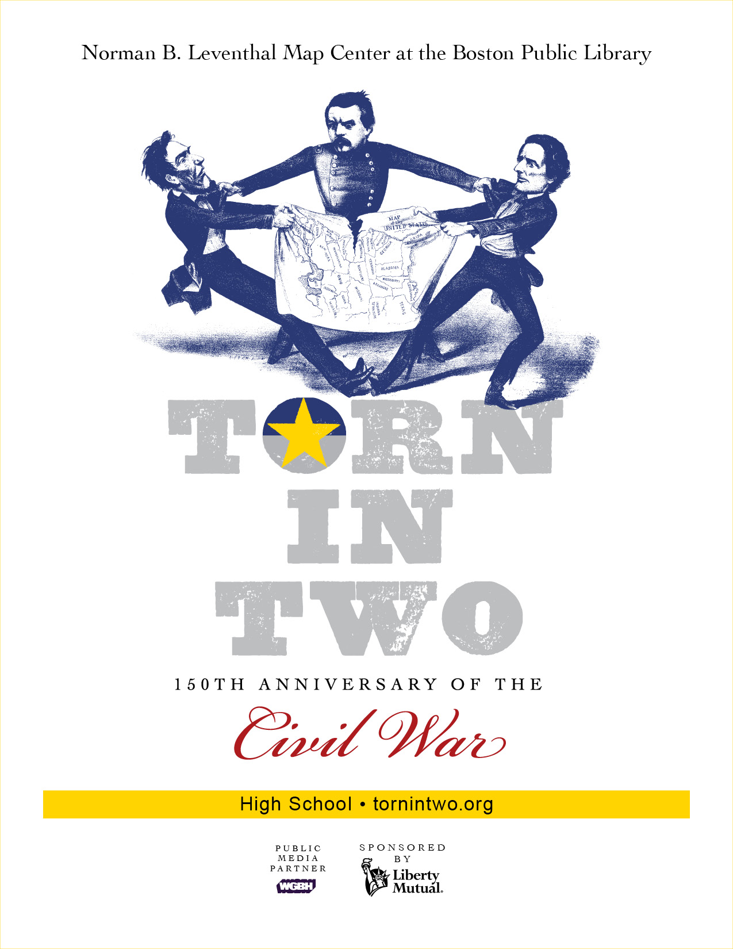
The lessons in this Curriculum Guide use objects from the Exhibition, Torn in Two: The 150th Anniversary of the Civil War. We hope you will use these lessons to supplement the standard United States History, 1763-1877 Curriculum as well as explore some new subjects. Specifically, we have drawn from the exhibit items and created lessons on the following topics: THE ECONOMIC GROWTH OF THE NORTH AND SOUTH, SLAVERY, CONSTITUTIONAL COMPROMISE, AND THE CIVIL WAR.

We have thought a great deal about the important skills and ideas that students need during high school. We know how valuable it is for students to have a strong foundation of concepts that cross disciplines and can be developed over the years. There is also overlap among both topics and ideas as well a many enrichment opportunities built into these lessons.

Each lesson may be used independently or in combination with other portions of these materials. All of these materials are also on our website, maps.bpl.org

TABLE OF CONTENTS:

Tab 1 - Lesson One: The Economic Power of the Antebellum North
Tab 2- Lesson Two: The Slave Economy of the South
Tab 3 - Lesson Three: The Louisiana Purchase: A Lesson in Constitutional Compromise Tab 4 - Lesson Four: Slave Options
Tab 5 - Lesson Five: Arguments For and Against Slavery
Tab 6 - Lesson Six: Massachusetts and the Civil War
Tab 7 - Lesson Seven: The Domestic Side of the Civil War
Tab 8 - Lesson Eight: Civil War Battle Plans
Tab 9 - Identities from the Torn in Two exhibition

EACH LESSON CONTAINS:

An overview sheet, including identified Massachusetts History and SS Curriculum Standards***
Teacher Sheets that include a detailed procedure, assessment criteria and enrichment activities
Student Students
Hardcopies and links to Supporting Materials

***PLEASE NOTE AS OF DECEMBER 1, 2012 COMMON CORE CURRICULUM STANDARDS ARE NOW ALSO INCLUDED ON THE LAST PAGE OF THE TEACHER SHEET IN EACH LESSON

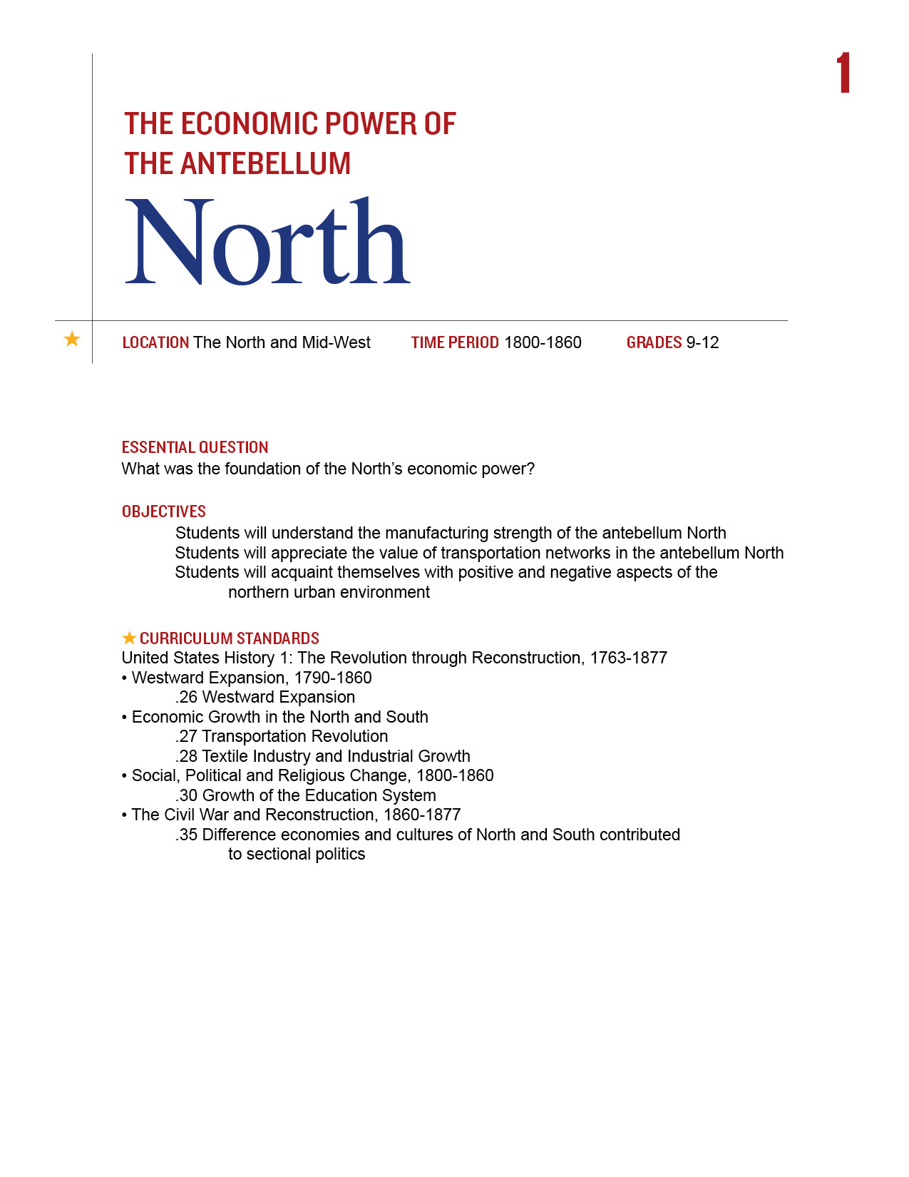
By the 1850s, there was a great deal of wealth in the northern and mid-western states. There was also the promise of much more wealth, as the slogan of the newly formed Republic Party promised: Free Soil, Free Labor, Free Men. But the fate of the western territories was hotly contested and it would be the horrific events of the Civil War that would determine their status. What was the situation of these northern states of the eve of succession?
You may do this lesson in conjunction with Lesson 2.

Procedure

- The intention of this lesson is to supplement material you are already covering with your students. Begin with the Map of Freedom and Slavery. The visual is quite basic. What do the Red and Blue states represent? Why are the Yellow areas the most important when this map was made in 1856? The data based on the 1850 census that this document provides is a treasure trove of information for your students. You will need to look at this map on line to see the data closely.
- Divide them into groups and assign them different portions of the data below the Map. Have each group present a summary of one of the following categories for the Northern States, using Part I of the Student Sheet:
Value of land (include farms, live stock, acres of improved land)
Educational Information (include newspaper circulation, library volumes)
Manufacturing Capital
Transportation information (include railroad and canal miles)
They may present their results in a graph, chart or other visual medium. Have each group
share its results with the rest of the class.
- Now discuss the value of transportation to manufacturing and look at the 1859 Railroad Map with your students. What differences do they notice between the North and South? How does this affect economic growth?
- Now have the students look at the Map of Lowell and complete Part II of the Student Sheet. You may do this as a class, in small groups or as an independent assignment. Discuss their results. Be sure to include the different circumstances for the mill owners and mill workers. Have them think about the wives of the mill owners too!

Time Allocation:

Part I: 45 minute, including time to share results
Part II 15-20 minutes

Materials Needed

1850 Map of Lowell, MA http://maps.bpl.org/details_11051/?srch_query=civil+war&srch_fields=all&srch_style=exact&srch_fa=save
1856 Map of Freedom and Slavery, http://maps.bpl.org/details_14346/?srch_query=civil+war&srch_fields=all&srch_style=exact&srch_fa=save
1859 Railroad Map http://maps.bpl.org/details_14344/?srch_query=civil+war&srch_fields=all&srch_style=exact&srch_fa=save
Assessment Criteria

Did students see the manufacturing strength of northern industry?
Did students appreciate the value of transportation networks in the antebellum North?
Did students acquaint themselves with positive and negative aspects of the northern urban environment?

Enrichment Activities

- Imagine some of the Identities from the Torn in Tow Exhibition [in Tab 9 of this Curriculum Guide] visiting or encountering one another on the streets of Lowell. Write of script of that interaction, or a diary entry one of them might write afterwards or a letter to a friend.
- Take the 1860 Census data, http://www.census.gov/prod/www/abs/decennial/1860.html and compile similar charts to the ones you did for the 1850 census. Did much change? Was the economic position of the North stronger or weaker? Can you see how it brought the nation closer to war?

Common Core Curriculum Standards
English/Language Arts Standards: Anchor Standards: CCRS Reading
Integration of Knowledge and Ideas
CCSS.ELA-Literacy.CCRA.R.7 Integrate and evaluate content presented in diverse media and formats, including visually and quantitatively, as well as in words

English/Language Arts: History/Social Studies: Grades 9-12
Key Ideas and Details
- CCSS.ELA-Literacy.RH.9-10.1 Cite specific textual evidence to support analysis of primary and secondary sources, attending to such features as the date and origin of the information.
- CCSS.ELA-Literacy.RH.11-12.1 Cite specific textual evidence to support analysis of primary and secondary sources, connecting insights gained from specific details to an understanding of the text as a whole.
Integration of Knowledge and Ideas
- CCSS.ELA-Literacy.RH.9-10.7 Integrate quantitative or technical analysis (e.g., charts, research data) with qualitative analysis in print or digital text.
- CCSS.ELA-Literacy.RH.9-10.9 Compare and contrast treatments of the same topic in several primary and secondary sources.
- CCSS.ELA-Literacy.RH.11-12.7 Integrate and evaluate multiple sources of information presented in diverse formats and media (e.g., visually, quantitatively, as well as in words) in order to address a question or solve a problem.
- CCSS.ELA-Literacy.RH.11-12.9 Integrate information from diverse sources, both primary and secondary, into a coherent understanding of an idea or event, noting discrepancies among sources.
There were a great many differences between North and South by 1850. The data on this map was drawn from the 1850 census.

Part I
You will be gathering data from the left side of the map.
- How are these states labeled? Why was it important to the mapmaker to use this language?
- Your teacher will assign your group one or more of the columns in the map. Be sure to include total information for the northern states as well as a comparison to the South and a state by state total.

Part II
Look at the Map of Lowell your teacher shows you and answer the following questions:
- From when and of where is this map?
- What images dominate the map?
- Why do you think they are so important?
- Based on what you see in this map, what were the most important things happening in Lowell at that time?
- Make a list of five people who might have lived in Lowell at that time. Do you think they all lived in the nice buildings that surround the map?
- Now make a list of 4 good things you can see about living in Lowell, based on what you see in the map.
- Make a list of 4 bad things you can see about living in Lowell, based on what you can see in the map.
- Pretend you are living at the time this map was made. Do you think you would have thought the same things were good and bad? Why or why not?

Map of Lowell

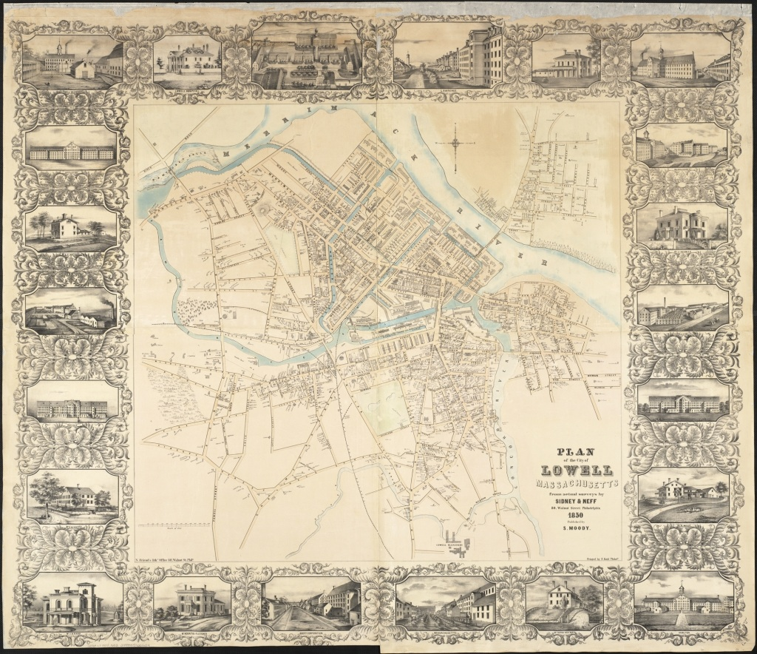

Map of Freedom and Slavery

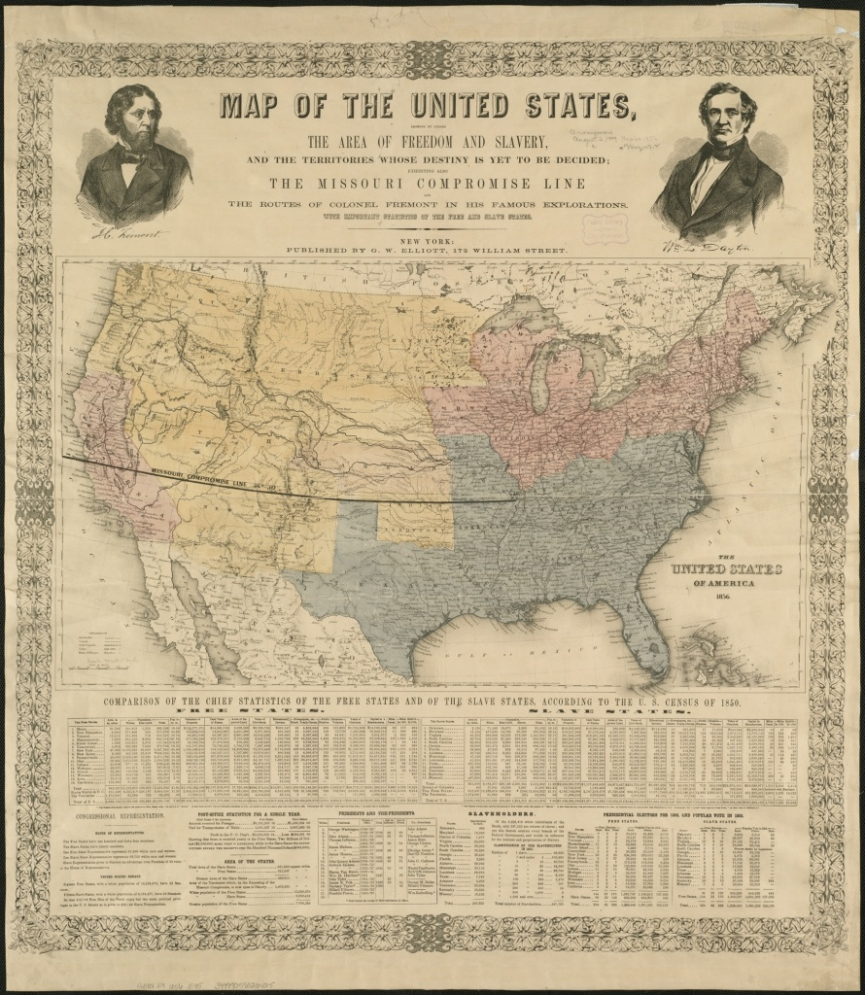

Railroad Map 1859

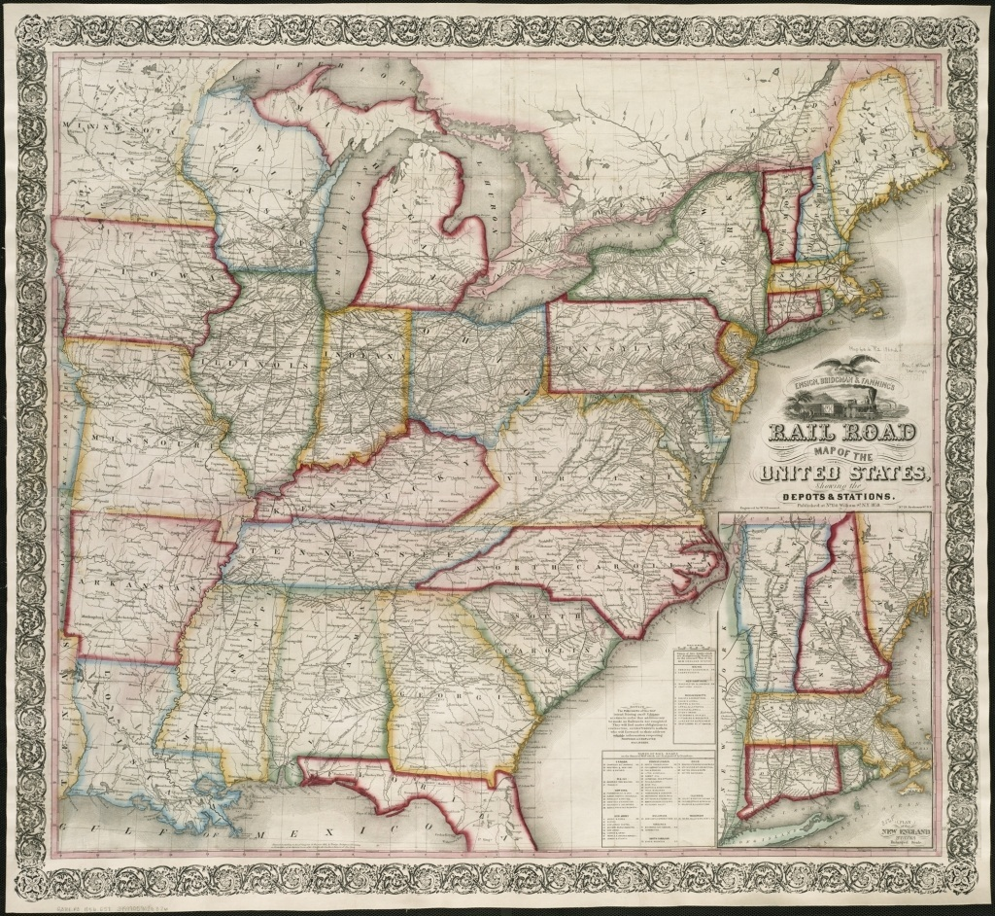
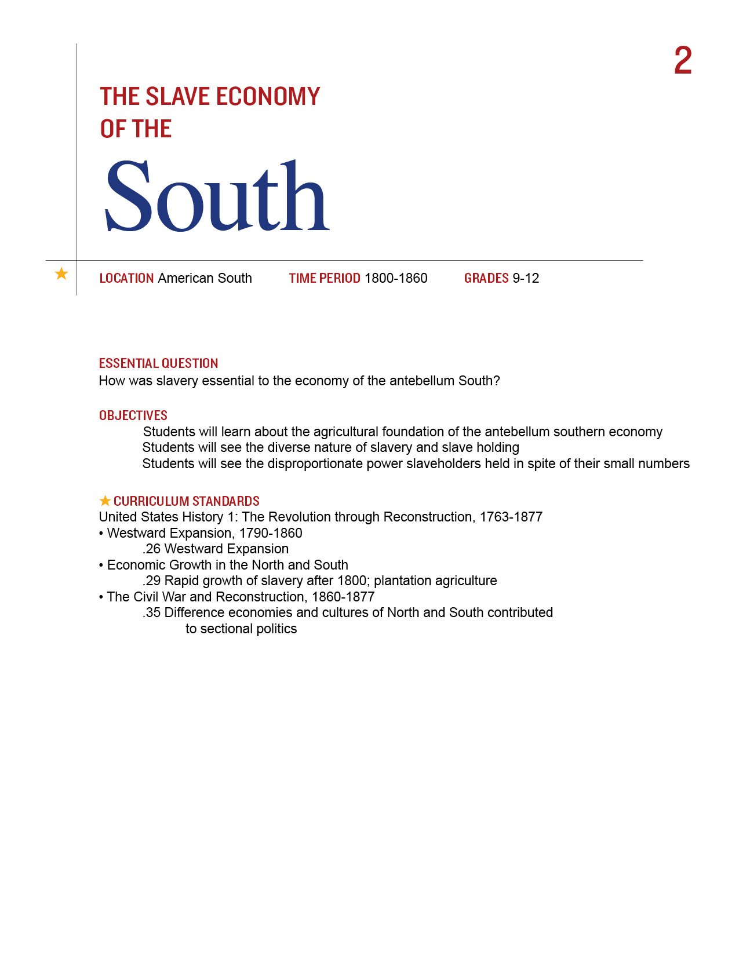

There was a great deal of wealth in the South. If history is about choices, the planter aristocracy committed the South to an agricultural society in which wealth was tied to the land and a forced system of labor. The stark reality that such a small number of individuals were making choices that affected so many is worth exploring with your students and one that will be woven throughout many of these lessons.
You may want to do this lesson in conjunction with Lesson 1.

Procedure

- The intention of this lesson is to supplement material you are already covering with your students. Begin with the Map of Freedom and Slavery. The visual is quite basic. What do the Red and Blue states represent? Why are the Yellow areas most important? The data based on the 1850 census that this document provides is a treasure trove of information for your students. You will need to look at this map on line to see the data closely.
- Divide them into groups and assign them different portions of the data below the Map. Have each group present a summary of one of the following categories for the southern States, using Part I of the Student Sheet:
Value of land (include farms, live stock, acres of improved land)
Educational Information (include newspaper circulation, library volumes)
Manufacturing Capital
Transportation information (include railroad and canal miles)
Data on Slaveholders (include numbers owned)
They may present their results in a graph, chart or other visual medium. Have each group
share its results with the rest of the class. Be sure to discuss the Data on Slaveholders.
Note not only the population of the South but of the entire country. See how few people
owned slaves as a percentage of the total population in the United States at that time.
- Now shift to the diversity of South. Show students the Slave Distribution Map as a class.
- What are their first reactions? What do they see? What do they think the map is showing them? Based on what they learned from the Freedom and Slavery Map data, are they surprised that slaves are not evenly distributed in the South?
- Have them answer the questions in Part II of the Student Sheet. They may do this as a class, in small groups or independently. Discuss their results.

Time Allocation:

Part I: 45 minutes, including time to present data
Part II: 30 minutes

Materials Needed

Southern Crop Map
1856 Map of Freedom and Slavery (See Lesson 1) http://maps.bpl.org/details_14346/?srch_query=civil+war&srch_fields=all&srch_style=exact&srch_fa=save
Map of Slave Distribution, http://maps.bpl.org/details_14001/?dl_pp=1&srch_query=civil+war&srch_fields=all&srch_style=exact&srch_fa=save

Assessment Criteria

Did students learn about the agricultural foundation of the antebellum Southern economy?
Did students see the diverse nature of slavery and slave holding?
Did students see the disproportionate power slaveholders held in spite of their small numbers?

Enrichment Activities

- Lincoln used the Slave Distribution Map before he issued the Emancipation Proclamation. Why? What do you think he was looking for in this document to help him in this important decision of his presidency?
- Cotton Production was greatly affected by the War. Look at the data from this map and
see if you can explain what happened: Cotton Export Map, http://www.flickr.com/photos/59843331@N03/5492480326/in/photostream

Common Core Curriculum Standards
English/Language Arts Standards: Anchor Standards: CCRS Reading
Integration of Knowledge and Ideas
CCSS.ELA-Literacy.CCRA.R.7 Integrate and evaluate content presented in diverse media and formats, including visually and quantitatively, as well as in words

English/Language Arts: History/Social Studies: Grades 9-12
Key Ideas and Details
- CCSS.ELA-Literacy.RH.9-10.1 Cite specific textual evidence to support analysis of primary and secondary sources, attending to such features as the date and origin of the information.
- CCSS.ELA-Literacy.RH.11-12.1 Cite specific textual evidence to support analysis of primary and secondary sources, connecting insights gained from specific details to an understanding of the text as a whole.
Integration of Knowledge and Ideas
- CCSS.ELA-Literacy.RH.9-10.7 Integrate quantitative or technical analysis (e.g., charts, research data) with qualitative analysis in print or digital text.
- CCSS.ELA-Literacy.RH.9-10.9 Compare and contrast treatments of the same topic in several primary and secondary sources.
- CCSS.ELA-Literacy.RH.11-12.7 Integrate and evaluate multiple sources of information presented in diverse formats and media (e.g., visually, quantitatively, as well as in words) in order to address a question or solve a problem.
CCSS.ELA-Literacy.RH.11-12.9 Integrate information from diverse sources, both primary and secondary, into a coherent understanding of an idea or event, noting discrepancies among sources
There were a great many differences between North and South by 1850. The data on this map was drawn from the 1850 census.

Part I
You will be gathering data from the right side of the map.
- How are these states labeled? Why was it important to the mapmaker to use this language?
- Your teacher will assign your group one or more of the columns in the map. Be sure to include total information for the southern states as well as a comparison to the North and a state by state total.

Part II
Look at the Southern Crop Map and the Slave Distribution Map and answer the following questions:
- How was life in the South diverse? What accounted for these differences?
- Where did the mapmaker get his data for the Slave Distribution Map?
- On the Slave Distribution Map, how are scale and key combined into one element?
- Which areas have the highest percentages of slaves? The lowest? What reasons might there have been for these differences?
- 15 states had slaves but only 11 seceded. Based on the data on this map, do you think you could have predicted which states would secede?
- This map was sold for a specific reason—can you find the reason on the map?
- Pretend you were an abolitionist living in 1861. Would this map have helped or hurt your cause?

Southern Crop Map

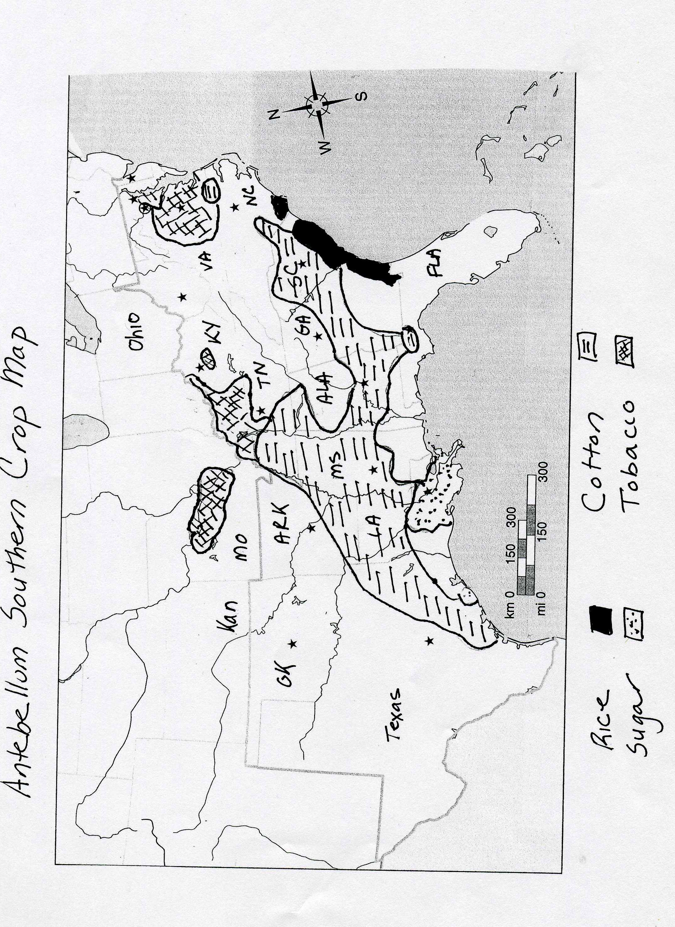

Slave Distribution Map

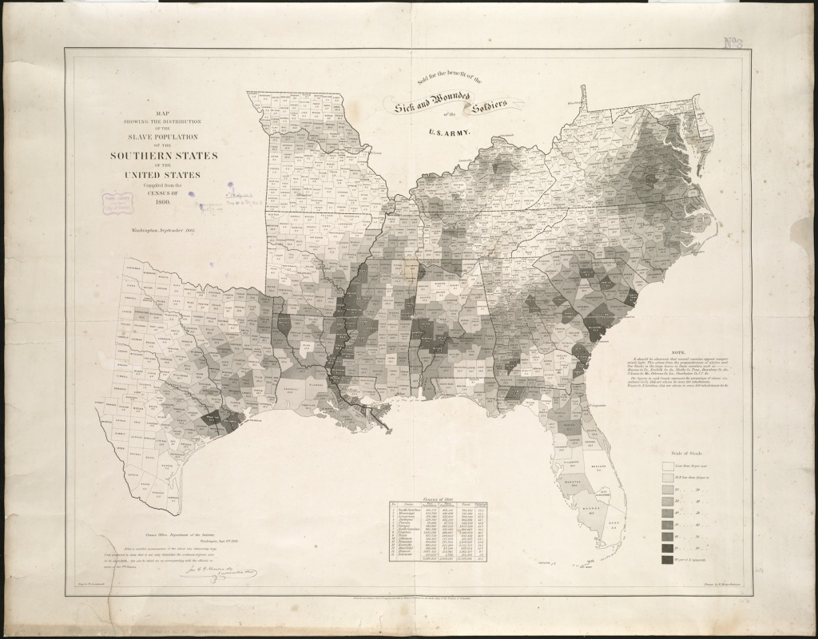
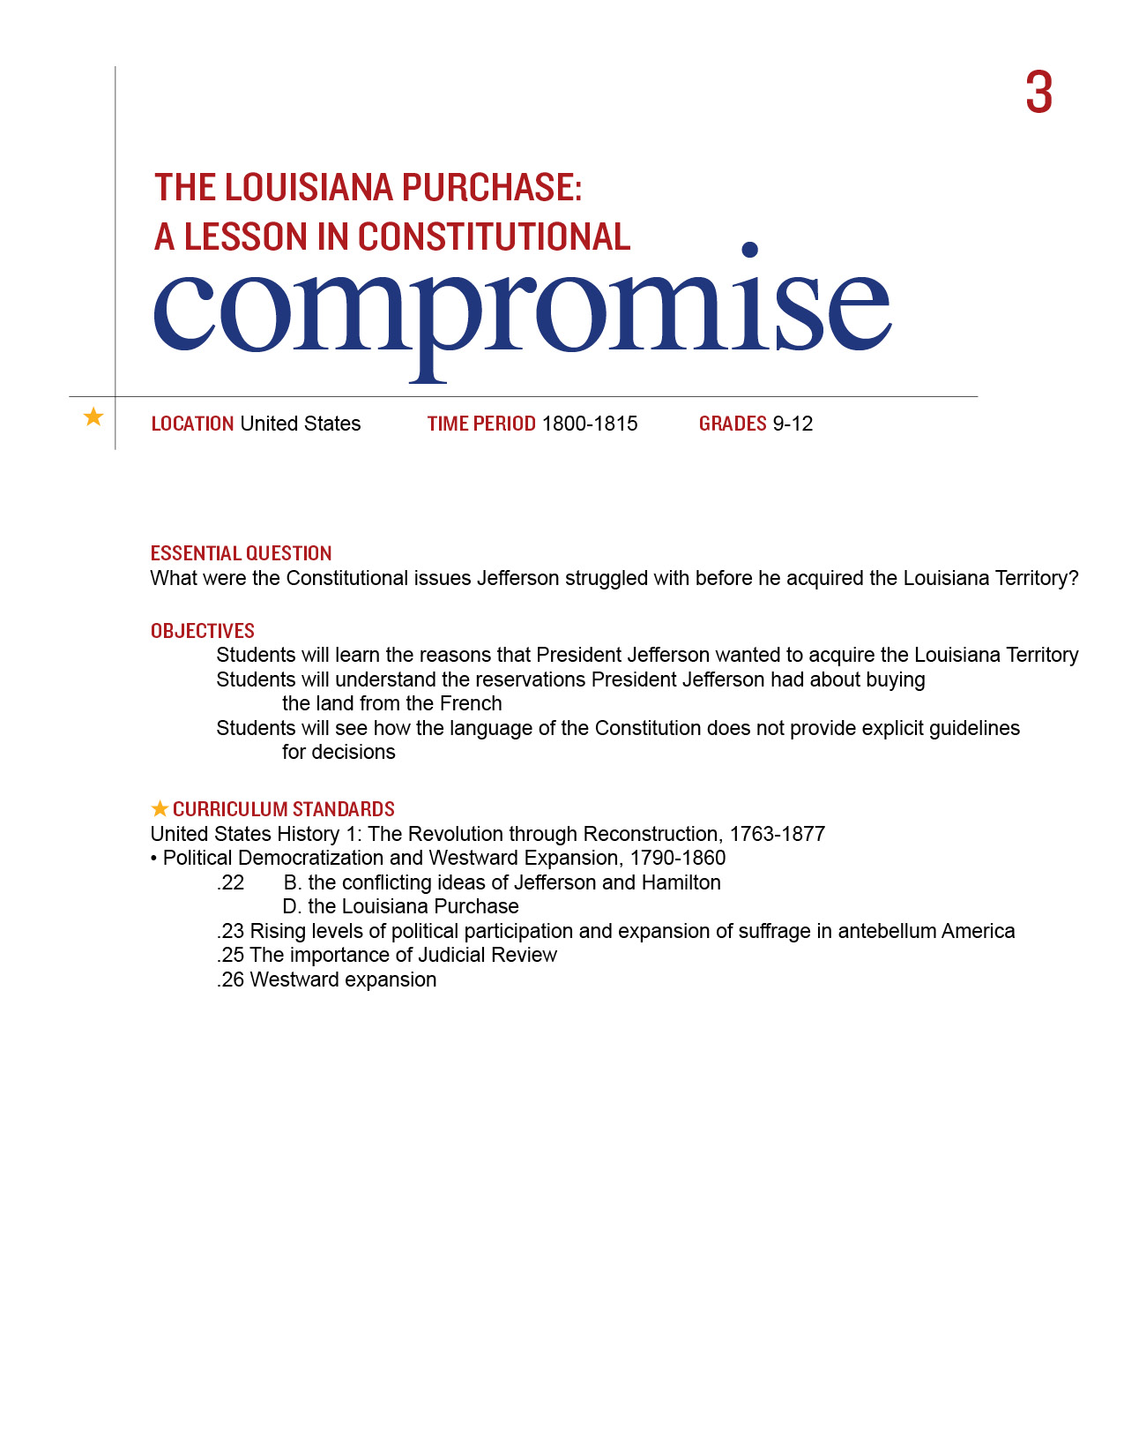
By 1800, the young nation was growing quickly. Its new President, Thomas Jefferson represented this growth in many ways. He was the voice of the Western farmer whom he believed would be the foundation of this new nation. But to acquire the dignity and virtue necessary to participate in this great republican experiment, land was needed. So when the opportunity to double the physical land mass presented itself, Jefferson, despite his reservations about Constitutional authority and the impact of all of that land of the fate of slavery, agreed to the terms of sale.

Procedure

- This lesson is designed to supplement your regular curriculum materials. Your students should be able to identify most of key concepts/terms/people listed on the Student Sheet from their text. You may want them to do so before you begin the lesson or use as a review at the end.
- To indicate the state of the country’s growth in 1800, show the students the US Population Chart and the Presidential Election Map of 1800. Have them complete Section I of the Student Sheet. Discuss their results.
- As the farmers moved westward, they needed to get their crops to market and the Mississippi River became increasingly important. Look at the Map of North America, 1799 with your Students. Find the Mississippi and the Port of New Orleans. Why was it a problem when the French stopped letting us use the port in 1802?
- The small farmer was very important to both Jefferson the revolutionary and Jefferson the President. He believed that the nation would be built on the farms of those who worked hard and learned the importance of virtue through their hard work. But land was necessary for these farms. Be sure to include Jefferson’s vision of the importance of the small farmer for the new nation.
- Review/Introduce Jefferson’s stand on Constitutional interpretation. Also have your students learn about the details of the Louisiana Purchase. It will be covered in their text. If you would like them to read about it elsewhere, there is a link provided in the Materials Section. Have Students complete Part II of the Student Sheet, particularly if you have not yet studied John Marshall and any of his key decision. Discuss their results. Be sure to explore the value of compromise in politics.
- In addition to the issues of Strict Construction, Jefferson knew that there would be issues over both Native Americans and the extensive of slavery. You may or may not want to explore these topics with your students at this time.

Time Allocation: Part I: 20-30 minutes Part II: 20-30 minutes

Materials Needed

US Population Chart, 1790-1810
Presidential Election Map, 1800
Map of North America, http://maps.bpl.org/details_10587/?mtid=1390
Overview of Louisiana Purchase, http://www.nps.gov/archive/jeff/lewisclark2/circa1804/heritage/louisianapurchase/louisianapurchase.htm
Assessment Criteria

Did students learn the reasons that President Jefferson wanted to acquire the Louisiana Territory?
Did students understand the reservations President Jefferson had about acquiring the land from the French?
Did students see how the language of the Constitution does not provide explicit guidelines for decisions?

Enrichment Activities

Stage a debate as Federalist and Democratic-Republicans over the Purchase of Louisiana

Common Core Curriculum Standards
English/Language Arts Standards: Anchor Standards: CCRS Reading
Key Ideas and Details
• CCSS.ELA-Literacy.CCRA.R.1 Read closely to determine what the text says explicitly and to make logical inferences from it; cite specific textual evidence when writing or speaking to support conclusions drawn from the text.
• CCSS.ELA-Literacy.CCRA.R.2 Determine central ideas or themes of a text and analyze their development; summarize the key supporting details and ideas.

Craft and Structure
• CCSS.ELA-Literacy.CCRA.R.4 Interpret words and phrases as they are used in a text, including determining technical, connotative, and figurative meanings, and analyze how specific word choices shape meaning or tone.
• CCSS.ELA-Literacy.CCRA.R.5 Analyze the structure of texts, including how specific sentences, paragraphs, and larger portions of the text (e.g., a section, chapter, scene, or stanza) relate to each other and the whole.
Reading: Informational Text, Integration of Knowledge and Ideas, 9-12
CCSS.ELA-Literacy.RI.9-10.9 Analyze seminal U.S. documents of historical and literary significance
CCSS.ELA-Literacy.RI.11-12.9 Analyze seventeenth-, eighteenth-, and nineteenth-century foundational U.S. documents of historical and literary significance (including The Declaration of Independence, the Preamble to the Constitution, the Bill of Rights, and Lincoln’s Second Inaugural Address) for their themes, purposes, and rhetorical features.
America has grown in size and population over its long history. There were many good reasons to expand the size of the country but sometimes there were also reasons to think twice. In 1803 the United States got the chance to double its size and the President had to think long and hard about what to do.

Key Concepts, Terms, & People
Strict v. Loose Interpretation of the Constitution
The growing importance of transportation in the new nation
The good and bad of Westward expansion
Jefferson the idealist v. Jefferson the politician

Robert Livingston Territorial Acquisition
Federalists Westward Expansion
Democrats Extension of Slavery

Part I
Look at the Population Chart and Presidential Election Map your teacher gives you.
- Which states had the largest populations in 1790? 1800? 1810?
- Which states were growing the fastest (that is even if their numbers were not as big, which ones were doubling or even tripling over a 10 year period)? What part of the country were they in?
- Whom do you think was moving to those parts of the country? Why do you think they were moving there?
- Look at the 1800 Presidential Election Map. Who voted for Jefferson? What did his supporters want?

Part II
The US Constitution was a complex and often complicated document. Consider these two parts:

Article I, Section 8 (the Powers of Congress)
To make all Laws which shall be necessary and proper for carrying into Execution for foregoing Powers, and all other Powers vest by this Constitution in the Government of the United States , or in any Department or Officer thereof.

Amendment Ten (part of the original Bill of Rights)
The powers not delegated to the United States of the Constitution, nor prohibited by it to the States, are reserved to the States respectively, or to the people.

- Suppose you wanted to build a road between New York and New Jersey. Who should make the laws about the road—the States or the Congress? How would you decide? Does the Constitution, based on what is above, help answer your question?
- How about a tax on a machine that is made in England but brought into the port of Charleston, South Carolina? Who should set the tax? Collect the tax? Again, does the Constitution, based on what is above, help answer your question?

Now consider the decision to acquire the Louisiana Territory.
Read about these events in your text and answer the following questions:

- What was Jefferson hoping to get when he sent Livingstone to France?
- What did Napoleon offer instead?
- What were the terms of the deal?
- Thomas Jefferson believed that he could only do things if they were exactly written in the Constitution but nowhere in the Constitution did it say that Presidents could buy land.
But he really wanted Louisiana for the farmers and for the nation.
7. What were the reasons to buy Louisiana?
8. Besides the Constitution, might there be any other problems with buying Louisiana?
9. Do you think Jefferson was right to purchase Louisiana for the country?

United States Population Chart

STATE | 1790 | 1800 | 1810
MAINE | 96540 | 151719 | 228705
NEW HAMPSHIRE | 141885 | 183858 | 214460
VERMONT | 85425 | 154465 | 217895
MASSACHUSETTS | 378787 | 422845 | 472040
RHODE ISLAND | 68825 | 69122 | 76931
CONNECTICUT | 237946 | 251002 | 261942
NEW YORK | 340120 | 589051 | 959049
NEW JERSEY | 184139 | 211149 | 245562
PENNSYLVANIA | 434373 | 602365 | 810091
OHIO |  | 45365 | 230760
INDIANA |  | 5641 | 24520
ILLINOIS |  |  | 12282
MICHIGAN |  |  | 4762
WISCONSIN
DELAWARE | 59096 | 64273 | 72674
MARYLAND | 319728 | 341548 | 380546
WASHINGTON DC |  | 8144 | 15471
VIRGINIA | 691737 | 807559 | 877683
W VIRGINIA | 55873 | 78592 | 105469
N CAROLINA | 393751 | 478103 | 555500
S CAROLINA | 249073 | 345591 | 415115
GEORGIA | 82548 | 162686 | 252433
FLORIDA
KENTUCKY | 73677 | 220995 | 406511
TENNESSEE | 35691 | 105602 | 261727
ALABAMA |  | 1250 | 9046
MISSISSIPPI |  | 7600 | 31306

Map of North America

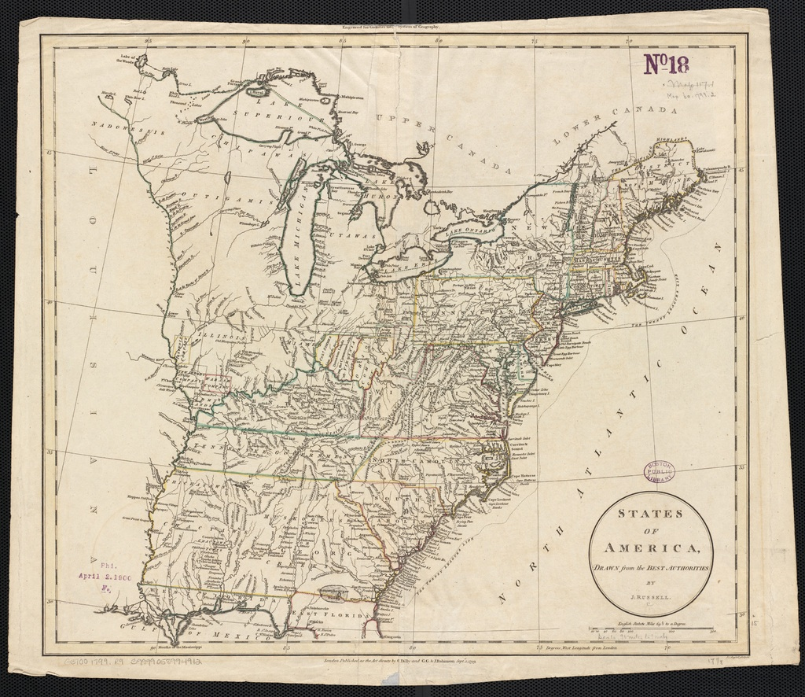

Presidential Elections Map 1800

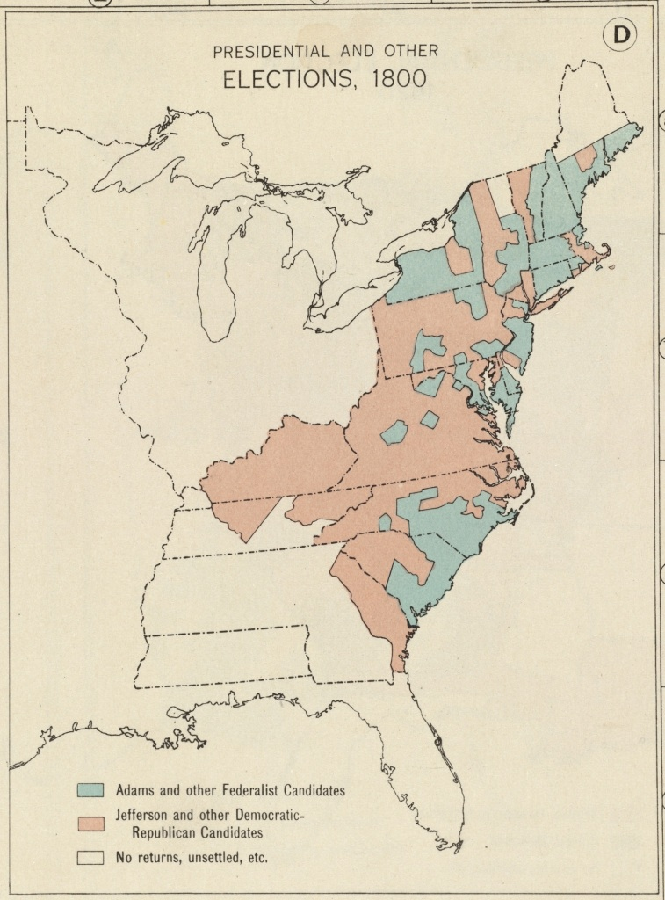
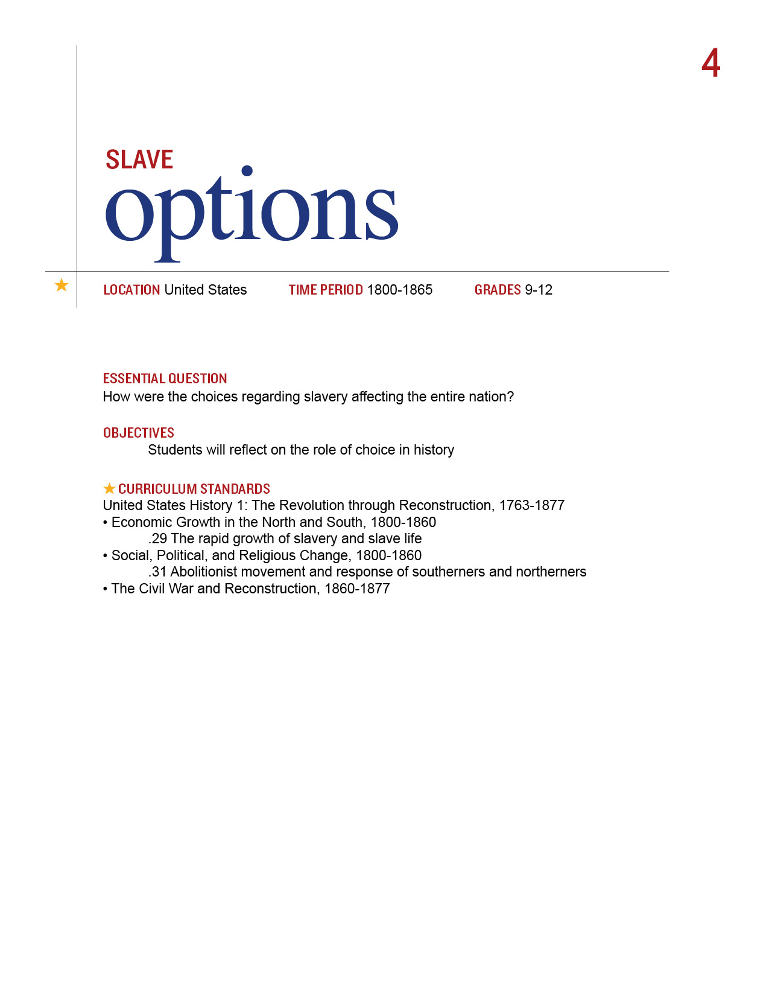
At its core, history is about choices—which ones were available, who got to make them and what impact did they have. To make sense of the history of the Civil War and slavery, our approach is to access this topic through this notion of choice. Who was making the decisions? How did so few people decide the destiny of so many? It is also imperative to recognize the power of the seemingly powerless to make choices about that which they could, to take chances, to control those aspects of their lives that they could.
This lesson is a template that you may expand or adapt to your students’ needs and interests. The questions included are just a starting point.

Procedure

- We suggest you begin with the students’ own lives. Ask them a series of seemingly basic questions about themselves. They are listed on the Student Sheet. You may have them create a chart with several columns. Label the first column ME. The next one could be for Amos, a 14 year old slave in 1850 South Carolina. The third column could be for Mrs. Jones, the wife of Amos’ owner.
- Number their chart, to begin with, 1-6. Have them answer YES or NO to the following:
- Do you go to school?
- Do you live with your family?
- Are you allowed to read?
- When you grow up, could you be President of the United States?
- When you grow up, will you be allowed to get married?
- When you grow up, will you buy a house?
They will respond YES to all of these questions.
- Now have them answer the questions as Amos would have. For Amos, all answers would have been NO. And Mrs. Jones. About half or more of her answers would have been NO as well. Discuss that even white women of privilege had limited freedoms in the antebellum South.
- Now transfer the lesson to the realities of how decisions were actually made at that time. Introduce the Identities from he Torn in Two exhibition. Have the students assume some or all of these personas and answers these questions as the Identities.
- Have them answer these questions that would have been pertinent to an antebellum audience:
- Would you return a runaway slave
- Would have voted yea or nay on the Kansas-Nebraska Act
- Did you support the Dred Scott Case
- Did you vote for Lincoln
- Would you have voted for secession?
- Look at the Slave Owner chart with your Students. Who was actually making the choices in the United States South during the antebellum period?

The conversation that ensues is up to you and your students. What did freedom mean? Under what circumstances do people have control over their lives? The lives of others? When is it OK to break the rules? The law?

Time Allocation: 30-45 minutes
Materials Needed

Identities from the Torn in Two: 150th Anniversary of the Civil War exhibition
Slave Owner Chart

Assessment Criteria

Again, up to the goals you set for you and your students.

Enrichment Activities

Have the Identities debate any of the questions raised in #5 above.

Common Core Curriculum Standards
English/Language Arts: History/Social Studies. 9-12
Integration of Knowledge and Ideas
CCSS.ELA-Literacy.RH.9-10.9 Compare and contrast treatments of the same topic in several primary and secondary sources.
CCSS.ELA-Literacy.RH.11-12.9 Integrate information from diverse sources, both primary and secondary, into a coherent understanding of an idea or event, noting discrepancies among sources.

What does it mean to be free? What choices do you get to make in your life? What happens to people who do not get to make choices? Might they decide to take the law into their own hands?

Assignment
Use this space to make your Slave Options Chart

Slave Owner Chart (based on 1850 census data)

Number of Slaves Owned Number of Slave Owners

  - 68,820

between 1-5 105, 683

between 5-10 80, 765

between 10-20 54,595

between 20-50 29,733

between 50-100 6,196

between 100-200 1479

between 200-300 187

between 300-500 56

between 500-1000 9

more than 1000 2

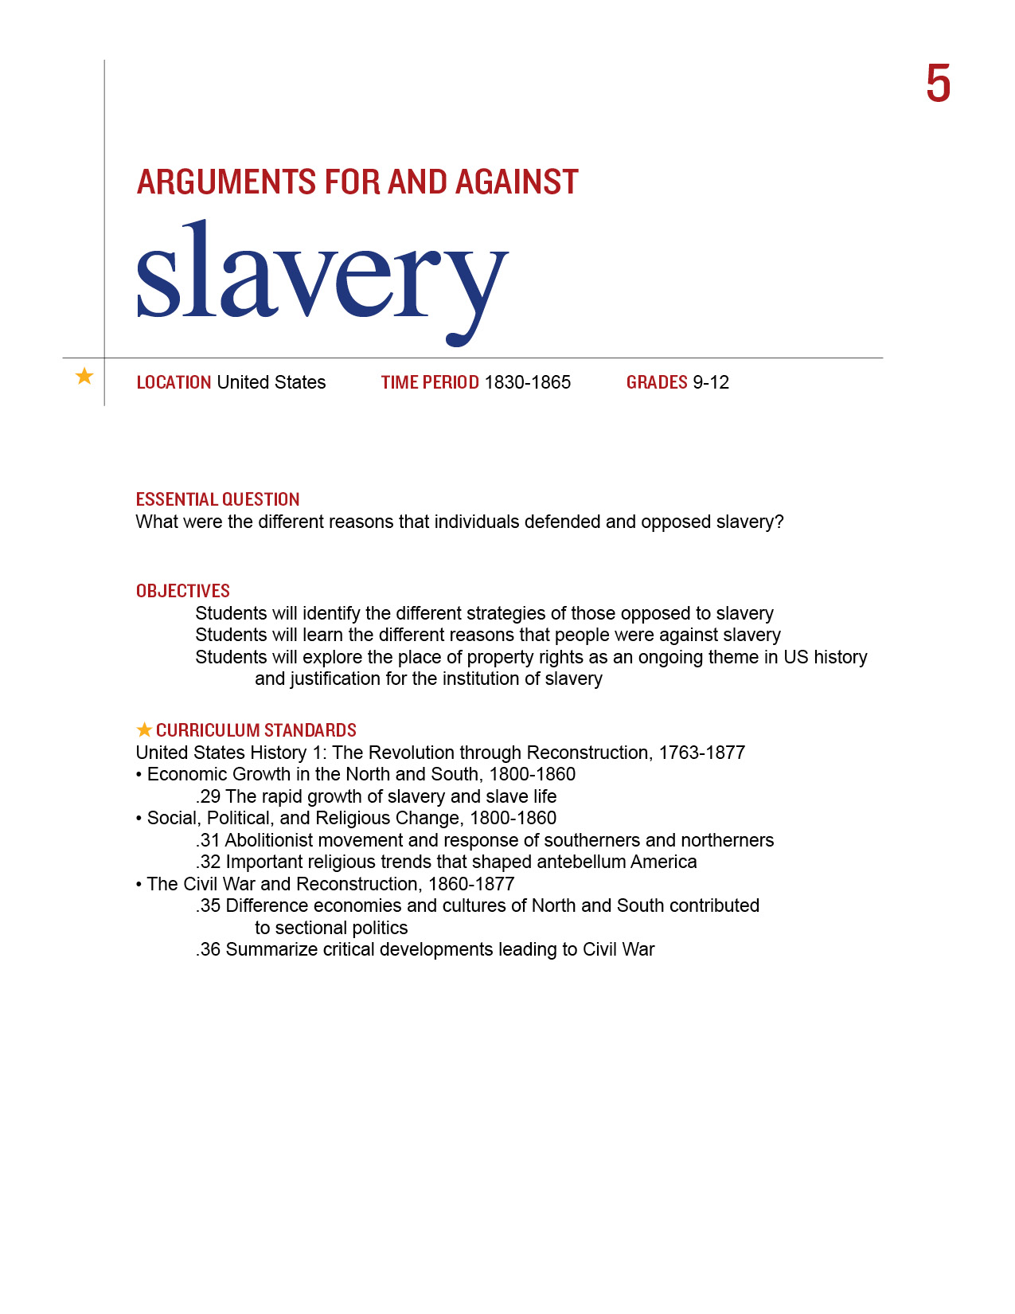
To modern sensibilities, slavery in the antebellum period is more than harsh. It is almost inconceivable that so many Americans supported this brutal system of forced labor. Close inspection reveals how few contemporaries believed that it should be abolished outright.

Procedure

- This lesson is designed to supplement your regular curriculum materials. They should be able to identify most of key terms/people on the Student Sheet from their text. You may want them to identify these terms before you begin the lesson or use as a review at the end.
- Begin with a discussion about property rights. How are they protected by law? Under what conditions does the government have the right to take an individual’s property? Review/introduce the concept of Eminent Domain.
- Now turn the discussion to the antebellum period and slavery. As harsh as it may be to hear, slaves were property and to many Americans during those years, that was not a subject of debate, except to confirm that it was wrong to take someone’s property.
- There were of course those who believed that slavery was a moral outrage. Have Students read excerpts from Douglass and Howe and complete of Part I of the Student Sheet. They may complete this as a class, in small groups or individually. Discuss their results.
- Not everyone who opposed slavery did so on moral grounds. Some believed it was inefficient economically. Others felt that it simply should not be extended to new territories acquired after the Mexican War. There were many strategies besides abolishing slavery suggested. Show Students the Maps of Liberia and American Missionary Society. What was their plan? Have Students complete Part II of the Student Sheet.
- Some slaves took matters into their own hands and ran away. They were helped in this through the efforts of the Underground Railroad but it was a crime to help the runaways and according to the Fugitive Slave Law, runaway slaves had to be returned. Show Students the Anthony Burns lithograph. They may read more on his case at the site listed in the Materials section. Discuss whether or not they thought it was right to return runaway slaves. Ask if they would have broken the law or returned the slave to his or her owner?
- There were those of course who thought that slaves were property and had no rights at all. Perhaps the strongest statement of this came in the Dred Scott decision in 1857. Have Students read Judge Taney’s decision and complete Part III of the Student Sheet.
- Finally, show class the lithograph, Arguments of the Chivalry which highlighted the battle between Charles Sumner and Preston Brooks over slavery. How does the cartoonist use the word Chivalry here? Is it a word of honor?

Time Allocation:

Part I: 30-45 minutes
Part II: 10-15 minutes
Part III: 30-45 minutes
Materials Needed

Frederick Douglass, “A Few Facts and Personal Observations of Slavery”: An Address Delivered in Ayr, Scotland on March 24, 1846 http://docsouth.unc.edu/neh/douglass/support7.html
Text for Battle Hymn of the Republic, http://www.flickr.com/photos/59843331@N03/5468268623/in/photostreamAnthony Burns Lithograph, http://www.flickr.com/photos/59843331@N03/5492481118/in/photostream
Background on Anthony Burns Case,
http://www.historynet.com/boston-combusts-the-fugitive-slave-case-of-anthony-burns.htm

Map of Liberia,
http://maps.bpl.org/details_14552/?srch_query=civil+war&srch_fields=all&srch_style=exact&srch_fa=save
Map of American Missionary Society, http://maps.bpl.org/details_14660/?srch_query=civil+war&srch_fields=all&srch_style=exact&srch_fa=save
Arguments of the Chivalry lithograph, http://www.flickr.com/photos/59843331@N03/5654458028/in/photostream
Dred Scott Decision, background and Supreme Court decision, http://www.pbs.org/wgbh/aia/part4/4h2933.html;

Assessment Criteria

Did students identify the different strategies of those opposed to slavery?
Did students learn the different reasons that people were against slavery?
Did students explore the place of property rights as an ongoing theme in US history and justification for the institution of slavery?

Enrichment Activities

Imagine how contemporaries felt about some of these issues. Use the Identities from the Torn in Two Exhibition, located in Tab 9 this Curriculum Guide. Have the students work in pairs. Have each pair assume the persona of one of the identities. Perhaps they can
- Respond to Douglass’ article or the lyrics to Howe’s song.
- Imagine how the slaves would have felt about being sent to Liberia
- Imagine if they would they have helped Anthony Burns or turned him in
- Decide if they would they have agreed with Judge Taney or hung him in effigy

Common Core Curriculum Standards
English/Language Arts Standards: Anchor Standards: CCRS Reading
Key Ideas and Details
• CCSS.ELA-Literacy.CCRA.R.1 Read closely to determine what the text says explicitly and to make logical inferences from it; cite specific textual evidence when writing or speaking to support conclusions drawn from the text.
• CCSS.ELA-Literacy.CCRA.R.2 Determine central ideas or themes of a text and analyze their development; summarize the key supporting details and ideas.

Craft and Structure
• CCSS.ELA-Literacy.CCRA.R.4 Interpret words and phrases as they are used in a text, including determining technical, connotative, and figurative meanings, and analyze how specific word choices shape meaning or tone.
• CCSS.ELA-Literacy.CCRA.R.5 Analyze the structure of texts, including how specific sentences, paragraphs, and larger portions of the text (e.g., a section, chapter, scene, or stanza) relate to each other and the whole.

English/Language Arts: History and Social Studies, 9-12
- CCSS.ELA-Literacy.RH.9-10.8 Assess the extent to which the reasoning and evidence in a text support the author’s claims.
- CCSS.ELA-Literacy.RH.9-10.9 Compare and contrast treatments of the same topic in several primary and secondary sources.
- CCSS.ELA-Literacy.RH.11-12.8 Evaluate an author’s premises, claims, and evidence by corroborating or challenging them with other information.
- CCSS.ELA-Literacy.RH.11-12.9 Integrate information from diverse sources, both primary and secondary, into a coherent understanding of an idea or event, noting discrepancies among sources.
Slavery was a harsh and horrible fact of life for many decades of our nation’s history. Many opposed but many also supported its existence. What drove each side in its beliefs?

Key Terms/People
Eminent Domain Charles Sumner Frederick Douglass
Fugitive Slave Law Preston Brooks Compromise of 1850
Personal Liberty Laws Dred Scott case Second Great Awakening

Part I
Read Both Douglass’ Speech and Howe’s song lyrics and answer the following questions:
- How does Douglass describe slavery?
- How does he make his individual story a criticism of the entire slave system?
- Why are the remarks about Mrs. Auld so useful to those who support the abolitionist cause?
- How do slaves manage to overcome some of those most harsh elements of their lives?
- Why was learning to read both dangerous and crucial?
- How do Howe’s lyrics capture the spirit of war?
- What is the Truth to which she refers?
- How do both invoke religion in their message? Do you think this was an effective strategy at that time? Why or why not?

Part II
Some individuals thought the best idea would be to send the slaves and even some of the free blacks back to Africa.
- Was this a good idea?
- What connections did the slaves have to Africa?
- Look at the Maps. What are the chances that the slaves came from that part of Africa?
- What do you think were the attitudes of those who suggested this plan? How were they part of other movements of the antebellum period?

Part III
- What were the key issues in the Dred Scott case?
- Why does the Court bring up the issue of citizenship?
- The decision mentions some of our nation’s founding principles. Which ones does it mention? How does it connect them to this case? Do you think this is how Thomas Jefferson and John Adams understood these ideals?
- How does the Court undo past gains made by not only slaves but free blacks as well?
- What other big effects did this decision have on the United States

Text for Battle Hymn of the Republic

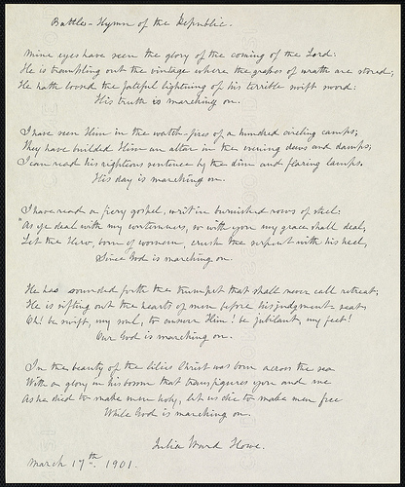

Anthony Burns Lithograph

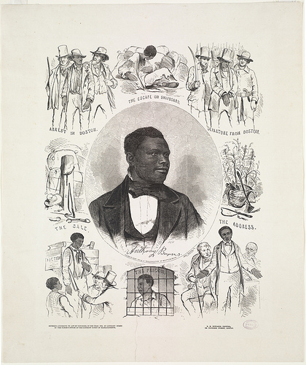

Map of Liberia

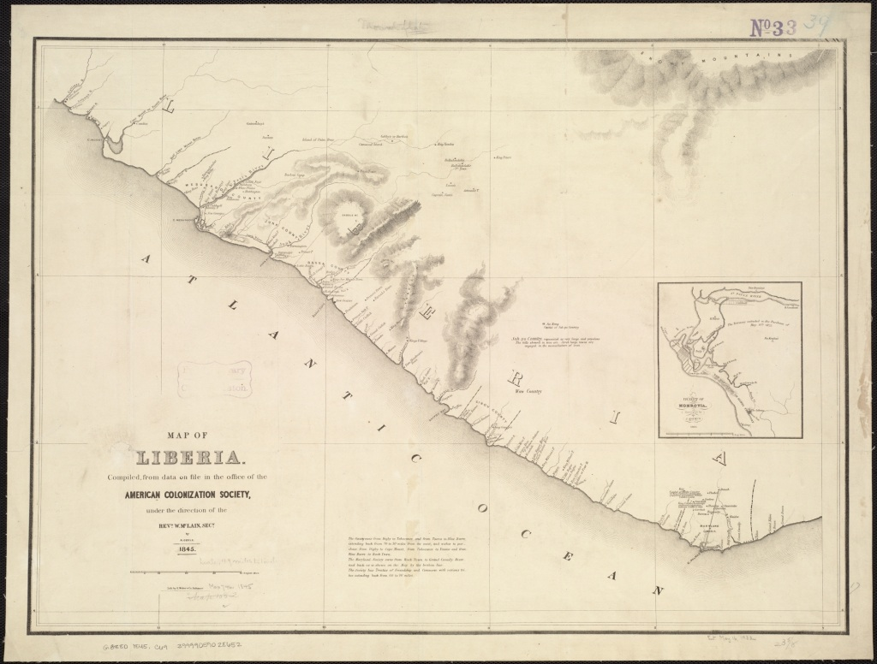

Map of American Missionary Society

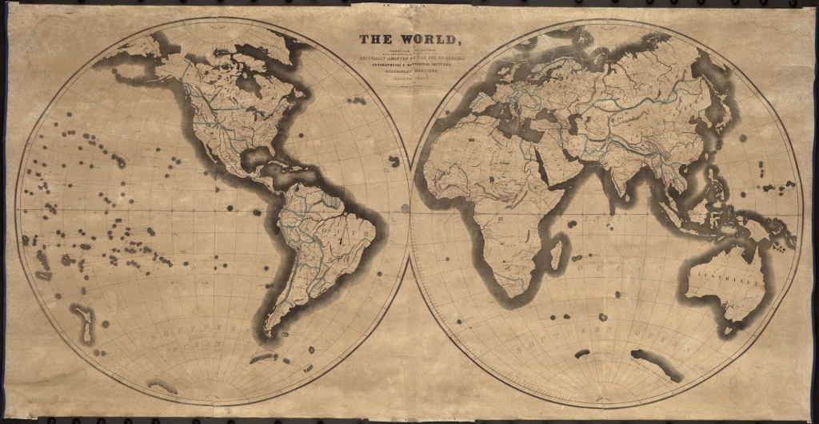

Arguments for Chivalry Lithograph

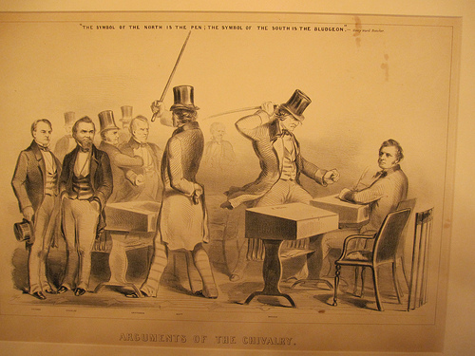
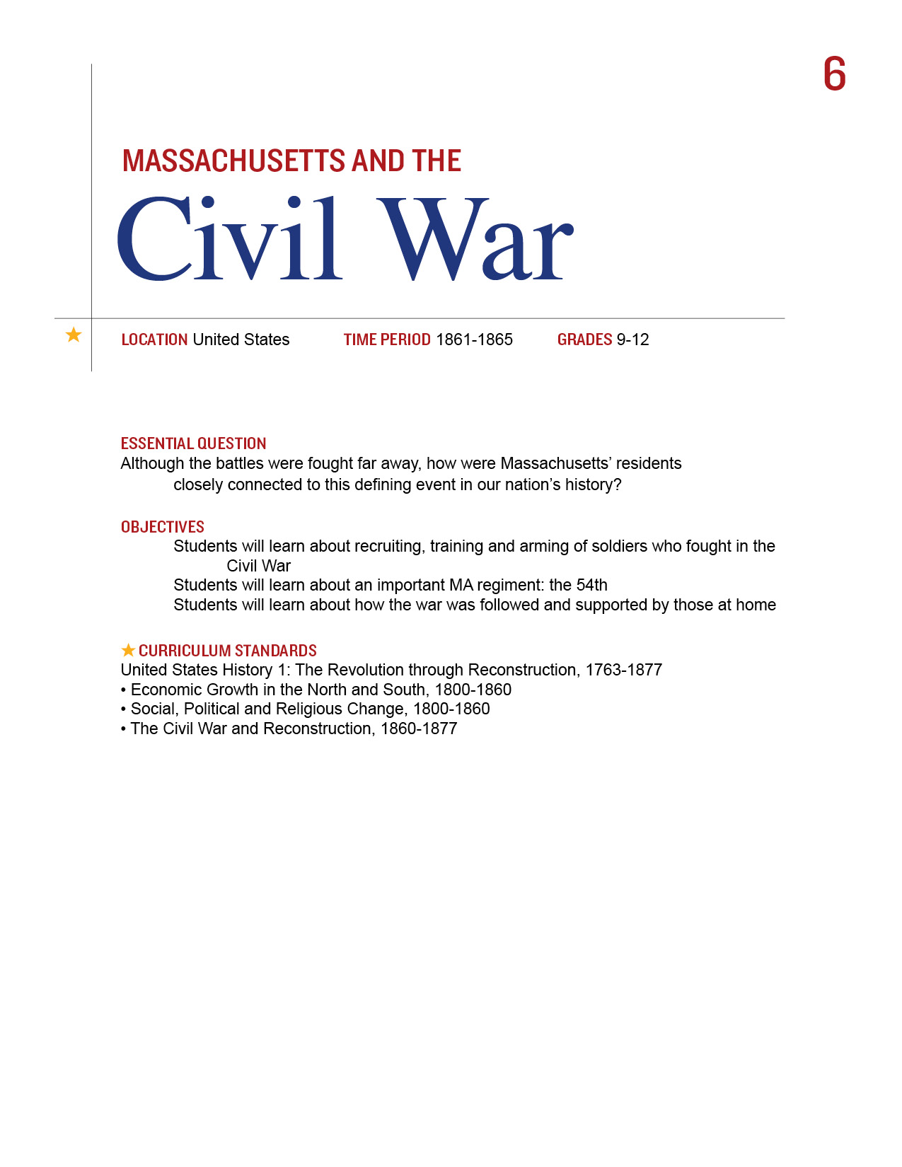
The Civil War was the most comprehensive event in our nation’s history. It touched the lives of everyone. Massachusetts, although far from the fighting, was involved in all aspect of the war.

Procedure
- Introduce the different aspect of war with your students. All items are noted in the Materials Needed Section. First talk about soldiers. They need to be recruited, trained and armed. Divide the class into five groups and give each group one of the following items:

Recruiting Soldiers on the Boston Common and Old South Church
Making Weapons at the Watertown Arsenal
Training Soldiers at Fort Warren and Camp Meigs
Have each group complete Part I of the Student Sheet for their item.
Allow time for each group to present its item.
- Introduce the Students to the Massachusetts 54th. There is information and an image in the Materials section. Then have them complete Part II of the Student Sheet. This may be done in small groups or for homework. Discuss their results.
- Explain that the war was fought far away and it was important to keep track of battles. Show the Students the War Telegram Marking Map and the Press on the Field Lithograph. Have them complete Part III of the Student Sheet. Discuss their results.
- Those at home wanted to help in any way that they could. Share the following images with your students and have them complete Part IV of the Student Sheet.

Time Allocation:

Part I: 15 minutes for group work and then 25 minutes to present to the class
Part II: 15-20 minutes
Part III: 15-20 minutes
Part IV: 15-20 minutes

Materials Needed

Recruiting Soldiers on the Boston Common and Old South Church
http://www.flickr.com/photos/59843331@N03/5468267745/
http://www.flickr.com/photos/59843331@N03/5468265429/
Making Weapons at the Watertown Arsenal http://www.flickr.com/photos/59843331@N03/5468267259/
Training Soldiers at Fort Warren
http://www.flickr.com/photos/59843331@N03/5468267117/
Camp Meigs http://www.flickr.com/photos/59843331@N03/5491885963/
Information about Shaw and the 54th, http://www.massmoments.org/moment.cfm?mid=157
Shaw Memorial image http://www.flickr.com/photos/59843331@N03/5468267973/in/photostream
War Telegram Marking Map http://maps.bpl.org/details_14379/?dl_pp=1&mtid=1117
Ladies of Roxbury at work on a Flag
http://www.flickr.com/photos/59843331@N03/5468265249/
Slipper pattern http://www.flickr.com/photos/59843331@N03/5491884611/
The Press on the Field http://www.flickr.com/photos/59843331@N03/5468267745/
Assessment Criteria

Did students learn about recruiting, training and arming of soldiers who fought in the Civil War?
Did students learn about an important MA regiment: the 54^{th?}
Did students learn about how the war was followed and supported by those at home?

Enrichment Activities

1. Have students compare these various aspects of the Civil War with the current conflicts in Iraq, Afghanistan and Libya. They may consider the following topics:
Military Recruitment Military
Support for Soldiers Care for the wounded
War Reporting Keeping in Touch

2. Imagine you have a member of your family fighting in the War. Write a letter to him. What do you think a letter from him might read like?

Common Core Curriculum Standards
English/Language Arts: History/Social Studies. 9-12
Integration of Knowledge and Ideas
CCSS.ELA-Literacy.RH.9-10.9 Compare and contrast treatments of the same topic in several primary and secondary sources.
CCSS.ELA-Literacy.RH.11-12.9 Integrate information from diverse sources, both primary and secondary, into a coherent understanding of an idea or event, noting discrepancies among sources.
Wars involve many parts. The Civil War included almost everyone living in the country at the time. In this lesson, you will see how the people of Massachusetts were involved in the war.

Part I
Look at the image your teacher gives you. Note the important details.
What are the individuals in the drawing doing? If there are no people, what other items are included?

Even though there is no battle shown, how is the picture here important to fighting the war?

Decide how you want to present this picture to the rest of the class.

Part II
During the Civil War, soldiers were organized by the states that lived in. Blacks were usually not allowed to fight but one special group of soldiers, the Massachusetts 54th Regiment, proved to be very brave. Read their story and look at this picture and answer the following questions.

- Were blacks allowed to fight for either the North or the South?

- Who organized the Massachusetts 54th Regiment?

- Where did they fight?

- What happened to most of the members of the 54th Regiment?

- How does the image show their story?

Part III
Soldiers fought very far from home. Newspapers were one way to keep track of the fighting. So were maps.
- What do the reporters seem to be doing in the pictures?

- Are the soldiers in the field happy to see them? How can you tell?

- What geographic areas are on the map? Why might they have been important in the Civil War?

Part IV
Those at home wanted to help in any way that they could.
- What are the Ladies of Roxbury doing? Why might this have been considered helpful?

- What was this a pattern for? Why do you think people made these during the war?

- If you were alive then, what might you have done to help?

- Imagine you are a soldier who receives one of these items. How would it have made you feel?

The Press on the Field / Recruiting Soldiers on the Boston Commons

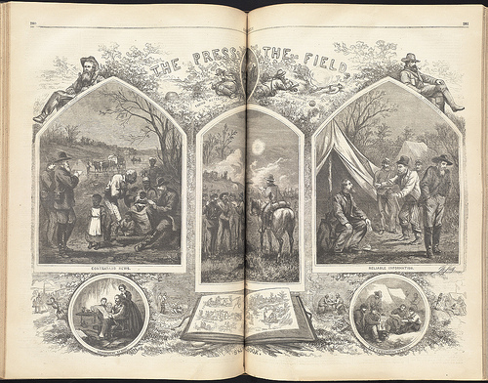

Recruiting Soldiers at the Old South Church

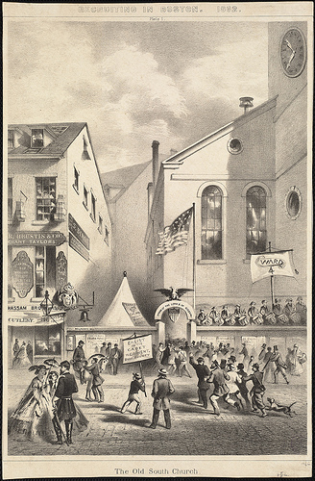

Making Weapons at the Watertown Arsenal

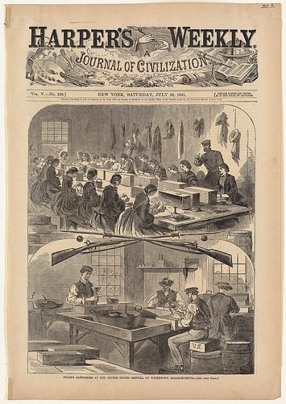

Training Soldiers at Fort Warren

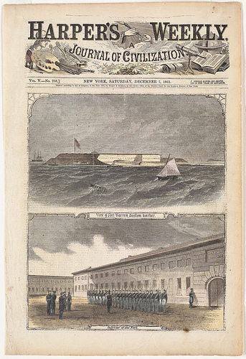

Camp Meigs

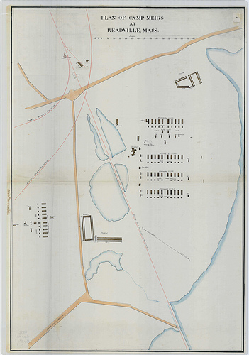

Memorial to Robert Gould Shaw, by Augustus Saint-Gaudens

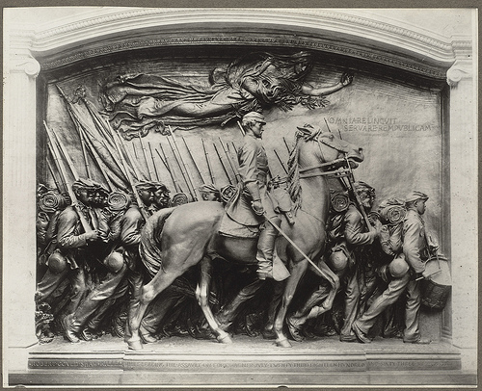

War Telegram Marking Map

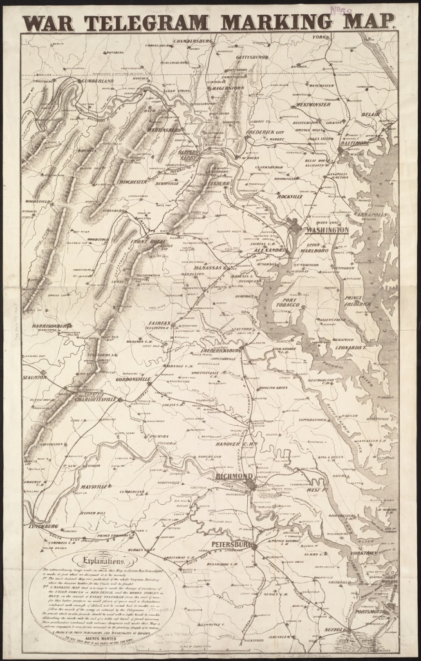

Ladies of Roxbury Working on a Flag

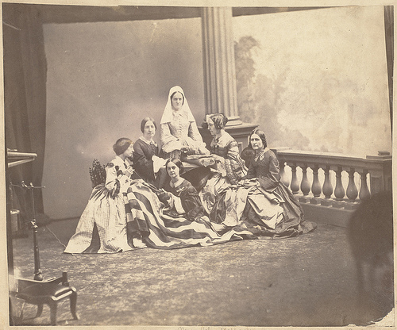

Hospital Slippers for the Sick and Wounded

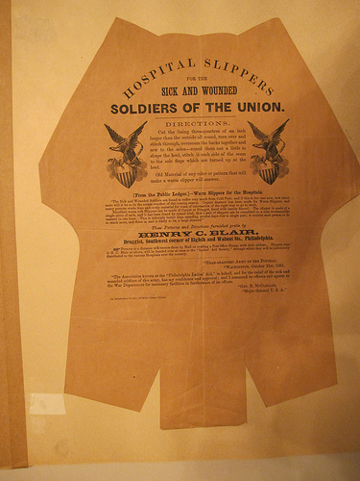

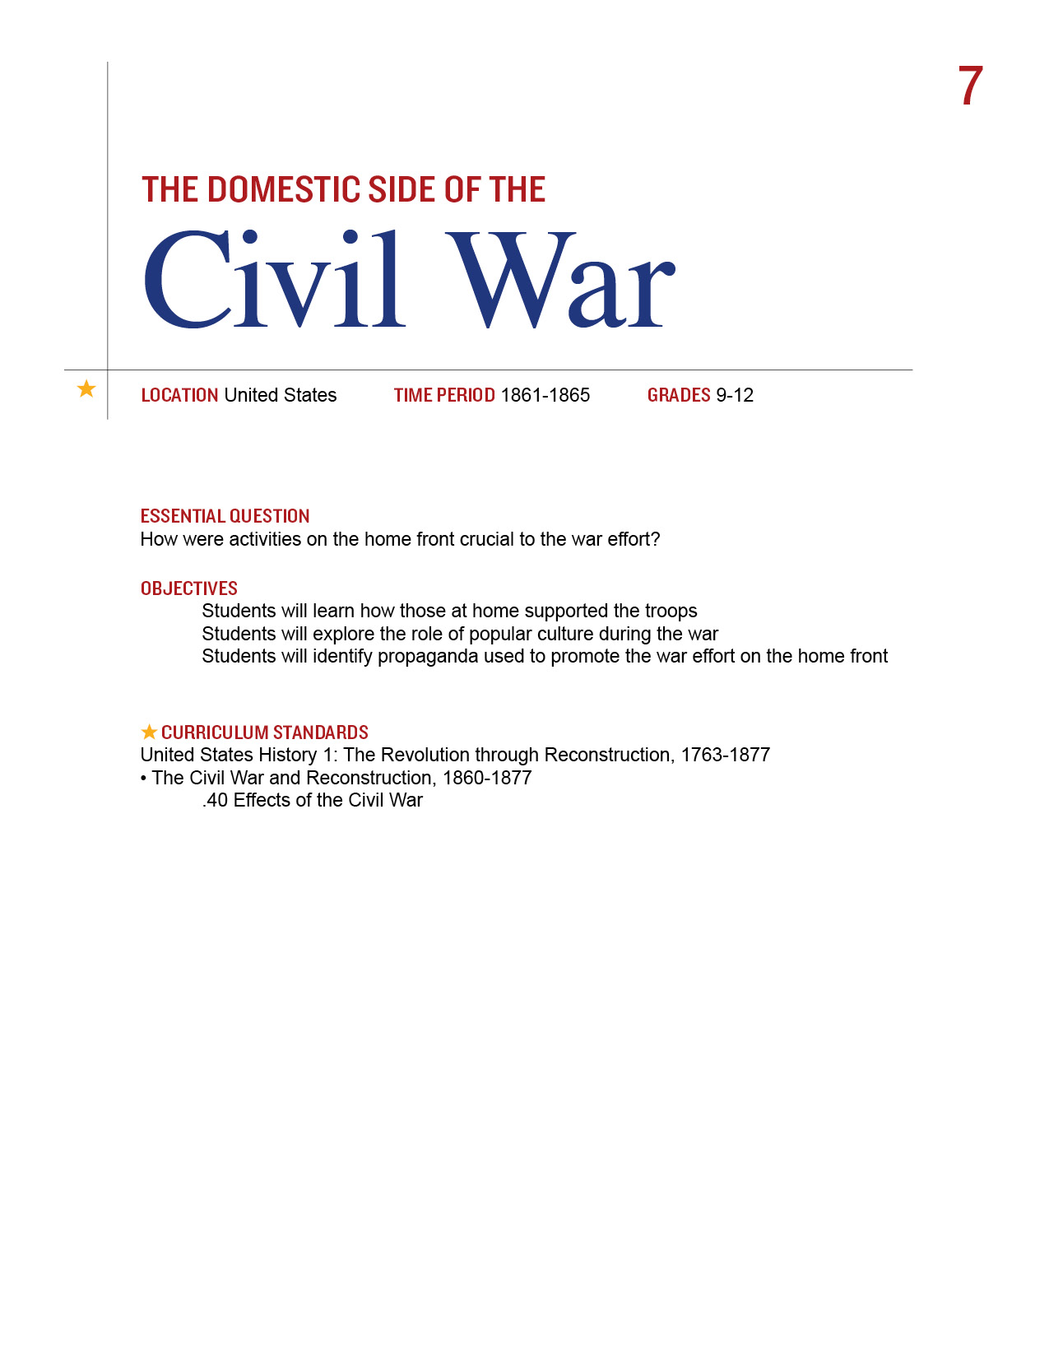
Many things go into fighting a war. Long before Vietnam, there was a sense of needing to win the hearts and minds of those at home. During the Civil War everyone was genuinely involved in the conflict. It was also the first war where popular culture played an important role in informing and in many cases, swaying, the public.

Procedure

- This lesson will definitely be an enrichment exercise but worth exploring if you have the time. Introduce to your students the advent of inexpensive printing techniques and the dissemination of images through lithographs and newspapers during this period of history. Show Students the Our Nations Heroes Poster and Song Covers. Have them complete Part I of the Student Sheet. You may do this a class, in small groups or individually. Discuss their results.
- Explore the notion of the ways in which visual media can shape opinion. We take this approach for granted now but the Civil War era was the first time it was done on a mass level. The mid-19th century saw the rise of the political cartoon. Show Students these three examples and have them complete Part II of the Student Sheet. You may do this a class, in small groups or individually. Discuss their results.
- Many people did want to help the soldiers and the rate of wounded during the war on both sides created enormous suffering. Show students the Map of the Convalescent Camp, the Slipper Patterns and Photograph of the Ladies of Roxbury. Have them complete Part III of the Student Sheet

Time Allocation:

Part I: 20-30 minutes
Part II: 20-30 minutes
Part III: 20-30 minutes

Materials Needed
Political cartoons
http://www.flickr.com/photos/59843331@N03/5468266775/in/photostream
http://www.flickr.com/photos/59843331@N03/5468860562/in/photostream/
http://www.flickr.com/photos/59843331@N03/5468266621/in/photostream/
Song covers
http://www.flickr.com/photos/59843331@N03/5468270233/in/photostream, http://www.flickr.com/photos/59843331@N03/5468270141/in/photostream
http://www.flickr.com/photos/59843331@N03/5468270029/in/photostream
http://www.flickr.com/photos/59843331@N03/5468266939/in/photostream
Heroes poster, http://maps.bpl.org/details_14556/?dl_pp=2&srch_query=civil+war&srch_fields=all&srch_style=exact&srch_fa=save
Map of convalescent home, http://maps.bpl.org/details_14375/?dl_pp=3&srch_query=civil+war&srch_fields=all&srch_style=exact&srch_fa=save
Slipper pattern (See Lesson 6) http://www.flickr.com/photos/59843331@N03/5491884611/in/photostream
Ladies of Roxbury photograph (See Lesson 6) http://www.flickr.com/photos/59843331@N03/5468265249/in/photostream
Assessment Criteria

Did students learn how those at home supported the troops?
Did students explore the role of popular culture during the war?
Did students identify propaganda used to promote the war effort on the home front?

Common Core Curriculum Standards
English/Language Arts: History/Social Studies. 9-12
Integration of Knowledge and Ideas
CCSS.ELA-Literacy.RH.9-10.9 Compare and contrast treatments of the same topic in several primary and secondary sources.
CCSS.ELA-Literacy.RH.11-12.9 Integrate information from diverse sources, both primary and secondary, into a coherent understanding of an idea or event, noting discrepancies among sources.
Wars are fought in many ways, often far from the front lines. How did the people back home contribute to the Civil War? How were they influenced in these efforts?

Part I: Heroes
Look at the images you teacher shows you and answer the following questions:
- What or who is honored? What have they done?
- What was being honored in song?
- Do the images on the song covers match the messages they are sending?
- Are there any major figures from the Civil War era (even on the Union side) that are absent from the Heroes poster?

- Suppose you were writing a song or making a poster about our nation’s heroes today. Who would you include?

- Our country is currently engaged in 3 military operations. Are we singing any songs about it? Why do you think this is the case?

Part II: Are these Cartoons Supposed to be Funny?
Political Cartoons became very popular in the middle of the 19th century as a way to express views and influence others. Look at the three examples your teacher gives you and answer the following questions:
- From whose point of view is the cartoon?
- How much does the language help to explain the visual image?
- Suppose there were no words. Would you be able to understand the intention of the cartoonist?
- Select one of the cartoons and write your own caption.
- Think of an issue we confront as a nation today. Find a cartoon you think expresses your opinion and bring it in to class.

Part III
There were hundreds of thousands of soldiers wounded during the Civil War and those back home wanted to help in any way that they could. Look at the 3 examples your teacher shows you and answer the following questions:

- In addition to the hospital, what else was on the grounds of the Convalescent Camp? Why do you think they were important to include?
- The US Sanitary Commission was a new agency, created during the Civil War. What do you imagine its central mission was?
- Read the instructions on the Slipper Pattern. Whom do you think was able to take the time to sew slippers?
- How about the Ladies sewing the flag in Roxbury?
- How do we help soldiers who are wounded today?

Political Cartoon 1: The old Bull Dog on the Right Track

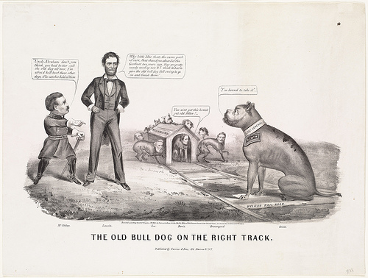

Political Cartoon 2: Why Don’t You Take it!

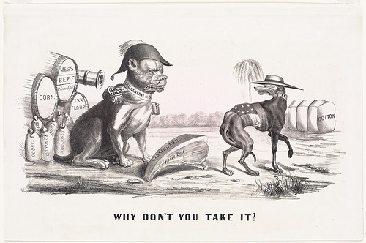

Political Cartoon 3: Torn in Two

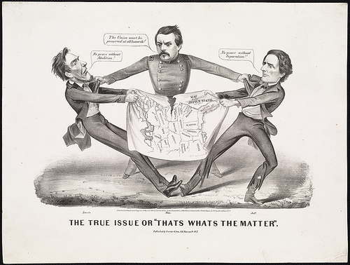
Song Cover 1: McClellan is the Man

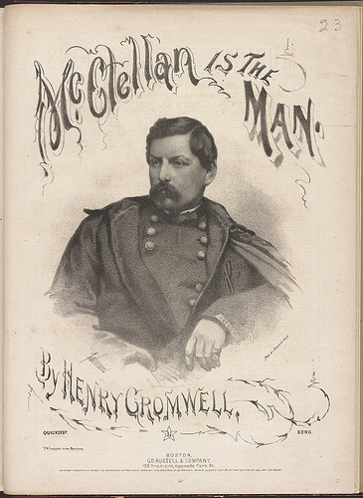

Song Cover 2: Hurrah for the 44th!

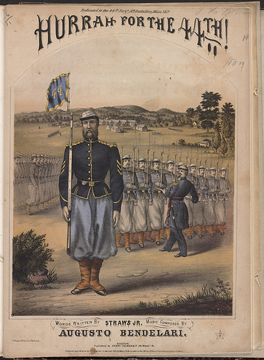

Song Cover 3: General Hooker’s Quickstep

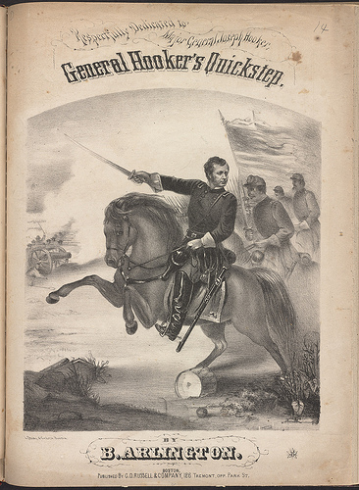

Song Cover 4: Songs of War

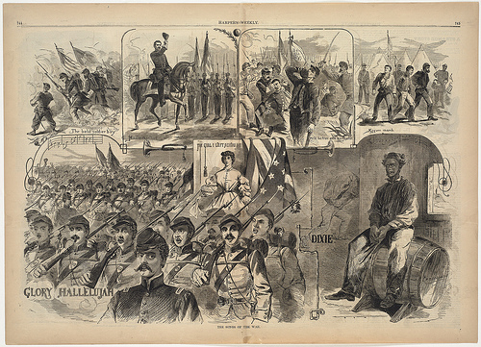

Our Nation’s Heroes Poster

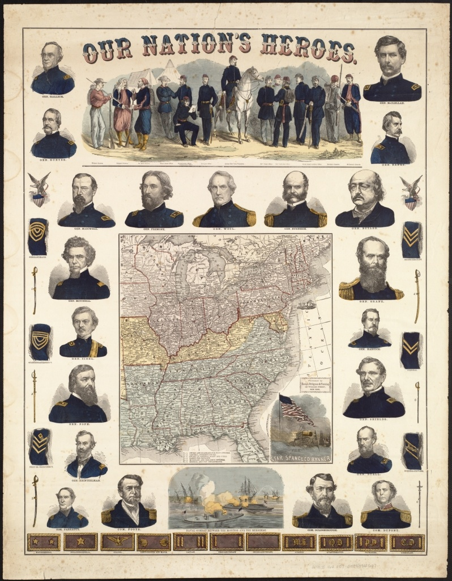

Map of Convalescent Home

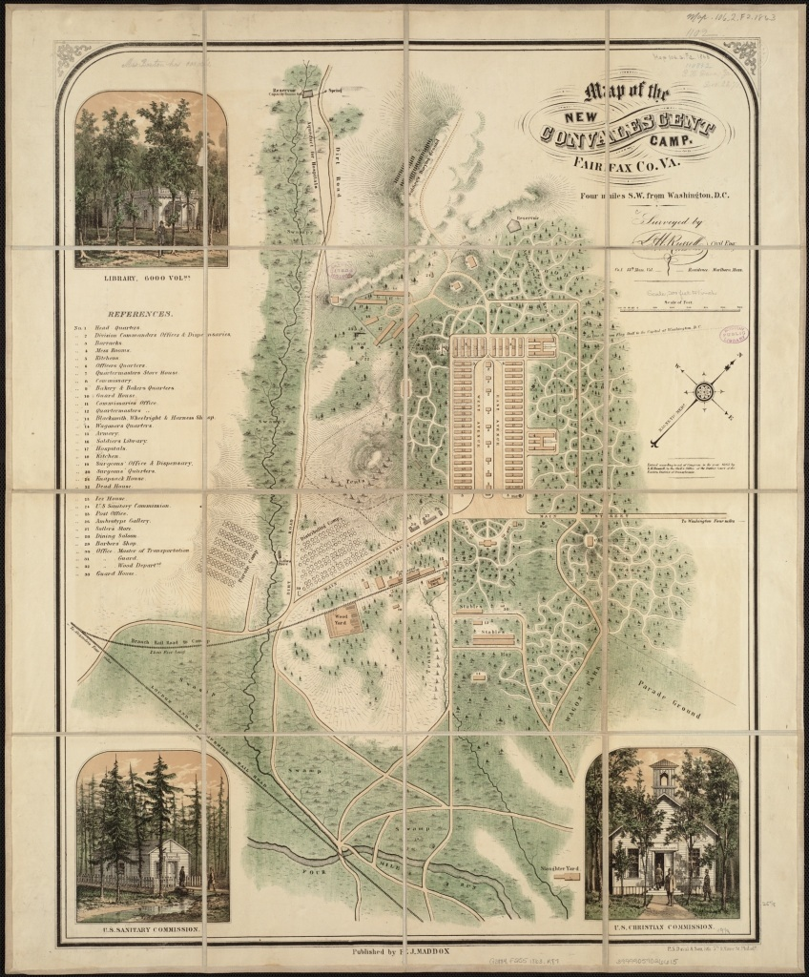
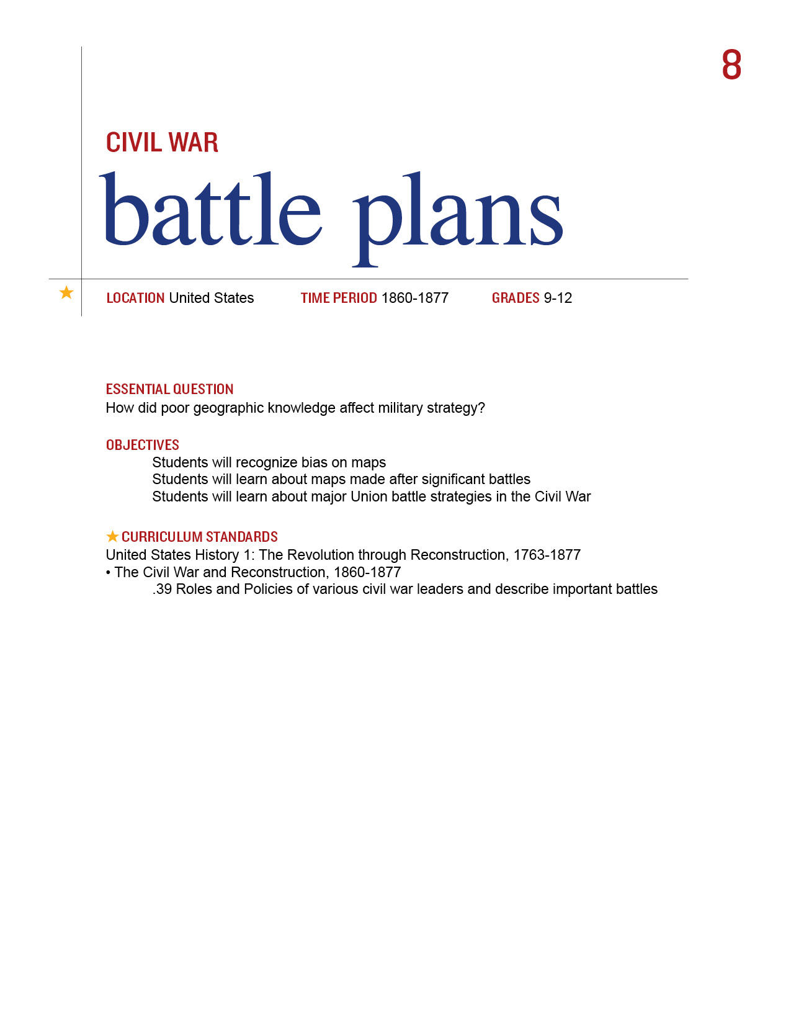
In his Second Inaugural Address, President Lincoln observed about the war: “Both parties deprecated war, but one of them would make war rather than let the nation survive, and the other would accept war rather than let it perish, and the war came.”

Much the same may be said about the geographic knowledge of the terrain upon which the war was fought. The North had few accurate maps of the areas of the South. This early advantage helped the South greatly because the battles were fought on its home turf. Most battle maps were drawn after the actual conflict. Maps, like other primary sources, also reflect a perspective, often in a literal sense. Students will explore how both location and historic time tempered what people saw and placed on maps.

Procedure

- Show Students the Map of the Battle of Greenbriar River. Although this was not a major battle of the war, how can they tell from whose point of view this map was drawn? What clues do they have that this was drawn from a Southern point of view?
- Now show them the three maps on Bull Run/Manassas and have them complete Part I of the Student Sheet. You may do this as a class, in small groups or individually. Discuss their results.
- Now look at the Map of Richmond, Charleston Harbor, Scott’s Great Snake and the Historical Sketch of the Rebellion. How do they show the overall Union strategy for capturing the South?
- Maps made after the battles were important to establishing the historic record. Have Students look at the 3 maps of the Gettysburg battle, completed over a decade after the war. Using these maps, how could they reconstruct the key events of that turning point in the war? Have them note the key events of each day on the Student Sheet. Discuss their results.

Time Allocation:
Part I: 20-30 minutes
Union Strategy: 20-30 minutes
Gettysburg Reconstruction: 45 Minutes

Materials Needed

Map of Battle of Greenbriar River, http://maps.bpl.org/details_14356/?dl_pp=1&srch_query=civil+war&srch_fields=all&srch_style=exact&srch_fa=save
3 Maps on Manassas/Bull Run
http://maps.bpl.org/details_14362/?dl_pp=1&srch_query=civil+war&srch_fields=all&srch_style=exact&srch_fa=save
http://maps.bpl.org/details_14360/?dl_pp=1&srch_query=civil+war&srch_fields=all&srch_style=exact&srch_fa=save
http://maps.bpl.org/details_14551/?dl_pp=4&srch_query=civil+war&srch_fields=all&srch_style=exact&srch_fa=sav
Map of Richmond, http://maps.bpl.org/details_14378/?dl_pp=2&srch_query=civil+war&srch_fields=all&srch_style=exact&srch_fa=save
Map of Charleston harbor, http://maps.bpl.org/details_14549/?dl_pp=2&srch_query=civil+war&srch_fields=all&srch_style=exact&srch_fa=save
Scott’s Great Snake, http://maps.bpl.org/details_14551/?dl_pp=4&srch_query=civil+war&srch_fields=all&srch_style=exact&srch_fa=sav
historical sketch of rebellion, http://maps.bpl.org/details_14546/?dl_pp=3&srch_query=civil+war&srch_fields=all&srch_style=exact&srch_fa=save
Gettysburg, Day 1, http://maps.bpl.org/details_14684/?dl_pp=4&srch_query=civil+war&srch_fields=all&srch_style=exact&srch_fa=save
Gettysburg, Day 2
http://maps.bpl.org/details_14685/?dl_pp=4&srch_query=civil+war&srch_fields=all&srch_style=exact&srch_fa=save
Gettysburg, Day 3, http://maps.bpl.org/details_14686/?dl_pp=4&srch_query=civil+war&srch_fields=all&srch_style=exact&srch_fa=save

Assessment Criteria

Did students recognize how maps convey bias?
Did students learn about maps made after significant battles?
Did students learn about the major Union battle strategies in the Civil War?

Common Core Curriculum Standards
English/Language Arts: History/Social Studies. 9-12
Integration of Knowledge and Ideas
- CCSS.ELA-Literacy.RH.9-10.7 Integrate quantitative or technical analysis (e.g., charts, research data) with qualitative analysis in print or digital text.
- CCSS.ELA-Literacy.RH.9-10.9 Compare and contrast treatments of the same topic in several primary and secondary sources.
- CCSS.ELA-Literacy.RH.11-12.7 Integrate and evaluate multiple sources of information presented in diverse formats and media (e.g., visually, quantitatively, as well as in words) in order to address a question or solve a problem.
- CCSS.ELA-Literacy.RH.11-12.9 Integrate information from diverse sources, both primary and secondary, into a coherent understanding of an idea or event, noting discrepancies among sources.

Maps are useful devices to help chart unfamiliar territory. This function is especially true for a battle but amazingly enough, the North had very few accurate maps of the places they fought before they went to war in 1861.

Part I
Look at these 3 Maps of the same battle and answer the following questions:
- What are the dates and titles of the three maps?
- On what do they agree?
- How do they differ?
- Are any of the three completely accurate?
- Are any of the three completely wrong?
- Which map would you have wanted to have before the battle?

Gettysburg Reconstruction
Day 1

Day 2

Day 3

Map of the Greenbriar River

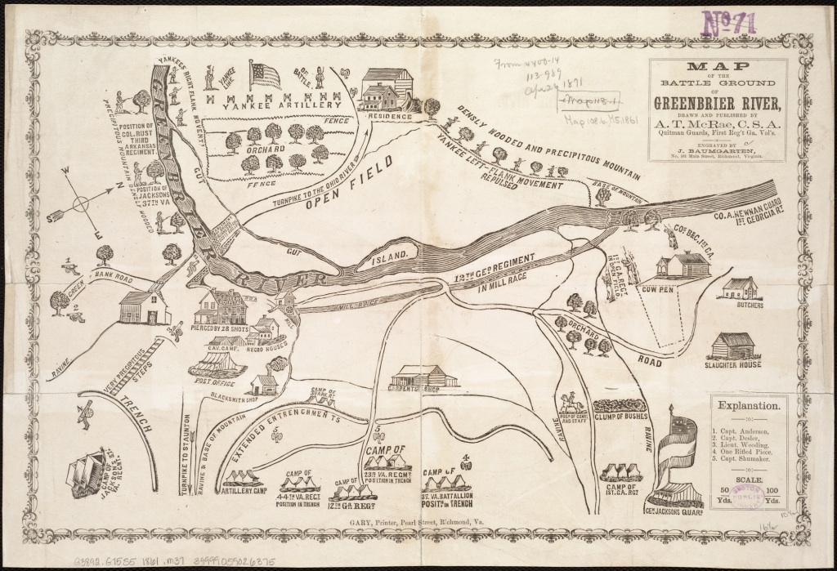

Map of Manassas/Bull Run 1

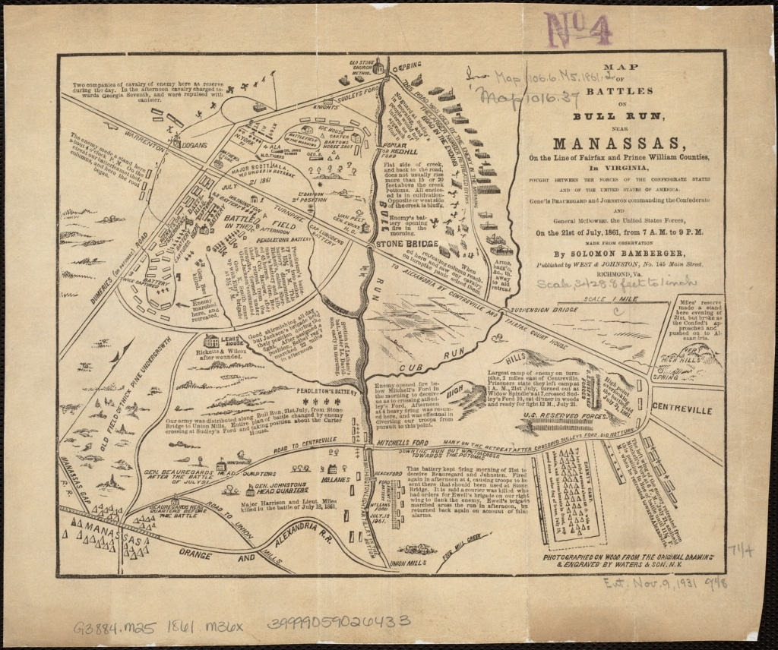

Map of Manassas/Bull Run 2

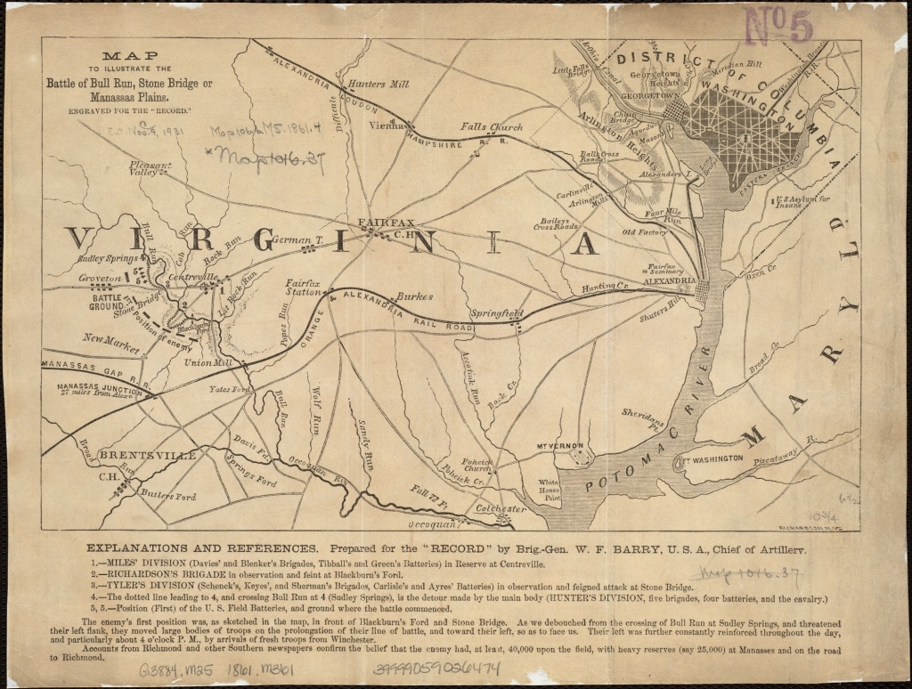

Map of Manassas/Bull Run 3

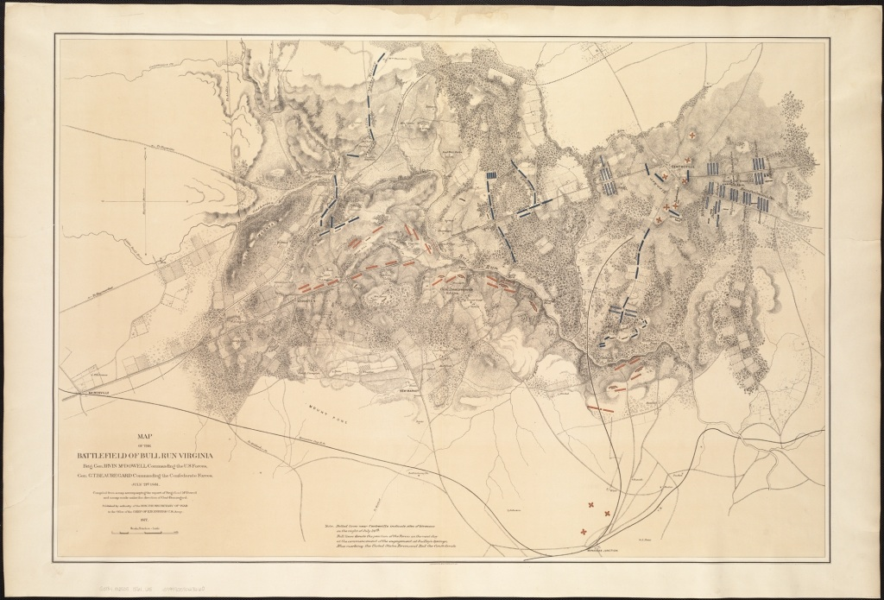

Map of Richmond

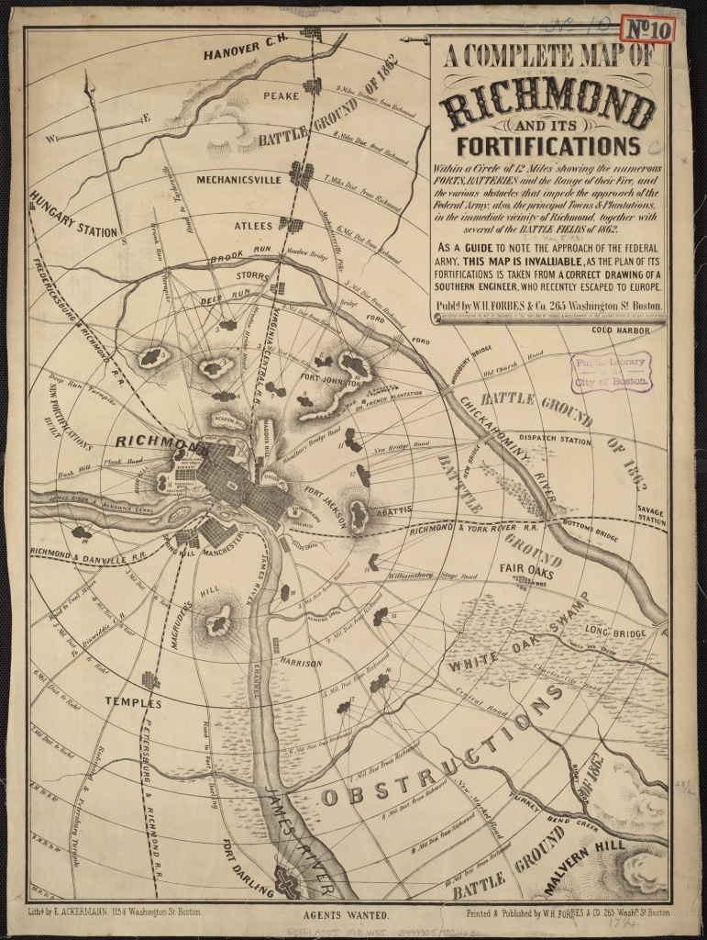

Map of Charleston Harbor

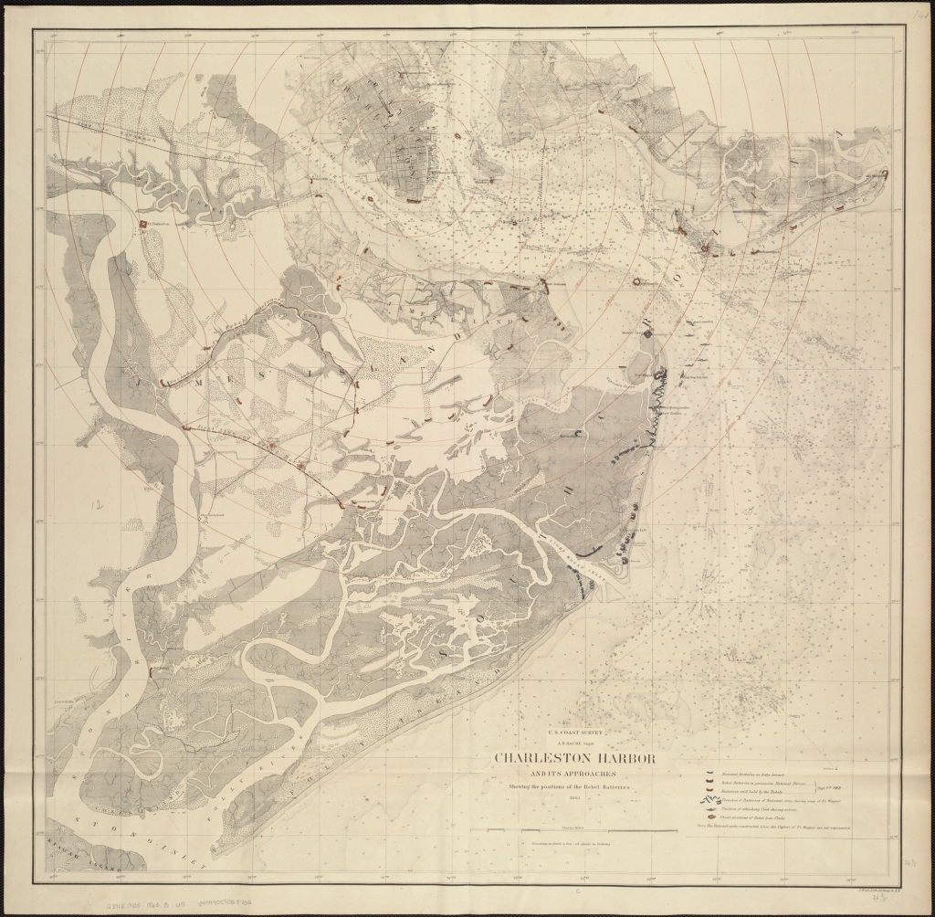

Scott’s Great Snake

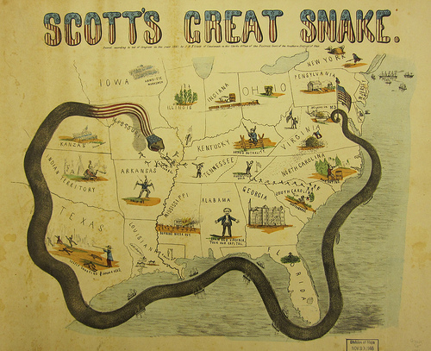

Historical Sketch of Rebellion

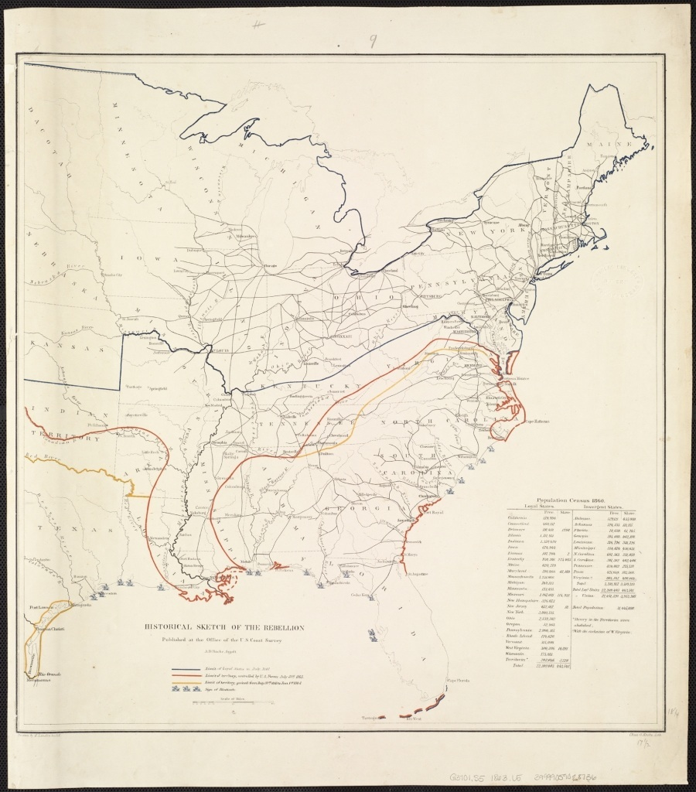

Battle of Gettysburg Day 1

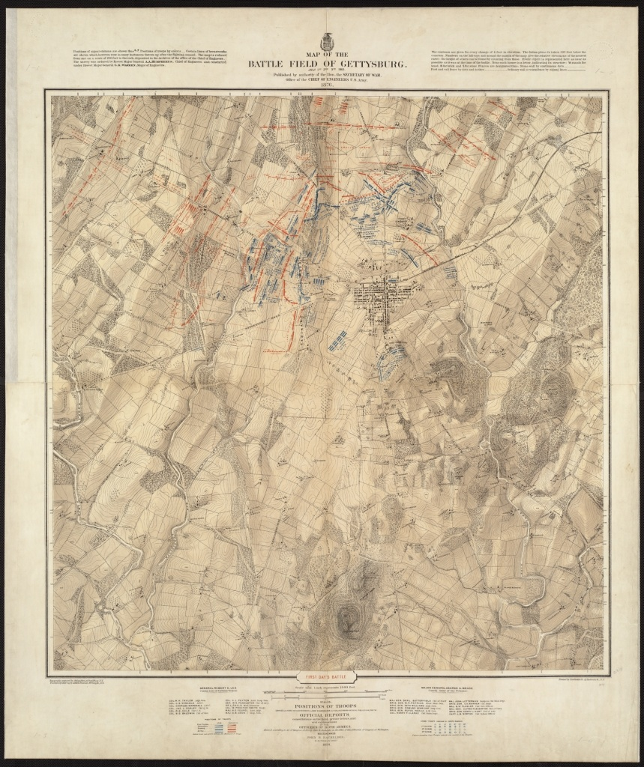

Battle of Gettysburg Day 2

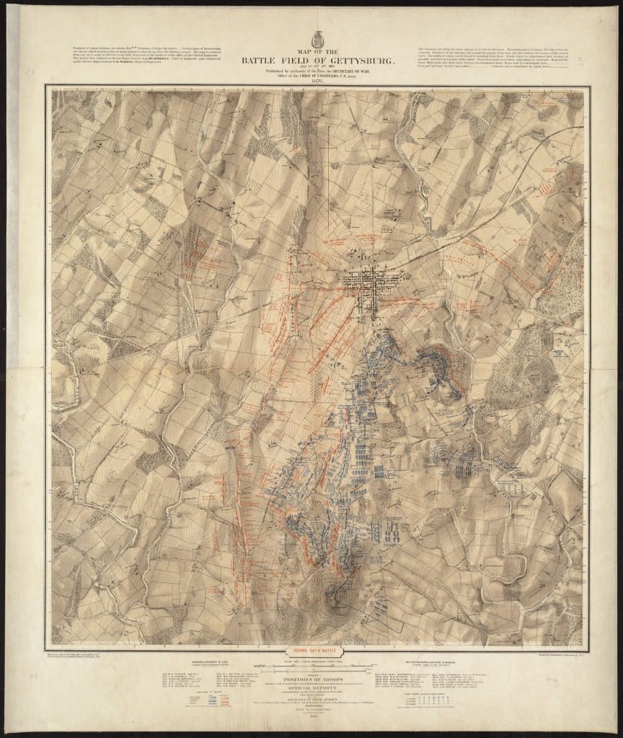

Battle of Gettysburg Day 3

Torn in Two: I.D. Cards

ANNIE SULLIVAN 1861
Irish immigrant
15 years old
Textile mill worker

HENRY BOURNE 1861

Age 19
Union Infantryman from Pennsylvania

STEPHEN HILL 1861

Confederate soldier
Age 18
37th North Carolina Infantry Regiment

ELIZABETH FARNSWORTH 1861

Civil War nurse
An educated girl of means in Concord, MA
18 years old

JOHN TILDEN 1861

Georgia crop farmer, non-slave owning
35 years old

ISAIAH WILKES 1861

Seminary Student and Abolitionist
Age 16

REBECCA PARRISH 1861

Slave, South Carolina
Age unknown, perhaps 20

JAMES HARRISON 1861

Plantation Owner
Georgia
55 years old

THOMAS WILLIAMS 1861

Printer
Framingham, Massachusetts
Volunteer, 54th Regiment

TOMMY O’MALLEY 1861
Son of a farmer who is a Copperhead
Illinois
18 years old

TILLY JOHNSON 1860
Personal maid to Mrs. Jefferson Davis
20 years old
Tennessee, Washington, Richmond

BECKY ROBBINS 1859
Ohio
Ten years old
Family home is an Underground Railroad stop

ANNIE SULLIVAN 1861
Irish immigrant
15 years old
Textile mill worker in Lowell, Massachusetts

BEFORE

My name is Annie Sullivan and I’m one of the people they call a mill girl in Lowell, Massachusetts. I guess the girls here all used to be Yankee girls, but when the Famine happened my family and a lot of others came here looking for work so a lot of us are Irish now. It’s so different from places in Europe where mill girls are beaten and paid almost nothing. At least that’s what they say. It’s true we have to work 11 hours, but the older girls had to work 12. We make twice as much as we could as servants or seamstresses and I am putting a bit of savings aside from what I send home. My parents don’t know. I told them there was a rent increase for our boarding but there really wasn’t. God forgive me! Anyway, now they say war is coming and I’m very scared.

DURING

Now that the war is on, I’m worried about what will happen to the mill. My family depends on my wages and I keep hearing that the mills will close. They can’t get cotton anymore for us to make into cloth. I got a letter from James, our friend from days in Kerry, who lives in Boston. He said they are going to draft immigrants to fight the war and he’s not going. James’s family were like slaves at home on a rich man’s farm and the man wouldn’t feed them when the Famine came. I would not say I love Lowell – I miss the green open land and the farm – but at least I have wages and two meals a day for now.

AFTER

Well, the mill did close. Almost everybody in Lowell was thrown out of work because most of the mills closed when the cotton stopped coming. Maybe it’s a good thing because I’ve started getting that mill girl’s cough from breathing in all those tiny little pieces of cotton dust. A lot of us die young from it. One of the girls, a waggish one, calls us high class coal miners.
The war is over now, but I have even bigger news. James asked me to marry him. He has a bit of savings and I have mine, and neither the one of us can stand the cities made of brick. So tomorrow we leave for St. Louis. We’ll join other families heading West in America but we haven’t decided exactly where yet. Maybe we will settle in Kansas, which we heard so much of before the war. We figure we’ll know the right place when we see it.

HENRY BOURNE 1861

Age 19
Union Infantryman from Pennsylvania

BEFORE/BEGINNING

Everybody next to me looks so calm. The crowd is cheering but a lot of people are crying, too. Most of those are mothers and sweethearts.
My name is Henry Bourne and I’m a new Infantryman in this war. We’re marching from town to the train station to take us South. I was really excited about going and I get excited again hearing the crowd. But I wish I had a sweetheart crying for me. All the girls will be taken by the time I get home, by those layabouts who stay behind or pay their way out. And I bet one of them will take my job at the bank.
We’ve arrived at the train. They tell us we’re going to Virginia. It sounds beautiful.

DURING

I can’t stop throwing up. Truth be told I’ve been crying too but I keep putting more dirt on my face to cover the tears. Why did they tell us we were going to fight a weak enemy who would disappear in six months? We ran today, like rabbits from the fox, as if we were the weak ones. We came to Bull Run and the first thing we saw were carriages and ladies and picnic baskets. People came out to watch the battle as if it were entertainment. It was grand to see them run faster than we did!
My buddy Aaron, right next to me, was hit by cannon fire. God forgive me, I can hardly speak it, but it crushed him until there was nearly nothing left. I must never tell his mother. I even threw up in front of our lieutenant, but he was even younger than I am and he was throwing up too. He put his hand on my shoulder and we both wept together. I found out later that Aaron was going to marry the lieutenant’s sister.

AFTER/END OF WAR

To Mr. Isaiah Bourne
Dear Mr. Bourne,
Your son Henry has died bravely and in combat and is now buried with honor in Petersburg, Virginia. I deeply regret this news, and hope that you will find solace in knowing that he was a patriot who served his country to the ultimate level of sacrifice. He and his comrades held the Federal forces back at Fort Gregg. By keeping them out of the city the first night of battle, we were able to evacuate and save many lives, thanks to these brave men.
He was well loved by his fellow men and could be relied upon by any and all who served with him. We will feel his loss but will remember him for his unwavering loyalty to his regiment.
I am Sir your obedient servant,

Robert Freeme, Lt.

STEPHEN HILL 1861

Confederate soldier
Age 18
37th North Carolina Infantry Regiment

BEFORE

We arrived today for the first days of training, all of us staunch soldiers ready to fight. Then we received our arms, and you never saw so many unhappy men anyplace but a funeral. They gave us flintlock muskets! We may as well be fighting the Mexican War, if it took place in 1800! When we saw that there were no bullets they gave us blocks of lead that we are supposed to melt down and make our own bullets from. No surprise that we lost our first battle at New Berne.
Our next battle was even worse because we had new rifles, but we were cut off from the other regiments and most of us captured. I lay exhausted in the bushes and to my shame they sent out wagons to pick up soldiers like me.

DURING

We are unlucky soldiers or maybe just bad ones. We were assigned to guard an ammunition wagon and an ambulance. But the Federals were hidden like the Swamp Fox along the road. (We Tar Heels know the story of the Swamp Fox well. They hid behind trees and bushes and even a fence along the road and mowed us down with their rifles and cannon. How will this war ever be over in six months? I notice the officers don’t say that anymore. By the end of today, one in three of us were gone. I prayed to God that night, for all of my regiment, for my family back home and especially for me.
But there’s good news! We’re going to be transferred to the Light Division! And we were finally at luck in battle. We charged the federals at Gaines’ Mill and kept on charging until they retreated. But we mourn the loss of our colonel, killed by an artillery shell. Not a man didn’t weep openly for him.

AFTER

Now that the war is over I am still haunted in my nightmares by our darkest day. At Chancellorsville, we were to blame for the volley of shots that killed our beloved iron soldier, General Stonewall Jackson. General Lee mourned grievously. The next day in battle we lost more of us than any other regiment.
The world will always remember that we killed our General. I was glad to be among the wounded. My arm, sorely infected, was cut off in the field hospital. Small punishment to ease my grief at the loss of Jackson. It is my daily reminder of shame.
Now home, I have seen Rosemary, my fiancée, but I shook with anxiety. How can I marry when I am unable to perform the most basic tasks? She came to me and held my face with those delicate alabaster hands, now scarred by work, and answered me without saying a word. I feel I don’t deserve her! But our whole town is rejoicing and my elderly father said the future was finally real again.

(Stephen Hill is a fictional character, but Michael C. Hardy’s article published in America’s Civil War, May 2003 issue, was very helpful in creating him.)

ELIZABETH FARNSWORTH 1861

Civil War nurse
An educated girl of means in Concord, Massachusetts
18 years old

BEFORE

I do not know why God in His wisdom has chosen the lot of women to be so oppressed. Now that Father has died, my elder sister Lucy’s husband controls our fortunes. He is a man of no knowledge and even less intelligence and I fear that he will leave us in ruin. Mother is too stricken with grief to be of influence. What will befall us? There are no professions for us to enter. The few places for women tarnish our reputation so deeply as to be impossible. If we teach, we are considered ill-bred. Will I be reduced to that? Is my education to mean nothing? Louisa May Alcott makes money sometimes from her stories but I have not that talent.

DURING

I am shaking with excitement and fear. Louisa and I have become nurses taking care of the brave men in our Army. We won’t be paid, but it will give us important work to do, and as many of our class are doing this we will not be looked down upon for “working.” They say the Army doesn’t want us, but I hear that when they see what we can do, they will at least treat us with courtesy. I am lucky to be taken, because those recruited by the activist Dorothea Dix were required to be middle-aged and plain, but Louisa vouched for me.
I had to grow used to death and violence with no delay, and I know I will never remove the stains of gore on my apron. The wounded’s agony broke my heart and called me to give my best to them. Whether I write letters for them or hold a hand until the last breath of life, I know I am doing God’s work and serving my country. There are thousands of us nurses – surely this will bring change to our world after the war!

AFTER

We are expected to return home and resume our old lives, but I cannot. No more insipid dinner conversation or having my decisions made for me by Lucy’s ridiculous husband, a coward who sidestepped the war by paying $3500 for someone else to serve. Imagine Father’s money being used for cowardice! I see them growing poorer and I am determined to leave Concord.
So I am headed to Seattle! A few girls have already gone and I will join the second journey. There I am promised a paying job as a teacher, a family who will host me, and the prospect of marriage. There are many men in Washington and far fewer in Concord. Whatever happens, I am ready for adventure and to become a real pioneer!

JOHN TILDEN 1861

Georgia crop farmer, non-slave owning
35 years old

BEFORE

Our leadership has lost its head by starting this war. They forget those of us who have no reason to go to war. I have never used slave labor on my farm in Georgia, nor do I live in a mansion of stately grandeur. I have ten children, all of whom work on the farm, and if they are not enough I hire the help I need. I am no Republican and I have little respect for Mr. Lincoln, but at least there is sense in that odd head of his. Imagine that Mr. Davis thinks my sons and I should go to war for the plantation owners. Everybody says this war is about the right of a state to govern itself, but then why do the same people talk more often about the impossibility of running plantations without slaves?

DURING

For the first time in the history of our country, we are to be conscripted. I guess our Confederate leadership thinks that states should be free to govern but people should not. It will not work where I come from. We will take to the woods with rifles before we join any Confederate regiment. Last night the farmers of our area met in secret to decide how to avoid being drafted. None of us can afford to hire substitutes, because the price is rising quickly and I wouldn’t be surprised if it goes as high as $5000. We can’t afford the $300 exemption fee either, and we don’t want to lie about our health to be exempt.
By the end of the night we had agreed to form our own militia to protect ourselves. Yes, we are stealing food from the plantations, because they expected to fight this rich man’s war with poor men’s blood. We even help Yankee prisoners to escape, and we all help each other to hide from the conscription.

AFTER

With God’s sharp irony governing our lives, we are finally defeated. Our real enemy was the plantation owners and conscription, and we “defeated” them. But it was General Sherman who came our way on his so-called “March to the Sea.” He burned our farm after they took everything they could eat, ride or sell. It wasn’t much to them but it was everything to us. So now Sadie and I will start over and most of the kids will still be at home to help. We grow corn and pigs and enough crops for us to live on. I hope we will have a good year and enough to eat. The children won’t get any schooling, but Sadie says the older ones could help teach the little ones to read. We are lucky to be self-sufficient. Just as we learned to distrust our own Confederate government, I am not easy with Andrew Johnson. I hope he will keep the promises made to the South at Appomattox and by Mr. Lincoln, but I have little faith.

ISAIAH WILKES 1861

Seminary Student and Abolitionist
Age 16

BEFORE

Can no one see the damnation of God’s fury that will descend upon us all? By all that is Holy, no man shall own another. How can he if he is to obey God’s law to love our neighbors and treat them as we would be treated? This is not only a Christian tenet, but one we share with our Jewish brethren. Preacher told us that a famous rabbi named Hillel called for the same law at the time Jesus lived. And as they both called that we shall love our God with all our soul and heart and mind, as in Deuteronomy 11:13-21, how can we not obey? Do we not know that should God send the angels of darkness upon us we shall all perish as one, not separated into sinner and believer? Father says it is time for me to quit the seminary and find honest labor. But I believe God calls me to fight this fight against evil in His name.

DURING

Our seminary is closed. Father was pleased so I pray for his soul. But I have volunteered to work for Mr. William Lloyd Garrison to help produce his newspaper, The Liberator. I tried to volunteer with an empty heart for war, but was rejected for my poor eyesight. Now I fear for our lives. Mr. Garrison has already been tried and dragged through the streets, mobbed and nearly lynched. The newspaper’s whole print run was stolen, which he could ill afford. But God’s fire is strong in him and keeps me fighting, too, even if it means working the printing press with little protection from the inks and chemicals. Mr. Garrison speaks like a powerful preacher and some people call him the nation’s conscience. Today the President announced the Emancipation Proclamation! Mr. Garrison was at a concert and they stopped the music to cheer him and Mr. Lincoln.

AFTER

The war is over and my soul compels me to return to Seminary life, but the active life of Mr. Garrison compels me to wish for more human work in addition to a prayerful life. I am bound for Virginia! The Protestant Episcopal Theological Seminary in Alexandria was occupied by the Union and used to house nearly 1700 wounded soldiers and as a burial ground. There will be much work to do to reopen it and I wish to help. Father is pleased at this goal, which he considers of greater importance than “praying until you grow blind.” I continue to pray for Father and for Mother who rests in heaven.

REBECCA PARRISH 1861

Slave, South Carolina
Age unknown, perhaps 20

BEFORE

I call myself a governess, not a slave. The only person who can be a slave is one who lets their mind be slaved. Joseph, a field hand, says it’s easy to say that when you’re an indoor slave. It’s true, my days are easier than Joseph’s. I teach ABCs and arithmetic to the little ones in the house ever since my master caught me reading. Before I was sold here, one of the boys in that house taught me to read. In the afternoon I get the older girls and the mistress ready for dinner, taking care of their hair and tightening their corsets. I caught 15-year-old Miranda trying to add rouge to her cheeks and I gave her a talking to. I take no mind to her pinching her cheeks to give her some color but any more than that will ruin her reputation.

DURING

My heart is pounding. A bunch of us slaves were taken by the Confederates to work for the Navy, though our Mr. Smalls was hired out! We families are all below deck while topside the most daring thing I ever heard of is happening. Robert Smalls, pilot, is about to steal this boat and get out of Charleston Harbor. He took the captain’s hat and stood on deck in the dusk, with his profile and the hat fooling everyone watching as he steered us to the Union ships. He’s the best pilot on the coast and got the Planter through the shoals and knows where every mine is. We hoisted a white flag before the Union ships could fire. They welcomed us and the news of our escape spread all over the country, even to Harper’s magazine. Robert traveled all over the country and people came to here him speak, but then he went back, became a Union pilot and was a big part of their success. We had stolen a Navy ship from right under their noses, a hundred yards from the headquarters of General Ripley!

AFTER

I believe my children really will breathe free. Robert Smalls has become a Congressman! From South Carolina!
Joseph and I are married now and living in Boston. We have good neighbors and Joseph got a job in a bank. He’s a smart man but the planter could only see his strength and put him in the field. We go to the Meeting House and it is so comforting to be among people who are free and have no fears of slavery anymore. I still teach and bring in a little money, and I try to grow some vegetables in our little piece of land. Sometimes I miss the great green pastures and the clime of South Carolina. But everyday I take an extra breath of air just to remind me where I came from.

With many thanks to Warren Ripley, who wrote about Robert Smalls in The Civil War at Charleston, published by The Post and Courier, Charleston, South Carolina 2006.

JAMES HARRISON 1861

Plantation Owner
Georgia
55 years old

BEFORE

I can’t stand this talk of war, but only because I am too old to volunteer. I will fight to the death to protect my land, where my family has lived for 75 years. It is the most beautiful piece of God’s earth in Georgia. There is no need for war if the North would stop their hypocrisy, lies and judgment of a world they know nothing of. They accuse us of being slave-mongering demons, yet they trap factory workers in a life of debt that never ends. Their workers have no freedom, and my slaves are better treated than any factory girl of theirs. My workers are fed well and kept healthy, while theirs starve and freeze to an early death from their working conditions. And if we have not the right to govern ourselves, they want us to throw away the Constitution of these very United States. We have no reason to be united with them any longer and would be well rid of them.

DURING

The Yankee is as heartless a devil as ever lived. While their cities see skirmishes, ours are destroyed. Charleston is home to the very bravest of us, Richmond too, people who will fight to the very end against every odd they are battered with. What kind of men can blockade and starve the women and children of a city? Are they so afraid of meeting our forces that they will kill the weakest among us? They have great force and artillery and more supplies, as they rake and raze their way through our lands. My land is reduced to charred fields, as they burn anything they cannot steal. The horses, any scrap of food, the cows and chickens, all gone. Our slaves have fled. It cannot be because of poor treatment so I believe they were kidnapped by Yankees and made to serve as soldiers.

AFTER

All is gone, but my boys are home from war at least. Together we will rebuild not only our plantation but the South itself. We will all rise again. How can we be subjected to watching the freed slaves, our own property, walking the streets as free as a jaybird? Yesterday I saw Henry, our butler in the golden times. Without waiting for me to speak, he spoke to me without removing his hat. Well, there are those among us who will continue the fight in our own way. I have joined with my neighbors in the secret Klan and tonight we will make sure that Henry remembers that we are not of equal station. All these fellows need is a little reminder of power and maybe they will go somewhere else to build their own mills and stores. My daughters plague me about trying to find a husband wearing their old and worn dresses, while our own freed slaves can afford corsets and shoes and even lace.

THOMAS WILLIAMS 1861

Printer
Framingham, Massachusetts
Volunteer, 54th Regiment

BEFORE

It seems all we talk about in Framingham, Massachusetts is war. I own a printing shop and every morning the men of my neighborhood gather and talk about their plans to volunteer. For them, as white men, this is courageous talk. For me, as a black man, it is nothing but pain. People say that we will never be allowed to fight, because they don't want to give us guns and because they believe we are all cowards who will run. Every black man wants to enlist, because we are patriotic Americans and because we want the chance to show our true character. We have a stronger reason to fight than any white man. But even Mr. Lincoln says no, because the border states will turn against the Union if they arm us.

DURING

Finally! We are the 54th Massachusetts, 600 strong! We left Battery Wharf with thousands of people cheering us and marching down with us from the State House---and we proved them right at the battle of James Island. Not that the Union won. But everyone is saying that we were brave and able and calling for more of us to serve! It's a big change! But change is happening so slowly -- when we first got here they had us doing manual labor instead of fighting and they pay us less than white men. Yet every one of us will fight to the death for the Union! William Carney, a God-fearing man who wants to be a minister, kept our flag safe while being shot three times at the battle for Fort Wagner. We rejoiced until we all heard the bitter news that Colonel Shaw is dead. I'll never forget him, and I know he'll live forever in the hearts of every man of the 54th.

AFTER

Our friend Carney is the first black man to receive the Medal of Honor! "I only did my duty," that's what he tells people. After everything he has seen I don't think he'll ever be a minister, but who knows what's in his heart.
I know the Shaw family must grieve terribly. When we marched through Boston before we headed for war, we passed their house. They were all so proud. We were proud of them being major abolitionists and all of us being free men. We found out that the Confederate General Hagood sent a vicious letter to Mr. Shaw, saying they dumped his body in one grave "surrounded by his N.....s." Pure venom, but Mr. Shaw wrote back and said his son couldn't ask for better company. God bless the Shaws and for every day of their lives grant them peace.

TOMMY O’MALLEY 1861
Son of a farmer who is a Copperhead
Illinois
18 years old

BEFORE

Last night Pa left the dinner table early. Usually we all sit around and Pa talks about politics here in Ohio and across the country. Ma wants him to stop because she doesn’t want any of us children getting involved in any of the hot issues that are flying around us. She once threatened to stop making pie at all if it was going to encourage us all to stay.
I ran upstairs, saying I had studying, but really to watch where Pa went. I noticed he took a lantern with him into the barn and I saw little twinkles of light moving toward our barn. I couldn’t help it – I wriggled my way through the window in my room, climbed down the pear tree and ran to the loose board in the barn. I ran back soon because what I heard scared me so much. Pa was becoming a Copperhead Some people call them “peace Democrats” because they are against the war that everyone says will happen soon. But lots of people call them traitors.

DURING

It wasn’t a secret for long -- Pa told us his views. They were called Copperheads like the poisonous snake, and they wore copper images of Liberty, which they cut from copper coins. They hated the war and they hated President Lincoln even more. They wanted peace by allowing slavery. Some called for Lincoln’s death!
They even attacked federal officers who came to town to draft men for the Army. Still, Ma insisted that we boys be sent to Toronto where we could get work on farms until the war ended. Ma is Irish from way back. She told us about the two hundred years when the English sold Irish people as slaves to America and the Caribbean. Hundreds of thousands of them. They were much cheaper than African slaves, who cost five times as much. She didn’t trust any one of English descent who was going to send the Irish to war. “We’ll be front line cannon fodder,” she said.
Copperhead newspapers cried for an end to war, a Union with slavery, and deposing Lincoln. They encouraged Union deserters and even had contacts with Confederate Army units. Confederates supported and encouraged the Copperheads, who had varying degrees of success in getting the public to turn against the war.

AFTER

As soon as the nation felt that the war was won by the Union, the Copperheads collapsed. Everyone yearned for home and peace. When the President was assassinated, though, I spied my parents sitting by the fire and they both had tears in their eyes. Even though they said Lincoln was a despot, “he was at least a smart one, and no other Republican is suited for that power.” Pa would have plenty of topics for the dinner table forever.
At least they never found out our secret, that oldest brother Stephen went to war. He’d send his letters to us and we’d send them on to Ma. We were young and never thought what would happen if he were wounded. God must have had a special eye on him to protect us all!
TILLY JOHNSON 1860
Personal maid to Mrs. Jefferson Davis
20 years old
Tennessee, Washington, Richmond

BEFORE

I’ve just been bought as a gift for a lady. It makes me boil inside that I can be bought like a box of chocolates and sent away from my parents, but they are sending me tomorrow. I have already cried all the tears the world has.
The lady is named Varina Davis. She is married to Jefferson Davis who has a plantation but is a Senator in Washington and used to be in the Army. He’s a lot older than she is. She’s different from most Southern ladies. She was a tom boy as a child. She is very educated and can express her opinions openly in any setting. I’ve never known a lady like that so at least I am curious.

DURING

What personal maid could survive such a rocky family! Who but a slave, who has no choice, would stay! Mrs. Davis has no rights to make any decisions, the eldest brother Joseph does that and it makes Mrs. Davis burn. And here I find myself in the home of the leadership of the Confederacy! We have moved to Richmond. Mr. Davis is the President and Mrs. Davis is First Lady. My mistress secretly thinks the Union will win so she is against the war but she can’t go about saying that, yet a lot of people know that’s what she thinks and she lost some of her popularity. She sees nothing wrong with slavery. She told me on my first day that I would be well treated by her family and I had nothing to fear about that. Well, every master thinks he is kind, and never understands that freedom is more precious than any kindness from Master. Mrs. Davis thinks we are an inferior race who needs to be taken care of.

AFTER

Mrs. Davis is crying and yelling at me at the same time. I am an ingrate, to begin with. I don’t understand how much refinement and education she gave me. I have been well-fed and well-clothed. The Davises are my real family, I should recognize that.
I do feel badly for the family. They have lost everything and Mr. Davis is in jail in Savannah, so Mrs. Davis and the children have moved there. She assumed that I would go with them. I explained that I would need a salary as well as time off to see my family and much shorter hours. I knew she would say that was impossible and I really intended to leave if my circumstances were to be less than freedom. So I am packing and she is yelling.
My family is outside of Atlanta and we have all gathered there to buy land together with what little money we have saved. I read in the newspaper that a former slave aimed a gun at the Davis family in Savannah. Mrs. Davis would no doubt understand how anyone she treated so kindly would do such I thing. I can almost hear her speech! She has now sent her children to Canada with her mother.

BECKY ROBBINS 1859
Ohio
Ten years old
Family home is an Underground Railroad stop

BEFORE

I woke up, hearing long banging noises. I was puzzled because it was still dark outside, like the middle of the night. I called out for Mother and the noises stopped. I tried to fall asleep again but I could barely breathe with fear. Finally, I just got up and decided I would boldly walk downstairs to find the noise. To my shock, it was Father, standing by the stairs surrounded by his tools. He told me sternly to go back to bed. Father so often encouraged me and so rarely corrected me that I could feel tears burning my cheeks. He came and put his arms around me. “Please go to sleep now, and I will explain this to you tomorrow.”

DURING

We had become a stop on the Underground Railroad! I knew about it because I heard adults talking about Harriet Tubman, a speaker at our Quaker Church, who was working hard to help slaves to get safely to the free states, and about Frederick Douglass, who not only spoke loudly about slavery but had two sons who were going to join the 54th regiment. Father hollowed out under the stairs leading to the second floor. Then he built a new wall with shelves on it. The shelves looked sturdy but could quickly move to reveal the door to the now secret room in our house. He filled the shelves with books and pretty things. I always kept the secret because if I told anyone they might tell someone else who might have Father arrested.
I can’t believe anyone can fit in the secret room but whole families did. If nobody was following them I would bring them soup and bread as well as blankets when they arrived. They told me I was a hero! I knew they were the heroes but still, I went to bed dreaming of being crowned a hero queen.
Dozens of families came through our house. Every night Mother would pray with me for their safety and remind me how lucky we are. Three times, the local militia came looking around for hidden rooms. My uncle was among them and he certainly knew that our shelves were new, but I learned that night that Uncle was a protector of the homes.

AFTER

Our Church had a special celebration when the War finally ended. It was special because it was a secret of all of the underground railroad families. I couldn’t believe who was there. Old Mrs. Wiggins, who always frowned and looked like she was drinking vinegar. Mr. Fitch, who wouldn’t spend a penny to help anyone and didn’t even give to help our own local poor. Mother reminded me not to judge lest I be judged and not to judge a book by its cover. But I heard Father laugh a little about the vinegar.
Mother never liked those shelves and wanted the wall back, but I told her and Father that we should leave the secret room there. Now that I was a mature young woman, I want there always to be a reminder of the people in need and the ones who helped them.

