GMS: Humanities December 1, 2016
Curriculum Planning Workshop

I. Defining Our Terms: What is Curriculum?

II. The GMS Graduate

III. How Do We Know In What Direction to Proceed?

IV. How to Construct a Scope and Sequence

V. Planning an Individual Unit
To be continued….

- What is Curriculum TS: Color-Symbol-Image
Participants will work individually and then share out full group to identify what they see as the salient aspects of Curriculum

Description of Strategy:
Color-Symbol-Image
Choose a color that you think best represents the essence of that idea person, event, whatever
Create a symbol that you think best represents the essence of that idea, person, event, whatever
Sketch an image that you think best captures the essence of that idea person, event, whatever

Students also have to explain their choices—think-pair-share

Alternative: 3-2-1
3 words
2 questions
1 metaphor/simile/analogy

Alternative: Compass Points
Post headings around the room--Excitement, Worry, Needs, Supports
Have teachers fill out to generate conversation around the topic

II: The GMS Graduate TS: Pair-Share

Look at UbD Blank Template (p. 3 below)--How Do These Work Together?

III: From Goals to Concrete, Measurable Objectives
Consider the following questions:
- What would you consider your core units you teach during the school year?
- What is your favorite unit to teach during the school year? Why?
- What is your most problematic unit to teach during the school year? Why?
- What would break your heart if your students walked out of your class in June not knowing, understanding, being able to do?
Take your responses to these questions and fill out the KDU Chart (p. 4 below)

IV: How to Construct a Scope and Sequence
Make the Vertical Horizontal
Using your responses on the KDU Chart, begin to map out the year.
META QUESTION:
Which should you fill out first--the Know, the Do, the Understand?

V: Planning an Individual Unit

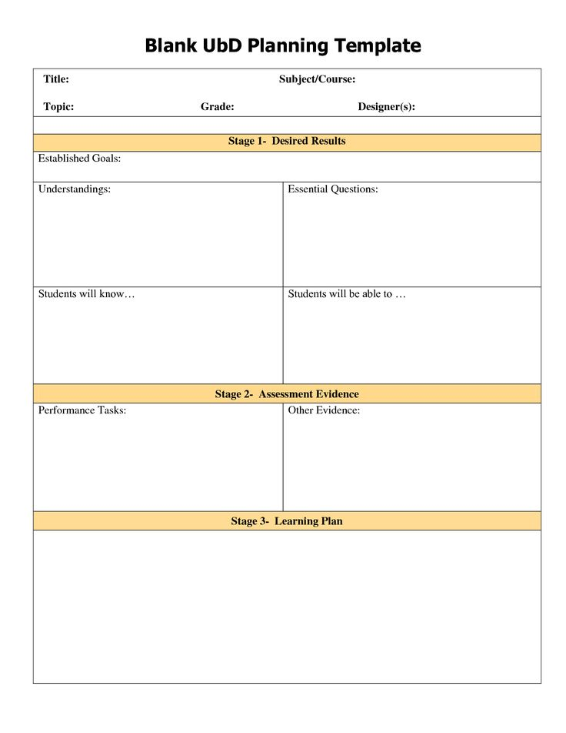

SUPPORTING MATERIALS FOR WORKSHOP
KNOW  WHAT DOES JUNE LOOK LIKE?? | DO | UNDERSTAND

