HOME FRONT AND THE CIVIL WAR
Many things go into fighting a war. Long before Vietnam, there was a sense of needing to win the hearts and minds of those at home. During the Civil War everyone was genuinely involved in the conflict. It was also the first war where popular culture played an important role in informing and in many cases, swaying, the public.

Procedure

- This lesson will definitely be an enrichment exercise but worth exploring if you have the time. Introduce to your students the advent of inexpensive printing techniques and the dissemination of images through lithographs and newspapers during this period of history. Show Students the Our Nations Heroes Poster and Song Covers. Have them complete Part I of the Student Sheet. You may do this a class, in small groups or individually. Discuss their results.
- Explore the notion of the ways in which visual media can shape opinion. We take this approach for granted now but the Civil War era was the first time it was done on a mass level. The mid-19th century saw the rise of the political cartoon. Show Students these three examples and have them complete Part II of the Student Sheet. You may do this a class, in small groups or individually. Discuss their results.
- Many people did want to help the soldiers and the rate of wounded during the war on both sides created enormous suffering. Show students the Map of the Convalescent Camp, the Slipper Patterns and Photograph of the Ladies of Roxbury. Have them complete Part III of the Student Sheet

Time Allocation:

Part I: 20-30 minutes
Part II: 20-30 minutes
Part III: 20-30 minutes

Materials Needed
Political cartoons
http://www.flickr.com/photos/59843331@N03/5468266775/in/photostream
http://www.flickr.com/photos/59843331@N03/5468860562/in/photostream/
http://www.flickr.com/photos/59843331@N03/5468266621/in/photostream/
Song covers
http://www.flickr.com/photos/59843331@N03/5468270233/in/photostream, http://www.flickr.com/photos/59843331@N03/5468270141/in/photostream
http://www.flickr.com/photos/59843331@N03/5468270029/in/photostream
http://www.flickr.com/photos/59843331@N03/5468266939/in/photostream
Heroes poster, http://maps.bpl.org/details_14556/?dl_pp=2&srch_query=civil+war&srch_fields=all&srch_style=exact&srch_fa=save
Map of convalescent home, http://maps.bpl.org/details_14375/?dl_pp=3&srch_query=civil+war&srch_fields=all&srch_style=exact&srch_fa=save
Slipper pattern (See Lesson 6) http://www.flickr.com/photos/59843331@N03/5491884611/in/photostream
Ladies of Roxbury photograph (See Lesson 6) http://www.flickr.com/photos/59843331@N03/5468265249/in/photostream

Assessment Criteria

Did students learn how those at home supported the troops?
Did students explore the role of popular culture during the war?
Did students identify propaganda used to promote the war effort on the home front?

Common Core Curriculum Standards
English/Language Arts: History/Social Studies. 9-12
Integration of Knowledge and Ideas
CCSS.ELA-Literacy.RH.9-10.9 Compare and contrast treatments of the same topic in several primary and secondary sources.
CCSS.ELA-Literacy.RH.11-12.9 Integrate information from diverse sources, both primary and secondary, into a coherent understanding of an idea or event, noting discrepancies among sources.

Wars are fought in many ways, often far from the front lines. How did the people back home contribute to the Civil War? How were they influenced in these efforts?

Part I: Heroes
Look at the images you teacher shows you and answer the following questions:
- What or who is honored? What have they done?
- What was being honored in song?
- Do the images on the song covers match the messages they are sending?
- Are there any major figures from the Civil War era (even on the Union side) that are absent from the Heroes poster?

- Suppose you were writing a song or making a poster about our nation’s heroes today. Who would you include?

- Our country is currently engaged in 3 military operations. Are we singing any songs about it? Why do you think this is the case?

Part II: Are these Cartoons Supposed to be Funny?
Political Cartoons became very popular in the middle of the 19th century as a way to express views and influence others. Look at the three examples your teacher gives you and answer the following questions:
- From whose point of view is the cartoon?
- How much does the language help to explain the visual image?
- Suppose there were no words. Would you be able to understand the intention of the cartoonist?
- Select one of the cartoons and write your own caption.
- Think of an issue we confront as a nation today. Find a cartoon you think expresses your opinion and bring it in to class.

Part III
There were hundreds of thousands of soldiers wounded during the Civil War and those back home wanted to help in any way that they could. Look at the 3 examples your teacher shows you and answer the following questions:

- In addition to the hospital, what else was on the grounds of the Convalescent Camp? Why do you think they were important to include?
- The US Sanitary Commission was a new agency, created during the Civil War. What do you imagine its central mission was?
- Read the instructions on the Slipper Pattern. Whom do you think was able to take the time to sew slippers?
- How about the Ladies sewing the flag in Roxbury?
- How do we help soldiers who are wounded today?

Political Cartoon 1: The old Bull Dog on the Right Track

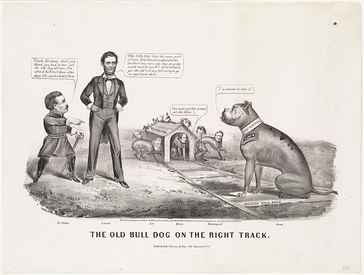

Political Cartoon 2: Why Don’t You Take it!

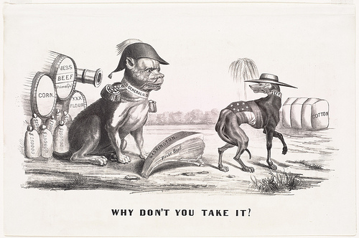

Political Cartoon 3: Torn in Two

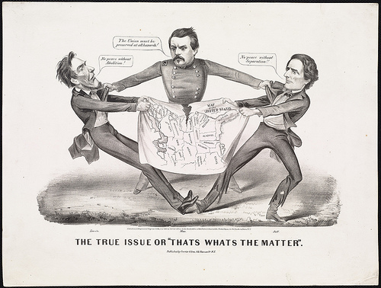
Song Cover 1: McClellan is the Man

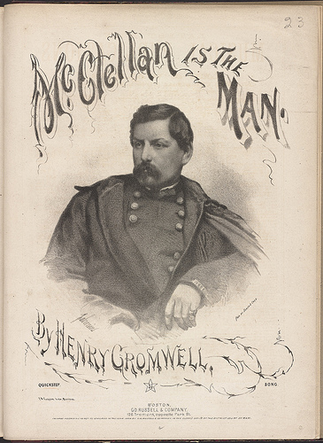

Song Cover 2: Hurrah for the 44th!

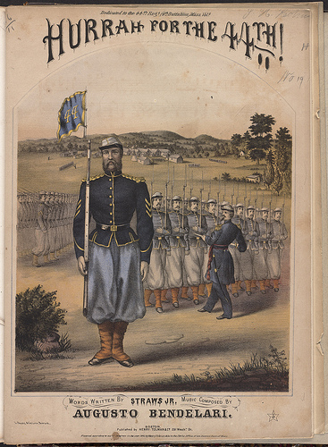

Song Cover 3: General Hooker’s Quickstep

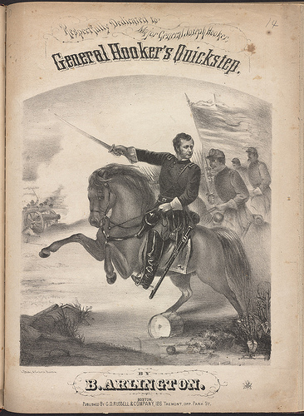

Song Cover 4: Songs of War

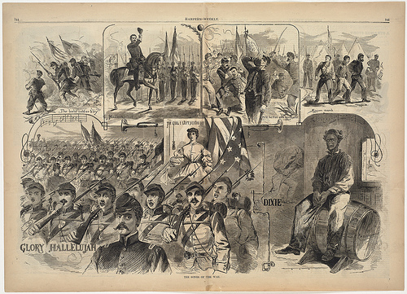

Our Nation’s Heroes Poster

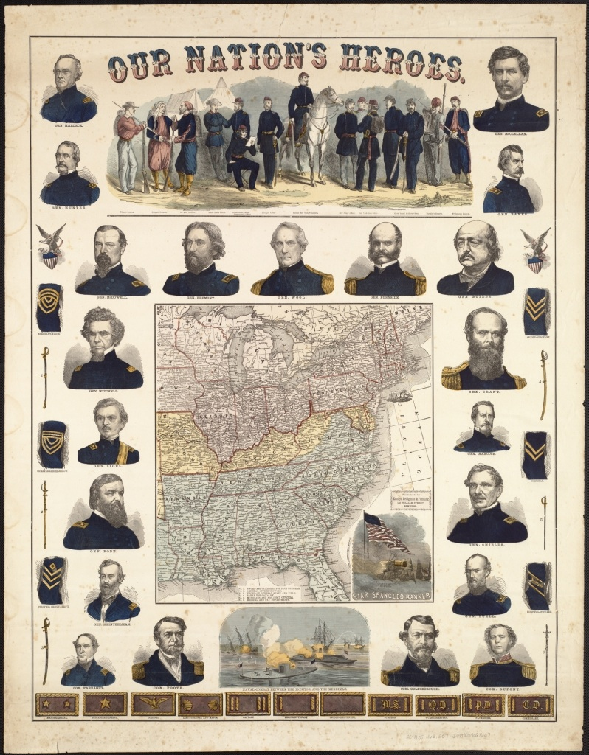

Map of Convalescent Home

