Lesson 9: the Math of Partisanship Middle School

Location: US Date: 1789-Present Grades 4-8

Essential Question: Are all votes equal? What is the math of political partisanship?

Objectives:
Students will learn about the role of the Census and political representation
Students will explore the historic influence of states based on their electoral weight
Students will compare the relative weight of a state’s vote in the contemporary landscape
Students will become acquainted with concepts like gerrymandering and packing electoral districts and their impact on political stalemate

Curriculum Standards:
COMMON CORE
ELA, Anchor Standards, Integration of Knowledge and Ideas
CCSS.ELA-LITERACY.CCRA.R.7
Integrate and evaluate content presented in diverse media and formats, including visually and quantitatively, as well as in words
CCSS.ELA-LITERACY.CCRA.R.9
Analyze how two or more texts address similar themes or topics in order to build knowledge or to compare the approaches the authors take.

MATH
Math Practices
2.Reason abstractly and quantitatively
3. Construct viable arguments and critique the reasoning of others.
4. Model with mathematics

7. Look for and make use of structure

National Geography Standards
Standard 1: How to Use Maps and Other Geographic Representations, Tools, and Technologies to Acquire, Process, and Report Information from a Spatial Perspective

MASSACHUSETTS CURRICULUM FRAMEWORKS
Grade 5
History and Geography
Civics and Government
The Principles and Institutions of American Constitutional Government
US History 1: The Revolution through Reconstruction, 1763-1877
The Formation and Framework of American Democracy
Political Democratization, 1800-1860
Civil War and Reconstruction
LESSON 9 TEACHER SHEET, P. 1
Lesson Overview
We like to think of voting as a straight forward process—one person, one vote. But the actuality is quite different thanks to the structure of the Electoral College, limits on the total number of representatives and Congressional districts that have been gerrymandered, packed, and fracked. The activities in this lesson allow you to explore these issues with your students and question the fairness of our electoral system and perhaps, suggest something more equitable.

Procedure:
- Begin with the census. See what students know about both what it is and why we take a count of the people every 10 years. What do they think happens in terms of how we vote? Have them complete Part I of the Student Sheet.
- Now show them the map that identifies the results of the 2010 Census and complete Part II of the Student Sheet. The idea that for one state to gain another must lose (even with population increases) is hard to digest given our sensibilities about fairness.
To see the historic impact on one state, complete Part III of the Student Sheet.
- Explain that once a state gains or loses electoral districts, they have to redraw the boundaries WITHIN their state. Begin Part IV with your students. It might work best to do this portion as a whole class. Explore questions of how states add and subtract districts, and why Congressional lines are drawn as they are.
- Part V allows you to explore questions of equity with your students. What does fairness mean when it comes to electing those who will represent us? How does it affect our ability to address our problems?

Time Allocation:
Part I: 10-15 minutes Part II: 10-15 minutes
Part III: 10-15 minutes Part IV: 15-20 minutes

Materials Needed:
All materials are included on the student sheet although they will need to access http://www.270towin.com/states/
Specific portions of the site are identified in the lesson

Assessment Criteria:
Did students learn about the role of the Census and political representation?
Did students explore the historic influence of states based on their electoral weight?
Did students will compare the relative weight of a state’s vote in the contemporary landscape?
Did students will become acquainted with the practice of gerrymandering and packing electoral districts?

Enrichment Opportunities:
Explore Gerrymandering—look at the 10 worst cases currently in the US:
https://www.buzzfeed.com/qsahmed/the-10-most-gerrymandered-districts-in-america-dh45?utm_term=.mwP8RGorW#.npRAjvzwJ
Is this the approach of just one party?

LESSON 9 STUDENT SHEET, P. 1

PART I: THE CENSUS
Article I, Section 2, US Constitution:
Representatives and direct Taxes shall be apportioned among the several States which may be included within this Union, according to their respective Numbers, which shall be determined by adding to the whole Number of free Persons, including those bound to Service for a Term of Years, and excluding Indians not taxed, three fifths of all other Persons. (Note: changed by section 2 of the Fourteenth Amendment.) The actual Enumeration shall be made within three Years after the first Meeting of the Congress of the United States, and within every subsequent Term of ten Years, in such Manner as they shall by Law direct. The Number of Representatives shall not exceed one for every thirty Thousand, but each State shall have at Least one Representative

- Why do we count the people in this country?
- How many representatives is each state guaranteed?
- Why do you think the framers created this system of representation?
- Below is a chart based on the most recent census.
- What information does it provide?
- Look at the first 10 states on the list—which is larger, their percent of electoral votes or percent of the population? How about the last 5 states on the list? Would you expect them to the be same?
- Why do some states have a larger percent of the Electoral Vote than they do of the population? [hint: look at the rules set out in Article 2, Section 1 of the Constitution]
- Where would you rather vote for President—Wyoming or California? Why?
- Does our current system of electoral votes represent a democratic process? Justify your response using the data in the chart below.

STATE PERCENT OF ELECTORAL AND POPULAR VOTE CHART

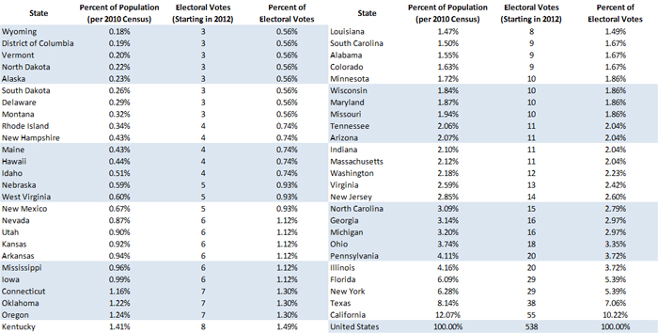
LESSON 9 STUDENT SHEET, P. 2

II: What Happened in 2010?

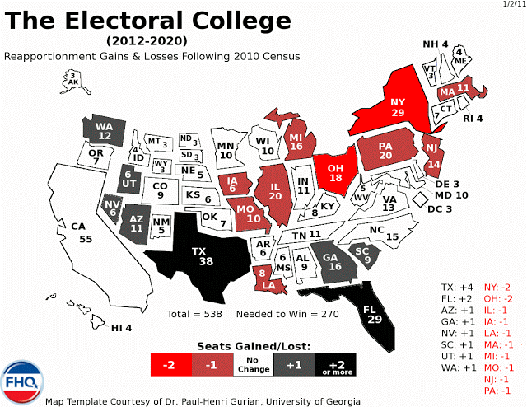

- Which states were the big winners? Losers?
- Why do you think the numbers changed, i.e. why did some states gain and others lose?

LESSON 9 STUDENT SHEET, P. 3

Part III: One State, Over Time
Now look at the following graph:

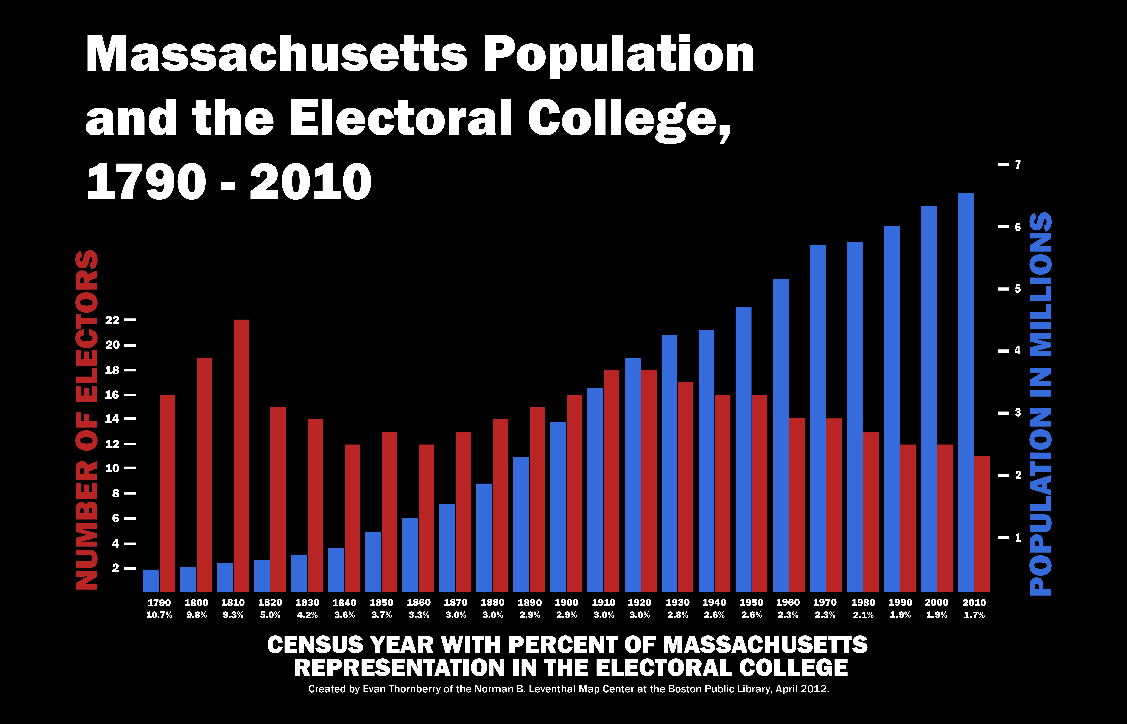

- What do the Red Lines show? The Blue?
- How is it possible that the Blue lines have risen while the Red lines have shortened?
- What has happened to Massachusetts’ political power over time?
- To compare the history of voting in Massachusetts with that of another state, go to
http://www.270towin.com/states/

Part IV: Within the States
- What does this image remind you of?
- What features dominate the ‘creature’?
- As you look at it more closely, what words are also on this picture?

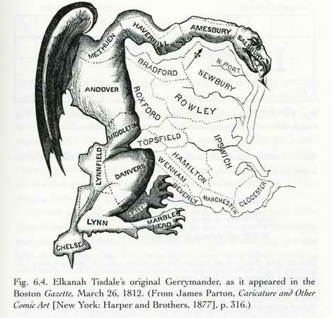

- After the 2010 Census, Texas gained 4 electoral votes. Its voting districts had to be redrawn. Look at the cartoon on the next page.
- What are the Elephant and Donkey doing?
- What is the message about drawing voting districts in Texas?

LESSON 9 STUDENT SHEET, P.5
TEXAS REDISTRICTS

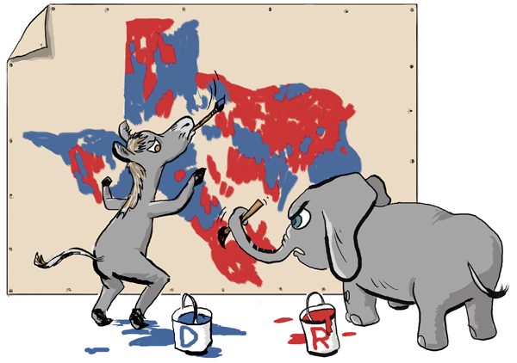

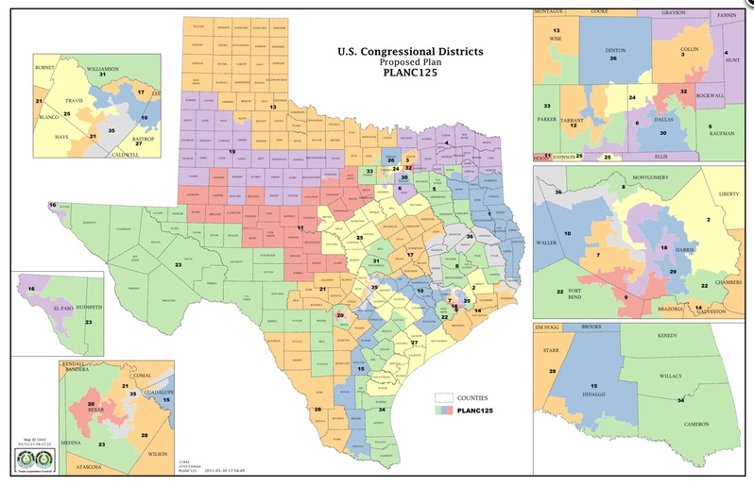
LESSON 9 STUDENT SHEET, P.6
Part V: Is It Fair??
Consider the case of Pennsylvania, http://www.270towin.com/states/Pennsylvania
- How has Pennsylvania Voted in the last 3 presidential elections? What percent of the vote did the Democrats get? The Republican?
- Pennsylvania sends 20 people to Congress—18 to theHouse of Representatives and 2 the Senate. Based on how the state voted in the last 3 presidential elections, how many Democrats would you expect to have from the state? How many Republicans?
- Now look at the state’s current representatives: http://www.270towin.com/elected-officials/pennsylvania
What might explain the discrepancy?

Now look at Rhode Island: http://www.270towin.com/states/Rhode_Island
- How has it voted in the last 3 presidential elections? By what percent did the candidate carry the state??
- Look at the state’s current representatives: http://www.270towin.com/elected-officials/rhode-island
- Is everyone in the state being fairly represented in Congress?

Consider the following problem:
What’s the Scoop?
The Sixth Grade at the Red, White, and Blue School needs to select 3 delegates to the National Ice Cream Convention. There are 100 students in the grade, divided into groups of 34, 33, and 33. Each group selects one delegate to attend the convention. Each student was given a choice of chocolate or vanilla ice cream. The grade wide vote was 66 for Chocolate Ice Cream, 34 for Vanilla. Somehow the Red, White and Blue 9th grade is sending two Vanilla representatives and one Chocolate representative to the National Ice Cream Convention in Burlington, VT this year.
How could this have happened?????

Group 1: Solve this problem using numbers. Be ready to SHOW the whole group your strategy.

Group 2: Solve this by using visuals--chart, graph, etc. Be ready to SHOW the whole group your strategy.

Group 3: Solve this problem using language. Be ready to show the whole group your strategy.
Group 4: Solve this problem using Hersheys kisses. Be ready to show your group your strategy.
- Is democracy being served in this election?
- Is it fair that the only two flavor choices are chocolate and vanilla?
- How might you ensure a more fair result?
- Imagine that all the representatives to the Ice Cream Convention come from districts like the ones described above. How much work do you think will get done at the convention? Why?
- How does the composition (make-up) of an electoral district affect the job its representative does?

PART V: DO A BETTER JOB
Clearly our current system has all sorts of problems. DESIGN A BETTER ONE!!

