GMS: Module R1: Talking, Reading, and Writing in Science November 10, 2016

Approaching Complex Text, Part I
Agenda
- OPENING ACTIVITIES
- TEXT PREPARATION: Well Begun is Half Done
- READING STRATEGIES
- CHECKS FOR STUDENT UNDERSTANDING
- LESSON STUDY/DEMO LESSONS
- PLAN NOVEMBER 22

All workshop materials can be found at the following website: http://mattersofeducation.org/workshop_materials/guilmette/
Password: lawrence
- OPENING ACTIVITIES
- Introductions--Show Us Your Text
B. Complex Texts TS: Compass Points, Color-Symbol-Image, 3-2-1
Participants will work individually and then share out full group to identify what they see as the salient aspects of Complex Texts

Description of Strategy:
Color-Symbol-Image
Choose a color that you think best represents the essence of that idea person, event, whatever
Create a symbol that you think best represents the essence of that idea, person, event, whatever
Sketch an image that you think best captures the essence of that idea person, event, whatever

Students also have to explain their choices—think-pair-share

Alternative: 3-2-1
3 words
2 questions
1 metaphor/simile/analogy

Alternative: Compass Points
Post headings around the room--Excitement, Worry, Needs, Supports
Have teachers fill out to generate conversation around the topic

C. Delivering a Curriculum with Fidelity: TS: Turn and Talk

D. Key Steps to Approaching a Complex Text
(and the value of cooperative learning)
- Text Selection
- Preparing the Text
- Reading the Text: Strategies, strategies everywhere
- Assessing Understanding through Active Engagement

II. ANALYZING COMPLEX TEXT: Step #1: BEFORE THE FIRST WORD
- Possible Options
- Background information--on the topic or procedures
- Language support--references to other scientific principles, topics
- Pre-teaching vocabulary: Tier 2 and 3 words
- Study Guides/Chapter Questions
- Adding Text Features
- Altering the text
- Using visuals: SEE-THINK-JUSTIFY-WONDER images students will encounter in the readin
Meta Questions:
- Are there any changes to the text that are off limits?
- How much do you do??
- How much should you provide for them?
- How often?

B. Unpack some of this
The World INSIDE the Text/The World OUTSIDE the Text
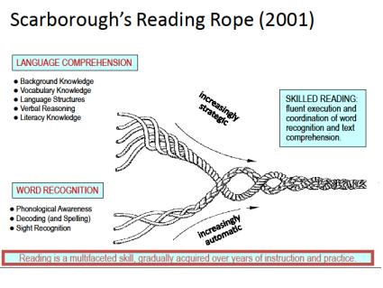

C. MODEL/PRACTICE Before The First Word
Round 1: Article #1 in Supporting Materials Packet
- Pre-Teach Vocabulary
- Add Text Features

Round 2: Preview Visual Images
TS: See-Think-Justify-Wonder
What do you See?
What do you think is going On?
Justify your answers—why do you think/say that? Show me in the text.
What does it make you Wonder?

Round 3: Practice on Your Know Atom Text

III. ANALYZING COMPLEX TEXT, Step #2: Reading the Text
- Big Questions
- which strategy for which text
- which strategy for which kids
- both informed by: what is your goal for the students (acknowledging this answer may vary among your students)

B. Strategies (just a sampling):
- Say-Mean-Matter (a/k/a What? So What? Now What?)
- Close Reading
- Partner Reading
- Think-Alouds
- The Final Word
- Jigsaw
- Chalk Talk

C. MODEL/PRACTICE
- DB will model two reading strategies for the group using Article #1
- Practice on Know-Atom Text or Article #2

IV. ANALYZING COMPLEX TEXT, Step #3: Checks for Understanding
- The importance of formative assessment
- A few favorite strategies (and all involve questioning which is a good foundation for Socratic Seminar)
- Numbered heads together
- Reciprocal Teaching
- Chalk Talk
- Fishbowl

C. Model/Practice
- DB will model two strategies for the group using Article #1
- Practice on Know-Atom Text or Article #2

V. Lesson study for November 22
- Proposal:
- 4 90 minute slots (1 per grade)
- Breakdown:
- 15 minutes prior to discuss what to look for/lesson goal
- 45 minutes for class (with observation template)
- 30 minute debrief
3. Option to have DB demo or have us coteach

B. Today create the 45 minute lesson
C. Observation form-: WHAT ARE WE LOOKING FOR?-
Target
Text
Task

VI: EXIT TICKET
RED LIGHT: Something that stopped me from learning today
YELLOW LIGHT: A question I had today
GREEN LIGHT: Something I learned today…
