
LESSON 8: HIGH SCHOOL
HOW AMERICA CHOOSES A PRESIDENT: POLITICAL PARTIES

Location: US Time Period: 1789-Present Grades: 8-12

Essential Question: What role do political parties play in the election of a president?

Objectives:
Students will identify the positions of the Democrats and Republicans in the 2012
Presidential Election
Students will compare Presidential election results by state and by county to note
party variation within state results
Students will note the evolution of political parties since 1790.

Common Core Standards
English Language Arts Standards: History/Social Studies
Integration of Knowledge and Ideas:
Grades 6-8
RH.6-8.7. Integrate visual information (e.g., in charts, graphs, photographs, videos, or maps) with other information in print and digital texts.
RH.6-8.8. Distinguish among fact, opinion, and reasoned judgment in a text.
Grades 9-10
Integration of Knowledge and Ideas:
RH.9-10.7. Integrate quantitative or technical analysis (e.g., charts, research data) with qualitative analysis in print or digital text.
RH.9-10.8. Assess the extent to which the reasoning and evidence in a text support the author’s claims.
RH.9-10.9. Compare and contrast treatments of the same topic in several primary and secondary sources.
Grades 11-12
RH.11-12.7. Integrate and evaluate multiple sources of information presented in diverse formats and media (e.g., visually, quantitatively, as well as in words) in order to address a question or solve a problem.
RH.11-12.8. Evaluate an author’s premises, claims, and evidence by corroborating or challenging them with other information.
RH.11-12.9. Integrate information from diverse sources, both primary and secondary, into a coherent understanding of an idea or event, noting discrepancies among sources.

Massachusetts Curriculum Standards:
US History 1: Revolution through Reconstruction
Concepts: Origins of Sectionalism
Formation and Framework of American Democracy and Concepts of Government
Political Democratization, 1790-1860

US History 2: 1877-2001
Industrializing America, 1870-1920
Age of Reform, 1900-1940
Contemporary America

Government elective

When the Constitution was adopted in 1789, there were no political parties. The framers were wary of political parties but somehow they have become one of the permanent fixtures of the political landscape. For a while, politics has been simplified into voter results as shown on maps, i.e. Red States and Blue States. The reality of both election results and party adherence is much more complicated.

Procedure

- Show the class the 1792 Presidential election map and the 1836 Presidential election map. Ask them to identify the differences between the two maps. Prompt them to see that there were no parties in 1792. Everyone voted for George Washington. Prompt them to see that there were several candidates in 1836, even more than one from the same party.
- Ask them about the role of political parties in the current election. What do they know about the positions of either one? There are no correct answers here but have them brainstorm and write their responses on the board. For homework, have them do some background research at the parties’ websites:
http://www.democrats.org/
http://gop.com/
- What else is on these websites? What is the tone of each?
- Explain that while the two current parties are the Democrats and the Republicans, there have been many parties in our country’s history. Have the students go to either http://www.edgate.com/elections/inactive/the_parties/
for an overview of the history of political parties and complete Part I of the Student Sheet for Homework. Discuss their results.
4. Show the class both 2004 Presidential Election results maps:
http://www.270towin.com [Select 2004]
http://www.usatoday.com/news/politicselections/vote2004/countymap.htm
How does their sense of Red State/Blue State change when they look at the county map? Which map is more accurate? Are they surprised to see Blue votes in states like Texas and Red votes in states like Massachusetts and California?
- Have class look at the National Atlas Wall Map of the Presidential Elections 1789-2000 and complete Part II of the Student Sheet. Discuss their results.

Time Allocation

Preliminary Discussion: 20 minutes
Part I: Homework Assignment
Part II: 15 minutes plus time to complete brief research out of class

Materials Needed

Access to the following websites:
http://www.democrats.org/
http://gop.com/
http://www.edgate.com/elections/inactive/the_parties/

National Atlas Wall Map: Presidential Elections 1789-2008



Presidential Election Map, 1792: included in Supporting Materials as well as
http://maps.bpl.org/details_12386
Presidential Election Map, 1836: included in Supporting Materials as well as
http://maps.bpl.org/details_12397
2004 Election Map, State results only included in Supporting Materials as well as
http://www.270towin.com [select 2004]
2004 Election Map, State and County results, included in Supporting Materials as well as
http://www.usatoday.com/news/politicselections/vote2004/countymap.htm]

Assessment Criteria

Did the students identify the positions of the Democrats and Republicans in the 2012
Presidential Election?
Did the students compare Presidential election results by state and by county to note
party variation within state results?
Did the students note the evolution of political parties since 1790?

Enrichment Activity

Does the Presidential Candidate always agree with his (or her) party? How can you find this information? Have students compare the Party Platform with the Candidate’s position on some key issues.


When the Constitution was adopted in 1789, there were no political parties. The framers were afraid of political parties but somehow they have become a big part of American politics. For a while, politics has been simplified into as shown by the way election results are reported on maps, i.e. Red States and Blue States. The reality of both election results and party politics is much more complicated.

Part I

Go to one of the following two websites to get an overview of the history of political parties http://www.edgate.com/elections/inactive/the_parties/ and answer the following questions for homework:

- What were the first two parties? What were their fundamental differences?

- Would today’s Democrats recognize the party of Jackson and Polk?

- How much do current Republicans have in common with the party of Lincoln?

Part II

On the Wall Map of Presidential Elections 1789-2008 look at the following elections:
1800, 1824, 1860, 1912, 1960 and 2000 and answer the following questions:

- In each election, which states (or sections of the country) did the Democrats win?

- What changes do you notice?

- Select two sequential elections from the above list (i.e 1800/1824 or 1824/1860 or 1860/1912 or 1912/1960 or 1960/2000). Find out what happened between the two elections to explain the geographic shift in party influence.

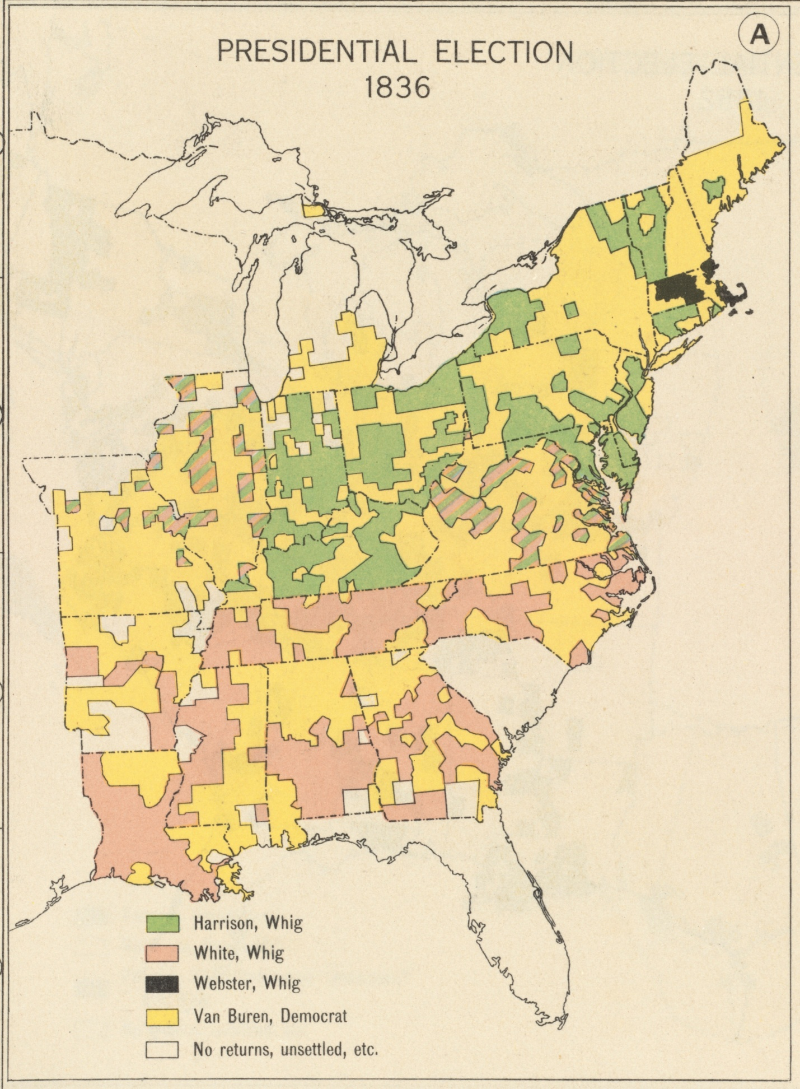
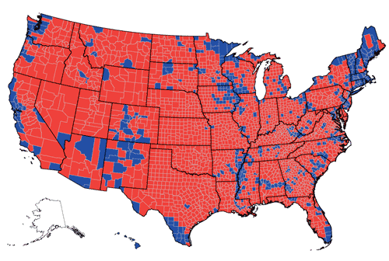

HIGH SCHOOL SUPPORTING MATERIALS LESSON 8

2004 PRESIDENTIAL ELECTION, STATE AND COUNTY RESULTS

HIGH SCHOOL SUPPORTING MATERIALS LESSON 8

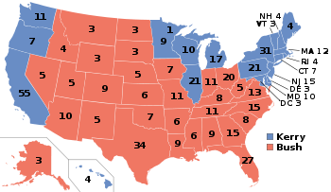

2004 PRESIDENTIAL ELECTION RESULTS BY STATE


