Presidential Election Maps: The Stories They Tell

Location: US Time: 1880-Present Grades 8 to 12

Essential Question: Why is there an inherent distortion in the presentation of presidential election results when a single visual image is used?

Objectives:
Students will look at a series of Presidential Election maps, beginning with the first attempts by cartographers in the 1880s.
Students will review the connection between voting by population and states via the Electoral College.
Students will observe that maps that highlight results by land mass rather than by population can create a distorted impression.

Curriculum Standards:
COMMON CORE
English and Language Arts, Grades 11 and 12, Integration of Knowledge and Ideas
RI.11-12.7. Integrate and evaluate multiple sources of information presented in different media or formats (e.g., visually, quantitatively) as well as in words in order to address a question or solve a problem.

English/Language Arts; History/Social Studies, Grades 9-12
Key Ideas and Details
RH.9-10-11-12.2. Determine the central ideas or information of a primary or secondary source; provide an accurate summary of how key events or ideas develop over the course of the text.
Integration of Knowledge and Ideas
RH.9-12.7. Integrate and evaluate multiple sources of information presented in diverse formats and media (e.g., visually, quantitatively, as well as in words) in order to address a question or solve a problem.

MASSACHUSETTS CURRICULUM FRAMEWORKS
US History 2: Reconstruction to the Present, 1877-Present
Industrial America, 1870-1920
Contemporary America, 1980-Present
American Government Elective

The results are in. What is the easiest way to show who won and who lost? More importantly, in a democracy, how can we keep track of our past? But one of the more interesting facets of US politics is that while we vote by population, given the Electoral College System, we need to report the results by state. This reality often creates a false visual impression, i.e. we vote by numbers but report by acreage in a standard state election map. In this lesson to supplement a standard Social Studies curriculum, explore different efforts by cartographers to present the results of Presidential elections and see for yourself if they clarify or confuse.

Procedure:
- Explain/review the process of presidential elections. The residents of each state vote. In most cases, the victor receives all of that state’s electoral votes. As a result, presidential election results are often placed on US maps that show the states. Yet this can be misleading, as the states are drawn in relative size by ACREAGE, not POPULATION, so California with the largest population (37,253,956) does not appear 66 times larger than the state with the smallest population, Wyoming (563,626). California has 55 electoral votes to Wyoming’s 3, so even allowing for disproportions in the Electoral system, it is not 18 times bigger on the map. Show students the Cartogram Maps of the 2008 Election and have them complete Part I of the Student Sheet. You might also want to consult the Chart of State Population and Electoral Votes.
- These new cartograms are pretty creative but cartographers have been trying to capture election results on a single page since 1888. Show Students the 1888 and 1893 presidential election maps. These early efforts were an attempt to capture a great deal of information in a single visual image yet often resulted in more confusion than clarity. The 1888 map provides past results as well as the opportunity to record state by state votes for 1888. Have your students look at both maps and complete Part II of the Student Sheet. You may want to do this with the full class or have them work in small groups. Discuss their results.
- There have obviously great strides since these early efforts to report presidential election results. Have your students select a single presidential election and find three different ways its results have been presented. Some possible resources are listed in the Materials Section.

Time Allocation:
Part I: 15-20 minutes
Part 2: 10-15 minutes
Part 3: will vary

Materials Needed:
Cartogram Maps of 2008 Presidential election, included in lesson and can be found at http://www-personal.umich.edu/~mejn/election/2008/
1888 Presidential Election Map, included below and located at http://maps.bpl.org/id/15289
1893 Presidential Election Map, to be included below and located at http://maps.bpl.org/id/15288
Chart of State Population and Electoral Votes, included below
Websites with Presidential election maps
http://campaign2012.c-span.org/electoral-college-map (1900-Present)
http://www.270towin.com/ (1789-Present)
http://maps.bpl.org/search/apachesolr_search (1789-1928)

Assessment Criteria:
Did students look at a series of Presidential Election maps, beginning with the first attempts by cartographers in the 1880s?
Did students review the connection between voting by population and states via the Electoral College?
Did students observe that maps that highlight results by land mass rather than by population create a distorted impression?

Enrichment Opportunities:
OK—why not give your students their own opportunity? See if they can create a presidential election map that is accurate, clear and proportional.

Every four years our country elects a president. And every four years, the results are presented. Mapmakers have been trying to show who won and who lost since the 1880s. Should be really easy, right? But there are a few problems:
- We vote by state, so whoever gets the most votes in numbers, wins that state
- Most maps draw states by their size in area, NOT NUMBERS, so standard state maps can confuse things

Look at these maps from the 2008 presidential election and answer the following questions. You may use the State Population and Electoral College Chart to help

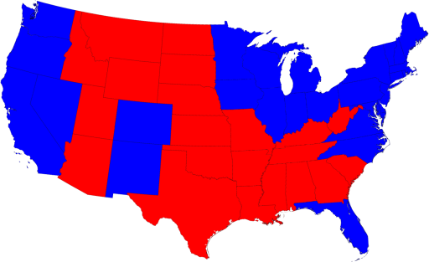
- Based on size alone, does it seems as if the red candidate won or the blue candidate did?

- Consider individual states, again based on their size as presented by this map—would a candidate rather win Idaho or Washington? Based on the number of electors?

- Locate California and Wyoming. Based on this map, would you think they were equally important in the election? In fact, how many more electors does California have than Wyoming?

Now look at this map that shows the states based on their population, not land mass: http://www-personal.umich.edu/~mejn/election/2008/

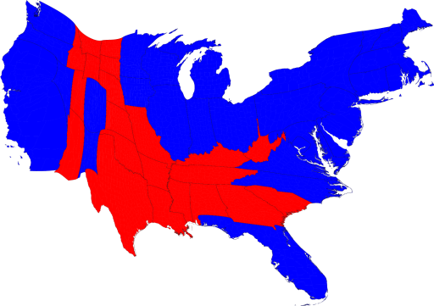

- Based on size alone, does it seems as if the red candidate won or the blue candidate did?

- Consider individual states, again based on their size as presented by this map—would a candidate rather win Idaho or Washington? Based on the number of electors?

- Locate California and Wyoming. Based on this map, would you think they were equally important in the election? In fact, how many more electors does California have than Wyoming?

This distinction becomes even more evident on the county level. Here are the results for the 2008 election by county. Which color dominates this map? Where do most of the people in the country live—in the red areas or the blue? How is this made clear on the second map?

2008 Presidential Election Results by County and by population:
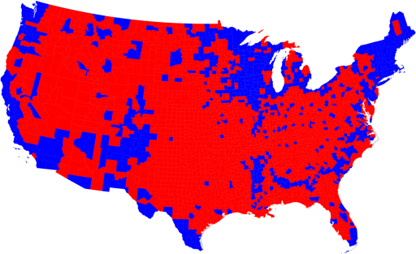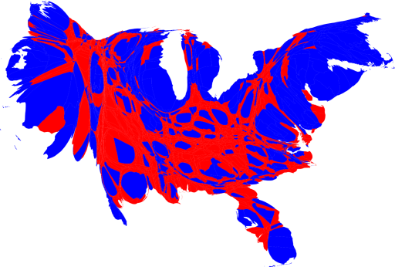

Part II

Look at the 1888 presidential election map
- What is the title of the map? What tone does the cartographer set by using this language?
- How has the mapmaker tried to provide an overview of previous presidential elections on this map?
- How does he hope people will use this map in the upcoming 1888 presidential election?
- What other information has he included? Does it make it easier or harder to understand election results?

Look at the 1893 Map
- What is its exact title?
- What is the mapmaker trying to show here?
- What does the color around the state indicate? The color of the county?
- What information is included in the chart on the lower left of the map? Why do you think he included this?

Consider both maps—do they clarify or confuse you about the results of Presidential elections?

Part III

From the earliest maps that you have just seen until today, there have been many creative attempts to present the results of presidential elections. Select any one of the races and find at least different ways in which the results have been presented. Some places for you to begin:
http://campaign2012.c-span.org/electoral-college-map
http://www.270towin.com/
http://maps.bpl.org/search/apachesolr_search

STATE POPULATION AND ELECTORAL VOTES CHART, BASED ON 2010 CENSUS

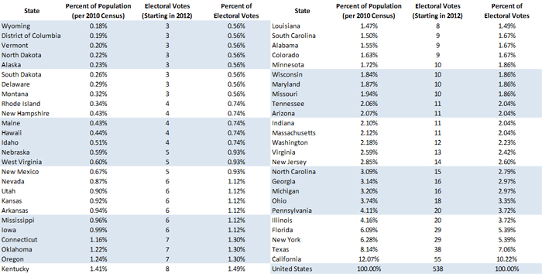

1888 PRESIDENTIAL ELECTION MAP
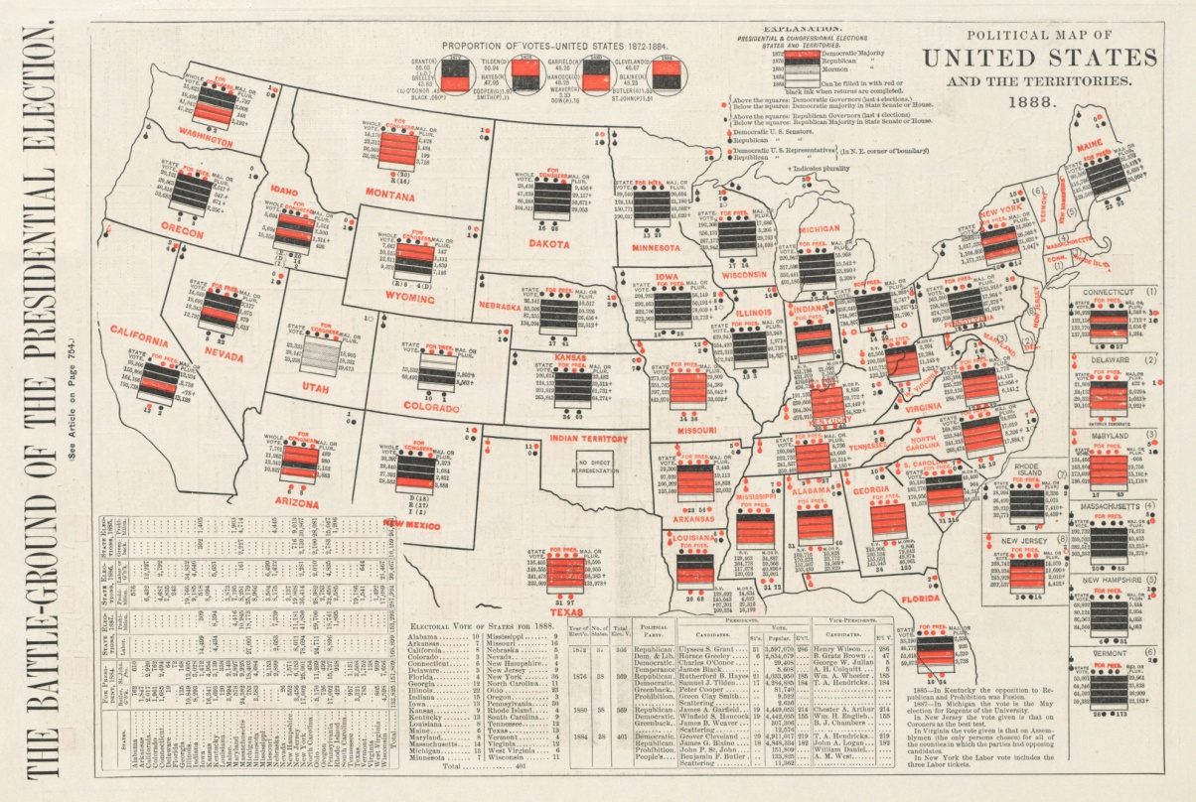

1892 PRESIDENTIAL ELECTION MAP

