THE GROWTH OF THE UNITED STATES

The goal of the lesson is to provide students with a basic understanding of the physical expansion of the United States during its first decades. Specifically, which states entered the country at what point and which had slaves and which did not? It is also important that students be able to identify those states that seceded from the Union at the start of the Civil War.

Common Core Curriculum Standards
Mathematics: Measurement and Data: Grades 3-5
Represent and Interpret Data

English Language Arts: Reading: Integration of Ideas and Information, Grades 2-4

Integration of Knowledge and Ideas
7. Integrate and evaluate content presented in diverse media and formats, including visually and quantitatively, as well as in words.

National Geography Standards
Standard 1: How to Use Maps and Other Geographic Representations, Tools, and Technologies to Acquire, Process, and Report Information From a Spatial Perspective
Standard 17: How to Apply Geography to Interpret the Past

Procedure

- Provide students with the outline map of the United States and the list of dates of entrance to the Union. Students may do this work independently or as a group.
- Provide students will Student Sheet and have them complete Part I, either in class or for homework. Have them share their maps.
- If you are teaching slavery to your students, you may want to complete Lessons 3 and 4 in this Curriculum Guide prior to completing Part II of this lesson. Provide Students with the List of Slave States and List of Order of Secession from the Union Sheets and have them complete Part II.
4. Discuss their results.

Time Allocation: Part I: 20 Minutes Part II: 10-15 minutes

Materials Needed

5 Colored markers
Outline Map of United States with States unlabeled
List of States by dates of entry to the United States
Map of slave States, 1860
Order of States' secession from the Union

Assessment Criteria

Did students ‘compile’ a map of US according to the date states entered the union?
Did students color outline sections based on historic periods, e.g. the Original 13 colonies, before the Civil War, after the Civil War?
Did students identify the states that had slaves and of those, the ones that seceded in the Civil War?

Enrichment Activities

- Have students look at a different model of the nation’s growth, Uncle Sam’s Family Tree.
http://maps.bpl.org/details_12971

Have them complete their own family history or a class history using this type of image.
- Have students show the growth of the country on a timeline, including important events such as the Civil War

Our country has grown in size since it began over 235 years ago. And for a few years in the 1860s, it looked like it might break apart! In this lesson, you will learn how the country grew.

Part I

- Using the Outline Map and list your teacher gives you, fill in each state and note the date it became part of the country.
- Outline the original 13 colonies in one color.
- Outline all of those states that were part of the country before the Civil War, 1861, in another color.
- Outline all of those states that joined the country after the Civil War in a third color

Part II

- 15 States had slaves. Use the information your teacher gives you to mark those states that had slaves before 1861.
- 11 states that had slaves left the country in 1860 and 1861. Use a fifth marker and color in those states.
- Where are the four slave states that stayed part of the country? Why do you think they didn’t leave?

Outline map of the United States

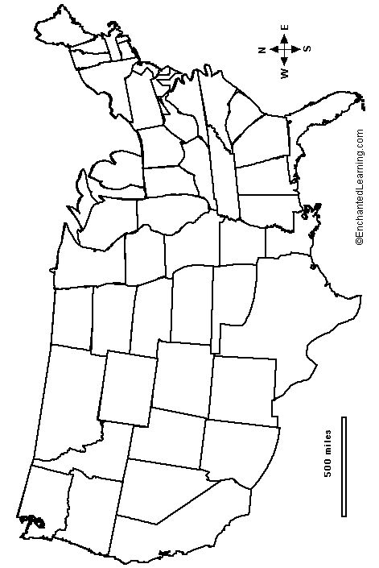

 | State |  | Admission ^{[2]} | Preceding Entity
1 |  | Delaware | December 7, 1787^{[2]} | Lower Counties on Delaware, then sovereign state in Confederation
2 |  | Pennsylvania | December 12, 1787^{[2]} | Province of Pennsylvania, then sovereign state in Confederation
3 |  | New Jersey | December 18, 1787^{[2]} | Province of New Jersey, then sovereign state in Confederation
4 |  | Georgia | January 2, 1788^{[2]} | Province of Georgia, then sovereign state in Confederation
5 |  | Connecticut | January 9, 1788^{[2]} | Connecticut Colony, then sovereign state in Confederation
6 |  | Massachusetts | February 6, 1788^{[2]} | Province of Massachusetts Bay, then sovereign state in Confederation
7 |  | Maryland | April 28, 1788^{[2]} | Province of Maryland, then sovereign state in Confederation
8 |  | South Carolina | May 23, 1788^{[2]} | Province of South Carolina, then sovereign state in Confederation
9 |  | New Hampshire | June 21, 1788^{[2]} | Province of New Hampshire, then sovereign state in Confederation
10 |  | Virginia | June 25, 1788^{[2]} | Virginia Colony, then sovereign state in Confederation
11 |  | New York | July 26, 1788^{[2]} | Province of New York, then sovereign state in Confederation
12 |  | North Carolina | November 21, 1789^{[2]} | Province of North Carolina, then sovereign state in Confederation
13 |  | Rhode Island | May 29, 1790^{[2]} | Colony of Rhode Island and Providence Plantations, then sovereign state
14 |  | Vermont | March 4, 1791 | Province of New York and New Hampshire Grants (ownership disputed), Vermont Republic
15 |  | Kentucky | June 1, 1792 | Split off from Virginia with that state's consent. The former huge Kentucky County
16 |  | Tennessee | June 1, 1796 | Formed from western land donated to the U.S. by North Carolina
17 |  | Ohio | March 1, 1803^{[1]} | The Northwest Territory, land donated to the U.S. by East Coast states such as Pennsylvania, Virginia, and New York
18 |  | Louisiana | April 30, 1812 | Territory of Orleans
19 |  | Indiana | December 11, 1816 | Indiana Territory, formed from the Northwest Territory
20 |  | Mississippi | December 10, 1817 | Mississippi Territory, formed from land donated to the U.S. by Georgia
List of States by dates of entry to the United States

21 |  | Illinois | December 3, 1818 | Illinois Territory, formed from the Northwest Territory
22 |  | Alabama | December 14, 1819 | Alabama Territory, formed from Mississippi Territory
23 |  | Maine | March 19, 1820 | Split off from Massachusetts with that state's consent (the former District of Maine)
24 |  | Missouri | August 10, 1821 | Missouri Territory
25 |  | Arkansas | June 15, 1836 | Arkansas Territory
26 |  | Michigan | January 26, 1837 | Michigan Territory, formed from the Northwest Territory
27 |  | Florida | March 3, 1845 | Florida Territory
28 |  | Texas | December 29, 1845 | Republic of Texas
29 |  | Iowa | December 28, 1846 | Iowa Territory
30 |  | Wisconsin | May 29, 1848 | Wisconsin Territory, formed from the Northwest Territory
31 |  | California | September 9, 1850 | Directly admitted from Mexican Cession
32 |  | Minnesota | May 11, 1858 | Minnesota Territory
33 |  | Oregon | February 14, 1859 | Oregon Territory
34 |  | Kansas | January 29, 1861 | Kansas Territory
35 |  | West Virginia | June 20, 1863 | Divided off from Virginia with the questionable consent of that state
36 |  | Nevada | October 31, 1864 | Nevada Territory, with part of Arizona Territory added on later
37 |  | Nebraska | March 1, 1867 | Nebraska Territory
38 |  | Colorado | August 1, 1876 | Colorado Territory
39^{[3]} |  | North Dakota | November 2, 1889 | Dakota Territory
40^{[3]} |  | South Dakota | November 2, 1889 | Dakota Territory
41 |  | Montana | November 8, 1889 | Montana Territory
42 |  | Washington | November 11, 1889 | Washington Territory
43 |  | Idaho | July 3, 1890 | Idaho Territory
44 |  | Wyoming | July 10, 1890 | Wyoming Territory
45 |  | Utah | January 4, 1896 | Utah Territory
46 |  | Oklahoma | November 16, 1907 | Oklahoma Territory and Indian Territory

47 |  | New Mexico | January 6, 1912 | New Mexico Territory
48 |  | Arizona | February 14, 1912 | Arizona Territory
49 |  | Alaska | January 3, 1959 | Russian America, Department of Alaska, District of Alaska and then Alaska Territory
50 |  | Hawaii | August 21, 1959 | Kingdom of Hawaiʻi, Republic of Hawaiʻi and then Hawaiʻi Territory

Map of slave States, 1860

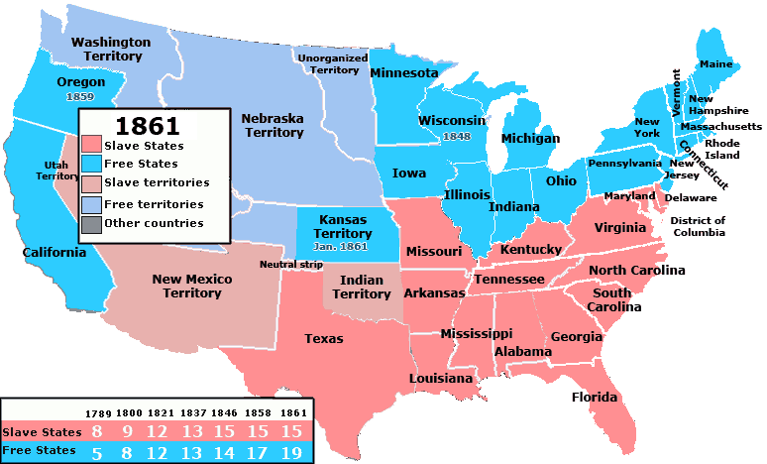

Order of States’ secession from the Union

State | Date of Secession
South Carolina | December 20, 1860
Mississippi | January 9, 1861
Florida | January 10, 1861
Alabama | January 11, 1861
Georgia | January 19, 1861
Louisiana | January 26, 1861
Texas | February 1, 1861
Virginia | April 17, 1861
Arkansas | May 6, 1861
North Carolina | May 20, 1861
Tennessee | June 8, 1861

