THE LOUISIANA PURCHASE: A LESSON IN CONSTITUTIONAL COMPROMISE
By 1800, the young nation was growing quickly. Its new President, Thomas Jefferson represented this growth in many ways. He was the voice of the Western farmer whom he believed would be the foundation of this new nation. But to acquire the dignity and virtue necessary to participate in this great republican experiment, land was needed. So when the opportunity to double the physical land mass presented itself, Jefferson, despite his reservations about Constitutional authority and the impact of all of that land of the fate of slavery, agreed to the terms of sale.

Procedure

- This lesson is designed to supplement your regular curriculum materials. Your students should be able to identify most of key concepts/terms/people listed on the Student Sheet from their text. You may want them to do so before you begin the lesson or use as a review at the end.
- To indicate the state of the country’s growth in 1800, show the students the US Population Chart and the Presidential Election Map of 1800. Have them complete Section I of the Student Sheet. Discuss their results.
- As the farmers moved westward, they needed to get their crops to market and the Mississippi River became increasingly important. Look at the Map of North America, 1799 with your Students. Find the Mississippi and the Port of New Orleans. Why was it a problem when the French stopped letting us use the port in 1802?
- The small farmer was very important to both Jefferson the revolutionary and Jefferson the President. He believed that the nation would be built on the farms of those who worked hard and learned the importance of virtue through their hard work. But land was necessary for these farms. Be sure to include Jefferson’s vision of the importance of the small farmer for the new nation.
- Review/Introduce Jefferson’s stand on Constitutional interpretation. Also have your students learn about the details of the Louisiana Purchase. It will be covered in their text. If you would like them to read about it elsewhere, there is a link provided in the Materials Section. Have Students complete Part II of the Student Sheet, particularly if you have not yet studied John Marshall and any of his key decision. Discuss their results. Be sure to explore the value of compromise in politics.
- In addition to the issues of Strict Construction, Jefferson knew that there would be issues over both Native Americans and the extensive of slavery. You may or may not want to explore these topics with your students at this time.

Time Allocation: Part I: 20-30 minutes Part II: 20-30 minutes

Materials Needed
US Population Chart, 1790-1810
Presidential Election Map, 1800
Map of North America, http://maps.bpl.org/details_10587/?mtid=1390
Overview of Louisiana Purchase, http://www.nps.gov/archive/jeff/lewisclark2/circa1804/heritage/louisianapurchase/louisianapurchase.htm

Assessment Criteria

Did students learn the reasons that President Jefferson wanted to acquire the Louisiana Territory?
Did students understand the reservations President Jefferson had about acquiring the land from the French?
Did students see how the language of the Constitution does not provide explicit guidelines for decisions?

Enrichment Activities

Stage a debate as Federalist and Democratic-Republicans over the Purchase of Louisiana

Common Core Curriculum Standards
English/Language Arts Standards: Anchor Standards: CCRS Reading
Key Ideas and Details
• CCSS.ELA-Literacy.CCRA.R.1 Read closely to determine what the text says explicitly and to make logical inferences from it; cite specific textual evidence when writing or speaking to support conclusions drawn from the text.
• CCSS.ELA-Literacy.CCRA.R.2 Determine central ideas or themes of a text and analyze their development; summarize the key supporting details and ideas.

Craft and Structure
• CCSS.ELA-Literacy.CCRA.R.4 Interpret words and phrases as they are used in a text, including determining technical, connotative, and figurative meanings, and analyze how specific word choices shape meaning or tone.
• CCSS.ELA-Literacy.CCRA.R.5 Analyze the structure of texts, including how specific sentences, paragraphs, and larger portions of the text (e.g., a section, chapter, scene, or stanza) relate to each other and the whole.
Reading: Informational Text, Integration of Knowledge and Ideas, 9-12
CCSS.ELA-Literacy.RI.9-10.9 Analyze seminal U.S. documents of historical and literary significance
CCSS.ELA-Literacy.RI.11-12.9 Analyze seventeenth-, eighteenth-, and nineteenth-century foundational U.S. documents of historical and literary significance (including The Declaration of Independence, the Preamble to the Constitution, the Bill of Rights, and Lincoln’s Second Inaugural Address) for their themes, purposes, and rhetorical features.

America has grown in size and population over its long history. There were many good reasons to expand the size of the country but sometimes there were also reasons to think twice. In 1803 the United States got the chance to double its size and the President had to think long and hard about what to do.

Key Concepts, Terms, & People
Strict v. Loose Interpretation of the Constitution
The growing importance of transportation in the new nation
The good and bad of Westward expansion
Jefferson the idealist v. Jefferson the politician

Robert Livingston Territorial Acquisition
Federalists Westward Expansion
Democrats Extension of Slavery

Part I
Look at the Population Chart and Presidential Election Map your teacher gives you.
- Which states had the largest populations in 1790? 1800? 1810?
- Which states were growing the fastest (that is even if their numbers were not as big, which ones were doubling or even tripling over a 10 year period)? What part of the country were they in?
- Whom do you think was moving to those parts of the country? Why do you think they were moving there?
- Look at the 1800 Presidential Election Map. Who voted for Jefferson? What did his supporters want?

Part II
The US Constitution was a complex and often complicated document. Consider these two parts:

Article I, Section 8 (the Powers of Congress)
To make all Laws which shall be necessary and proper for carrying into Execution for foregoing Powers, and all other Powers vest by this Constitution in the Government of the United States , or in any Department or Officer thereof.

Amendment Ten (part of the original Bill of Rights)
The powers not delegated to the United States of the Constitution, nor prohibited by it to the States, are reserved to the States respectively, or to the people.

- Suppose you wanted to build a road between New York and New Jersey. Who should make the laws about the road—the States or the Congress? How would you decide? Does the Constitution, based on what is above, help answer your question?
- How about a tax on a machine that is made in England but brought into the port of Charleston, South Carolina? Who should set the tax? Collect the tax? Again, does the Constitution, based on what is above, help answer your question?

Now consider the decision to acquire the Louisiana Territory.
Read about these events in your text and answer the following questions:

- What was Jefferson hoping to get when he sent Livingstone to France?
- What did Napoleon offer instead?
- What were the terms of the deal?
- Thomas Jefferson believed that he could only do things if they were exactly written in the Constitution but nowhere in the Constitution did it say that Presidents could buy land.
But he really wanted Louisiana for the farmers and for the nation.
7. What were the reasons to buy Louisiana?
8. Besides the Constitution, might there be any other problems with buying Louisiana?
9. Do you think Jefferson was right to purchase Louisiana for the country?

United States Population Chart

STATE | 1790 | 1800 | 1810
MAINE | 96540 | 151719 | 228705
NEW HAMPSHIRE | 141885 | 183858 | 214460
VERMONT | 85425 | 154465 | 217895
MASSACHUSETTS | 378787 | 422845 | 472040
RHODE ISLAND | 68825 | 69122 | 76931
CONNECTICUT | 237946 | 251002 | 261942
NEW YORK | 340120 | 589051 | 959049
NEW JERSEY | 184139 | 211149 | 245562
PENNSYLVANIA | 434373 | 602365 | 810091
OHIO |  | 45365 | 230760
INDIANA |  | 5641 | 24520
ILLINOIS |  |  | 12282
MICHIGAN |  |  | 4762
WISCONSIN
DELAWARE | 59096 | 64273 | 72674
MARYLAND | 319728 | 341548 | 380546
WASHINGTON DC |  | 8144 | 15471
VIRGINIA | 691737 | 807559 | 877683
W VIRGINIA | 55873 | 78592 | 105469
N CAROLINA | 393751 | 478103 | 555500
S CAROLINA | 249073 | 345591 | 415115
GEORGIA | 82548 | 162686 | 252433
FLORIDA
KENTUCKY | 73677 | 220995 | 406511
TENNESSEE | 35691 | 105602 | 261727
ALABAMA |  | 1250 | 9046
MISSISSIPPI |  | 7600 | 31306

Map of North America

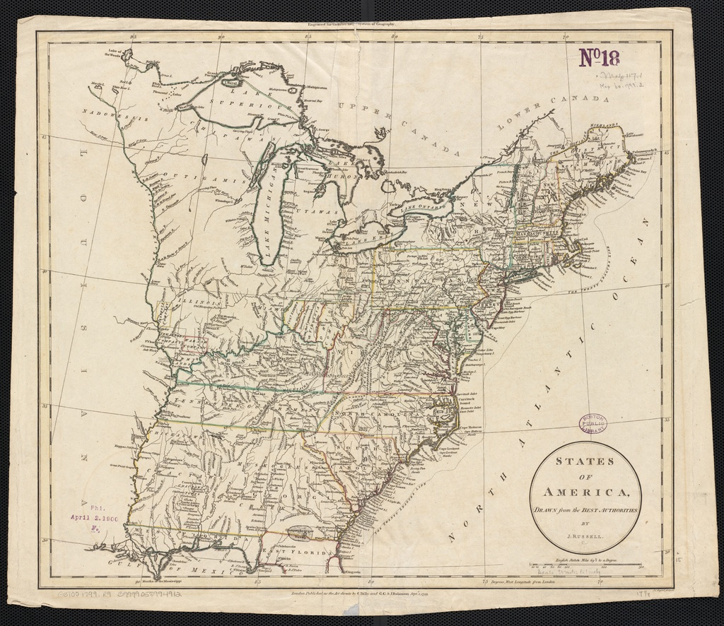

Presidential Elections Map 1800

