THE MEDIA AND WAR, GR 6-8
The Civil War was the first war in which the press was actively engaged in reporting the war from the field. New technologies enabled reporters to communicate the events in a relatively short amount of time. Printing capacities enabled newspapers to show diagrams, maps and photographs of the actual battles, feeding the increasing demand of the public. The scope of the conflict generated interest from readers of all backgrounds.

Procedure

- Introduce/discuss the role of the reporter to the story. Have them look at the lithograph, The Press on the Field and complete Part I of the Student Sheet. This may be done for homework, in small groups or as a class. Discuss their results.
- Now provide the class with one or both of the Newspaper reports and have them complete Part II of the Student Sheet. Depending on the age and skill level of your students, you can go into as much or as little detail in this section as you like.
- Have students consider the nature of war reporting in other eras. Have them select another war since the Civil War and find at least 2 examples of news reports from that conflict. Have them complete Part III of the Student Sheet. You may choose to turn this into a more extensive research project as suggested in the Enrichment Activities. Students may also work in groups for this part of the assignment. They may present their results in charts, graphs, written reports, power points or other visual media.
- Have a final discussion about the ways in which we talk about war. Is it the same way we tell other stories? Why or why not?

Time Allocation:

Part I: 15 minutes
Part II: will vary by age and skill level of students
Part III: Time to conduct outside research. Time to present results

Materials Needed

Thomas Nast Lithograph, The Press on the Field
http://www.flickr.com/photos/59843331@N03/5468267745
Newspaper reports from the Civil War
http://maps.bpl.org/details_14658/?dl_pp=1&srch_query=civil+war&srch_fields=all&srch_style=exact&srch_fa=save
http://maps.bpl.org/details_14659/?dl_pp=1&srch_query=civil+war&srch_fields=all&srch_style=exact&srch_fa=save

Assessment Criteria

Did students learn about war reporting during the Civil War?
Did students compare war reporting during the Civil War with war reporting from another era?
Did students consider the impact of the reporter on the story?

Enrichment Activities

- Have Students do more extensive research to learn about the reporting of another war.
- You may also choose to compile a classroom chart comparing several wars.
- Have Students create a Press on the Field lithograph for a different war.

Common Core Curriculum Standards
English/Language Arts: Anchor Standards: CCRS for Reading
Key Ideas and Details
- CCSS.ELA-Literacy.CCRA.R.1 Read closely to determine what the text says explicitly and to make logical inferences from it; cite specific textual evidence when writing or speaking to support conclusions drawn from the text.
- CCSS.ELA-Literacy.CCRA.R.2 Determine central ideas or themes of a text and analyze their development; summarize the key supporting details and ideas.
Craft and Structure
- CCSS.ELA-Literacy.CCRA.R.4 Interpret words and phrases as they are used in a text, including determining technical, connotative, and figurative meanings, and analyze how specific word choices shape meaning or tone.
- CCSS.ELA-Literacy.CCRA.R.5 Analyze the structure of texts, including how specific sentences, paragraphs, and larger portions of the text (e.g., a section, chapter, scene, or stanza) relate to each other and the whole.
- CCSS.ELA-Literacy.CCRA.R.6 Assess how point of view or purpose shapes the content and style of a text.
English/Language Arts: History/Social Studies, Grades 6-12
Integration of Knowledge and Ideas
- CCSS.ELA-Literacy.RH.6-8.7 Integrate visual information (e.g., in charts, graphs, photographs, videos, or maps) with other information in print and digital texts.
- CCSS.ELA-Literacy.RH.6-8.8 Distinguish among fact, opinion, and reasoned judgment in a text
- CCSS.ELA-Literacy.RH.6-12.9 Analyze the relationship between a primary and secondary source on the same topic.

Wars are big news. Reporters covering these stories must get close to the front lines to cover the action. The first American war where this occurred was the Civil War. But does the reporter ever become part of the story itself?

Part I
You teacher will show you a picture with drawings entitled, The Press on the Field. Please answer the following questions:
- What is the title of the picture on the left? From whom are the reporters getting their information? What perspective do they bring?
- What is the title of the picture on the right? Why do you thing the artist included this title?
- What was the purpose of this drawing? What impression of the press does it give?

Part II
Newspapers did report on the conflict on a regular basis. Look at the example your teacher gives you and answer the following questions:
- What information is included in the article(s)?
- In addition to news articles, what other material does the newspaper provide to its readers to let them know what is happening in the war?
- Why might this type of material have been valuable? Do you think it helped newspaper sales?
- Do these articles and other items seem objective to you? Why or why not?

Part III
Reporting on Wars has become very important both to the American people and to news agencies and reporters. Select from the list below and find at least two reports from those wars. Any medium is acceptable. For each, identify
- How the reporter presents his or her information
- How he or she got this information
- The major facts he or she includes
- Any images
- Any personal information the reporter includes
6. Does the reporter seem to have a particular point of view or bias? How can you tell?

The Spanish American War
World War One
World War Two
The Korean War
The Vietnam War
The First Gulf War
Our Current Conflicts in Iraq, Afghanistan and/or Libya

The Press on the Field

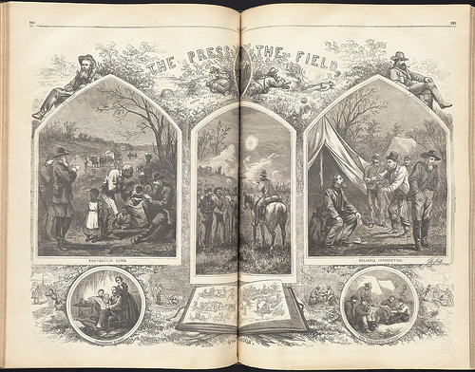

Newspaper Report from the Civil War

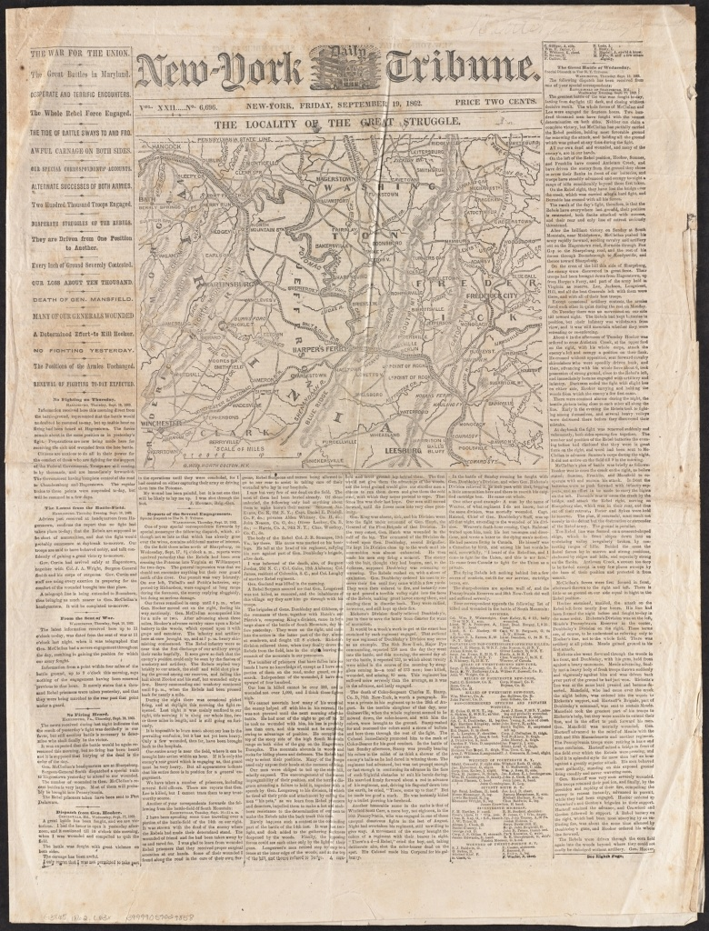

Newspaper Report from the Civil War

