THE RISE OF POPULAR CULTURE IN THE 19TH CENTURY

Several factors came together in the middle of the 19th century that led to the rise of new forms of popular culture. Technological advancements made newspapers, photographs, cartoons, sheet
music and lithographs relatively inexpensive to produce. A rising middle class had disposable income and a strong desire for items that would allow them to copy their wealthier role models.

The onset of the Civil War spurred demand for information as well as a shift to wartime content. Visual images, not dependent on literacy, and available to the working classes, were increasingly desired. Everything that was produced had a point of view, a perspective and often a definite bias.

Procedure

- Discuss with your students the role of popular culture.
- We have taken 22 objects from the exhibition and placed them in a flickr account, noted in the Materials Needed section.
- You may want to look at three closely with your students. Have them complete Part I of the Student Sheet. They may work individually, in small groups or as a class.
- Then have them select one form of popular culture: photographs, cartoons, lithographs, sheet music, or popular press. Have them learn more about their topic and present their findings to the class. They may write a paper, create a chart, prepare a power point or some other form of presentation. You may used Part II of the Student Sheet as a template for the assignment or create your own.

Time Allocation:
Part I: 20-30 minutes
Part II: will vary, depending on age and skill level of your students

Materials Needed
Popular Culture objects from Torn in Two Exhibition, http://www.flickr.com/photos/59843331@N03/sets/72157626516014650/with/546826939/

Assessment Criteria

Did students learn about different forms of popular culture from the middle of the 19th century? Did students explore the bias of these new forms of popular culture?
Did students select one form of popular culture and explore it closely?

Common Core Curriculum Frameworks
English/Language Arts: Anchor Standards, CCRS for Reading Integration of Knowledge and Ideas
- CCSS.ELA-Literacy.CCRA.R.7 Integrate and evaluate content presented in diverse media and formats, including visually and quantitatively, as well as in words.1
- CCSS.ELA-Literacy.CCRA.R.8 Delineate and evaluate the argument and specific claims in a text, including the validity of the reasoning as well as the relevance and sufficiency of the evidence.
- CCSS.ELA-Literacy.CCRA.R.9 Analyze how two or more texts address similar themes or topics in order to build knowledge or to compare the approaches the authors take.

Popular culture, those sounds, words and pictures that we see every day, weren’t always here. Starting about 150 years ago, technology enabled us to see and hear the same images and sounds throughout society. And that changed everything.

Part I
To learn about these first examples of popular culture, your teacher will show you three examples. Please look at them and then answer the following questions:

- The first is a cover of Sheet Music entitled The Songs of War, http://www.flickr.com/photos/59843331@N03/5468266939/in/set-72157626516014650.

What words do you see? What images?

How do the soldiers going off to war seem? For what or whom are they fighting?

- The next is a political cartoon, http://www.flickr.com/photos/59843331@N03/5468266621/in/set-72157626516014650 Look at the words. Do they seem to go with the picture?

Suppose there were no words—what words would you put with this cartoon?

- Finally, this photograph of Union soldiers following the battle of Gettysburg, http://www.flickr.com/photos/59843331@N03/5468265763/in/set-72157626516014650

What do you see?

How long after the battle do you think this picture was taken?

Do you think this is exactly how the soldiers looked after they were shot? Is there any way you could tell??

Part II
Select one of the following:
political cartoons, popular press, sheet music covers, photographs, lithographs Learn more about them
Find examples from the 19th century

Prepare a presentation/report on your topic
Be sure your presentation includes answers to the following questions: Did people did need to be able to read to understand this item?
Could people from different backgrounds see this at the same time?

Would they see the same things in this object or image? Why or why not?
How might this object bring people together or give them something in common?

Was this object biased or reflect a specific point of view? Is this still a medium we use today?
Is it still effective?

Songs of War

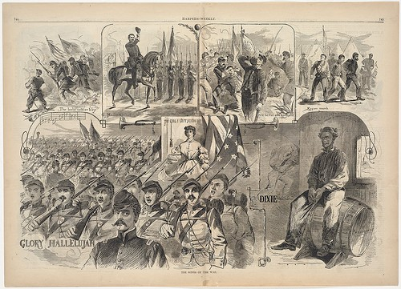

Torn in Two Cartoon

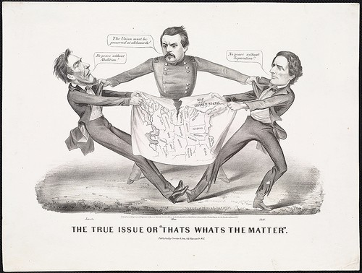

Union Soldiers following the Battle of Gettysburg

