THE SLAVE ECONOMY
At its core, slavery was an economic system. Closer inspection reveals it to be one of enormous inequity, with a surprisingly small percentage of Southerners owning the majority of slaves and controlling affairs well beyond their numbers.

Procedure

- Show students the picture of the Slaves on Hilton Island. Have them complete Part I of the Student Sheet and discuss their results.
- Discuss the nature of the geography and climate of the South using the maps in the Materials Section, noting that the farming was very labor intensive. It required a lot of people. Show students the Southern Crop Map and have them complete Part II of the Student Sheet
- Discuss their results. Based on the location of the crops, where might they expect to find the most slaves? Now look at the information on the Slave Data Chart. Is this where the most slaves are? Explain that you might need more information to answer this question and show the students the Slave Distribution Map. This is a complex map. Ask the students what they notice. What do they think the areas of dark and light might be showing? Why would it be important to show these differences visually?
- You may complete Part III of the Student Sheet as a class or in small groups. Discuss their results, emphasizing the uneven distribution of slaves throughout the South.
- To make this point further, show them the Slave Owners Chart and have them complete the questions in Part IV. Again, you might want to do this as a class, exploring the concept of majority rules and question how the minority, i.e. the slave holders, might have had so much influence.

Time Allocation:

Part I: 10 minutes
Part II 10 minutes
Part III: 20 Minutes
Part IV: 10 minutes

Materials Needed

Antebellum Crop Map
Slave Ownership Chart
Slave Data Chart
Slave Distribution Map
Photograph of Slaves Picking Cotton on Hilton Head

Assessment Criteria

Did students learn about the geographic elements of the Slave South?
Did students learn about the diversity of the slave economy?
Did students learn about the diversity of slave distribution and ownership?
Enrichment Activities

- Look at the Slave Data Chart. Have Students create Pie Charts or Bar Graphs to present this information in a graphic form.
- Have the Students Use the materials in this lesson to make a case for the Abolition of Slavery.
- Have Students look at the Map of Lowell., http://maps.bpl.org/details_11051/?srch_query=lowell&srch_fields=all&srch_style=exact&srch_fa=save.
How were the factories in this town connected to the farmlands in the South?

Common Core Curriculum Standards
Mathematics: Measurement and Data: Grades K-4
Represent and Interpret Data

English Language Arts: Reading: Informational Text: Grades 3-4
RI.3.7. Use information gained from illustrations (e.g., maps, photographs) and the words in a text to demonstrate understanding of the text (e.g., where, when, why, and how key events occur).
RI.3.9. Compare and contrast the most important points and key details presented in two texts on the same topic.
RI.4.7. Interpret information presented visually, orally, or quantitatively (e.g., in charts, graphs, diagrams, time lines, animations, or interactive elements on Web pages) and explain how the information contributes to an understanding of the text in which it appears.

English Language Arts: Reading: Integration of Ideas and Information, Grades 2-4

Integration of Knowledge and Ideas
7. Integrate and evaluate content presented in diverse media and formats, including visually and quantitatively, as well as in words.

National Geography Standards
Standard 1: How to Use Maps and Other Geographic Representations, Tools, and Technologies to Acquire, Process, and Report Information From a Spatial Perspective
Standard 17: How to Apply Geography to Interpret the Past

Slaves worked on farms in the South for years. They were forced to work long hours and had few choices in their day-to-day lives.

Part I
Look at the photograph your teacher shows you and answer the following questions:
- Describe the people in the picture. List all of the details you see.

- Select one of the people and imagine what he or she might be thinking.

- In those days, it took a long time to take a picture. What directions might the photographer have given the people in the picture?

- Pictures capture a single moment. What might the people in the photograph have been doing 5 minutes before the picture was taken? 5 minutes after?

Part II
Using the crop map your teacher gives you, please answer the following questions:
1. What crops are grown in the Southern States?

2. Why do you think the same crops are not grown everywhere?

3. Slaves worked on farms that grew cotton, rice, sugar, and tobacco. Do you think slaves worked on farms that grew other things too?

Part III
Use the Map your teacher has given you and answer the following questions:
1. What is the title and date of this map?

2. Find the “Scale of Shade.” What information does this give you?

3. Where are the darkest areas on the map? Why do you think the most slaves lived in those places?

4. How did the mapmaker get the information for this map? Using the box in the bottom center portion, to answer the following questions:
- What is a census?
- What year was the census taken?
- How many states’ populations are listed here?
- What information is included?

5. Look at the Key. Was slavery important everywhere in the South?

6. Find the Mississippi River on the map. Are the areas around it dark or light? Why do you think it was this way? Why were rivers important in the South at this time? Why was the Mississippi River important?

7.This map was sold for a special reason? Can you find this reason on the map?

Part IV
Look at the Slave Owner Chart and answer the following questions:
- There were a total of 6, 184, 477 white people who lived in the South in Slave States in 1850 and about 3 million slaves. Of those, how many owned slaves?

- Were slave owners the MAJORITY or the MINORITY in the South?

- Why do you think the slave owners had so much influence?
Antebellum Crop Map

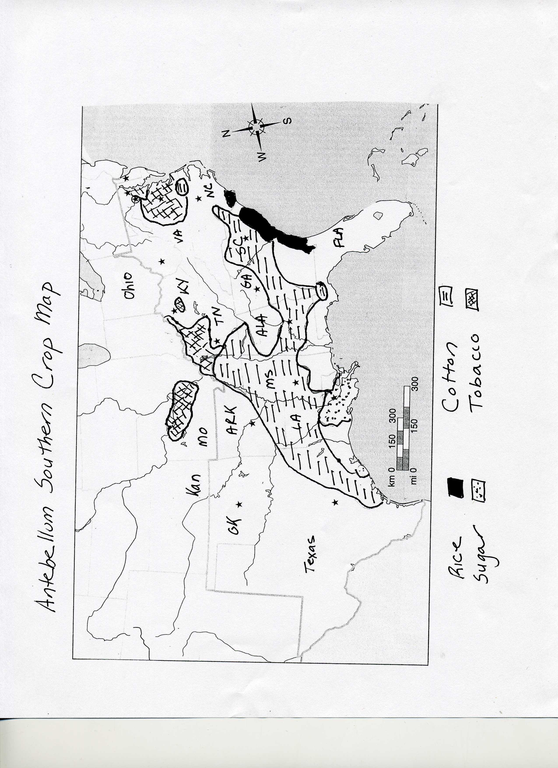
Slave Data Chart (based on 1850 Census Data)

slave states | population | slaves | slave  holders | free  blacks | slaves as% of population
Delaware | 91 532 | 2290 | 809 |  | 2.5
Maryland | 583034 | 90368 | 16040 |  | 15.5
Virginia | 1421661 | 472528 | 55063 |  | 33
North Carolina | 869039 | 288548 | 28302 |  | 33
South Carolina | 668507 | 384984 | 25596 |  | 57.6
Georgia | 906165 | 381682 | 38456 |  | 42
Florida | 87445 | 39310 | 3520 |  | 45
Alabama | 771623 | 342844 | 29295 |  | 44.4
Mississippi | 606526 | 309878 | 23116 |  | 51
Louisiana | 517762 | 244809 | 20670 |  | 47
Texas | 212592 | 58161 | 7747 |  | 27.3
Arkansas | 209897 | 47100 | 5997 |  | 22.4
Tennessee | 1002717 | 239459 | 33864 |  | 23.9
Kentucky | 982405 | 210981` | 38385 |  | 21.5
Missouri | 682044 | 87422 | 19185 |  | 12.8

Slave Owner Chart (based on 1850 census data)

Number of Slaves Owned Number of Slave Owners

  - 68,820

between 1-5 105, 683

between 5-10 80, 765

between 10-20 54,595

between 20-50 29,733

between 50-100 6,196

between 100-200 1479

between 200-300 187

between 300-500 56

between 500-1000 9

more than 1000 2

Slave Distribution Map

To look at this map more closely, you may want to go on line to http://maps.bpl.org/details_14001/?dl_pp=1&srch_query=1861&srch_fields=all&srch_style=exact&srch_fa=save

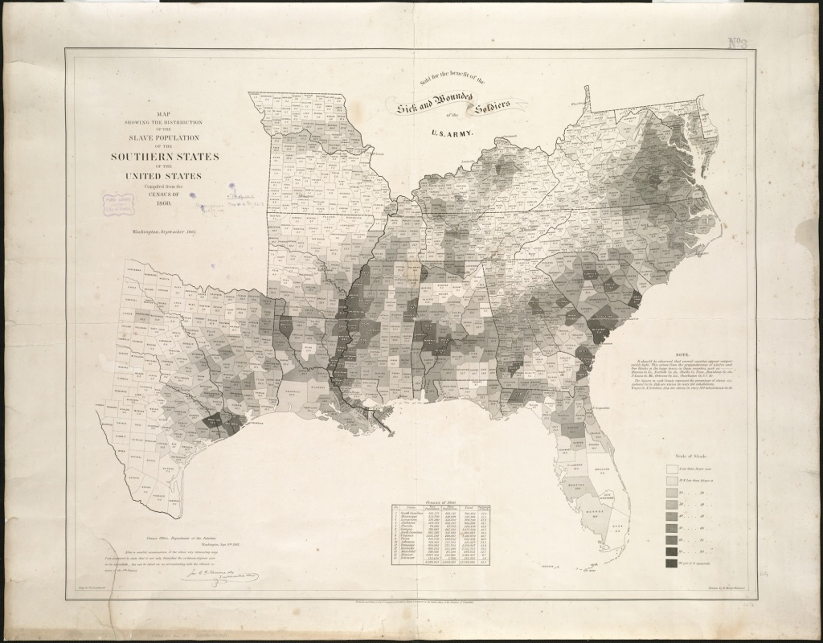

Slaves Picking Cotton

