LESSON 5: What Does it Mean To Vote?

Location: US Time Period: 1789-Present Grades: 4-8

Essential Question: How has the right to vote evolved over the course of the nation’s history?

Objectives:
Students will learn when different groups in America got the vote.
Students will consider what voting is and the impact of their votes.
Students will learn which Amendments gave different groups the right to vote.
Students will explore obstacles that existed despite the promises of voting.
Students will understand property qualifications as a criterion for voting.

Curriculum Standards:
Common Core
Grade 5: English/Language Arts

Range of Reading and Level of Text Complexity
RI.5.10.
By the end of year, read and comprehend informational texts, including history/social studies, science, and technical texts, in the grades 4–5 text complexity band proficiently, with scaffolding as needed at the high end of the range.

Grades 6-8: English/Language Arts; History/Social Studies
Key Ideas and Details
RH.6-8.2. Determine the central ideas or information of a primary or secondary source; provide an accurate summary of the source distinct from prior knowledge or opinions.
Integration of Knowledge and Ideas
RH.6-8.7. Integrate visual information (e.g., in charts, graphs, photographs, videos, or maps) with other information in print and digital texts.

National Geography Standards
Standard 1: How to Use Maps and Other Geographic Representations, Tools, and Technologies to Acquire, Process, and Report Information from a Spatial Perspective
Standard 3: How to Analyze the Spatial Organization of People, Places, and Environments on Earth’s Surface
Standard 17: How to Apply Geography to Interpret the Past

Massachusetts Curriculum Frameworks
Grade 5
US History, Geography, Economics and Government
Democratic Institutions and Ideas
Responsibilities and Powers associated with federal officials
The Principles and Institutions of American Constitutional Government

US History 1
History and Geography
Interpret Graphs, Charts and Maps
The Formation and Framework of American Democracy
Historical and Intellectual Origins of the US during the Constitutional Era
Basic Framework of American Democracy and Concepts of Government
Antebellum Expansion of Suffrage
Age of Jackson
Civil War and Reconstruction

LESSON 5 TEACHER SHEET, P. 1
Lesson Overview
Voting is both a right and a privilege in the United States. Who gets to vote has been one of the most important parts of our nation’s story. Originally, only white men who owned property were allowed to vote. The struggle to include everyone else has reflected the best and worst of our history.

Procedure
- Ask students what it means to vote. Prompt responses that include making choices, expressing an opinion. Have the Class complete Part I of the Student Sheet. You may have them do this individually or in small groups. Discuss their results. Extend the discussion to voting for a president and encourage them to see how voting is a way to influence their society.
- Write the words RIGHT and RESPONSIBILITY on the board. Ask the students to define each word. A RIGHT is something you want the freedom to do. A RESPONSIBILITY is something you must do. Help them to see that being a good member of a society means having certain privileges and obligations.
- Tell the class that even though Americans have been voting since 1789, not every one got to vote. Ask them what might have prevented some people from voting.
- Give the class the Voting Amendment Sheet. You may choose to read it together as a class or allow students to read it independently or in small groups. Also give them the Voting Rights Cartoon. Then have students complete Part I of the Student Sheet. Discuss their results.
- Explain what property is. When the Constitution was first written, only people with property were allowed to vote. Ask the students why that might have been the case. Look for answers that focus on being able to trust who was voting, being afraid of how some people might vote. Show the students the following 3 maps:
Property Qualifications for Suffrage, 1775
Property Qualifications for Suffrage, 1800
Property Qualifications for Suffrage, 1830
Explain that Suffrage means voting. Have them complete Part II of the Student Sheet independently or in small groups. Discuss their results.

Time Allocation: Part I: 10-15 minutes Part II: 10-15 minutes Part III: 10-15 minutes

Materials Needed:

Property Qualifications for Suffrage Map, 1775
Property Qualifications for Suffrage Map, 1800
Property Qualifications for Suffrage Map, 1830
Voting Amendment Sheet
Voting Access Cartoon

LESSON 5 TEACHER SHEET, P. 2
Assessment Criteria:
Did the students explore what voting is and the impact of their votes?
Did the students learn when different groups in America got the vote?
Did the students learn which Amendments gave different groups the right to vote?
Did the students explore obstacles that existed despite the rules?
Did the students understand property qualifications as a criterion for voting?

Enrichment Activities:

- States determine voter eligibility. Have the students see what the requirements are in their state to vote. Voter eligibility is usually under the state Secretary of State. This information is on the state’s website. You may also find the information here:
http://www.cnn.com/2016/08/14/politics/how-to-register-to-vote-in-every-us-state-and-territory/index.html

- Look at the dates of the four Amendments on the Voting Amendment Sheet. What else was happening in the United States before each of these was passed? How did their passage reflect broader issues of the time period?

LESSON 5 STUDENT SHEET, P. 1
Voting is about making choices. Americans have been voting in presidential elections since 1789. But everyone has not always been allowed to vote. The United States Constitution contains few specifics about How we are to exercise this right and responsibility so essential to our form of government.

Part I: What Is Voting?
WHAT IS IT?
- When do you get to make choices in your life?
- How is making a choice when you are part of a group different from choices you make as an individual? How are they the same?
- Think about choices you make when you are part of a group. Is it always best for everyone to have an equal say? When might it best for just one person to make a choice for a group? When is it important to have everyone involved in the decision?
- How does casting a vote for the President like other choices you make? How is it different?

AND ONCE THE VOTE IS CAST???
A group has held a vote. For which of the following, must you go along with the group’s decision?
1. Three friends decide to order a pizza. Two want sausage. Does the third who ‘voted’ for mushrooms
- Have to eat the pizza?
- Have to pay for the pizza?
Would your answer change if you learned that the third person doesn’t eat meat because she doesn’t like it? How about if her religion forbade her from eating pork?

2. Your town has a school tax increase of 3%. Do you have to pay the School Tax if
You don’t have children who attend the town’s schools?
Your children attend a private school?

3. The US Congress declares war on Mexico and decides that everyone who is 19 may be drafted into the army.
Do I have to pay taxes for a war I don’t believe in?
Do I have to fight in a war I don’t believe in?

4. The State Board of Health mandates that all children receive a vaccine against disease X. Proof of vaccination is required for school attendance. Do I have to get my child vaccinated?

5. There are two states next to one another, State A and State B. State A has voted in very strong regulations about air, water, and land pollution. All factories in the state have to follow the laws which include, for many, expensive repairs to their factories. State B prefers to have no regulations other than what the Federal government mandates and many factory owners know it will cost them less money to pay the federal fines than update their factories.

You live in State A, on the border of State B. High levels of lead are found in the soil in your town. Is there anything you can do?
You are a factory owner in State A, on the border of State B. Would you update your factory?

LESSON 5 STUDENT SHEET, P. 2
Part II: Voting in America
In 1789, the Constitution became the rule book for America. Changes to the Constitution are made by Amendments. Read the Voting Amendment Sheet and answer the following questions

- Which four groups needed specific Amendments to help them get the vote?

- The language in all four Amendments says that you can’t stop someone from voting because of their race, gender, age or ability to pay a tax. Might there be some other way to stop someone from voting even with these new rules in place?

- All four Amendments have a second part. What do they say? Why you think Congress is mentioned in all four?

- Why is the right to vote placed in the Constitution? Why wasn’t it enough just for Congress to pass a law?

- Look at the Voting Rights Cartoon. What does the White person have to do to vote? What obstacles are in the way for the Black man to vote? How does each obstacle work against the promises of the 15th Amendment?

LESSON 5 STUDENT SHEET, P. 3
Part III

Look at the three property qualification maps and election map that your teacher gives you and answer the following questions:

- What do the yellow states represent? The blue states? The green states?

- A ‘T’ on a state means that there is an alternative (or different) way to vote, even if you do not own property. Will that allow more people to vote? Will it allow all people to vote?

- Do the voting rules seem fair to you? Why or why not?

Voting Amendment Sheet
Amendment 15 Ratified February 3, 1870.
- The right of citizens of the United States to vote shall not be denied or abridged by the United States or by any State on account of race, color, or previous condition of servitude.

- The Congress shall have power to enforce this article by appropriate legislation.

Amendment 19 Ratified August 18, 1920.
The right of citizens of the United States to vote shall not be denied or abridged by the United States or by any State on account of sex.
Congress shall have power to enforce this article by appropriate legislation.

Amendment 24 Ratified January 23, 1964.
- The right of citizens of the United States to vote in any primary or other election for President or Vice President, for electors for President or Vice President, or for Senator or Representative in Congress, shall not be denied or abridged by the United States or any State by reason of failure to pay any poll tax or other tax.

- The Congress shall have power to enforce this article by appropriate legislation.

Amendment 26 Ratified July 1, 1971.

- The right of citizens of the United States, who are eighteen years of age or older, to vote shall not be denied or abridged by the United States or by any State on account of age.

- The Congress shall have power to enforce this article by appropriate legislation.
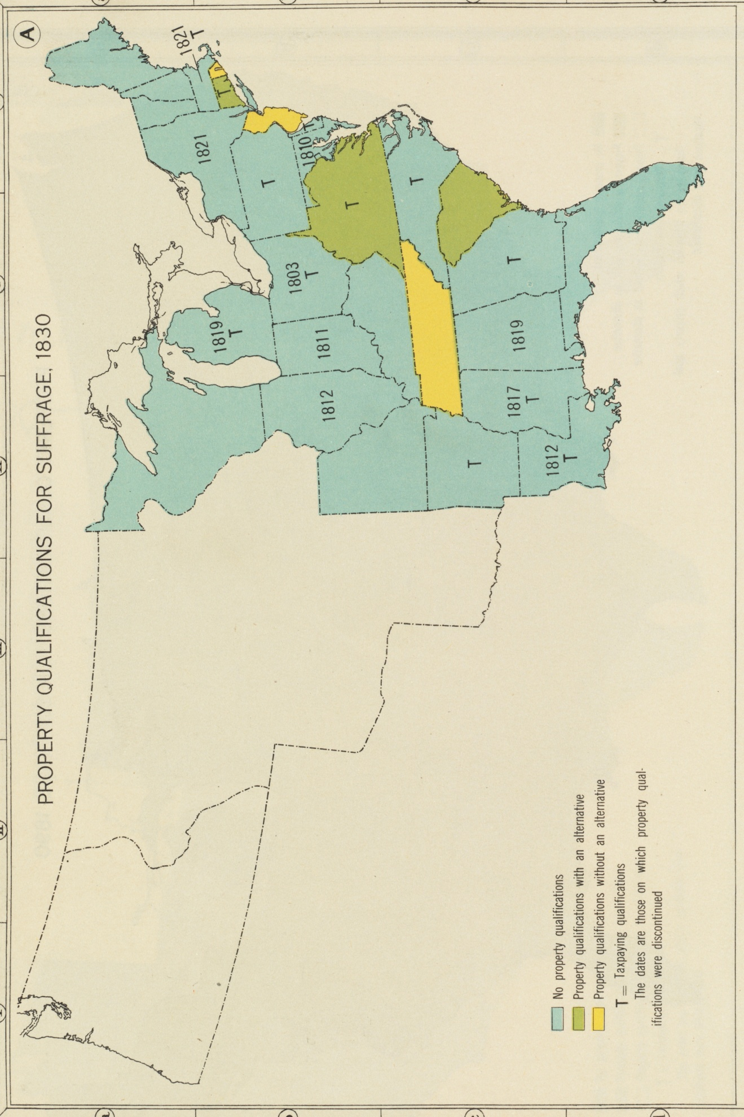
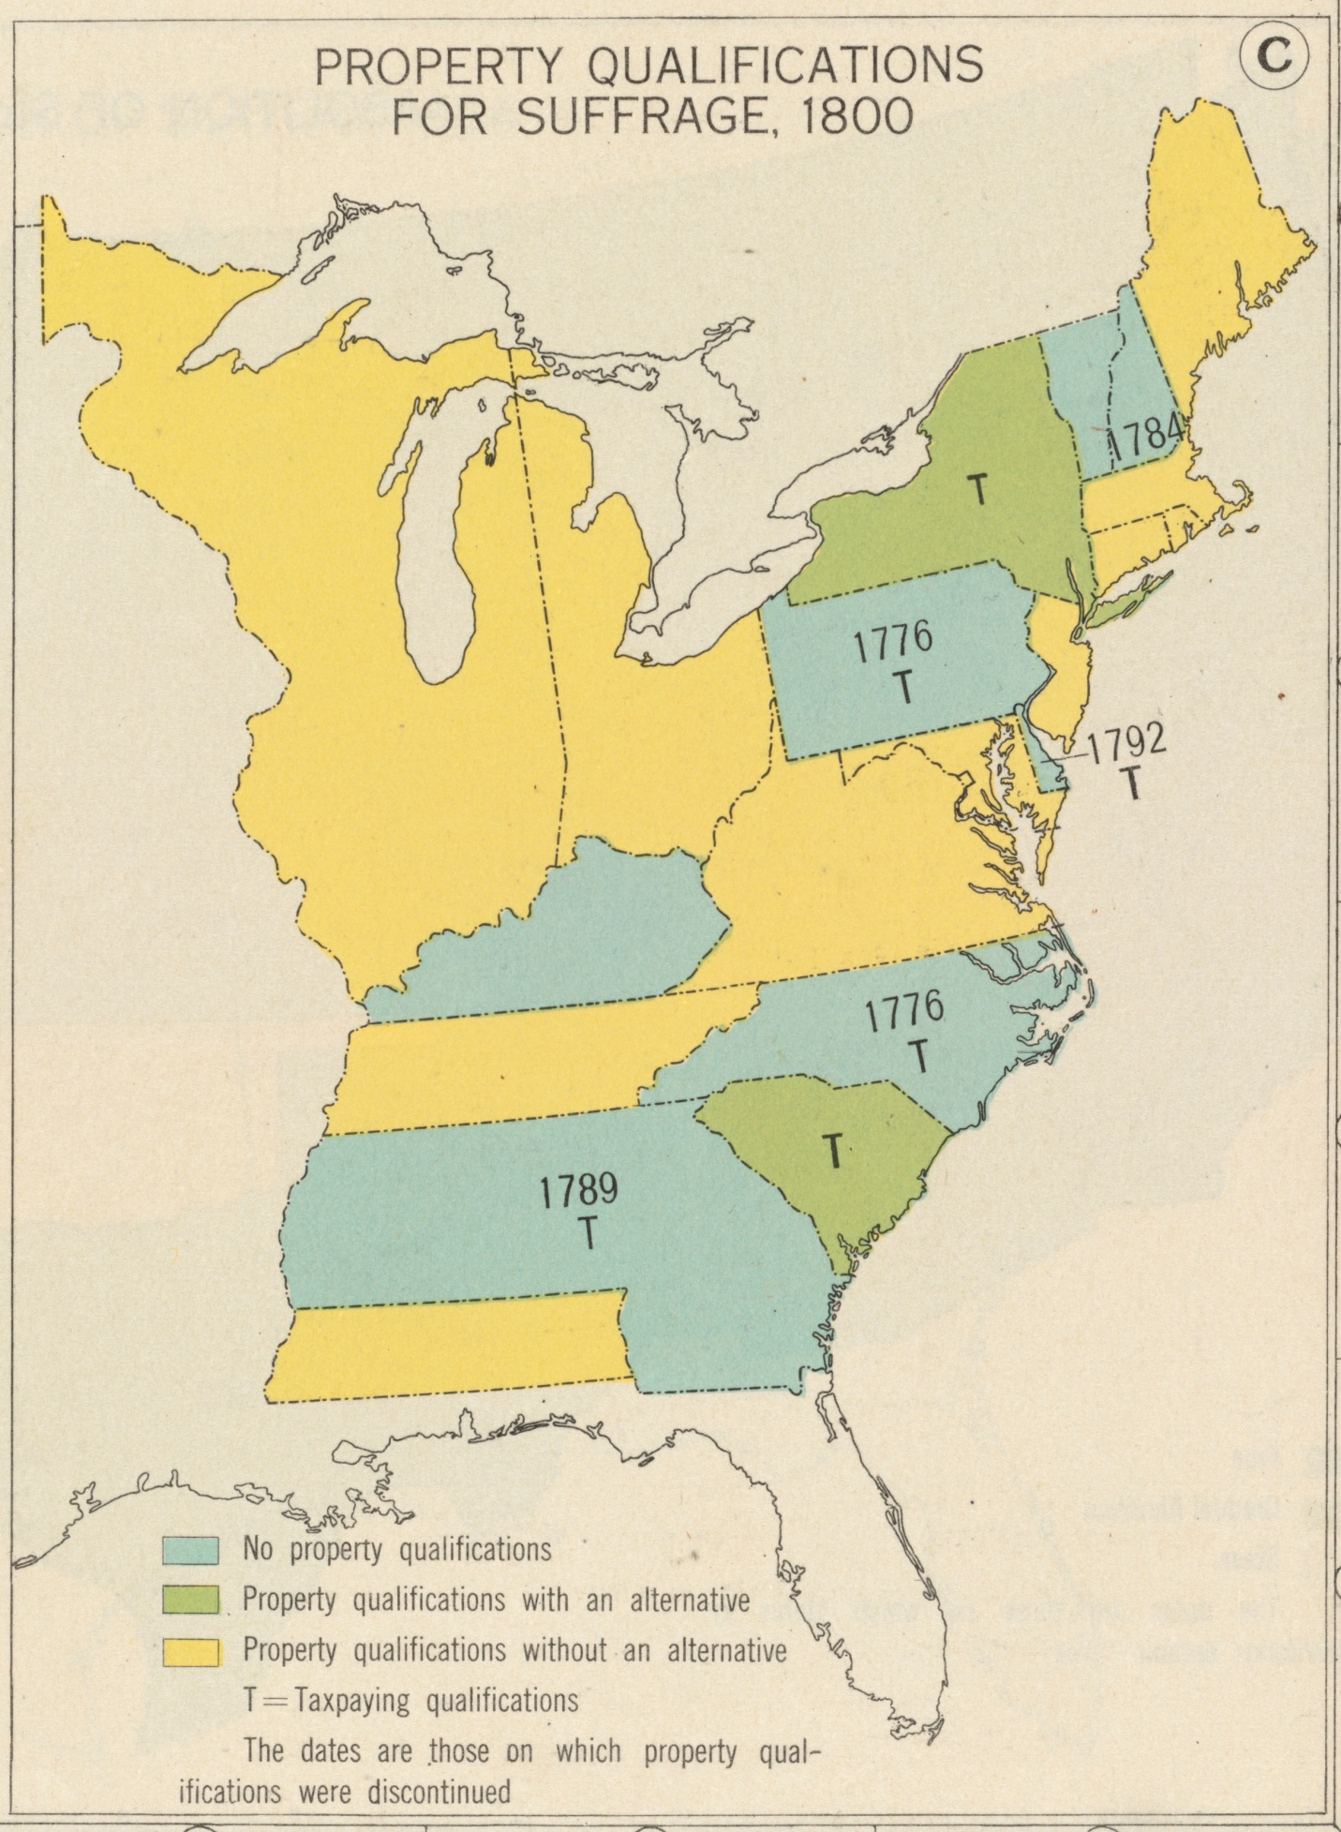
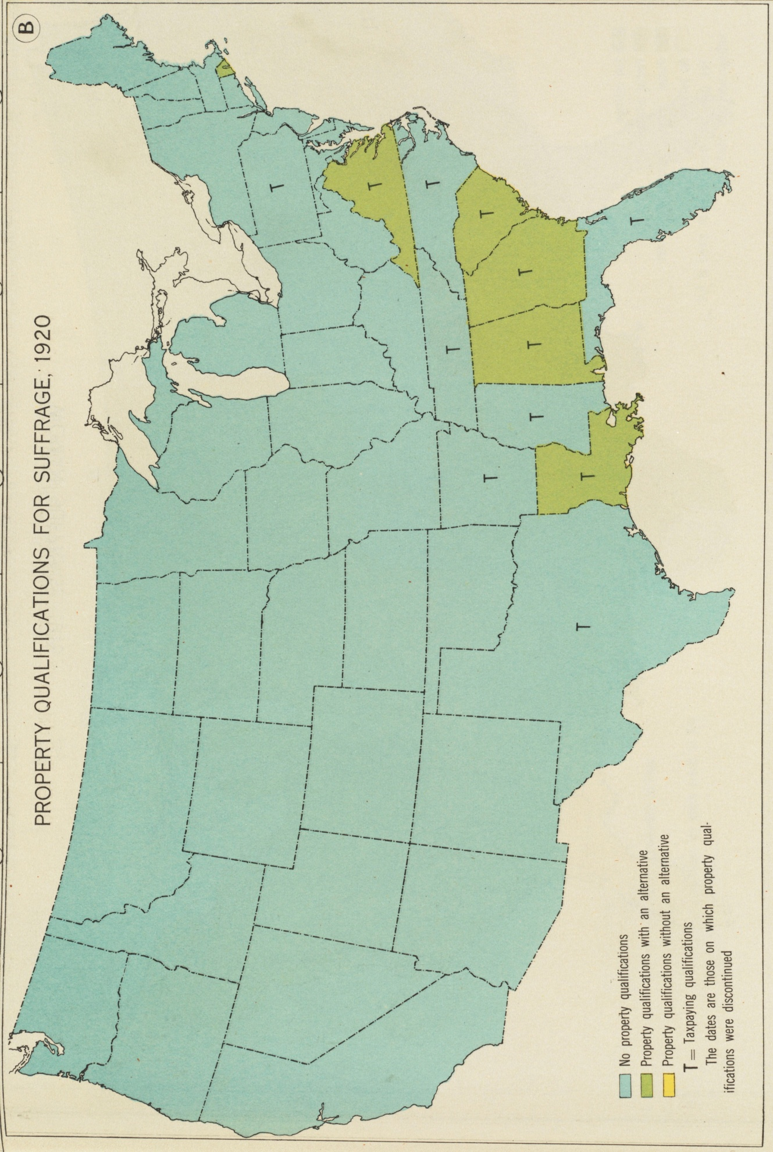

Voting Access Cartoon

