Lesson 9: the Math of Partisanship High School

Location: US Date: 1789-Present Grades 8-12

Essential Question: Are all votes equal? What is the math of political partisanship?

Objectives:
Students will learn about the role of the Census and political representation
Students will explore the historic influence of states based on their electoral weight
Students will compare the relative weight of a state’s vote in the contemporary landscape
Students will become acquainted with terms like gerrymandering and packing electoral districts and their impact on political stalemate

Curriculum Standards:
COMMON CORE
ELA
English and Language Arts, Grades 11 and 12, Integration of Knowledge and Ideas
RI.11-12.9. Analyze seventeenth-, eighteenth-, and nineteenth-century foundational U.S. documents of historical and literary significance (including The Declaration of Independence, the Preamble to the Constitution, the Bill of Rights, and Lincoln’s Second Inaugural Address) for their themes, purposes, and rhetorical features.

English/Language Arts; History/Social Studies, Grades 9-12
Key Ideas and Details
RH.9-12.7. Integrate and evaluate multiple sources of information presented in diverse formats and media (e.g., visually, quantitatively, as well as in words) in order to address a question or solve a problem.

MATH
Math Practices
2. Reason abstractly and quantitatively
- Model with mathematics

Reason quantitatively and use units to solve problems, HS.
CCSS.MATH.CONTENT.HSN.Q.A.1
Use units as a way to understand problems and to guide the solution of multi-step problems; choose and interpret units consistently in formulas; choose and interpret the scale and the origin in graphs and data displays.

MASSACHUSETTS CURRICULUM FRAMEWORKS
US History 1: The Revolution through Reconstruction, 1763-1877
The Formation and Framework of American Democracy
Political Democratization, 1800-1860
Civil War and Reconstruction
US History 2: Reconstruction to the Present, 1877-Present
The Age of Reform, 1900-1940
Cold War America at Home, 1945-1980
Contemporary America, 1980-Present
American Government Elective
LESSON 9 TEACHER SHEET, P. 1
Lesson Overview
We like to think of voting as a straight forward process—one person, one vote. But the actuality is quite different thanks to the structure of the Electoral College, limits on the total number of representatives and Congressional districts that have been gerrymandered, packed, and fracked. The activities in this lesson allow you to explore these issues with your students and question the fairness of our electoral system and perhaps, suggest something more equitable.

Procedure:
- Begin with the census. See what students know about both what it is and why we take a count of the people every 10 years. What do they think happens in terms of how we vote? Have them complete Part I of the Student Sheet.
- Now show them the map that identifies the results of the 2010 Census and complete Part II of the Student Sheet. The idea that for one state to gain another must lose (even with population increases) is hard to digest given our sensibilities about fairness.
To see the historic impact on one state, complete Part III of the Student Sheet.
- Explain that once a state gains or loses electoral districts, they have to redraw the boundaries WITHIN their state. Begin Part IV with your students. It might work best to do this portion as a whole class. Explore questions of how states add and subtract districts, and why Congressional lines are drawn as they are.
- Part V allows you to explore questions of equity with your students. What does fairness mean when it comes to electing those who will represent us? How does it affect our ability to address our problems?

Time Allocation:
Part I: 10-15 minutes Part II: 10-15 minutes
Part III: 10-15 minutes Part IV: 15-20 minutes

Materials Needed:
All materials are included on the student sheet although they will need to access http://www.270towin.com/states/
Specific portions of the site are identified in the lesson

Assessment Criteria:
Did students learn about the role of the Census and political representation?
Did students explore the historic influence of states based on their electoral weight?
Did students will compare the relative weight of a state’s vote in the contemporary landscape?
Did students will become acquainted with the practice of gerrymandering and packing electoral districts?

Enrichment Opportunities:
Explore Gerrymandering—look at the 10 worst cases currently in the US:
https://www.buzzfeed.com/qsahmed/the-10-most-gerrymandered-districts-in-america-dh45?utm_term=.mwP8RGorW#.npRAjvzwJ
Is this the approach of just one party?

LESSON 9 STUDENT SHEET, P. 1

PART I: THE CENSUS
Article I, Section 2, US Constitution:
Representatives and direct Taxes shall be apportioned among the several States which may be included within this Union, according to their respective Numbers, which shall be determined by adding to the whole Number of free Persons, including those bound to Service for a Term of Years, and excluding Indians not taxed, three fifths of all other Persons. (Note: changed by section 2 of the Fourteenth Amendment.) The actual Enumeration shall be made within three Years after the first Meeting of the Congress of the United States, and within every subsequent Term of ten Years, in such Manner as they shall by Law direct. The Number of Representatives shall not exceed one for every thirty Thousand, but each State shall have at Least one Representative

- Why do we count the people in this country?
- How many representatives is each state guaranteed?
- Why do you think the framers created this system of representation?
- Below is a chart based on the most recent census.
- What information does it provide?
- What do the first 31 states on the list have in common?
- Where would you rather vote for President—Wyoming or California? Why?
- Does our current system of electoral votes represent a democratic process? Justify your response using the data in the chart below.

STATE PERCENT OF ELECTORAL AND POPULAR VOTE CHART

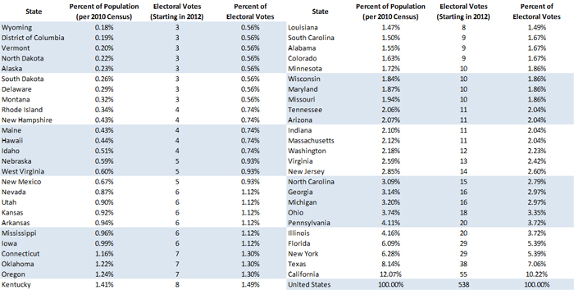

LESSON 9 STUDENT SHEET, P. 2

II: What Happened in 2010?

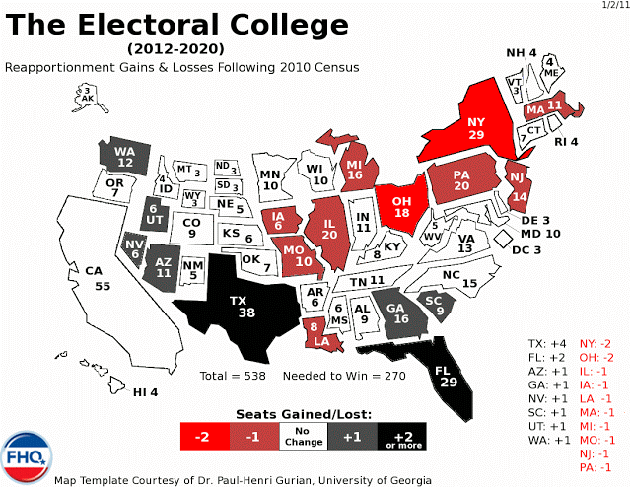

- Which states were the big winners? Losers?
- Why do you think the numbers changed, i.e. why did some states gain and others lose?

LESSON 9 STUDENT SHEET, P. 3

Part III: One State, Over Time
Now look at the following graph:

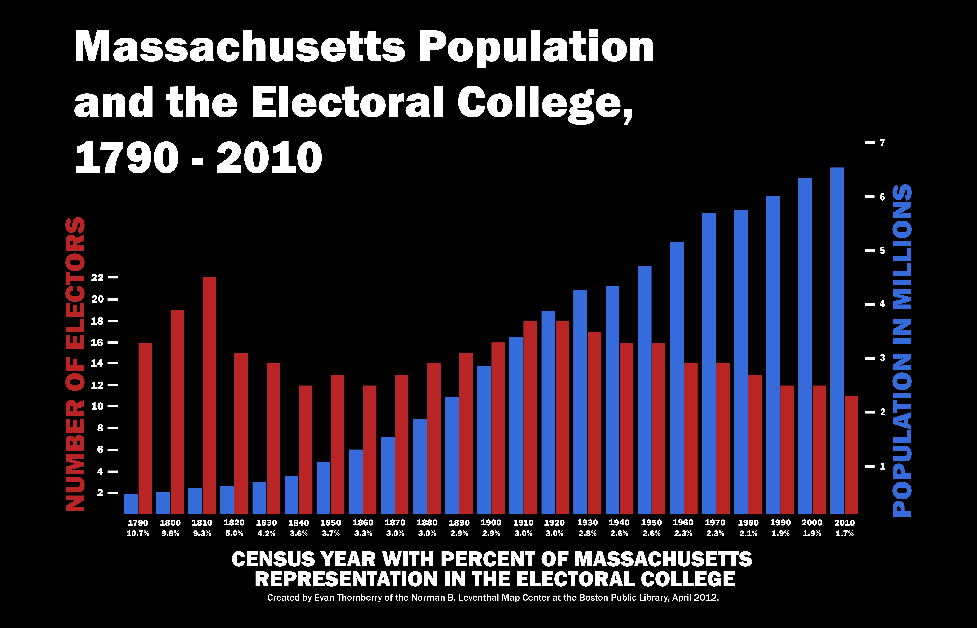

- What do the Red Lines show? The Blue?
- How is it possible that the Blue lines have risen while the Red lines have shortened?
- What has happened to Massachusetts’ political power over time?
- To compare the history of voting in Massachusetts with that of another state, go to
http://www.270towin.com/states/

LESSON 9 STUDENT SHEET, P. 4

Part IV: Within the States
- What does this image remind you of?
- What features dominate the ‘creature’?
- As you look at it more closely, what words are also on this picture?

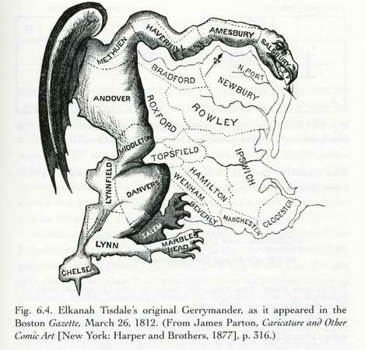

- Look at the current cartoon and map from Texas (on the next page). What is the cartoonist’s point about the current redistricting process in Texas?
- What conclusions can you draw about the history of redistricting from these two cartoons? Do you think it is a fair assessment?

LESSON 9 STUDENT SHEET, P.5
TEXAS REDISTRICTS

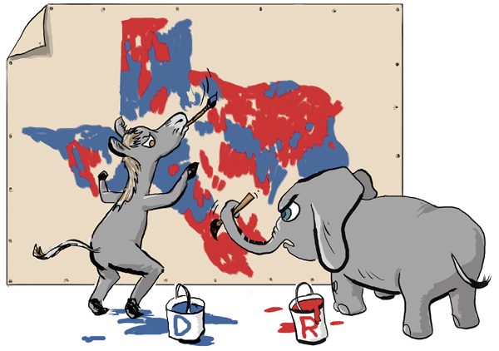

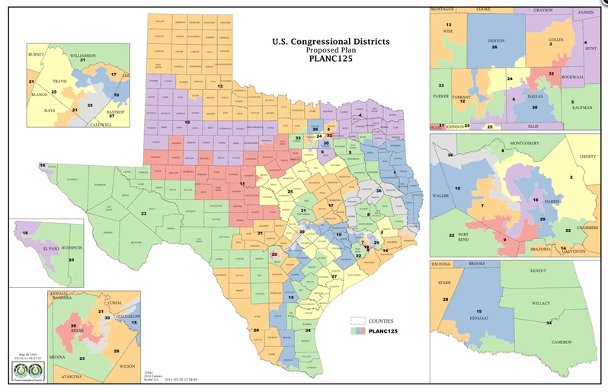
LESSON 9 STUDENT SHEET, P.6
Part V: Is It Fair??
Consider the case of Pennsylvania, http://www.270towin.com/states/Pennsylvania
- How has Pennsylvania Voted in the last 3 presidential elections? By how many percentage points did the candidate carry the state?
- Based on that data alone, what would expect the Congressional delegation (18 to the House of Representatives and 2 the Senate) from the state to look like?
- Now look at the state’s current representatives: http://www.270towin.com/elected-officials/pennsylvania
What might explain the discrepancy?

Now look at Rhode Island: http://www.270towin.com/states/Rhode_Island
- How has it voted in the last 3 presidential elections? By what percent did the candidate carry the state??
- Look at the state’s current representatives: http://www.270towin.com/elected-officials/rhode-island
- Is everyone in the state being fairly represented in Congress?

Consider the following problem: What’s the Scoop?
The Ninth Grade at the Red, White, and Blue School needs to select 3 delegates to the National Ice Cream Convention. There are 100 students in the grade, divided into groups of 34, 33, and 33. Each group selects one delegate to attend the convention. Each student was given a choice of chocolate or vanilla ice cream. The grade wide vote was 66 for Chocolate Ice Cream, 34 for Vanilla. Somehow the Red, White and Blue 9th grade is sending two Vanilla representatives and one Chocolate representative to the National Ice Cream Convention in Burlington, VT this year.
How could this have happened?????

Group 1: Solve this problem using numbers. Be ready to SHOW the whole group your strategy.

Group 2: Solve this by using visuals--chart, graph, etc. Be ready to SHOW the whole group your strategy.

Group 3: Solve this problem using language. Be ready to show the whole group your strategy.
Group 4: Solve this problem using Hersheys kisses. Be ready to show your group your strategy.

- Is democracy being served in this election?
- Is it fair that the only two flavor choices are chocolate and vanilla?
- How might you ensure a more fair result?
- Imagine that all the representatives to the Ice Cream Convention come from districts like the ones described above. How much work do you think will get done at the convention? Why?
- How does the composition (make-up) of an electoral district affect the job its representative does?

PART VI: DO A BETTER JOB
Clearly our current system has all sorts of problems. DESIGN A BETTER ONE!!

