Amending the Constitution: What Really Changes?

Location: US Time: 1789-1935 Grades: 8-12

Essential Question: How effective a process is the Constitutional Amendment at generating the intended goals of change?

Objectives:
Students will explore the general process of amending the Constitution.
Students will explore three specific cases of paths of Constitutional Amendment:
Votes for Women
Votes for Blacks
Prohibition (and repeal)
Students will consider the effectiveness of the Amendment strategy to achieve articulated goals, including unintended consequences, particularly illegal activity.

Curriculum Standards:
COMMON CORE
English and Language Arts, Grades 11 and 12, Integration of Knowledge and Ideas
RI.11-12.8. Delineate and evaluate the reasoning in seminal U.S. texts, including the application of constitutional principles and use of legal reasoning (e.g., in U.S. Supreme Court majority opinions and dissents) and the premises, purposes, and arguments in works of public advocacy (e.g., The Federalist, presidential addresses)
RI.11-12.9. Analyze seventeenth-, eighteenth-, and nineteenth-century foundational U.S. documents of historical and literary significance (including The Declaration of Independence, the Preamble to the Constitution, the Bill of Rights, and Lincoln’s Second Inaugural Address) for their themes, purposes, and rhetorical features.

English/Language Arts; History/Social Studies, Grades 9-12
Key Ideas and Details
RH.9-10-11-12.2. Determine the central ideas or information of a primary or secondary source; provide an accurate summary of how key events or ideas develop over the course of the text.
Integration of Knowledge and Ideas
RH.9-12.7. Integrate and evaluate multiple sources of information presented in diverse formats and media (e.g., visually, quantitatively, as well as in words) in order to address a question or solve a problem.

MASSACHUSETTS CURRICULUM FRAMEWORKS
US History 1: The Revolution through Reconstruction, 1763-1877
The Formation and Framework of American Democracy
Political Democratization, 1800-1860
Civil War and Reconstruction
US History 2: Reconstruction to the Present, 1877-Present
The Age of Reform, 1900-1940
American Government Elective

What are the paths to political change? What choices are available and why have certain options been chosen for different causes? In this lesson to supplement a standard US History survey course, explore those instances when a Constitutional Amendment has been the method of choice. Often unwieldy, it was perceived as the most effective means available, in the case of two long standing goals: Votes for Women and the Prohibition of Alcohol. More importantly, did it accomplish changes intended??

Procedure:
1. The framers understood that the Constitution would need to be a document that could be changed to suit a growing nation but they also guaranteed that this process would be rigorous and respectful of the power of the people, as represented through the states. If necessary, review Article V of the Constitution (reproduced in Supporting Materials below) with the students to identify the exact steps. For more information on this process, please go to http://www.usconstitution.net/constam.html

2. There have been many paths to change in American history—laws, court cases, and actions of individuals to identify only a few. Only 17 times since the Constitution was ratified have we added new amendments to the original Bill of Rights (and one of those was to reverse a prior amendment!!). Have your students read the text of four of these amendments and have them complete Questions 1-3 on Part I of the Student Sheet. Discuss their results.

3. Can the intentions of a Constitutional Amendment be thwarted? To what extent might this reflect the history of the 15th Amendment, i.e. what forces led to its passage? Have them complete the rest of Part I of the Student Sheet. Discuss their results. For more information on the passage of the 15th Amendment, please go to: http://www.pbs.org/wgbh/americanexperience/features/general-article/grant-fifteenth/

4. In contrast, it took almost 80 years for women to get the vote but once they did, they generally were able to exercise this right if they so chose. Have students look at The Victory Map, Suffrage Cartoon, and Anti-Suffrage Pamphlet and complete Part II of the Student Sheet. For additional background information, you might want to direct your students to: http://www.socialwelfarehistory.com/eras/woman-suffrage-history/

5. Another Amendment that was decades in the making was the prohibition of alcohol. With roots in the 19th century Temperance Movement, enough states ratified the 18th Amendment to end the sale and consumption of alcohol. Not only did these efforts fail and lead to the only repeal of a constitutional Amendment, but also resulted in enormous criminal activity and expense at efforts to prevent these illegal enterprises. Have your students complete look at the Facts of the Prohibition Map and Make the Map All White Poster and complete Part III of the Student Sheet. The Facts of the Prohibition Map is quite detailed, so you might want to divide the class and have different groups summarize each section.
For more background information on all phases of this chapter in our nation’s story, please consult, http://prohibition.osu.edu/

6. General Wrap Up: Do Constitutional Amendments help or hinder progress?

Time Allocation:
Part I: 20 to 30 minutes
Part II: 15 to 20 minutes
Part III: 30-45 minutes

Materials Needed:
Article V, US Constitution, reproduced in Supplementary Materials
Amendments 15, 18, 19 and 21, US Constitution, reproduced in Supplementary Materials
Make the Map White, reproduced below and at:
http://www.encyclopediavirginia.org/media_player?mets_filename=evm00000997mets.xml
The Facts of Prohibition Map, reproduced below and also located at: http://maps.bpl.org/id/15523
Victory Map, reproduced below and also located at http://maps.bpl.org/id/15286
Woman’s Suffrage Cartoon, reproduced below and at:
http://content.lib.washington.edu/exhibits/suffrage/
[click on tab five]
Pamphlet Opposed to Women’s Suffrage, reproduced below and also located at: http://jwa.org/teach/primarysources/orgrec_08_detail.html
Results of the Fifteenth Amendment, reproduced below and also located at: http://maps.bpl.org/id/15182
Voting Access Cartoon, reproduced below

Assessment Criteria:
Did students explore the general process of amending the Constitution?
Did students explore three specific cases of paths of Constitutional Amendment?
Votes for Women
Votes for Blacks
Prohibition (and repeal)
Did students consider the effectiveness of the Amendment strategy to achieve articulated goals, including unintended consequences, particularly illegal activity?

Enrichment Opportunities:
- Explore failed efforts to amend the constitution, such as the Equal Rights Amendment—why did this fail? For an overview, you may want to begin here, http://www.equalrightsamendment.org/default.htm
- What current issues are being considered for a Constitutional Amendment? Have students research the path and progress of some contemporary topics, e.g.
Making English the National Language. For an overview, please consult http://www.usconstitution.net/consttop_lang.html
- Have Students select one of the organizations listed on the Facts of the Prohibition Map and research its role in the Temperance Movement.

There are many paths to change in our nation’s past. When the framers wrote the Constitution, they understood that the country’s rulebook would need to be updated but they also knew that it would be unwise to make this process too simple. In this lesson, you will look at some examples of Constitutional changes.

Part I

Read the text of the four Amendments and answer the first three questions:
1. Look at the language—what actual changes are made? What is guaranteed?
2. By what mechanisms are these changes to be implemented?
3. Each amendment lists a date proposed and ratified. What happens between those two dates?
The remaining questions are about the 15th Amendment only:
4. Consider the extension of the franchise as outlined in the 15th Amendment. What specifically is promised??
5. Look also the Results of the Fifteenth Amendment lithograph. How does it capture the hope of the period immediately following the Civil War?
6. Now look at the Voting Access cartoon. What proved to be the reality for voting?
Rights for blacks for the first century after the passage of the 15th Amendment?

Part II

Look at the Victory Map
1. What is the range of dates in which states gave women the vote? Why do you think it took so long for women to get the vote?
2. Look at the key at the bottom. How many different ‘types’ of suffrage were there? Why do you think these distinctions mattered at the time?
3. How many states had no suffrage at all? What is their geographic concentration?
4. Read the anti-suffrage pamphlet—what were some of the arguments against giving women the vote? How can this help you answer Question #1?
5. Look at the cartoon—how was giving women the vote a sign of optimism?
6. Describe the poster on the wall. What is the central image? What name and date are included? Why do you think the cartoonist felt these were important to his message?

Part III

Look at Make the Map White
- How is the argument one of numbers as well as an appeal to the emotions?
- Which section(s) of the country seem to provide the strongest support for the cause?
- Are there any exceptions within those regions? Locate them. Why do you think those places resisted prohibition?

Look at The Facts of Prohibition map
- What do you think the cartographer wrote Information not Propaganda across the top of the map?
- Whose pictures are placed in the corners? Why do you think they were chosen?
- Prohibition led to a great deal of illegal activity. Look at both the Export from Canada Chart (top right) and Activities of the Government (Department of Treasury, Justice and Agents Killed) Charts (center bottom). What were the real costs of Prohibition?
- The cartographer also includes two treaties—one with Canada and one with Great Britain. Why did Prohibition make these agreements necessary?
- Use the Legend to identify all of the ways that a state might have prohibited alcohol, e.g. was it due to a popular vote or an act of a state legislature? Did your state prohibit alcohol? If so, by what means?
- Look at the chronology on the left side of the map. Why do you think it took so long for accomplish the goal of Prohibition? Why was it so unsuccessful?
- The intention of this map was to show the virtue of Prohibition. How does it actually convey its many weaknesses?

Amendment 15
1. The right of citizens of the United States to vote shall not be denied or abridged by the United States or by any State on account of race, color, or previous condition of servitude.
2. The Congress shall have power to enforce this article by appropriate legislation.
Proposed 2/26/1869
Ratified 2/3/1870

Amendment 18
1. After one year from the ratification of this article the manufacture, sale, or transportation of intoxicating liquors within, the importation thereof into, or the exportation thereof from the United States and all territory subject to the jurisdiction thereof for beverage purposes is hereby prohibited.
2. The Congress and the several States shall have concurrent power to enforce this article by appropriate legislation.
3. This article shall be inoperative unless it shall have been ratified as an amendment to the Constitution by the legislatures of the several States, as provided in the Constitution, within seven years from the date of the submission hereof to the States by the Congress.
Proposed 12/18/1917
Ratified 1/16/1919

Amendment 19
The right of citizens of the United States to vote shall not be denied or abridged by the United States or by any State on account of sex.
Congress shall have power to enforce this article by appropriate legislation.
Proposed 6/4/1919
Ratified 8/18/1920

Amendment 21
1. The eighteenth article of amendment to the Constitution of the United States is hereby repealed.
2. The transportation or importation into any State, Territory, or possession of the United States for delivery or use therein of intoxicating liquors, in violation of the laws thereof, is hereby prohibited.
3. The article shall be inoperative unless it shall have been ratified as an amendment to the Constitution by conventions in the several States, as provided in the Constitution, within seven years from the date of the submission hereof to the States by the Congress.
Notes for this amendment:
Proposed 2/20/1933
Ratified 12/5/1933

ARTICLE V
The Congress, whenever two thirds of both Houses shall deem it necessary, shall propose Amendments to this Constitution, or, on the Application of the Legislatures of two thirds of the several States, shall call a Convention for proposing Amendments, which, in either Case, shall be valid to all Intents and Purposes, as part of this Constitution, when ratified by the Legislatures of three fourths of the several States, or by Conventions in three fourths thereof, as the one or the other Mode of Ratification may be proposed by the Congress; Provided that no Amendment which may be made prior to the Year One thousand eight hundred and eight shall in any Manner affect the first and fourth Clauses in the Ninth Section of the first Article; and that no State, without its Consent, shall be deprived of its equal Suffrage in the Senaate.

Victory Map

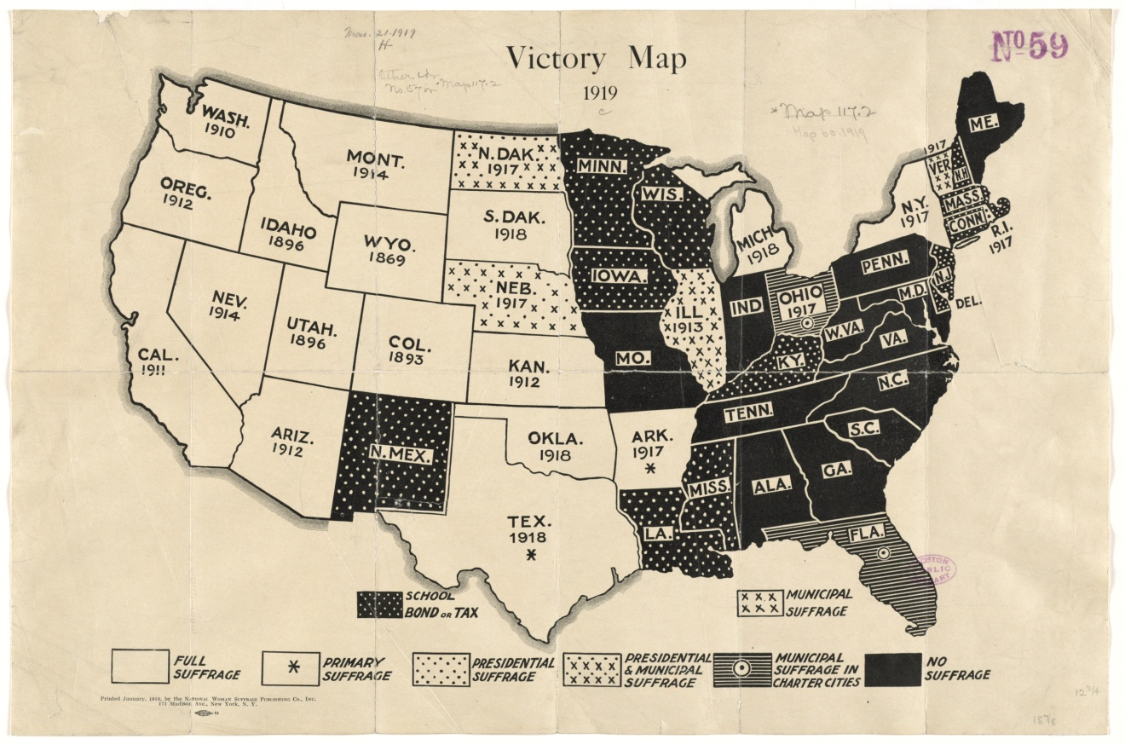

Woman’s Suffrage Cartoon

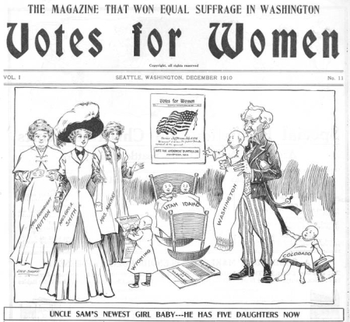

Pamphlet Opposing Woman’s Suffrage

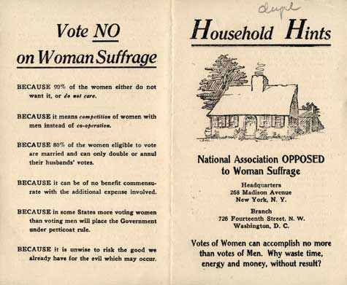

Pamphlet Opposing Woman’s Suffrage

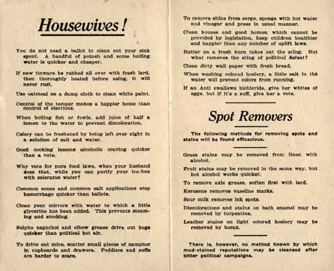

The Results of the Fifteenth Amendment Lithograph

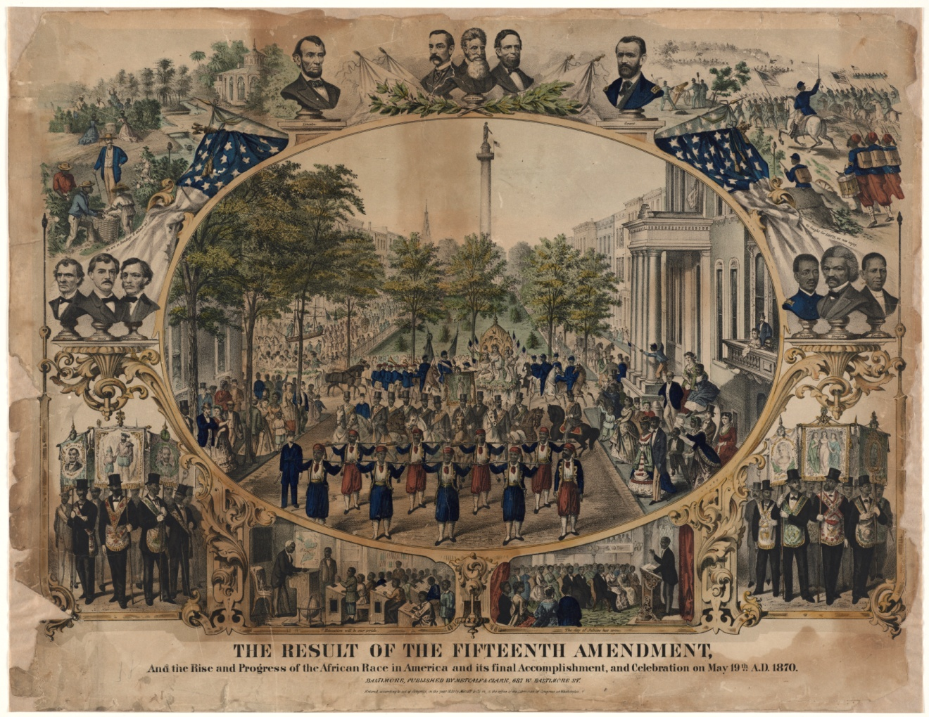

Voting Access Cartoon

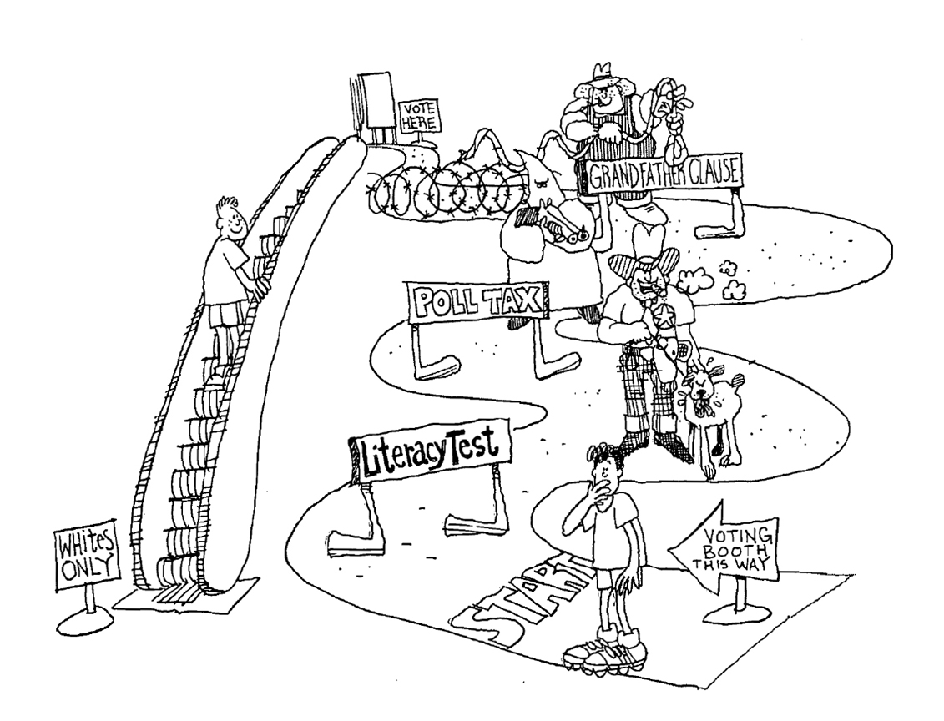

The Facts of Prohibition map

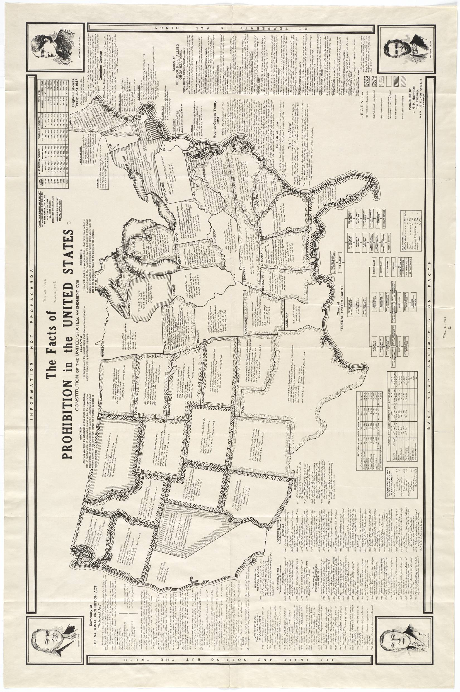

Make the Map All White

