AMERICA VOTES RESOURCE PACKET
Background Articles
Indepth article on authoritarianism in general
http://www.vox.com/2016/3/1/11127424/trump-authoritarianism

State Level Politics
http://democracyjournal.org/magazine/39/how-the-right-trounced-liberals-in-the-states/
(article on what happened on the state level) theda skocpol

Voting Rights and Access
John Oliver, Season 3, Episode #1—on voter ID laws
http://www.dailymotion.com/video/x3s7fj4
From 10:00-24:00 [warning inappropriate language and sexual suggestion]
Can the States Save American Democracy?
http://www.nytimes.com/2016/08/21/opinion/can-the-states-save-american-democracy.html?ref=opinion&_r=0
Voting Rights Success, Not So Fast
http://www.nytimes.com/2016/08/18/opinion/voting-rights-success-not-so-fast.html

Selling the Candidates
How to Win An Election
http://www.nytimes.com/2016/02/18/opinion/how-to-win-an-election.html?smprod=nytcore-iphone&smid=nytcore-iphone-share
• The Living Room Candidate www.livingroomcandidate.org - This site has TV commercials from every U.S. presidential election since 1952, with background information on each one, a visual display of how each electoral college vote turned out, and suggested lesson plans.
• FlackCheck.org www.flackcheck.org - A compendium of resources on the techniques used in political advertising, including a section on “Patterns of Deception.” There’s also an analysis of the 1844 campaign pitting Abraham Lincoln against George McClellan, posing the question, “Could Lincoln be reelected today?”

Truthiness
Colbert’s Original Word, October 17, 2005
http://www.cc.com/video-clips/63ite2/the-colbert-report-the-word---truthiness
Michael P Lynch March 9, 2016, Googling is Believing
http://opinionator.blogs.nytimes.com/2016/03/09/googling-is-believing-trumping-the-informed-citizen/?smprod=nytcore-iphone&smid=nytcore-iphone-share

The Age of Post-Truth Politics,William Davies, August 24, 2016
http://nyti.ms/2bheLgr
Fact Checking Websites:
www.politifact.com
http://www.washingtonpost.com/blogs/fact-checker

http://www.nytimes.com/interactive/2016/us/elections/fact-check.html?ref=politics&_r=0

How to register to VOTE in each of the 50 states
http://www.cnn.com/2016/08/14/politics/how-to-register-to-vote-in-every-us-state-and-territory/index.html

ELECTION CURRICULUM
http://mattersofeducation.org/

Useful Electoral College Maps/Information

Seats gained and lost 2010 census
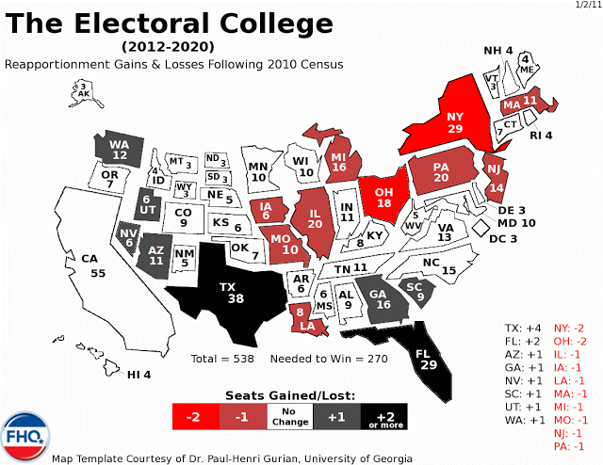
http://3.bp.blogspot.com/-dDY8VxE8JQw/TaO9F3-6tKI/AAAAAAAADe0/HDsHq-oOc4E/s640/electoral.college.map.2012.v.final.gif
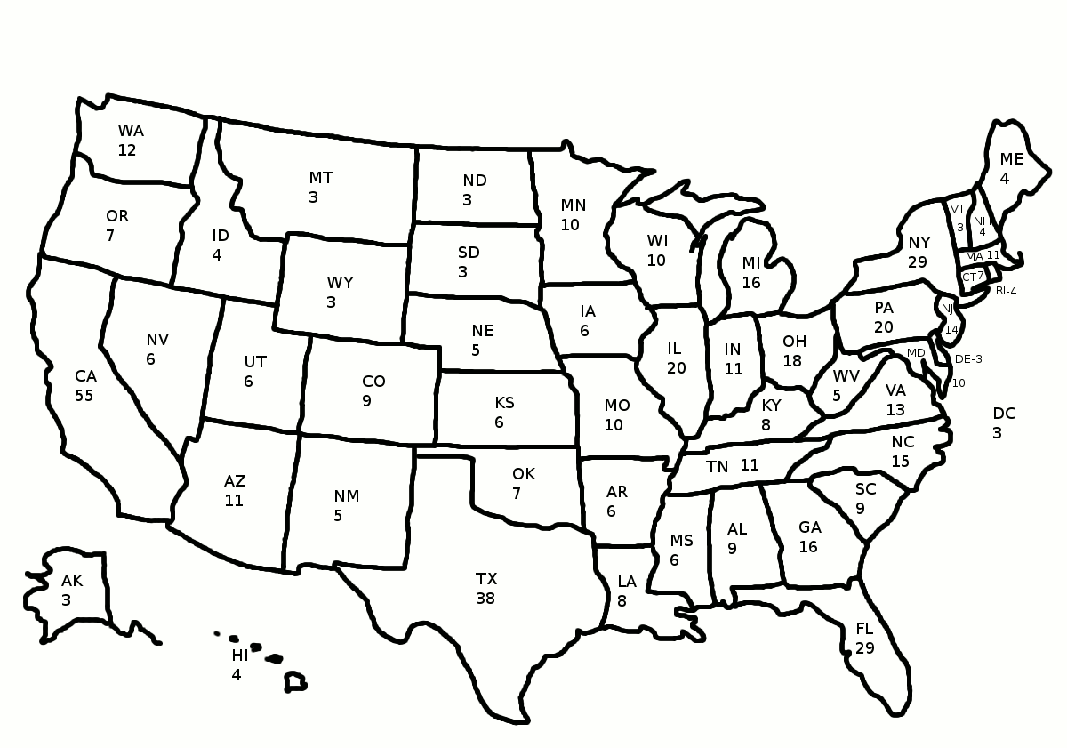
Googling is Believing Michael Lynch March 9, 2016
About a week before he used the national political stage to ask viewers to think about Donald Trump’s “finger” size, Marco Rubio told the audience during another recent Republican presidential debate to Google “Donald Trump and Polish workers.” They did.

Rubio wanted voters to see news stories about Trump illegally hiring undocumented Polish workers more than 35 years ago to demolish a building to make way for Trump Tower. Searches for those terms, and the fraudulent “Trump University,” shot way up. It was like a public version of the now ubiquitous phenomenon of everyone whipping out smartphones to verify a disputed fact at a party or meeting. Not that it did much good in this case; as numerous commentators have noted, Trump and many of his supporters don’t seem particularly worried about minor annoyances like “facts.” (For the record, PolitiFact, which checks the veracity of politicians’ statements, judged Rubio’s charge to be “half true.”)

Nonetheless, Rubio’s Google gambit and Trump’s (non)reaction to it, reveals an interesting, and troubling, new change in attitude about a philosophical foundation of democracy: the ideal of an informed citizenry. Political thinkers have long claimed with Jefferson that, “An educated citizenry is a vital requisite for our survival as a free people.” The idea is obvious: If citizens are going to make even indirect decisions about policy, we need to know the facts about the problem the policy is meant to rectify, and to be able to gain some understanding about how effective that policy would be. In the larger sense, if we are going to decide who runs the country — and we are, if you think the electoral college allows for that — we need to know the facts about the candidates’ records.

This is one reason philosophers have always been worried about the ebb and flow of information, and who controls it. Plato argued in “The Republic” that the fact that democracies couldn’t control that flow and point it toward truth was one reason they often dissolved into tyranny. In a different vein, Noam Chomsky argued in the 1980s that consent was being “manufactured” by Big Media — large consolidated content-delivery companies (like this newspaper) that could cause opinions to sway one way or the other at their whim. Knowledge is power; capture it and you capture power in a democracy.

The political importance of information — and the fear that it can be manipulated — has not changed. What has changed is how we are informed about politics or anything else, or how we aren’t. The Big Media that worried Chomsky 30 years ago is largely a thing of the past; many of the largest newspapers are gone, and others are shadows of their former selves. In the halcyon early days of the Internet, when we began excitedly exploring the information Garden of Eden, still free of the shadow of social media, it was easy to think that knowledge itself had become democratic, and that Plato’s worry had at last been shown to be bankrupt. But the worry hasn’t gone away — it has just changed form.

The worry is no longer about who controls content. It is about who controls the flow of that content. It is no coincidence that we are now seeing Big Data companies like Facebook sponsor presidential debates. Nor is it a coincidence that people are increasingly following the election on social media, using it both as the source of their information and as the way to get their view out. Consent is still being manufactured, but the manufacturing is being done willingly by us, usually intended for consumption by other people with whom we already agree, facts or no facts.

It really isn’t a surprise that Rubio would ask us to Google for certain facts; that’s how you and I know almost everything we know nowadays — it is a way of knowing that is so embedded into the very fabric of our lives that we don’t even notice it. What else could Rubio ask us to do to fact-check Trump? We used to say that seeing is believing; now Googling is believing. Of course, in many ways following that norm — Google it! — can help us realize the Jefferson ideal of an informed citizen I sketched above. That ideal, recall, emerges out of the simple fact that reasonable action requires knowledge, and reasonable political action requires political knowledge.

And Google places more politically important information at our fingertips than ever before. So if the ideal of being informed means having more information available for uptake, there is a case for saying that we are now closer than ever to realizing that ideal. That is behind the thought, commonly voiced in the early part of this century, that the Internet has “democratized” knowledge. The problem of course is that having more information available, even more accurate information, isn’t what is required by the ideal. What is required is that people actually know and understand that information, and there are reasons to think we are no closer to an informed citizenry understood in that way than we ever have been. Indeed, we might be further away. One reason for thinking so is that searching the Internet can get you to information that would back up almost any claim of fact, no matter how unfounded. It is both the world’s best fact-checker and the world’s best bias confirmer — often at the same time.

Group polarization on the Internet is a fact of digital life. Liberals “friend” liberals and share liberal-leaning media stories and opinions with them; conservatives friend conservatives, and do the same. And the flow of digital information is just as prone to manipulation as its content — even when that flow is directed at an audience larger than our own immediate circle. Take an example: Search for “what really happened to the dinosaurs” and one of the top results is likely to be from a site called answersingenesis.org — not, I suggest, a good source of information on the T-Rex. But it illustrates how canny use of search engine metrics can be used to push an agenda. No wonder Trump and his followers on Twitter immediately shrugged off Rubio’s inconvenient truths; there is nothing to fear from information when counterinformation is just as plentiful. That’s why the real worry here isn’t about the regrettable if obvious fact that citizens are less informed than our ideals demand. Nor is it simply the amusing specter of candidates’ shouting competing Googling instructions at the audience like so many carnival barkers. The real worry concerns our faith in the ideal of an informed citizenry itself. That worry, as I see it, has two faces.

First, as Jason Stanley and others have emphasized recently, appeals to ideals can be used to undermine those very ideals. People on both the left and the right tell one another that “the information is right there; people just aren’t paying attention to the facts (Google it!).” The very availability of information can make us think that the ideal of the informed citizen is more realized than it is — and that, in turn, can actually undermine the ideal, making us less informed, simply because we think we know all we need to know already. Second, the danger is that increasing recognition of the fact that Googling can get you wherever you want to go can make us deeply cynical about the ideal of an informed citizenry — for the simple reason that what counts as an “informed” citizen is a matter of dispute. We no longer disagree just over values. Nor do we disagree just over the facts. We disagree over whose source — whose fountain of facts — is the right one. And once disagreement reaches that far down, the daylight of reason seems very far away indeed.

LESSON PLAN: THE ELEPHANT (AND DONKEY) IN THE ROOM
Overview
The two candidates running for President are unlike any in our nation’s past. One has never held political office. The other is the first female candidate from a major party as well as the spouse of a former president. Yet these details are not what make them unique. The way they speak and are spoken about represents a new low in American politics. Differences are magnified and accelerated in rapid fire thanks to the use and misuse of media. How can we make sense of this campaign?

Part I: CHOICES
Both candidates faced serious opposition in their primary races.
- What were the other choices for the voters besides Clinton and Trump?
- Your teacher will assign your group one of the following:
Ted Cruz, Bernie Sanders, John Kasich, Marco Rubio, Ben Carson
- What were his positions on the issues? Each has a website. There are videos of their debate performances and speeches in front of voters. When did he agree with the person who got the party nomination? On what issues did he disagree? Why do you think he did not get his party’s nomination? Be prepared to present your findings to the rest of the class.

Part II: MORE CHOICES
1. The candidates have staked out strong positions on many issues. Use their websites or others to determine what they would do as President.
https://www.donaldjtrump.com/positions
https://www.hillaryclinton.com/issues/
http://www.nytimes.com/interactive/2016/us/elections/candidates-on-the-issues.html
http://www.washingtonpost.com/wp-srv/politics/issueengine/issueengine.html
Be sure to site the source of your information. It would great to have hard evidence, e.g. a speech they gave on the subject. Youtube is a great resource here. Compare what you find there to videos on the candidates’ websites

2. How does each candidate represent a distinct choice on all or any of the following?:
ISSUE* | CLINTON | TRUMP
Immigration
Education
National Security/Fighting Terrorism
The Economy
Health Care
*Please substitute issues that are important to you. These are just suggestions
Part III: EVEN MORE CHOICES
It is the candidates’ personalities and pasts, not their policies, that seem to represent the most distinctive choice. Most Americans (more than 50%) dislike both candidates, http://elections.huffingtonpost.com/pollster

- What are the objections to each candidate? Watch either candidate speak or listen to a round table on one of the cable news networks.
- What is the source of these objections, i.e. actions and language of the candidate her/himself or what others say and do?
- How do their supporters respond to these criticisms?
Use the two graphic organizers below to help organize this information

Hillary Clinton
OBJECTION | SOURCE | DEFENSE

Donald Trump
OBJECTION | SOURCE | DEFENSE

Part IV: Stories
All campaigns try to tell a story, both about their own candidate and their opponent. Watch this video and answer the following questions: http://www.nytimes.com/2016/02/18/opinion/how-to-win-an-election.html?smprod=nytcore-iphone&smid=nytcore-iphone-share

- Who is the person speaking in the video? Why is he a good source to learn about presidential campaigns and stories?
- How do stories shape/affect campaigns?
- What is the story Secretary Clinton is trying to tell about herself? About Mr. Trump?
- What is the story Mr. Trump is trying to tell about himself? About Secretary Clinton?
- Who else participates in the telling of these stories for and against the candidates?
- How do we know whom to believe?
- We live in an ever changing world regarding technology. What role have these changes played in this campaign? How have the candidates use of social media affected their ability to convey their message as well as those who oppose it? Both campaigns take to twitter, instagram, Facebook as well as more traditional methods of campaigning in person.
How does the medium affect the message?
Part V: What is the Truth?
According to Politifact.com, 70% of Donald Trump’s statements contain some element of untruth. And an NBC/Wall St. Journal poll in July sited 67% of Americans found Hillary Clinton untrustworthy http://graphics.wsj.com/wsjnbcpoll/
What does this data reveal about both the candidates and the American electorate?

Between now and November 8, watch what the candidates say and do. Keep track of how each item other supports or refutes the story they are trying to tell. You may also go back and watch and read other things they have said this year and in the past.

Use this graphic organizer to keep track:
WHAT CLINTON SAYS ABOUT HERSELF | WHAT TRUMP SAYS ABOUT CLINTON | WHAT OTHER PEOPLE SAY ABOUT CLINTON
WHAT TRUMP SAYS ABOUT HIMSELF | WHAT CLINTON SAYS ABOUT TRUMP | WHAT OTHER PEOPLE SAY ABOUT TRUMP

To check the accuracy of what they are each saying, please consider consulting these websites:
www.politifact.com
http://www.washingtonpost.com/blogs/fact-checker
http://www.nytimes.com/interactive/2016/us/elections/fact-check.html?ref=politics&_r=0
Resources:
Colbert’s Original Word, October 17, 2005
http://www.cc.com/video-clips/63ite2/the-colbert-report-the-word---truthiness
Michael P Lynch March 9, 2016, Googling is Believing
http://opinionator.blogs.nytimes.com/2016/03/09/googling-is-believing-trumping-the-informed-citizen/?smprod=nytcore-iphone&smid=nytcore-iphone-share

The Age of Post-Truth Politics, William Davies, August 24, 2016 http://nyti.ms/2bheLgr

Fact Checking Websites:
www.politifact.com
http://www.washingtonpost.com/blogs/fact-checker
http://www.nytimes.com/interactive/2016/us/elections/fact-check.html?ref=politics&_r=0

Up to date polling, Polling Report and Pew Research
http://www.pollingreport.com/index.html
http://www.people-press.org/2016/07/07/4-top-voting-issues-in-2016-election/

The Candidates and the Issues:
https://www.donaldjtrump.com/positions
https://www.hillaryclinton.com/issues/
http://www.nytimes.com/interactive/2016/us/elections/candidates-on-the-issues.html
http://www.washingtonpost.com/wp-srv/politics/issueengine/issueengine.html

Constructing Political Narratives:
http://www.nytimes.com/2016/02/18/opinion/how-to-win-an-election.html?smprod=nytcore-iphone&smid=nytcore-iphone-share

Enrichment Activities
1. There are many who are not happy with the choices we have in this election. While it is usual to have opponents from other parties, this campaign season has seen opposition within parties. Have students research and present opposition from within each party to its own candidates.

2. Other times in American History have witnessed venomous campaigning—Presidential Elections of 1800, 1828, 1860, 1884, and 1928 were pretty nasty by any metric. Have students research the issues and personalities involved. Compare those campaigns to 2016 and note similarities and differences.

