ARGUMENTS FOR AND AGAINST SLAVERY
To modern sensibilities, slavery in the antebellum period is more than harsh. It is almost inconceivable that so many Americans supported this brutal system of forced labor. Close inspection reveals how few contemporaries believed that it should be abolished outright.

Procedure

- This lesson is designed to supplement your regular curriculum materials. They should be able to identify most of key terms/people on the Student Sheet from their text. You may want them to identify these terms before you begin the lesson or use as a review at the end.
- Begin with a discussion about property rights. How are they protected by law? Under what conditions does the government have the right to take an individual’s property? Review/introduce the concept of Eminent Domain.
- Now turn the discussion to the antebellum period and slavery. As harsh as it may be to hear, slaves were property and to many Americans during those years, that was not a subject of debate, except to confirm that it was wrong to take someone’s property.
- There were of course those who believed that slavery was a moral outrage. Have Students read excerpts from Douglass and Howe and complete of Part I of the Student Sheet. They may complete this as a class, in small groups or individually. Discuss their results.
- Not everyone who opposed slavery did so on moral grounds. Some believed it was inefficient economically. Others felt that it simply should not be extended to new territories acquired after the Mexican War. There were many strategies besides abolishing slavery suggested. Show Students the Maps of Liberia and American Missionary Society. What was their plan? Have Students complete Part II of the Student Sheet.
- Some slaves took matters into their own hands and ran away. They were helped in this through the efforts of the Underground Railroad but it was a crime to help the runaways and according to the Fugitive Slave Law, runaway slaves had to be returned. Show Students the Anthony Burns lithograph. They may read more on his case at the site listed in the Materials section. Discuss whether or not they thought it was right to return runaway slaves. Ask if they would have broken the law or returned the slave to his or her owner?
- There were those of course who thought that slaves were property and had no rights at all. Perhaps the strongest statement of this came in the Dred Scott decision in 1857. Have Students read Judge Taney’s decision and complete Part III of the Student Sheet.
- Finally, show class the lithograph, Arguments of the Chivalry which highlighted the battle between Charles Sumner and Preston Brooks over slavery. How does the cartoonist use the word Chivalry here? Is it a word of honor?

Time Allocation:

Part I: 30-45 minutes
Part II: 10-15 minutes
Part III: 30-45 minutes

Materials Needed

Frederick Douglass, “A Few Facts and Personal Observations of Slavery”: An Address Delivered in Ayr, Scotland on March 24, 1846 http://docsouth.unc.edu/neh/douglass/support7.html
Text for Battle Hymn of the Republic, http://www.flickr.com/photos/59843331@N03/5468268623/in/photostreamAnthony Burns Lithograph, http://www.flickr.com/photos/59843331@N03/5492481118/in/photostream
Background on Anthony Burns Case,
http://www.historynet.com/boston-combusts-the-fugitive-slave-case-of-anthony-burns.htm

Map of Liberia,
http://maps.bpl.org/details_14552/?srch_query=civil+war&srch_fields=all&srch_style=exact&srch_fa=save
Map of American Missionary Society, http://maps.bpl.org/details_14660/?srch_query=civil+war&srch_fields=all&srch_style=exact&srch_fa=save
Arguments of the Chivalry lithograph, http://www.flickr.com/photos/59843331@N03/5654458028/in/photostream
Dred Scott Decision, background and Supreme Court decision, http://www.pbs.org/wgbh/aia/part4/4h2933.html;

Assessment Criteria

Did students identify the different strategies of those opposed to slavery?
Did students learn the different reasons that people were against slavery?
Did students explore the place of property rights as an ongoing theme in US history and justification for the institution of slavery?

Enrichment Activities

Imagine how contemporaries felt about some of these issues. Use the Identities from the Torn in Two Exhibition, located in Tab 9 this Curriculum Guide. Have the students work in pairs. Have each pair assume the persona of one of the identities. Perhaps they can
- Respond to Douglass’ article or the lyrics to Howe’s song.
- Imagine how the slaves would have felt about being sent to Liberia
- Imagine if they would they have helped Anthony Burns or turned him in
- Decide if they would they have agreed with Judge Taney or hung him in effigy

Common Core Curriculum Standards
English/Language Arts Standards: Anchor Standards: CCRS Reading
Key Ideas and Details
• CCSS.ELA-Literacy.CCRA.R.1 Read closely to determine what the text says explicitly and to make logical inferences from it; cite specific textual evidence when writing or speaking to support conclusions drawn from the text.
• CCSS.ELA-Literacy.CCRA.R.2 Determine central ideas or themes of a text and analyze their development; summarize the key supporting details and ideas.

Craft and Structure
• CCSS.ELA-Literacy.CCRA.R.4 Interpret words and phrases as they are used in a text, including determining technical, connotative, and figurative meanings, and analyze how specific word choices shape meaning or tone.
• CCSS.ELA-Literacy.CCRA.R.5 Analyze the structure of texts, including how specific sentences, paragraphs, and larger portions of the text (e.g., a section, chapter, scene, or stanza) relate to each other and the whole.

English/Language Arts: History and Social Studies, 9-12
- CCSS.ELA-Literacy.RH.9-10.8 Assess the extent to which the reasoning and evidence in a text support the author’s claims.
- CCSS.ELA-Literacy.RH.9-10.9 Compare and contrast treatments of the same topic in several primary and secondary sources.
- CCSS.ELA-Literacy.RH.11-12.8 Evaluate an author’s premises, claims, and evidence by corroborating or challenging them with other information.
- CCSS.ELA-Literacy.RH.11-12.9 Integrate information from diverse sources, both primary and secondary, into a coherent understanding of an idea or event, noting discrepancies among sources.

Slavery was a harsh and horrible fact of life for many decades of our nation’s history. Many opposed but many also supported its existence. What drove each side in its beliefs?

Key Terms/People
Eminent Domain Charles Sumner Frederick Douglass
Fugitive Slave Law Preston Brooks Compromise of 1850
Personal Liberty Laws Dred Scott case Second Great Awakening

Part I
Read Both Douglass’ Speech and Howe’s song lyrics and answer the following questions:
- How does Douglass describe slavery?
- How does he make his individual story a criticism of the entire slave system?
- Why are the remarks about Mrs. Auld so useful to those who support the abolitionist cause?
- How do slaves manage to overcome some of those most harsh elements of their lives?
- Why was learning to read both dangerous and crucial?
- How do Howe’s lyrics capture the spirit of war?
- What is the Truth to which she refers?
- How do both invoke religion in their message? Do you think this was an effective strategy at that time? Why or why not?

Part II
Some individuals thought the best idea would be to send the slaves and even some of the free blacks back to Africa.
- Was this a good idea?
- What connections did the slaves have to Africa?
- Look at the Maps. What are the chances that the slaves came from that part of Africa?
- What do you think were the attitudes of those who suggested this plan? How were they part of other movements of the antebellum period?

Part III
- What were the key issues in the Dred Scott case?
- Why does the Court bring up the issue of citizenship?
- The decision mentions some of our nation’s founding principles. Which ones does it mention? How does it connect them to this case? Do you think this is how Thomas Jefferson and John Adams understood these ideals?
- How does the Court undo past gains made by not only slaves but free blacks as well?
- What other big effects did this decision have on the United States

Text for Battle Hymn of the Republic

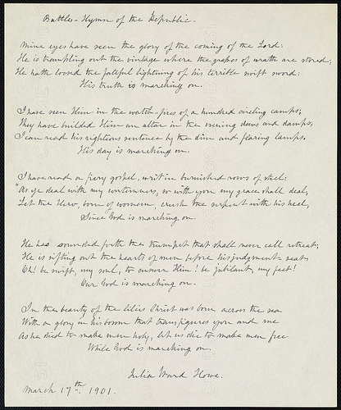

Anthony Burns Lithograph

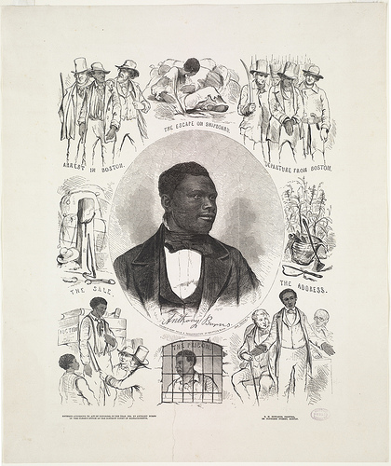

Map of Liberia

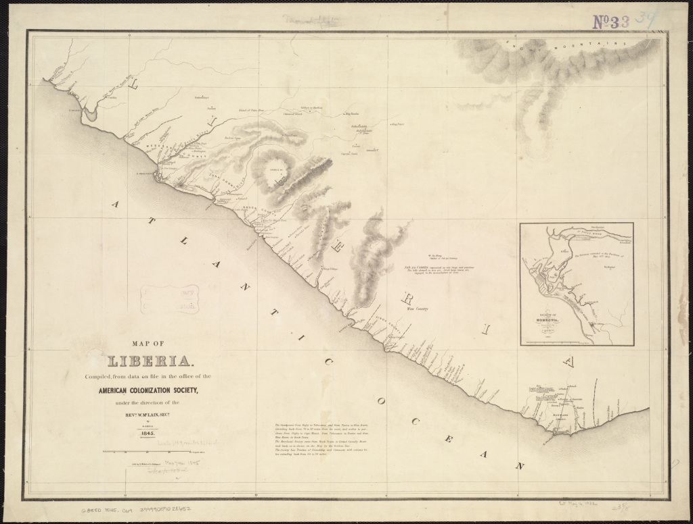

Map of American Missionary Society

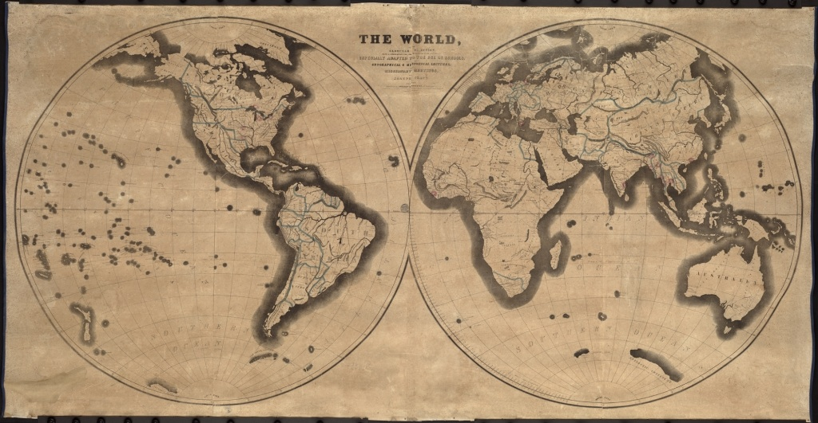

Arguments for Chivalry Lithograph

