Curriculum Planning Workshop, Part Deux
Acushnet Public Schools September 21, 2015

- Where Were We???

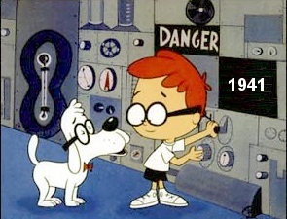

- Revisiting Know/Do/Understand
- How They Affected Our Planning
- Templates
- Unit
- Year Long Map

- Where Are We??
- Individual Check-in
- Group Check-in
- Feedback/Questions/Concerns

- Where Are We Going??
- Goal Setting
- What Can I/We Accomplish Today?
- MUST DO—Agree on unit template
- Questions/Concerns/Supports

- And Beyond??
- What Are Next Steps?
- Concerns?
- Supports Needed

- Teachers21 Survey—on mattersofeducation.org website or
www.teachers21.org/survey

SUPPORTING MATERIALS FOR WORKSHOP
II. Where Are We??

ME | TEAM | QUESTIONS/  CONCERN

Good Resource on Essential Questions:
http://www.ascd.org/publications/books/109004/chapters/What-Makes-a-Question-Essential%A2.aspx

III. Focus For Today

QUESTIONS/
CONCERNS GOALS
UNIT

COURSE

TEAM

Notes…..

