CIVIL WAR NARRATIVES—IN VISUAL IMAGES
Procedure

There are six images here. Each tells part of the story of the Civil War in a different way. One option is to show them the images and have them brainstorm, perhaps write captions for them or imagine them as part of a series. What image came before or after? We are including some background to give you information that you may share with your students.

Specific Questions to Consider

- For the two Song Covers: Songs were a way to pay tribute as well as generate support for one side or another. Perhaps have students write a song about someone they consider to be special or brave. How would they show that in a picture?
- The Heroes Poster. What is a Hero? What traits do they consider to be heroic? Who are the heroes of their lives? Do they know any heroes?
- The Torn in Two Cartoon. The country is literally being torn in half. This is a cartoon but it is not funny. How can cartoons show serious problems we face? What might the next frame of the cartoon have looked like? Are there any topics in the news now that they might show in a cartoon?
- For more on the Burns Lithography, please refer back to Lesson Five. This tells his story in a series of pictures. Imagine the life of someone else told in this way.
- Scott’ Great Snake. This is a simple version of the military strategy of the North in the Civil War. What do they think the North is planning to do? How will they defeat the South? Why did the map maker choose a snake? What other images do they see in the drawing?

Time Allocation:

Time to introduce Exhibit Items: 30-45 minutes
Time to Research Topic: homework and class time
Time to Create Own Image: homework and class time
Class Presentations: your own discretion

Materials

Anthony Burn’s Lithograph
McClellan Song Cover
Scott’s Great Snake
Torn in Two Cartoon
Hurrah for the 44th Poster
All of the above items may be found at http://www.flickr.com/photos/59843331@N03/

Assessment Criteria

Did student learn several ways to present information in a non-verbal way?
Did students select a story to tell?
Did students present their story effectively?

Common Core Curriculum Standards
English/Language Arts: Anchor Standards: CCSR for Writing
• CCSS.ELA-Literacy.CCRA.W.1 Write arguments to support claims in an analysis of substantive topics or texts using valid reasoning and relevant and sufficient evidence.
• CCSS.ELA-Literacy.CCRA.W.2 Write informative/explanatory texts to examine and convey complex ideas and information clearly and accurately through the effective selection, organization, and analysis of content.
CCSS.ELA-Literacy.CCRA.W.3 Write narratives to develop real or imagined experiences or events using effective technique, well-chosen details and well-structured event sequences.

English Language Arts: Reading: Informational Text: Grades 3-4
RI.3.7. Use information gained from illustrations (e.g., maps, photographs) and the words in a text to demonstrate understanding of the text (e.g., where, when, why, and how key events occur).
RI.3.9. Compare and contrast the most important points and key details presented in two texts on the same topic.
RI.4.7. Interpret information presented visually, orally, or quantitatively (e.g., in charts, graphs, diagrams, time lines, animations, or interactive elements on Web pages) and explain how the information contributes to an understanding of the text in which it appears.

English Language Arts: Reading: Integration of Ideas and Information, Grades 2-4

Integration of Knowledge and Ideas
7. Integrate and evaluate content presented in diverse media and formats, including visually and quantitatively, as well as in words.

There are many ways to tell a story, often using pictures as well as words

Assignment
You will see cartoons, maps, song covers, even snakes! Each one will tell you a story from the past. You will then decide on a story to tell.

GATHER INFORMATION
What are the important details of the story you want to tell?

What other information should you include?

PLAN
How are you going to tell your story?

What materials will you need?

TELL YOUR STORY

CHECK TO SEE IF YOU LEFT ANYTHING OUT

Torn in Two Cartoon Image

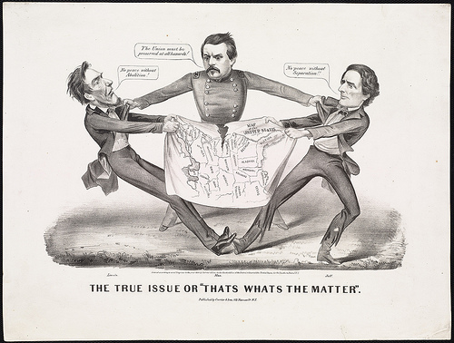

Published late in the war during the 1864 Presidential campaign, this political cartoon depicts Abraham Lincoln and Jefferson Davis pulling on opposite ends of a map, tearing the United States in two pieces. This graphic image, incorporating caricature and map, characterizes our story, that the Civil War almost dissolved a tenuous union forged eighty-five years earlier. We do not focus just on the actual “tearing” (the war and the various battles), but we also examine the process by which the young nation reached this critical point in its history, and how the war and its heroes were remembered which became part of the process of mending the “tear” and reuniting the nation.

Anthony Burns Lithograph

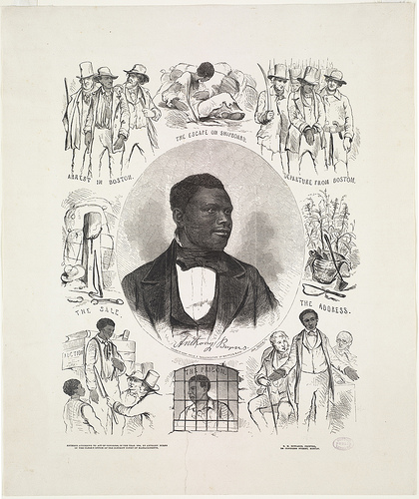

Of the many fugitive slaves coming to Boston, one who received considerable publicity was Anthony Burns. Escaping slavery in Virginia in 1854, he ran away to Boston. Under provisions of the 1850 Fugitive Slave Act, he was arrested and tried. Subsequently, there was a protest rally at Faneuil Hall as well as attempts to “rescue” him. President Franklin Pierce sent Federal marshals to ensure order during the trial and a military escort for Burns’ return.

The case stirred passions among those who had been indifferent. Massachusetts, one of several northern states, passed personal liberty laws to counteract the power of the Federal government. While the ultimate statement of slaves as property would come with the 1857 Dred Scott decision, the Burns case was one more step on the road to disunion.

J.B. Elliott. Scott’s Great Snake

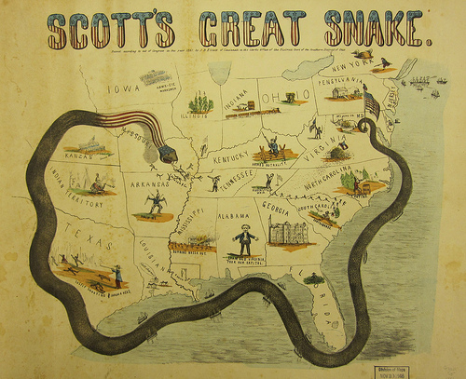

In the spring of 1861, when war was inevitable, Union Army General-in-Chief Winfield Scott devised a long-term strategy to economically and militarily crush the Confederacy. The plan called for a naval blockade of southern ports and a major offensive down the Mississippi River, thereby cutting off supply routes and dividing the South.

Scott’s tactic was dubbed the “Anaconda Plan,” as it was intended to constrict the insurgent States, as would a snake. The plan was depicted graphically in this 1861 pictorial map. Although not prevalent during the Civil War, propaganda maps such as this were designed to have maximum emotional effect on the user, as more civilians became aware of wartime activities.

Ensign, Bridgman & Fanning. Our Nation’s Heroes.
If you would like to view this more closely on line, please go to http://maps.bpl.org/details_14556/?dl_pp=2&srch_query=civil+war&srch_fields=all&srch_style=exact&srch_fa=save

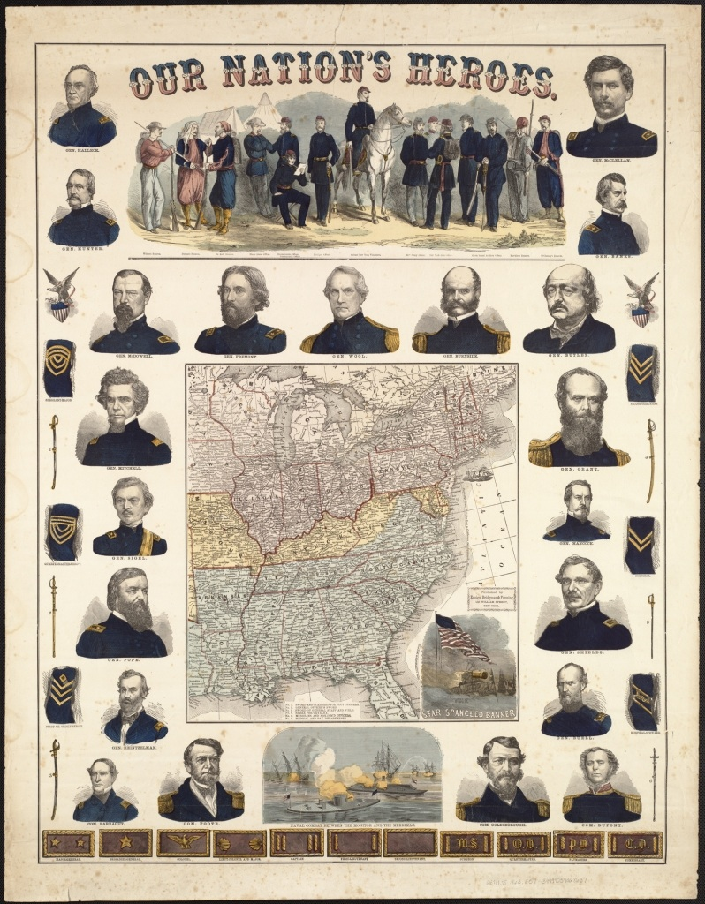

Most likely published as a commemorative souvenir fostering northern patriotism, this colorful broadside displays an array of graphic illustrations intended to appeal to a living room audience. The central focus is a small map of the eastern United States. Although it does not identify the Confederate states as a separate nation, the seceded states were colored blue and the border slave states which did not secede yellow.

The marginal illustrations include portraits of 21 Union generals and commodores, as well as a variety of military memorabilia. There are also three vignettes – one depicting fourteen soldiers dressed in different Union uniforms, another illustrating the battle between the two ironclad ships Monitor and Merrimack, and the third, a symbolic representation of the Star-Spangled Banner flying gloriously over a battle scene.

Song Covers. McClellan is the Man

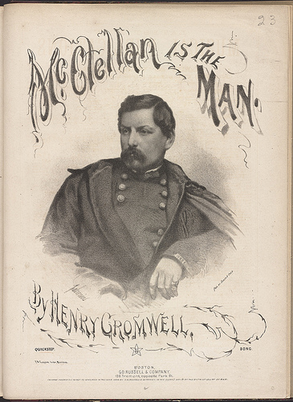

Printed sheet music increased in popularity during the middle of the 19th century as printing technologies improved and music playing in middle class homes became a fashionable pastime. Musical compositions relating to the Civil War, as illustrated by examples of sheet music published in Boston, highlighted the accomplishments of individuals such as Massachusetts-born Gen. Joseph Hooker, individual regiments including the Massachusetts 44th, and military campaigns, notably the Battle of the Wilderness.

Decorative covers were added to the printed scores to adorn and advertise the lyrics. These war-time covers, which display powerful visual images, convey the glory and struggle of the conflict. They reminded those on the home front of the soldiers’ affections, the causes for which they fought, and the ne’er do wells they opposed.

Hurrrah for the 44th! Poster

