FIGHTING AGAINST SLAVERY
There were many people in both the North and South who opposed slavery and tried to help. Some fought in the courts and others in government. Others tried to help the slaves directly. Some slaves took matters into their own hands and tried to escape from slavery. They were helped by those along the way at a series of stops in churches, farms and other ‘safe’ places, collectively known as the Underground Railroad.

Procedure

- Discuss the reasons that people opposed slavery and the different ways that they tried to help the slaves. Go to this website, http://www.eduplace.com/kids/socsci/books/applications/imaps/maps/g5s_u6/index.html
and have students complete Part I of the Student Sheet. Discuss their results.
- There was a lot of anti-slavery activity in New England. Show students the following two maps and have them complete Part II of the Student Sheet. You may want to complete this portion as a class or in small groups.
- Not all of the runaway slaves were successful. Show the students the Anthony Burns lithograph and have them complete Part III of the Student Sheet. You may also want to have them read his story. Discuss their results.

Time Allocation:

Part I: 10 minutes
Part II: 10 minutes
Part III: 10 minutes

Materials Needed

Paths of the Underground Railroad, located at http://www.eduplace.com/kids/socsci/books/applications/imaps/maps/g5s_u6/index.html
Map of the Jackson Homestead, Newton, Massachusetts
Reconstructed Map of the Underground Railroad
Anthony Burns Lithograph

Assessment Criteria
Did students learn about efforts of the Underground Railroad?
Did students learn about anti-slavery activity in New England?
Did students learn the story of one run away slave?

Enrichment Activities

1. Learn about the free black community of Boston before the Civil War:
Use the Directory, http://www.flickr.com/photos/59843331@N03/5468862802/ and Street Atlas of Boston, http://www.flickr.com/photos/59843331@N03/5468858292/ to determine where the free blacks lived and what institutions they had in their community.
2. Have students use the model of the Anthony Burns Lithograph to tell about an event or the story of another person or something that happened to them.
3. Have students look at, the Slave Distribution Map, http://maps.bpl.org/details_14001/?dl_pp=1&srch_query=1861&srch_fields=all&srch_style=exact&srch_fa=save. From which areas would they expect the most slaves to have run away? The fewest? Check their estimates against: the actual origins of the runaway slaves.
4. Many other anti-slavery activities occurred in New England. Have Students learn about the following people:
William Lloyd Garrison Harriet Beecher Stowe American Anti-Slavery Society

Common Core Curriculum Standards
English/Language Arts: Anchor Standards: CCSR for Reading
CCSS.ELA-Literacy.CCRA.R.7 Integrate and evaluate content presented in diverse media and formats, including visually and quantitatively, as well as in words

English Language Arts: Reading: Informational Text: Grades 3-4
RI.3.7. Use information gained from illustrations (e.g., maps, photographs) and the words in a text to demonstrate understanding of the text (e.g., where, when, why, and how key events occur).
RI.3.9. Compare and contrast the most important points and key details presented in two texts on the same topic.
RI.4.7. Interpret information presented visually, orally, or quantitatively (e.g., in charts, graphs, diagrams, time lines, animations, or interactive elements on Web pages) and explain how the information contributes to an understanding of the text in which it appears.

English Language Arts: Reading: Integration of Ideas and Information, Grades 2-4

Integration of Knowledge and Ideas
7. Integrate and evaluate content presented in diverse media and formats, including visually and quantitatively, as well as in words.

National Geography Standards
Standard 1: How to Use Maps and Other Geographic Representations, Tools, and Technologies to Acquire, Process, and Report Information From a Spatial Perspective
Standard 17: How to Apply Geography to Interpret the Past

Slaves took an enormous risk when try tried to escape. In this lesson, you will learn about the big picture and small stories of those who tried to escape.

Part I
1. What might a slave do before he or she ran away?

2. What dangers did he or she face?

3. Would you have taken these risks?

Part II
Look at the two maps your teacher has given you. One is a farm that was a safe house on the Underground Railroad. The other shows the general routes taken.

1. What was the safest way to travel?

2. How did the slaves know whom to trust?

3. Does the Jackson farm look safe to you?

Part Three
These pictures tell the story of Anthony Burns. He ran away from Virginia in 1854.

1. Looking at the pictures, what other part of his story can you learn?

2. Does his story have a happy ending?

3. It was a law to return slaves that ran away. Would you have followed this law or broken it if you were living in Boston in 1857?

Map of the Jackson Homestead, Newton, Massachusetts

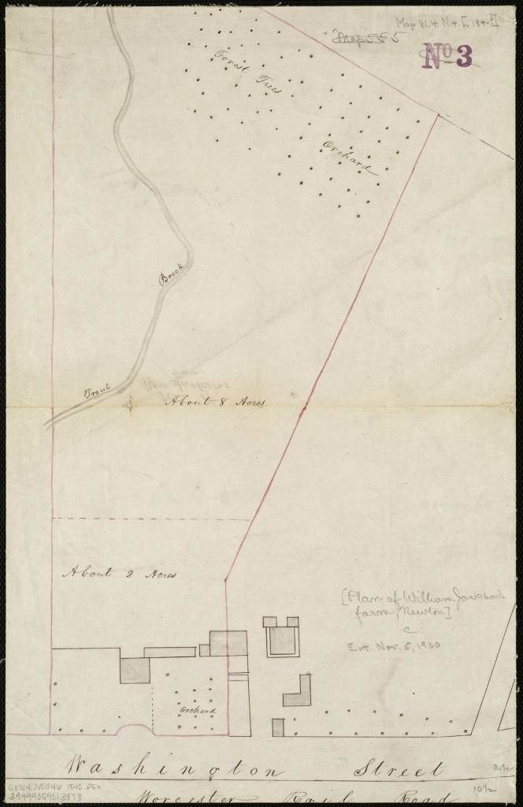

Reconstructed Map of the Underground Railroad

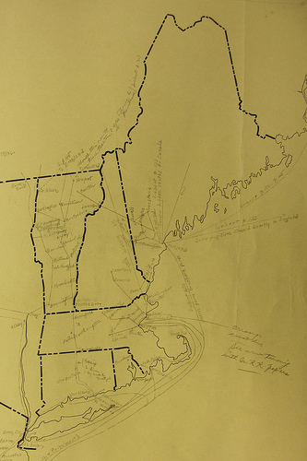

Anthony Burns Lithograph

