HISTORICAL THINKING SKILLS: TUTORIAL 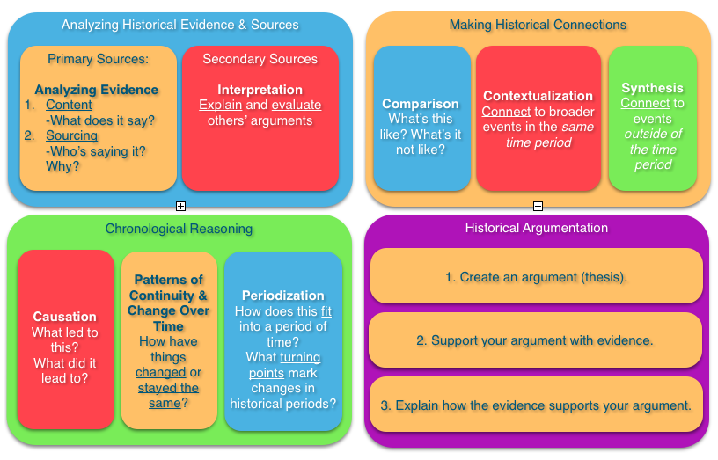

Ask yourself: What does it mean to study the past?
What tools does the historian use?
The ability to think and ask questions is probably the most important tool we have. That’s why the AP US History exam focuses so much on Historical Thinking Skills.
In order to understand how we can think historically, let’s take a look at how we could study the Civil War.

Chronological Reasoning

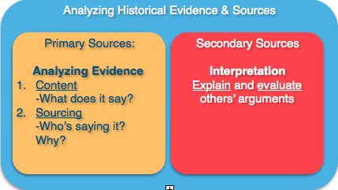

When thinking about history, most people think about dates. And as it turns out, dates are pretty important.
"When" matters.
And we’re lucky to live in a world where information on the “When” is really accessible for a lot of people. Thanks, Wikipedia.

So, the Civil War was fought between 1861 and 1865. It helps to know those dates.

“Before” matters as well , because it can help us understand causes. The election of Lincoln in 1860 is important, but so is the War with Mexico in 1848. When it comes to the Civil War, we can go back to the beginning--when the first slaves were brought to the colonies in 1619. How far back you go depends on what questions you are trying to answer, but it is important because you also get to see long term patterns and themes in American history.

We wonder what changed and what stayed the same, so “After” needs to be considered. And we have the same issue--how far after an event do we need to go to understand what happened? In some ways, we are still dealing with the effects of the Civil War as current debates over the Confederate Flag suggest.

But the biggest question to consider is this:
If things changed, did they change for everyone?

What was it like for slaves before and after the war? To what extent did things change for them in contrast to the slave owners? Were they the only black people in America??

Were their variations within groups as well as between them?

These are just a few of the ways that we think about time and dates, and you’ll find your own.

In sum, when thinking about historic change, we’ll want to consider:
- immediate and long term causes of these developments
- those aspects that stayed the same and those that changed
- the extent to which change varied for specific individuals and groups.

Making Historical Connections

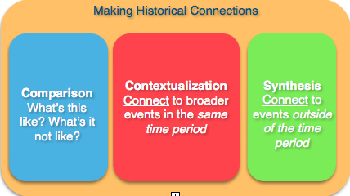

In order to answer our questions about the past, we’ve to connect a lot of dots. Understanding the “When,” “Before,” and “After,” will help us find those dots.
When we contextualize, we connect to the “When.” This helps us understand how events are part of larger things happening in their own time.
We also connect to events in other contexts or time periods, a process the College Board calls synthesizing.

Let’s think about COTTON, which was at the heart of the slave economy.
And let’s consider all of the historical connections to COTTON:
- The cotton gin led to soil depletion that created a need for Westward expansion.
-The planter aristocracy made political and social decisions based on economic need of the cotton economy.
- There was an impact on not only the South, but on the Northern textile industry, trade with England, and eventually development of the Indian sub-continent.

Just look at the change in British cotton imports during the Civil War, which was obviously a critical time for the South and the plantation system:
http://www.deltabravo.com.au/wp-content/uploads/2013/05/Minard_jpg_600x600_q85.jpg

Individual experiences within the lives of slaves varied greatly. This is another context to consider. History is about choices:
- How did decisions to stick to the cotton economy affect so many other decisions?
- Who made these choices?

So, to understand the past more fully, you’ll need to apply insights about the past to other times and places.
In other words, make connections from the specific topic in some other direction.
So if you are given some information about Reconstruction, think about the aftermath of another war.
For example:
How did things go after World War I or World War II?

Think about blacks moving North or the integration of the Army, or the Civil Rights movement. How did the Black Codes of Reconstruction connect to the economic discrimination of Jim Crow or the Political gains of the 15th Amendment link to the Dixiecrats of the 1960s or the removal of the Confederate flag from the South Carolina State House?

In sum, to interpret the past you need to:
- consider similar events in different time periods.
- identify other events and broader developments in the same time period that are connected.

Creating and Supporting an Historical Argument

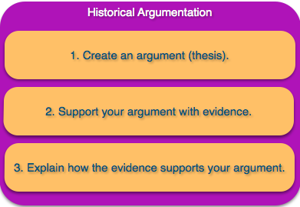

Let’s start with slavery:
What is an argument we can make about this topic?

An argument is not simply the answer to a question. It also conveys a point of view or an opinion.
Obviously slavery was bad. But you can’t just express an opinion, and opinions come from facts. Of course, different people look at different facts to make their points and defend them.

So, our opinions or arguments need to stem from concrete evidence.

Now let’s look at a single piece of evidence:

http://opinionator.blogs.nytimes.com/2010/12/09/visualizing-slavery/?_r=0

From this one document, what do you see?
Make a list of everything that you notice.

Consider the following:
- What information do you get?
- What opinion about slavery might this support?
- Why do you need more than one document to get the full picture of slavery?

The job of the historian to ask questions and find answers.
What questions can you ask using this document?
Where are the slaves?
Why do some areas have so many and some areas so few?
What was happening in the areas that had few slaves? Did those areas support the war?
What different documents might we use to get a fuller or different picture?
Census data, voting records, newspaper articles

Historians use lots of different types of evidence to complete or support their answers to make an argument, to convince people of their point of view. It’s not about the evidence, but how you use it.

So let’s prove a point with this piece of evidence.

For example:

Although not evenly distributed, slave owners greatly influenced antebellum society and politics, eventually leading to war.

How can we connect this argument to historical understanding?

How did the slave owners appeal to the non-slaveowners?
- Many aspire to be owners.
- in the hierarchy of the South, they ranked higher than slaves,free blacks.
-Romantic notions of war.
-From the perspective of many non-slaveowners, the federal government had invaded.

And think about border states, which ranked among the lowest in percentage of slaves. They didn’t secede.

In sum, when building an historical argument, you need to structure your response to any question in a way that allows you to incorporate effective evidence that reinforces the argument you are trying to make.

Analyzing Historical Sources and Evidence

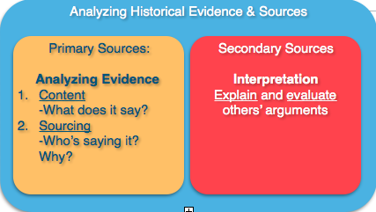

Historians use lots of different types of evidence to complete or support their arguments. That’s necessary to convince people of their point of view.

Stronger sources make stronger arguments.

We should ask 4 questions of every document:
Who is the intended audience?
What’s the historical context?
What’s the Purpose?
How would you describe the Point of View?

In the case of the previous document, we can see on close inspection that the map was sold to benefit Sick and Wounded Union troops. Thus, we can ask some more specific questions about its point of view and purpose.

Why would a Union fundraiser consist of a map of slave population? This definitely seems to support an argument that makes slavery the central cause of the war.

Taking these components into account affects how we interpret the past.
Before you can add to the conversation, you need to know what was said first.
Who was speaking?
When were they speaking?
What questions did they ask?
What materials did they use or even have access to?
How did they know if they were correct?

Back to the Civil War.
In the immediate aftermath, people were asking, “how did we even let this happen?”
The questions historians ask are a product of the time in which they ask them.

So a question from the late 19th century is impacted the changes the country is going through at that time. Those questions would be flavored by the upheavals of industrialization/urbanization/immigration.

That’s why 30 years later, Americans started to produce explanations that highlighted economic causes and differences between the north and south.

How might our own time affect the questions we ask about the past??

In sum, when considering historical evidence, please notice how it was understood at the time:
- Audience
- Context
- Purpose
- POV

When you use this evidence to interpret the past, you need to consider:
- other events at the same time
- similar events in different time periods.

The answers you get are affected by not only which questions you ask, but when you ask them.

