Market Economy Basics

What is a Market??
Let’s first start with a market. Actually let’s start before a market. Before there were markets there were households. Everything people needed, they made within their own homes. People lived in extended families and produced everything they needed but of course, they were content with a lot less than we are today. Somehow, they seemed happier not getting a new iPhone every two years. Sorry, I digress. At some point, really early on, people left their caves and began to trade stuff. Once you are trading things--raw materials, things you make, your labor, you are engaged in trade and that occurs in a market. Items are bought and sold. There is a supply and a demand for items, a price people are willing to pay and an amount people are willing to give. Now we are in a market, which is defined where things are bought and sold.

This is much easier to explain with a series of graphs. Let’s start with the most basic:

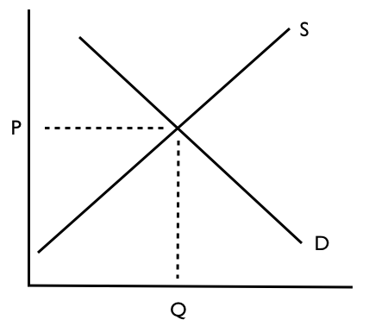

Let’s start on the Left, the vertical axis. This is price or cost of something--it can be what it may cost to buy a cookie or an hour of someone’s time to bake the cookie or a pound of chocolate chips to mix in the cookie.

On the bottom is the Amount or Quantity--how much of something--how many cookies or hours or pounds of chocolate. With me so far?? Great. Go eat and a cookie and then come back.

Everything in life can be reduced to this simple graph or market--people buy and sell--there is a price and quantity. Goods or services or resources are supplied and demanded at various prices and amounts.

Now look at the D and the S lines. D represents Demand, how much people WANT something. If you read the graph properly, you will see, that how much (Q) people Demand of something is linked to its cost (P). That makes sense.

This is easier when we add some numbers
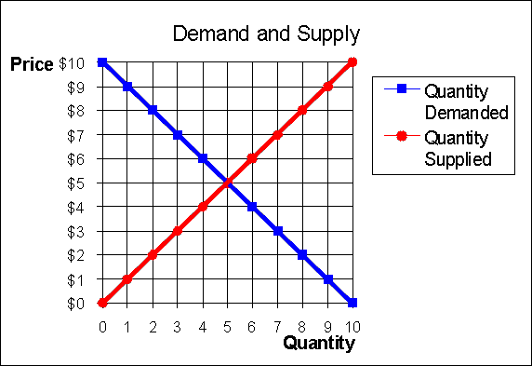

The graph represents two forces--buyers and sellers--Buyers are represented by the Demand line and Sellers by the Supply line. Not surprisingly, people want to spend as little as they can to buy something (Demand) but if they are selling something, they want to get as much as they can.
MARKET EQUILIBRIUM--what a fancy shmancy term. It simply means where what people are willing to pay intersects (meets up with) what people are willing to sell something for.

Everything has a market. Think about our cookies again. There is a market for the cookie. But there is also a market for each of the ingredients, and for the labor for the workers who make the cookies. All of these go into how the manufacturers decide how much to sell them for, i.e. how they set their supply line in the graph.

How do the demand lines get set? Well here is where things like advertising come in. All cookies are pretty much the same, so why we want want brand of cookie over another? Why do we think Oreos are better than Hydrox? Why do they cost more than Hydrox? Why do Oreos cost more in Boston than they do in Wyoming?

FACTORS OF PRODUCTION
These are only three elements that go into producing a good
Raw Materials--the items that we need to make the good.
Labor--the person hours needed to make the good
Capital (which is the $$ we need to go into production as well as physical plant like factories). We’ll get into how a company raises $$ later.
Each of these has a market of its own but these markets contribute to the market for the finished product.

FIXED AND VARIABLE COSTS.
Thinking about going into the cookie business? What will it cost you to make the first cookie--you will need all of the factors of production--it will be a lot less expensive to make all the rest of the cookies once you get started. You need to build the factory, hire the workers, get the supplies.
The cost of making the very first cookie is called the Fixed Cost. Sometimes it can be high. Sometimes it can be low.
To make each additional cookie is the Variable Cost.

TARIFFS
Overview
A tax is a charge added to the cost of an item or an activity. Taxes are a good way for governments to raise money but they increase what it costs to buy or do something. The British government imposed (put) a lot of taxes on its American colonies to pay for their defense after the Seven Years War ended in 1763. How did these taxes affect the colonists? How did those who were upset show their displeasure? Why did some people in the colonies like the taxes?

Section I: Tax and Tariff Review
1. Please define these key terms:
Producer Consumer Raw Material Labor Capital

2. Production Costs
How are production costs determined?
How does a producer set prices?
How does a producer earn a profit?

3. Example: A Man’s Suit
What is a Producer?
Who is the Consumer?
What Raw Materials are required? What Labor? What Capital? How do these contribute to the Cost of Production?
How is the Sale Price set? What will be the Producer’s Profit?

4. Taxes
A tax is a charge the government adds to a good or service or income earned. The government collects the taxes and uses the money. They are a way for a government to earn money.

Can you think of examples of taxes?

What does a tax do to the price of an object?
If everyone pays the same tax for an item, does it affect all individuals equally? Why or why not?

Consider the example above. Suppose a 10% tax was added on the fabric. What would it do to the cost of the suit? How would it affect the producer’s profit? What might the producer do to the price of the item? How might this affect the consumer’s behavior?

5. Tariffs
A tariff is a tax put on a good or service that is imported into or exported out of a country. Tariffs are also a way for a government to collect money.

What is the impact of a tariff on someone who makes or manufactures a product locally?

What is the difference if the tariff is high (15%) or low (2%)?

What is the impact of a tariff on the consumer of a product?

