New England Hebrew Academy September 1, 2015

September to June: Planning for a Great Year

I. Ice Breaker: The World in 1700
Learning Strategy: See-Think-Wonder
Instructional Focus: Student Inquiry

II. Where Does Learning Begin?
Learning Strategies: Jigsaw; Turn and Talk
Instructional Focus: Differentiation

III. Get into the 360 °Mirror: Reflective Practice and Goal Setting
Learning Strategy: Pair –Square-Share
Instructional Focus: Reflective Practice
Goal Setting
IV: How Do We Measure Progress??:
Learning Strategy: Think-Puzzle-Explore
Instructional Focus: Assessment (by Grade Bands)

V: Components of All Learning: Perspective/Bias/Choice/Narrative
Learning Strategies: Numbered Heads Together, Explanation Game, Gallery Walk
Instructional Focus: Well-Structured Lessons
Lessons in Language
Essential Questions/Enduring Understandings

All Workshop materials located at http://mattersofeducation.org/workshop_materials/neha/

Password: brookline

Please do not leave without filling out survey, either from website or using this link
http://www.formstack.com/forms/?1649190-ACGNSk7XU0
Survey ID: Vj4k0

I. Ice Breaker
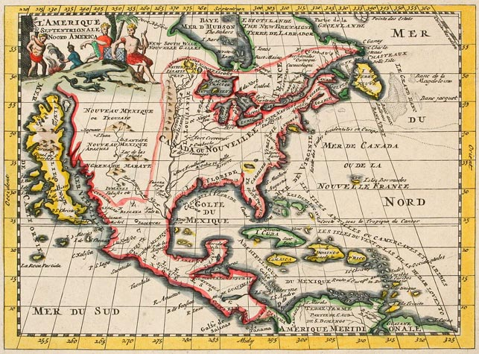

II Where Does Learning Begin
- Small Group Activity
Each group will be getting part of the story of the Williams Family.
In your group,
1. please read the selection you have been given
2. be prepared to explain to the other groups how the story of the Williams family began in the location described in your reading
3. note any questions you have

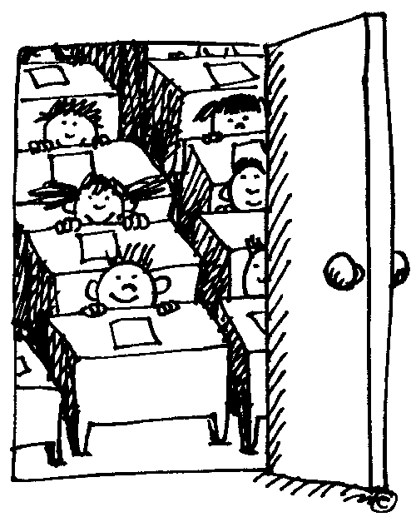
- Now think about the students in your class. Where does the story of their learning begin? Do all of their stories begin in the same place?
Turn to the person sitting to your right. Briefly discuss where learning begins in your classroom. There are no right or wrong answers here. Be prepared to present your partner’s answer to the group.

III. Reflective Practice
ME 9/1 | ME, Year 1 | Supervisor | Colleague | Beloved Student | Challenging Student

GOAL

Objective #1:

Objective #2:

Objective #3:

IV. Please go to Supporting Materials Document

V. Components of All Learning: Perspective/Bias/Choice/Narrative
A. Visual Texts
- Choice
- Bias
- Perspective
- Changing Knowledge
- Narrative

B. What is a Map??
1. Basic Questions:
- What Goes on a Map?
- Who Uses Maps?
- How Do You Make Maps?--as you review map elements

2. Let’s Make a Map: Restrict Options

3. Map Rules
· Maps are about Choices
· Reason we make a map affects Choices
· Person doing the Choosing Affects Choices
· You can only MAP WHAT YOU KNOW

4. Let’s Play History Detective

5. How can what we know change???

6. Which is the Better Visual?

7. Maps Tell Stories

Interesting Images of Brookline:
http://www.beaconinn.com/wp-content/uploads/2013/01/BPC-14-1024x645.jpeg
http://www.historicmapworks.com/Map/US/1567925/Plate+023/Brookline+1913/Massachusetts/

What is a Map? Resources
Ptolemy Map http://maps.bpl.org/id/m8610
1702 World Map http://www.geocurrents.info/wp-content/uploads/2014/06/map-31492.jpg
Two Boston Maps
1630: http://maps.bpl.org/id/10924
1723: http://maps.bpl.org/id/11122
Two China Maps
http://maps.bpl.org/id/m8785 and http://maps.bpl.org/id/m8696

B. Lessons in Language
1. Choices Matter
Working with a partner, in each sentence pair, please circle the simple subject. Draw a box around the main verb.
Who is doing the action? Who is being acted upon?
What is simple predicate (main verb) of each sentence or phrase?

Set #1:
John leaves the country.
Rebel leader, John Smith, was ousted from the war torn area.

Set #2:
Susan cries in sadness.
William berates Susan for her sadness.

Set #3:
Rebels are victorious in battle.
Patriots suffer defeat at hands of unruly mob.

Although this seems to be a lesson of grammar and vocabulary, also a lesson in perspective, bias, choice, narrative and changing knowledge. It may be used in a variety of ways with students—Social Studies, Science, English, Math and of course Judaics. Works even better if you have visuals to support.
OK—now try a set from your subject matter. Post on the wall and then we’ll do a Gallery Walk.
2. Story Jigsaw
Step 1: In your group, decide how your character sees the story and present his/her version.
Step 2: Have the students count off in each group—1, 2, 3, and so on
Step 3: Now put all the 1s in a group, all the 2s and so on
Step 4: Now the ‘mixed’ groups have to present the story, balancing the points of view of the narrative from each character’s point of view. The story may be presented in the following way:

Orally (song/skit)
Visually (drawing/3-D representation)
In Writing (Headlines/Captions/Tweets, Paragraph)
(Or some combination)

For younger students, you might want to do the
Number/Letter Activity
Draw the Room Activity [NB: these are both essential to Visual Documents activities as well]
This activity works well with any topic that has a narrative.

There are other ways to ‘divide’ things in a jigsaw. Find someone who teaches the same topic you do and try to ‘jigsaw’ a lesson.

3. Facts and Opinions
It’s cold out
It’s 42 degrees out

John is short
John is 5’2”

Mr. Smith is a hard teacher
Mr. Smith gives 60 minutes of homework each night

Ok, now generate 2 examples in your discipline that you might use with your students

