NEHA SUPPORTING MATERIALS SEPTEMBER 1

Part I: Ice Breaker (on the work plan)
Part II: Where Does Learning Begin? (on the work plan)
Part III: Reflective Practice (on the work plan)

Part IV: ASSESSMENT

For all of these, please consider the following questions:
1. How does the lesson reflection his instructional goal?
2. How does the lesson connect his specific objective to his instructional goal?
3. What is does this lesson specifically assess?
4. Does it provide criteria for assessment, i.e. do the students know the metrics by which they will be evaluated?
5. How might this information be communicated to them?
6. How does this lesson connect to the other 4 instructional goals—
· Meeting Diverse Needs
· Well Structured Lessons
· Clear Expectations
7. What might be some good next steps for this teacher?

GRADES 1 & 2: LESSONS IN PERSPECTIVE
http://mattersofeducation.org/materials_k-2/building-perspective
Provided by facilitator

GRADES 3 AND 4: THE ONE SENTENCE PROJECT
Please read the following lesson reflection from Kim, a Grade 3 public school teacher in Massachusetts. Prior to reading her lesson, look at the One Sentence Project strategy:

ONE SENTENCE PROJECT
Daniel Pink explaining the project
http://www.danpink.com/2010/10/whats-your-sentence-the-movie/
Examples
http://vimeo.com/18347489
Extend to education—one sentence about a book you read, a person you learned about, an event
what you want the students to understand
Illustrate your sentence
Do one sentence for key terms—like Teacher, Student or subject matter-Math, Science or halachic concept

Kim, Grade 3 Teacher,
Lesson Reflection

Brief Overview of the Lesson:
Wrap up an author study of Patricia Polacco with the One Sentence Project.

Estimated Time Required for the Lesson: 30­45 minutes

Prior Knowledge Required:
Knowledge of Patricia Polacco gained by reading several of her stories from her life.

Lesson Objectives: Students will identify, locate, and summarize learning about the studied author.

Primary Sources:
The Keeping Quilt by Patricia Polacco
My Rotten Redheaded Older Brother by Patricia Polacco
Thundercake by Patricia Polacco
Thank you, Mr. Falker by Patricia Polacco
The Junkyard Wonders by Patricia Polacco
Chicken Sunday by Patricia Polacco

Materials: Chart paper, Poster board, pencils, crayons

CCSS Standards:
RL.1 Demonstrate understanding by referring explicitly to the text.
RL.10 Comprehend literature.
RI.2 Recount key details.
RI.7 Use information gained from illustrations and words in the text to demonstrate understanding.
L.1i Produce simple, compound and complex sentences.
SL.4 Report on a topic or text.

Lesson Procedure:
After reading the memories of Patricia Polacco, wrap up the author study with the One Sentence Project.

1. Group students in groups of 4 ­ 6. Each group will brainstorm a list of facts they have learned about the author and will record them on chart paper. Students must also identify which book each fact came from.

2. Each individual student will select one fact and will write it as a complete sentence on his or her poster. Facts can not be duplicated.

3. Each student will illustrate his or her one sentence.

4. Each student will share his or her project orally with the class.

Reflections:

1. This lesson went very well. The students were excited to work with one another and to be able to share their learning in an artistic way. They generated so many facts that I had to urge them to move on. Each group was given the books as references but most students knew just which
books their facts originated from without needing to look back in the text. I did have them go back if they were unsure of which book their fact originated from or if they needed help spelling a word I knew could be found in the text.

What I was really excited about was how they were able to interpret story events and write them as concrete facts. For example, in Thundercake, Patricia shares her story of being a young girl who was afraid of thunderstorms. When a storm hits, her babushka takes her to gather all of the ingredients for Thundercake and they bake one. One student's sentence was "Patricia's babushka helped her face her fear of thunderstorms by distracting her." This is a third grader!

2. I learned that some of my students are still concrete thinkers ("Patricia was scared of thunder") while others are able to interpret story events. I also learned that many are quite creative and artistic. I asked for their feedback on this lesson and all agreed it was fun. I I don't think they were even aware that I was assessing their learning. Best of all, they asked when we could do this again!

3. I learned that I rely too heavily on paper/pencil assessments and can assess my students in more engaging and creative ways. I also learned that these types of "assessments" actually reveal more about some of my students than a graded assessment might have.

GRADE 5/6 ASSESSMENT: TAKE ME OUT TO THE BALL GAME
http://mattersofeducation.org/materials_3-5/take-me-out-to-the-ball-game/
Provided by facilitator

Grade 7/8 ASSESMENTS
(two choices here—Science or Social Studies)
A NEW KIND OF POP QUIZ: MS Science
Popping open a can of soda, Alan Rodas told his junior high school science class that they were about to learn more about one of their favorite beverages - soda pop. They would be given two unmarked samples of soda. Without tasting the pop, students were to decide which was the diet variety and which was the regular kind -based solely on the samples' physical and chemical properties.
Their task was to identify and evaluate promising laboratory techniques for distinguishing the regular soda from the same brand's diet variety. They were to devise a research plan, test the techniques that they had proposed to see which was most reliable scientifically, and apply the technique they had identified on unknown samples of soda. Their work would be done in small groups.

The "pop quiz" was designed to help Mr. Rodas and his class gauge students' progress along several important dimensions, including their capacity to:

• Understand scientific concepts and principles and apply them to real - world situations;
• Design an empirical test;
• Apply scientific laboratory procedures; and work effectively with peers.

Mr. Rodas asked students to get started by themselves. They wrote down at least three ways to distinguish between the two sodas, and explained why they chose those methods.

Then they joined small groups and brainstormed. Each group chose two tests to carry out and designed an experimental plan for these tests. Students chose a variety of techniques, including testing the samples' boiling point, freezing point, density, conductivity, and solubility. Some students suggested using the "sticky test" or urine glucose test strips to gauge sugar content. Some wanted to add yeast and Benedict's solution to test chemical reactions of the samples. Others suggested adding sulfuric acid to identify caramel. Students also proposed testing the samples' aroma, color, and amount of fizz.

To challenge his students, Mr. Rodas put our various pieces of equipment and materials that were not necessarily needed. He encouraged the class to use these materials in ways that were not thought of previously.

Once Mr. Rodas approved their plans, the groups carried out their experiments. Then groups prepared a report of their results and presented their findings orally to the class. Mr. Rodas filled out a form for each group gauging how well they met the objectives. Performance was rated as "excellent, "good," or "needing improvement." If a student's work was exceptional, he noted that
Each group also rated each member's performance on the following measures: group participation; staying on the topic; offering useful ideas; showing consideration to other group members; judging the extent to which each involved others; and ability to communicate. If the group could not agree on a rating, they could comment on the process.

When the ratings were complete, Mr. Rodas asked the students to finish the exercise by themselves. He told them to imagine that they were given two samples of liquids, one containing a mixture of two sugars (fructose and sucrose), the other containing only one of the sugars.

Students were asked to list all of the tests that had been hied on the soda samples that would also be useful in testing the two new samples. Then Mr. Rodas asked students to propose other tests.

Finally, students were asked to react to the experiment, stating what they liked and didn't like; how they felt about working in the group; why they would or would not like more group problem-solving activities; how they felt about using tasks to evaluate knowledge and skills; and what, if anything, they had learned.

Then Mr. Rodas opened up a case of soda and the class happily consumed its evidence.
Source: The National Center for Improving Science Education, 50.39
Grades7/8 Social Studies MASSACHUSETTS AND POLITICAL POWER:
Please use the following graph and answer the questions below

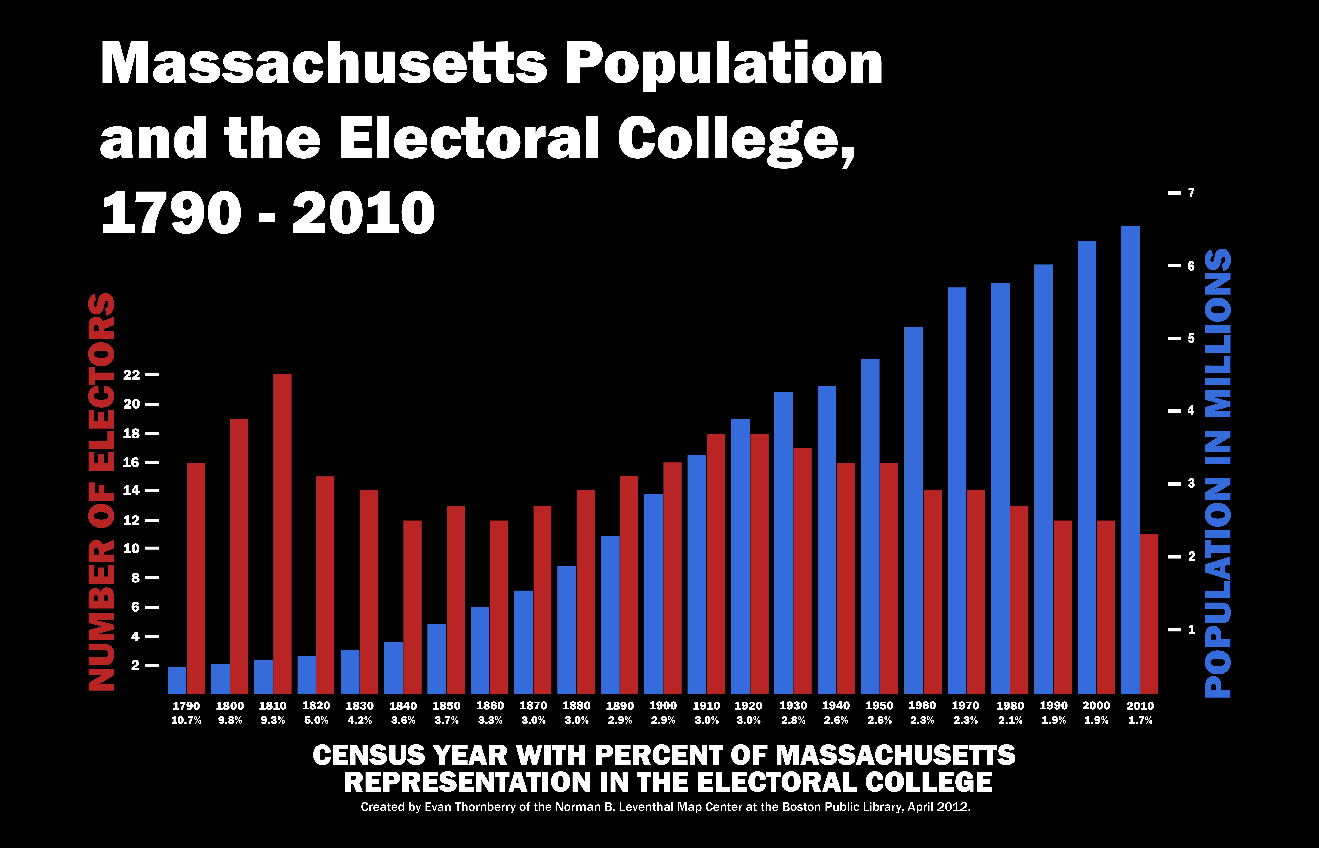

- What do the Red lines represent?
- What do the Blue lines represent?
- What information is shown in white?
- Have things improved for the voters of Massachusetts? Use the information in the graph to write a well structured paragraph defending your answer.
- Write two other questions you could answer using the information in this graph.

