REMEMBERING IMPORTANT EVENTS AND PEOPLE
How do we honor the memory of someone from the past? Throughout Boston, we have many memorials and landmarks to those who fought in the Civil War. Students will see images of not only these men but also their mementos, what was important to them. They will then create their own memorial to someone or something that had personal meaning to them.

Procedure

- Discuss the idea of a memento, a personal artifact.
- Show the students the war mementos from the exhibition and have them complete Part I of the Student Sheet. They may do this as a class, in small groups or for homework. Discuss their results.
- Many of the people from that time also had monuments built to them. Show the Students the images of the following monuments: Lions in the McKim Building, Shaw Memorial, Sumner Statue and have them complete Part II of the Student Sheet. They may do this as a class, in small groups or for homework. Discuss their results.
- Now ask the students to think about creating their own memorial, using Part III of the Student Sheet as a guide.

Time Allocation

Part I: 10 minutes
Part II: 15 minutes
Part III: Time to Research Topic: Homework and class time
Time to Create Own Image: Home work and class time
Class Presentations: Up to your discretion

Materials Needed
War Memento 1: The Book of Common Prayer http://www.flickr.com/photos/59843331@N03/5468269013
War Memento 2: Mementos of Francis Palfrey http://www.flickr.com/photos/59843331@N03/5468269561/
War Monument 1: Statue of Charles Sumner http://www.flickr.com/photos/59843331@N03/5468861888/
War Monument 2: Memorial to Robert Gould Shaw, by Augustus Saint-Gaudens located at http://www.flickr.com/photos/59843331@N03/5468267973/
Saint-Gaudens Lions, Grand Staircase, Boston Public Library http://www.flickr.com/photos/59843331@N03/5468269747/
All of the above items may be found at http://www.flickr.com/photos/59843331@N03/

Assessment Criteria

Did students learn about important individuals and groups from the Civil War?
Did students learn what was important to some of those of who fought in the Civil War?
Did student choose a way to present a memorial of someone important to them?

Enrichment Activities

Go to the Commons and visit the Memorials to Shaw and Sumner.
Do you have things that you save? How do you decide what to save? Why are these items important to you? In this lesson, you will see things that soldiers who fought in the Civil War saved. You will also see what other people decided was important to remember about them too.

Part I
Look at the pictures of the following objects and answer these questions:
- What objects did this soldier save?

- Why do you think they were important to him?

- What would you save if you had been in a battle?

- What would you want your family to have?

Part II
These monuments were built to honor or remember important individuals or groups.
- The lions were put in the library to honor a group of young men. Why do you think they chose two lions?

- Charles Sumner fought against slavery in Congress long before the Civil War. How does his statue show what was special about him?

- Charles Gould Shaw and the Massachusetts 54th Regiment also fought for the rights of black people. How does their memorial show the way helped?

Part III
Now it is your turn!!!
You will get to create a memorial.

GATHER INFORMATION
- What are the important details of the story you want to tell?

- What other information should you include?

PLAN
- How are you going to tell your story?

- What materials will you need?

TELL YOUR STORY

CHECK TO SEE IF YOU LEFT ANYTHING OUT

The Book of Common Prayer War Mementos

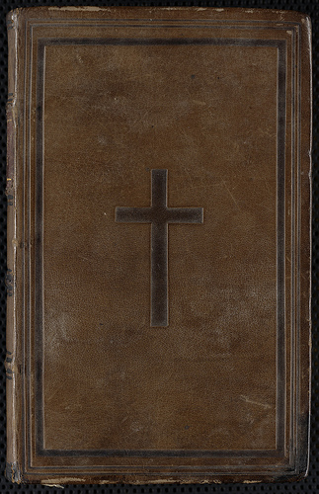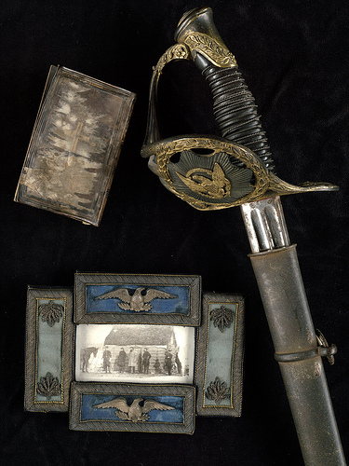

Col. Francis W. Palfrey’s Civil War memorabilia, including a photograph framed with epaulets, and his sword

A photograph, framed with epaulets, of officers standing in front of a cabin at Antietam, his sword, and a prayer book are several of the more unusual items found among the Civil War related artifacts and books saved and collected by Col. Francis W. Palfrey. The prayer book, which is inscribed with Palfrey’s initials, reportedly saved his life by stopping a bullet when he was wounded at Antietam.

Palfrey’s widow donated his collection to the Boston Public Library in 1892. These materials form the cornerstone of the 20th Regiment Collection, which continues to be funded by residue moneys contributed by the 20th Massachusetts Regiment Association for the installation of the Louis Saint-Gaudens lions on the landings of the Library’s grand stair case
Statue of Charles Sumner

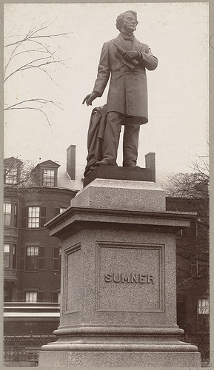

A great bronze statue, located on the south side of the Public Garden, honors Charles Sumner, U.S. Senator, orator, and staunch abolitionist. This memorial, created by the noted sculptor Thomas Ball, stands nine feet tall and sits on a twelve-foot tall square granite pedestal. Bearing no inscription except the subject’s last name, it was unveiled on December 23, 1878, to an audience of 300 with very little formality.

Born and educated in Boston, Sumner entered the U.S. Senate as a Free Soil candidate, later becoming a Radical Republican. He spoke harshly against the institution of slavery, including a stern speech titled “The Crime against Kansas” directed toward the authors of the Kansas-Nebraska Act.

Memorial to Robert Gould Shaw, by Augustus Saint-Gaudens

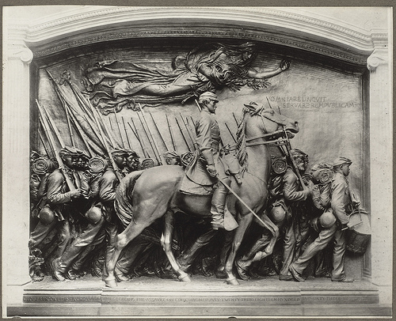

During the last decade of the 19th century, several more important sculptures were added to the city’s growing list of Civil War monuments. One, known as the Shaw Memorial, was unveiled May 31, 1897, on the Boston Common facing the State House. It was designed by Augustus Saint-Gaudens, the nation’s premier sculptor.

It immortalizes the brave soldiers of the all black 54th Massachusetts Volunteer Infantry Regiment and their colonel, Robert Gould Shaw, who gained recognition for their ill-fated attack on Fort Wagner near Charleston, South Carolina, July 18, 1863. This bronze relief is eleven feet tall and fourteen feet wide; it depicts three rows, increasing in depth, of fully equipped soldiers marching off to battle, and in the foreground is an impressive equestrian statue of Colonel Shaw.

Saint-Gaudens Lions, Grand Staircase, Boston Public Library

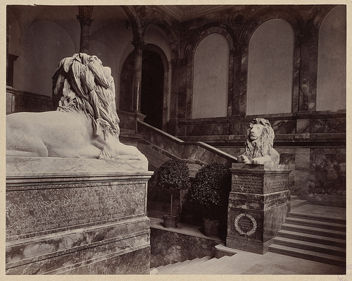

Another memorial erected in the 1890s consists of twin lions mounted on either side of the grand stair case at the new Boston Public Library in Copley Square, which opened to the public in February 1895. These sculptures were designed by Augustus Saint-Gaudens’ brother, Louis.

The two large reclining lions were carved from solid blocks of unpolished Sienna marble. One sculpture is dedicated to the 2nd Massachusetts Infantry and the other honors the 20th Massachusetts Volunteer Infantry, also known as the Harvard Regiment. Directly below the lions’ paws, there is a list of the battles and campaigns in which each regiment took part

