ROAD TO THE CIVIL WAR
The causes of the Civil War are complex and complicated. Historians who have grappled with the subject for years remain frustrated that the nation was unable to resolve its differences and reach successful compromise over its conflicts. And perhaps that is the place to begin with your students.

Procedure

- Begin with the general state of affairs of the country in the 1850s. Use the Map of Slavery and Freedom and have Students complete Part I of the Student Sheet. You may do this as a class, in small groups or individually. Discuss their results. Be sure they become aware that the fate of the Yellow areas is important to both the Slave and Free States.
- Discuss the Fugitive Slave Law with your students. Begin by talking about property in general. Do they think you should return someone’s property? Suppose that property is a human being. Have them read the pieces below on the Act and on Anthony Burns and look at the Anthony Burns lithograph. Have them complete Part II of the Student Sheet. You may do this as a class, in small groups or individually. Discuss their results. Be sure they understand that just calling something a compromise does not necessarily make it one.
- Many other important events occurred during the 1850s but the pattern was the same—the unwillingness or inability to find common ground. When Abraham Lincoln was elected in 1860, the Southern States felt they had no choice but to secede from the Union.
Have Students look at the 1860 Presidential Election Map and the Torn in Two cartoon and complete Part III of the Student Sheet. Discuss their results.

Time Allocation:

Part I: 20-30 minutes Part II: 30-45 minutes Part III: 10-15 minute

Materials Needed

Anthony Burns Lithograph (http://www.flickr.com/photos/59843331@N03/5492481118/in/photostream)
Brief overview of Anthony Burns (http://www.blackpast.org/?q=aah/burns-anthony-1834-1862)
Overview of the Compromise of 1850 and The Fugitive Slave Act (http://www.pbs.org/wgbh/aia/part4/4p2951.html)
Torn in Two Cartoon (http://www.flickr.com/photos/59843331@N03/5468266621/in/photostream)
Slavery and Freedom Map (See Lesson 6)
(http://maps.bpl.org/details_14346/?srch_query=1856&srch_fields=all&srch_style=exact&srch_fa=save)
Presidential Election of 1860 Map (http://maps.bpl.org/details_12403/?dl_pp=1&srch_query=paullin&srch_fields=all&srch_style=exact&srch_fa=save)

Assessment Criteria

Did students understand the role the following issues played in causing the Civil War?:
- The extension of slavery into Western territories
- The tension between states rights and the federal government
- The breakdown of the ability to compromise
Did students explore different types of images that showed the mounting tensions?

Enrichment Activities

1. Have Students learn about other important events of the 1850s that further reduced the nation’s ability to find middle ground or compromise:
The Kansas Nebraska Act The Dred Scott Decision
2. Have students present other historical events in the same manner as the Burns lithograph or the political cartoon.

Common Core Curriculum Standards

English/Language Arts: Anchor Standards: CCSR for Reading
Key Ideas and Details
CCSS.ELA-Literacy.CCRA.R.1 Read closely to determine what the text says explicitly and to make logical inferences from it; cite specific textual evidence when writing or speaking to support conclusions drawn from the text.
Integration of Knowledge and Ideas
CCSS.ELA-Literacy.CCRA.R.7 Integrate and evaluate content presented in diverse media and formats, including visually and quantitatively, as well as in words
CCSS.ELA-Literacy.CCRA.R.9 Analyze how two or more texts address similar themes or topics in order to build knowledge or to compare the approaches the authors take.

English/Language Arts: History and Social Studies
Key Ideas and Details
• CCSS.ELA-Literacy.RH.6-8.1 Cite specific textual evidence to support analysis of primary and secondary sources.
Integration of Knowledge and Ideas
CCSS.ELA-Literacy.RH.6-8.7 Integrate visual information (e.g., in charts, graphs, photographs, videos, or maps) with other information in print and digital texts.

By the 1850s, things were very tense in the United States. North and South were different in terms of how people earned their living. The Western part of the country was very important too. But the biggest problem seemed to be that people forgot how to COMPROMISE.

Part I
Look at the Map of Slavery and Freedom and answer the following questions:
- What do the blue areas show? The pink areas? The yellow areas?
- Which part of the map takes up the largest amount of space?
- Look at the charts below the Map under the Free States. Find the Column Area in Square Miles. How much is in the Slave States? The Free States? The Territories?
- If you were from a Blue state, would you want the Territories to be Blue or Pink? Suppose you were from a Pink state, how would you feel?
- Find the Column Capital and In Manufactures. How much is in the Free States? The Slave States? The Territories? Where is most of the manufacturing the United States?

Part II
- What were some of the problems facing the country in 1850?
- How did Henry Clay and the others try to solve the problem?
- What solutions did they propose?
- What were the terms of the Fugitive Slave Law of 1850? Earlier you learned that a compromise was trying to find a middle ground between what two sides wanted. Was this law a compromise? Why or why not?
- Look at the pictures of Anthony Burns. How does it tell his story?
- Would you have returned Anthony Burns? Would you have helped runaway slaves even if it meant breaking the law?
- You learned about Compromises when you learned about the Constitution. Does the Compromise of 1850 seem like a real compromise to you? Why or why not?

Part III
Look at the Presidential Election of 1860
- How many candidates ran?
- Why do you think there were two candidates from the same party?
- How does this fact show how little compromise there was, even within a single party?
- Did any candidate win an entire state?
- Compare this map to the Map of Slavery and Freedom. How did Lincoln do in the Free states? The Slave states? What do you the people in the slave states will do after he wins?

Now look at the Torn in Two Cartoon
- What are the men in the picture doing?
- What do the words say?
- Do they seem to fit the picture?
- Suppose there were no words—what words would you put with this picture?
- Think one more time about compromise. What do the images in the cartoon say about compromise?

Anthony Burns Lithograph

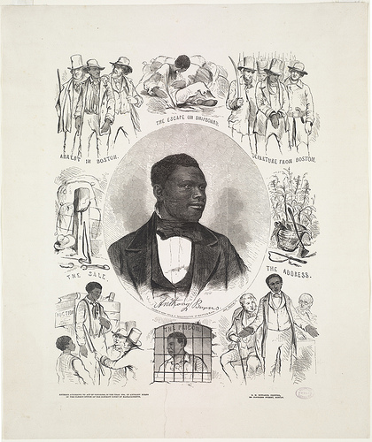

Anthony Burns (1834-1862)

The youngest of 13 children, Anthony Burns was born May 31, 1834 into slavery; his family was owned by the Suttle family of Virginia. His mother married three times; Burns’s father was her third husband. Burns’s father died when his last child was very young.
A few years later their owner, John Suttle, died leaving his wife with financial problems which prompted her to sell five of Burns’s siblings. To gain more income, she hired out the remaining siblings including Anthony. Burns performed a variety of jobs including personal servant, sawmill worker and tavern employee. He also was given the responsibility of managing four other slaves owned by Mrs. Suttle; he was allowed this freedom as long as he paid his master a fee from his earnings.
In March of 1854, Burns escaped from his master in Virginia and boarded a ship to Boston. When he arrived in Boston he found employment with a clothing store operated by Lewis Hayden, an abolitionist. His freedom was short-lived, however. On May 24, 1854, Burns was arrested under the Fugitive Slave Act, a component of the Compromise of 1850. This controversial federal law allowed owners to reclaim escaped slaves by presenting proof of ownership.
In support of Burns, many black and white Boston abolitionists who opposed the Fugitive Slave Act seized on the Burns arrest as a way to demonstrate their disapproval of the federal statute. On May 26, 1854, Lewis Hayden and Worcester clergyman Thomas W. Higginson led the abolitionists in an attack on the Suffolk County Courthouse in a futile attempt to free Burns. Their action resulted in the death of one marshal and the arrest of 13 people. The next day, Burns was sent to trial where he was represented by Richard Henry Dana, Jr., a prominent white Boston attorney who stepped forward to defend him without charge, and African American attorney Robert Morris. Despite their spirited defense, Judge Edward G. Loring ruled in favor of Suttle, citing the Fugitive Slave Act.
To ensure the judge’s order to return Burns to Virginia slavery, about 2,000 federal soldiers were assigned on June 2, 1854 to escort Burns to a Boston dock and waiting ship. Anthony Burns, surrounded by soldiers, was marched through an angry crowd of abolitionists on the way to the harbor. There he was placed on the ship and returned to Virginia. Boston abolitionists, however, did not give up on liberating Burns from slavery. Boston Baptist preacher Leonard A. Grimes led supporters in raising money to purchase Burns’s freedom. On February 22, 1855 their efforts succeeded and Burns returned to Massachusetts a free man.
Burns later attended Oberlin College in Ohio and then spent time as a pastor of a black Baptist church in Indianapolis. Later he moved to Canada where he became the pastor of St. Catharine’s Ontario Baptist Church. On July 17, 1862, Burns died in Ontario at the age of 28.
Sources:
Joseph Meredith Toner, Boston Slave Riot, and Trial of Anthony Burns: Containing the Report of the Faneuil Hall (Detroit: Fetridge and Company, 1854); http://pbs.org; http://www.masshist.org.

Torn in Two Cartoon

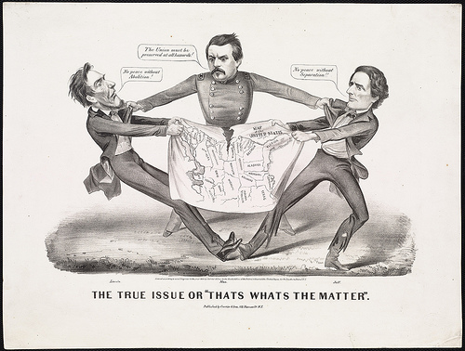

Presidential Elections of 1860 Map

