Cardinal Spellman HS Workshop Materials December 1, 2015

Why Complex Teacher Evaluations Don't Work By Mike Schmoker EDWEEK August 28, 2012
Here they come: those complex, bloated, evaluation templates that are now being dumped on teachers and administrators. These are supposed to make schools perform better.
Once again, we are rushing into a premature, ill-conceived innovation—without any solid evidence that it promotes better teaching. These jargon-laced, confusing documents are to be used to evaluate or even to compensate teachers on the basis of multiple, full-period, pre-announced classroom observations. Each observation is to be preceded and followed by meetings between teachers and administrators that will require enormous amounts of time, paperwork, and preparation. Like so many past reforms, this one will be launched nationally, like a bad movie, without being piloted and refined first. (Imagine if we did this with prescription drugs.) It will consume a disproportionate share of precious training time and promote misguided practices that could endure for the next decade. Rather than improve schools, it will only crowd out and postpone our highest, most urgent curricular and instructional priorities.
Don't misunderstand me: Teacher observation and evaluation are among the strongest components of effective school-improvement efforts. If you visit classrooms across the nation (as many of us do), you know that most teaching is at odds with some of the most obvious elements of sound practice. But these frameworks aren't the solution. They lack clarity and focus, and their use should be postponed on the basis of their sheer bulk (most are dozens of pages long) and their murky, agenda-driven language.
In February, The New York Times reported that one of these frameworks contains an astonishing 116 "subcategories" by which educators' lessons are to be assessed. I can only imagine teachers, whose morale is already at a record low, encountering these unwieldy instruments and the anxiety they will provoke.
Done right, teacher evaluation could ensure precisely the kind of systematic action that would guarantee immediate improvement, i.e., by clarifying a minimal set of the most essential, widely known criteria for effective curriculum, such as rich content taught largely thought literacy activities and sound instruction.

Once clarified, evaluation would then focus on only one or two elements at a time, with multiple opportunities for teachers to practice and receive feedback from their evaluators. Teachers' progress and performance on these criteria would be the basis for evaluation.
Jim Collins, the business consultant and author of Good to Great, and the organizational-improvement expert Marcus Buckingham discovered that the performance and morale of both employees and managers skyrockets when managers:
• Severely reduce the number of criteria by which they judge an employee's performance; and
• Have "crystal clarity" for those very few criteria, abandoning any language that could confuse a practitioner.
Teachers need assurances that we will never, ever require them to pore through dozens of bewildering boxes and bullets about how they should perform. Policymakers have yet to learn that less is more with respect to strategic planning, our (still-gargantuan) standards documents, or our ever-expanding and exotic menus of programs and professional-development offerings. And now teacher-evaluation frameworks.
One popular multipage framework requires that lessons be taught with "simultaneous multisensory representations" during the lesson and "facilitation . . . that results in students' application of interdisciplinary knowledge through the lens of local and global issues." Another framework—in similarly mangled language—requires that lessons "reflect understanding of prerequisite relationships among topics and concepts and a link to necessary cognitive structures." I guarantee that is not the kind of advice average teachers need to improve their lessons. Moreover, most of these frameworks insist—against all research and evidence to the contrary—that teachers must provide lessons that include special materials for each individual student or subgroup, all while addressing dozens of other criteria.
We'll never improve instruction this way. Here's the alternative.
First, we should do everything in our power to ensure that there is a clear, coherent curriculum in place before we attach high stakes to any evaluation. The absence of such a curriculum explains a great portion of the aimless, ineffective lessons we see in our schools. In addition, this curriculum must include generous amounts of what is now—finally—being emphasized in the "three shifts" that capture the essence of the English/language arts common core, i.e., daily opportunities to read, discuss, and write. These should all be grounded in evidence found in high-quality, content-rich texts across the disciplines. This simple, timeless emphasis is the key to success on tests, in college, and in careers. It is nowhere to be found, however, in our most popular evaluation templates.
Without such a curriculum, instruction inevitably devolves into the kinds of inane worksheets, group activities, and misguided practices that now predominate in our schools.
Once such a curriculum is in place, we should evaluate teachers on whether they are actually implementing and improving their curriculum in teams, with their same-course colleagues.
"Done right, teacher evaluation could ensure precisely the kind of systematic action that would guarantee immediate improvement."
Finally, we should observe and evaluate teachers on the basis of (mostly) short, frequent, unannounced classroom visits, using the same, few, age-old criteria. The noted researcher Robert Marzano, among others, exhorts us to regard these as "routine components" of any and every effective lesson:
• Attention and engagement (i.e., steps are taken to ensure that all students are attentive and on task throughout the lesson);
• A clear, well-defined purpose and objective to the lesson; followed by ...
• Multiple short segments of instruction; immediately followed by ...
• Opportunities for students to process or practice what was just taught, while the teacher checks and monitors to see how well the class has learned; followed by ...
• Adjustments to the lesson and the pace of the lesson to ensure that all students, or as close to that as possible, can succeed on each phase of instruction, until they can achieve the objective of that day's lesson or group project.
These elements, which guarantee improvement, can actually be found in some of the evaluation frameworks. But they are not written clearly or prominently enough to be seen as indispensable priorities. Instead, they are obscured by the dozens of other specious, confusing evaluation criteria that surround them. To reiterate: The observations that are the basis of an evaluation must occur largely unannounced. We can't afford to repeat the feckless protocols refuted decades ago—those built around pre-announced visits, followed by lengthy pre- and post-conferences.

Until this changes, as the author and teacher-evaluation expert Kim Marshall and others have made so clear, teacher evaluation will continue to be nothing more than what teachers and administrators have aptly called a dog-and-pony show, with one difference: It will be even more confusing and time-consuming.
It is high time that the reform community grows up and learns that schools won't improve until we put the brakes on untested, overblown initiatives. These prevent us from focusing on the most effective practices long enough for them to take hold.
Clear, minimalist, priority-driven teacher evaluation could play a central role in ensuring that such practices become the norm. If they do, we will beyond any doubt hasten the improvement of schools in virtually any setting.

OBSERVATION OPTIONS

Five-Minute Observation Form
In the box next to each General Feature indicate +, -, or NA.
Check the circle next to each observed area.

Instructor models instructional tasks when appropriate.
- Demonstrates the task (e.g., uses think alouds)
- Proceeds in step-by-step fashion
- Limits language to demonstration of skill
- Makes eye contact with students, speaks clearly while modeling skill

Instructor provides explicit instruction.
- Sets the purpose for the instruction
- Identifies the important details of the concept being taught
- Provides instructions that have only one interpretation
- Makes connection to previously-learned material

Instructor engages students in meaningful interactions with language during lesson.
- Provides and elicits background information
- Emphasizes distinctive features of new concepts
- Uses visuals and manipulatives to teach content as necessary
- Makes relationships among concepts overt
- Engages students in discourse around new concepts
- Elaborates on student responses

Instructor provides multiple opportunities for students to practice instructional tasks.
- Provides more than one opportunity to practice each new skill
- Provides opportunities for practice after each step in instruction
- Elicits group responses when feasible
- Provides extra practice based on accuracy of student responses

Instructor provides corrective feedback after initial student responses.
- Provides affirmations for correct responses
- Promptly corrects errors with provision of correct model
- Limits corrective feedback language to the task at hand
- Ensures mastery of all students before moving on

Instructor encourages student effort.
  - Provides feedback during and after task completion
  - Provides specific feedback about student’s accuracy and/or effort
  - Majority of feedback is positive
  - Celebrates or displays examples of student success in reading

Students are engaged in the lesson during teacher-led instruction.
- Gains student attention before initiating instruction
- Paces lesson to maintain attention
- Maintains close proximity to students
- Transitions quickly between tasks
- Intervenes with off-task students to maintain their focus

Students are engaged in the lesson during independent work.
- Independent work routines and procedures previously taught
- Models task before allowing students to work independently
- Checks for student understanding of the task(s)
- Students use previously-learned strategies or routines when they come to a task they don’t understand
- Independent work is completed with high level of accuracy

Students are successful completing activities at a high criterion level of performance.
- Elicits a high percentage of accurate responses from group
- Elicits a high percentage of accurate responses from individuals
- Holds same standard of accuracy for high performers and low performers

COMMENTS:

Classroom Walk Through Checklist

Scoring: 3 = Evident 2 = Somewhat Evident 1 = Not Evident 0 = Not Observed

Instruction (36 possible) Subtotal:
During the 90 minute reading block, the district’s reading materials are implemented with a high degree of expertise
The district’s identified supplemental and intervention materials are used with fidelity
Explicit instruction occurs during most of the observation (Model – Prompt – Practice)
Objective(s) for the lesson is/are clear and articulated
Reading materials are organized, accessible, and proficiently used effectively and efficiently
Reteaching occurs when necessary
Modeling is provided by teacher, followed by guided practice with ample opportunities for students to practice skill(s)
Direct instruction of vocabulary – word identification and word meaning
Comprehension skills are modeled and directly taught for literal, inferential, and critical
Teacher sets purpose of reading through text structures (C/C, C/E, Descriptive, Q/A, P/S, C/S, Prop/Sup)
Pacing is appropriate for reading level with high expectations for all students

Students are engaged: (6 possible) Subtotal
Teacher talk: | All students respond: | One student responds: | Time observed:  12-18 minutes
List observed strategies (i.e., unison responses, choral reading, partner reading, think-pair-share, cloze technique

Teacher behaviors: (9 possible) Subtotal
Teacher moves around the room (proximity), provides support for struggling students, checks for understanding
Teacher uses a brisk pace, knows materials, uses clear instructional routines and procedures
Teacher uses established classroom management procedures and routines – Transitions less than 2 minutes
(Total Points Possible = 51) Total Points
STORY JIGSAW
Once students are familiar with the text of a story, divide into groups and have each group take on one of the major characters from the story. Each group decides what its character’s point of view is.

Then count off within each group and mix them up, so now each group is comprised of all of the characters. Now the group has to tell the story, combining all the character’s points of views. They may present their version however they wish—in writing, song, visually but with the perspective of each character represented.

Works as a great way to review plot, character, theme, perspective, bias, narrative.

This strategy also works well with any content. It allows students to go deep, take ownership, and demonstrate mastery.

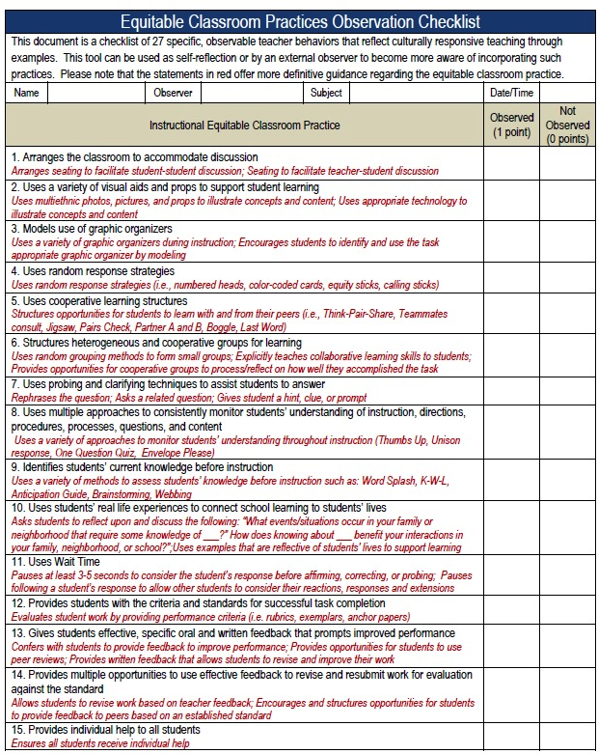
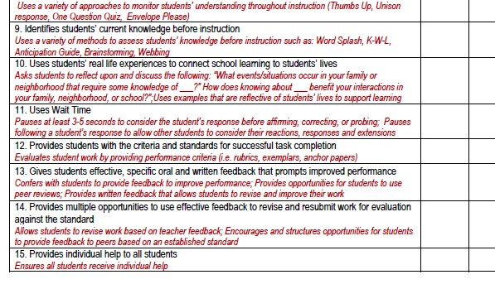

QUESTIONS TO FRAME FEEDBACK CONVERSATION:

- Tell me about the Highlights of your lesson.
- Was this lesson different from what you planned? If so, what do you think accounted for this difference?
- What evidence from this lesson tells you if your students achieved the lesson’s goals?
- Teachers make many decisions as they teach. What decisions did you find yourself making during this lesson? Tell me about some of them and please share your decision making process. How did you arrive at these decisions?
- What did you learn that you will apply to future lessons?

OR

- “I noticed that you [ ]...could you talk to me about how that fits within this lesson or unit?”
- “Here’s what I saw: [ ] ...is that what you thought was happening at the time?”
- “I noticed that [ ] ...how did you feel about how that went?”
- “I noticed that students [ ] ...how did that compare with what you had expected to happen when you planned the lesson?”
- “I saw that [ ] ...what did you think of that, and what do you plan to do tomorrow?”
- “At one point in the lesson, it seemed like [ ] ...did it seem that way to you, too? What was your take?”
- “Tell me about when you [ ] ...what made you choose that response?”
- “I noticed that [ ] ...could you tell me about what led up to that, perhaps in an earlier lesson?”
- “I found myself wondering if [ ] ...is that something you’re thinking about?”
- “What effect did you think it had when you [ ]?”

OR

- What do you want the teacher to know, think about or do differently?
Be specific.
- How will you start the conversation? With a statement or with a question.
Write the words you will speak.
- How will you get the conversation focused on the area that you want the teacher to improve on?
Write the words you will speak.
Giving Feedback | Receiving Feedback
- Focus feedback on behavior rather than the person.  - Focus feedback on observations, rather than inferences. Concentrate on what you can actually see or hear in the behavior of another person.  - Share ideas and information, rather than give advice. Focus feedback on exploration of alternatives, rather than answers or solutions. In the role of a facilitator, this is important to guide students to learn. Use strategies that challenge or encourage the student to look deeper into an issue, avoid giving them the answer. Ask open questions such as:  - How can you use this information to…  - What are the implications of…?  - Think of some more ways that you can …?  - Focus on a variety of procedures and means for accomplishing a particular goal.  - Focus feedback on the value it may have to the receiver. Help and feedback need to be given and heard as an offer, not as something you force upon another person.  - Focus feedback on the amount of information that the receiver can use, rather than on the amount you might like to give. Be sensitive as to the appropriate time and place to give feedback.  - Focus feedback on description, rather than judgment.  - Focus feedback on what is said rather than why it is said.  - To minimize the threat, use the ‘feedback sandwich’ approach. Give a positive piece of feedback then a negative and finish off with a positive comment. | - Thank the giver and respect their honesty and their point of view.  - Value the comments.  - Reflect on the feedback and make a decision as to whether it is reasonable or not. If reasonable, act immediately, or at least set up a plan for dealing with the problem or issue. If unreasonable, work through the problem or issue with the giver.  - Learn from the experience.  - Model the process for your students.  Cathy Down, RMIT, November 2000, cathy.down@rmit.edu.au

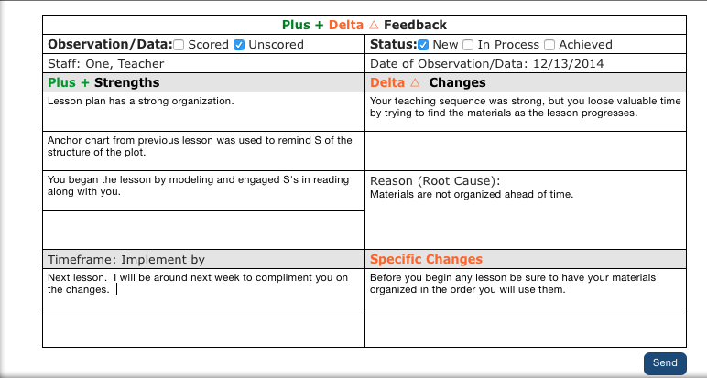

Faculty Observation and Feedback
Observation Organizer

Learning Focus | Strengths | Questions/Considerations
Prior Knowledge: What evidence did you see of the instructor assessing, using, correcting, or otherwise engaging with students’ prior knowledge of the course material?

Knowledge Organization: What evidence did you see of the instructor helping students organize course concepts to build appropriate understanding of the material?
Motivation: What evidence did you see of the instructor making clear the material’s value and relevance to real world phenomenon? What evidence did you see of the instructor making clear the kinds of effort necessary to acquire the skills being taught?
Mastery: What evidence did you see of students integrating and applying skills they were acquiring?
Practice and Feedback: What evidence did you see of students getting practice using course concepts towards an explicit goal and getting feedback on that practice (for example, practice questions, in-class activities, etc.)?
Class Climate: What evidence did you observe of the class climate being a good fit for students’ social, emotional, or intellectual needs? What active engagement among students did you see
Self-Directed Learning: What evidence did you see of students getting help learning how to learn? (Assessing the demands of a task, evaluating their own knowledge and skills, planning, monitoring their own progress, and making adjustments as needed?)
General Delivery/Facilitation: What aspects of delivery or facilitation drew your attention? Consider aspects of presentation skill, student-to-student interaction, student questions both asked and answered, use of technology, structure and pace of activities, etc.

LESSON SELF-REFLECTION TEMPLATE

Brief overview of the Lesson
Estimated Time Required for the Lesson
Prior Knowledge Required
Lesson Objectives
Essential Questions
Primary Resource(s)
Secondary Sources
Materials
CCSS STANDARDS
MA CONTENT STANDARDS
Teaching Strategy (ies)
Lesson Procedure
Questions
Formative Assessment(s)
Summative Assessment
Reflections | 1. Was the objective met for this lesson? What evidence do you have?  2. Were all students actively engaged with the lesson? If not, how could the lesson be modified to engage all  students?  3. Was the lesson plan easy to follow or does it need to be modified?  4. Was the material/technology sufficient?  5. Would I use this lesson again? Why or why not?  6. Would I recommend this lesson to others? If so, are  there special considerations to be made for using it?  7. Overall, how did the lesson go?  What worked well?  What didn’t work at all?  8. What did I learn from my students?  9. What did I learn about myself?

