THE SLAVE ECONOMY
At its core, slavery was an economic system. It was also highly unequal, with a small number of individuals wielding a great deal of power. Wealth was measured in property, land and slaves owned.

Procedure

- Show your Students the Southern Crop Map and have them complete Part I of the Student Sheet. Discuss their results.
- Now show the Students the Slave Distribution Map. First have them brainstorm. What are the first things they notice about the map? What do they think it is showing? What do they think the light and dark represent? Once they have had a chance to look at it for a while, have them complete Part II of the Student. You may do have students do this as a class, in small groups or individually. Discuss their results.
- Now show Students the Map of Freedom and Slavery from 1856. Again, this is a fairly complex document. Ask them what they notice. What do the three colors represent? The really exciting information is the data at the bottom. Divide the class into 4 groups and have them use the data at the bottom. Have one group present the population data for the South. Have another group present the data about libraries, newspapers and churches. Have the third group present the data about livestock and farms. Have the fourth groups present the data about manufacturing, railroads and canals. They may present this information in graphs or charts.
- As they share this information, ask them about the wealth of the South. Have them complete Part III of the Student Sheet. They may do this as a class, in small groups or individually. Discuss their results.
- Now look at the Slave Owner Chart with the Students. What conclusions can they draw about the number of slaves owned?

Time Allocation:

Part I: 5 minutes Part II: 20-30 minutes
Part III: 45-60 minutes (including charts from Map of Slavery and Freedom work)

Materials Needed

Antebellum Crop Map, in Supporting Materials Section
Slave Distribution Map (http://maps.bpl.org/details_14001/?srch_query=slavery&srch_fields=all&srch_style=exact&srch_fa=save)
Map of Slavery and Freedom (http://maps.bpl.org/details_14346/?srch_query=1856&srch_fields=all&srch_style=exact&srch_fa=save)
Slave Owner Chart, in Supporting Materials

Assessment Criteria

Did students learn about the slave economy?
Did students learn about the diversity of slaveholding?
Did students learn about the demographics of the slave states?
Did students consider what it meant to be wealthy in the antebellum South?
Enrichment Activities

Have students compare wealth in the North with wealth in the South using data from the 1856 map.

Common Core Curriculum Standards

English/Language Arts: Anchor Standards: CCSR for Reading
Integration of Knowledge and Ideas
CCSS.ELA-Literacy.CCRA.R.7 Integrate and evaluate content presented in diverse media and formats, including visually and quantitatively, as well as in words
CCSS.ELA-Literacy.CCRA.R.9 Analyze how two or more texts address similar themes or topics in order to build knowledge or to compare the approaches the authors take.

English/Language Arts: History and Social Studies
Key Ideas and Details
• CCSS.ELA-Literacy.RH.6-8.1 Cite specific textual evidence to support analysis of primary and secondary sources.
Integration of Knowledge and Ideas
CCSS.ELA-Literacy.RH.6-8.7 Integrate visual information (e.g., in charts, graphs, photographs, videos, or maps) with other information in print and digital texts.

Farming was very important in the South. Many different kinds of crops were grown. Farms were also different sizes. Those with the biggest farms needed the most workers and often used forced or slave labor. There were many different ways to measure the wealth of those who lived in the South.

Part I
Look at the Antebellum Crop Map and answer the following questions.
- What crops are grown in the South?
- Why do you think the same crops are not grown everywhere?
- Which crops do you think required the most workers? Why?

Part II
Use the Map your teacher has given you and answer the following questions:
- What is the title and date of this map?
- Find the “Scale of Shade.” What information does this give you?
- Where are the darkest areas on the map? Why do you think the most slaves lived in those places?
- How did the mapmaker get the information for this map? Using the box in the bottom center portion, to answer the following questions:
  - What is a census?
  - What year was the census taken?
  - How many states’ populations are listed here?
  - What information is included?
- Look at the Key. Was slavery important everywhere in the South? Are most areas 80% or higher? Or are they 10% or less? How do you think those who owned slaves were able to have so much influence over everyone else?
- Find the Mississippi River on the map. Are the areas around it dark or light? Why do you think it was this way? Why were rivers important in the South at this time? Why was the Mississippi River important?
- This map was sold for a special reason? Can you find this reason on the map?

Part III
Consider the charts that you and your classmates created from the data on the Map of Slavery and freedom and answer the following questions:
- What does it mean to be wealthy in the South?
- Where does the greatest wealth seem to be located?
- Refer back to the Slave Distribution map. Are the places with the most slaves in the wealthiest areas that you identified in your charts?

Antebellum Crop Map

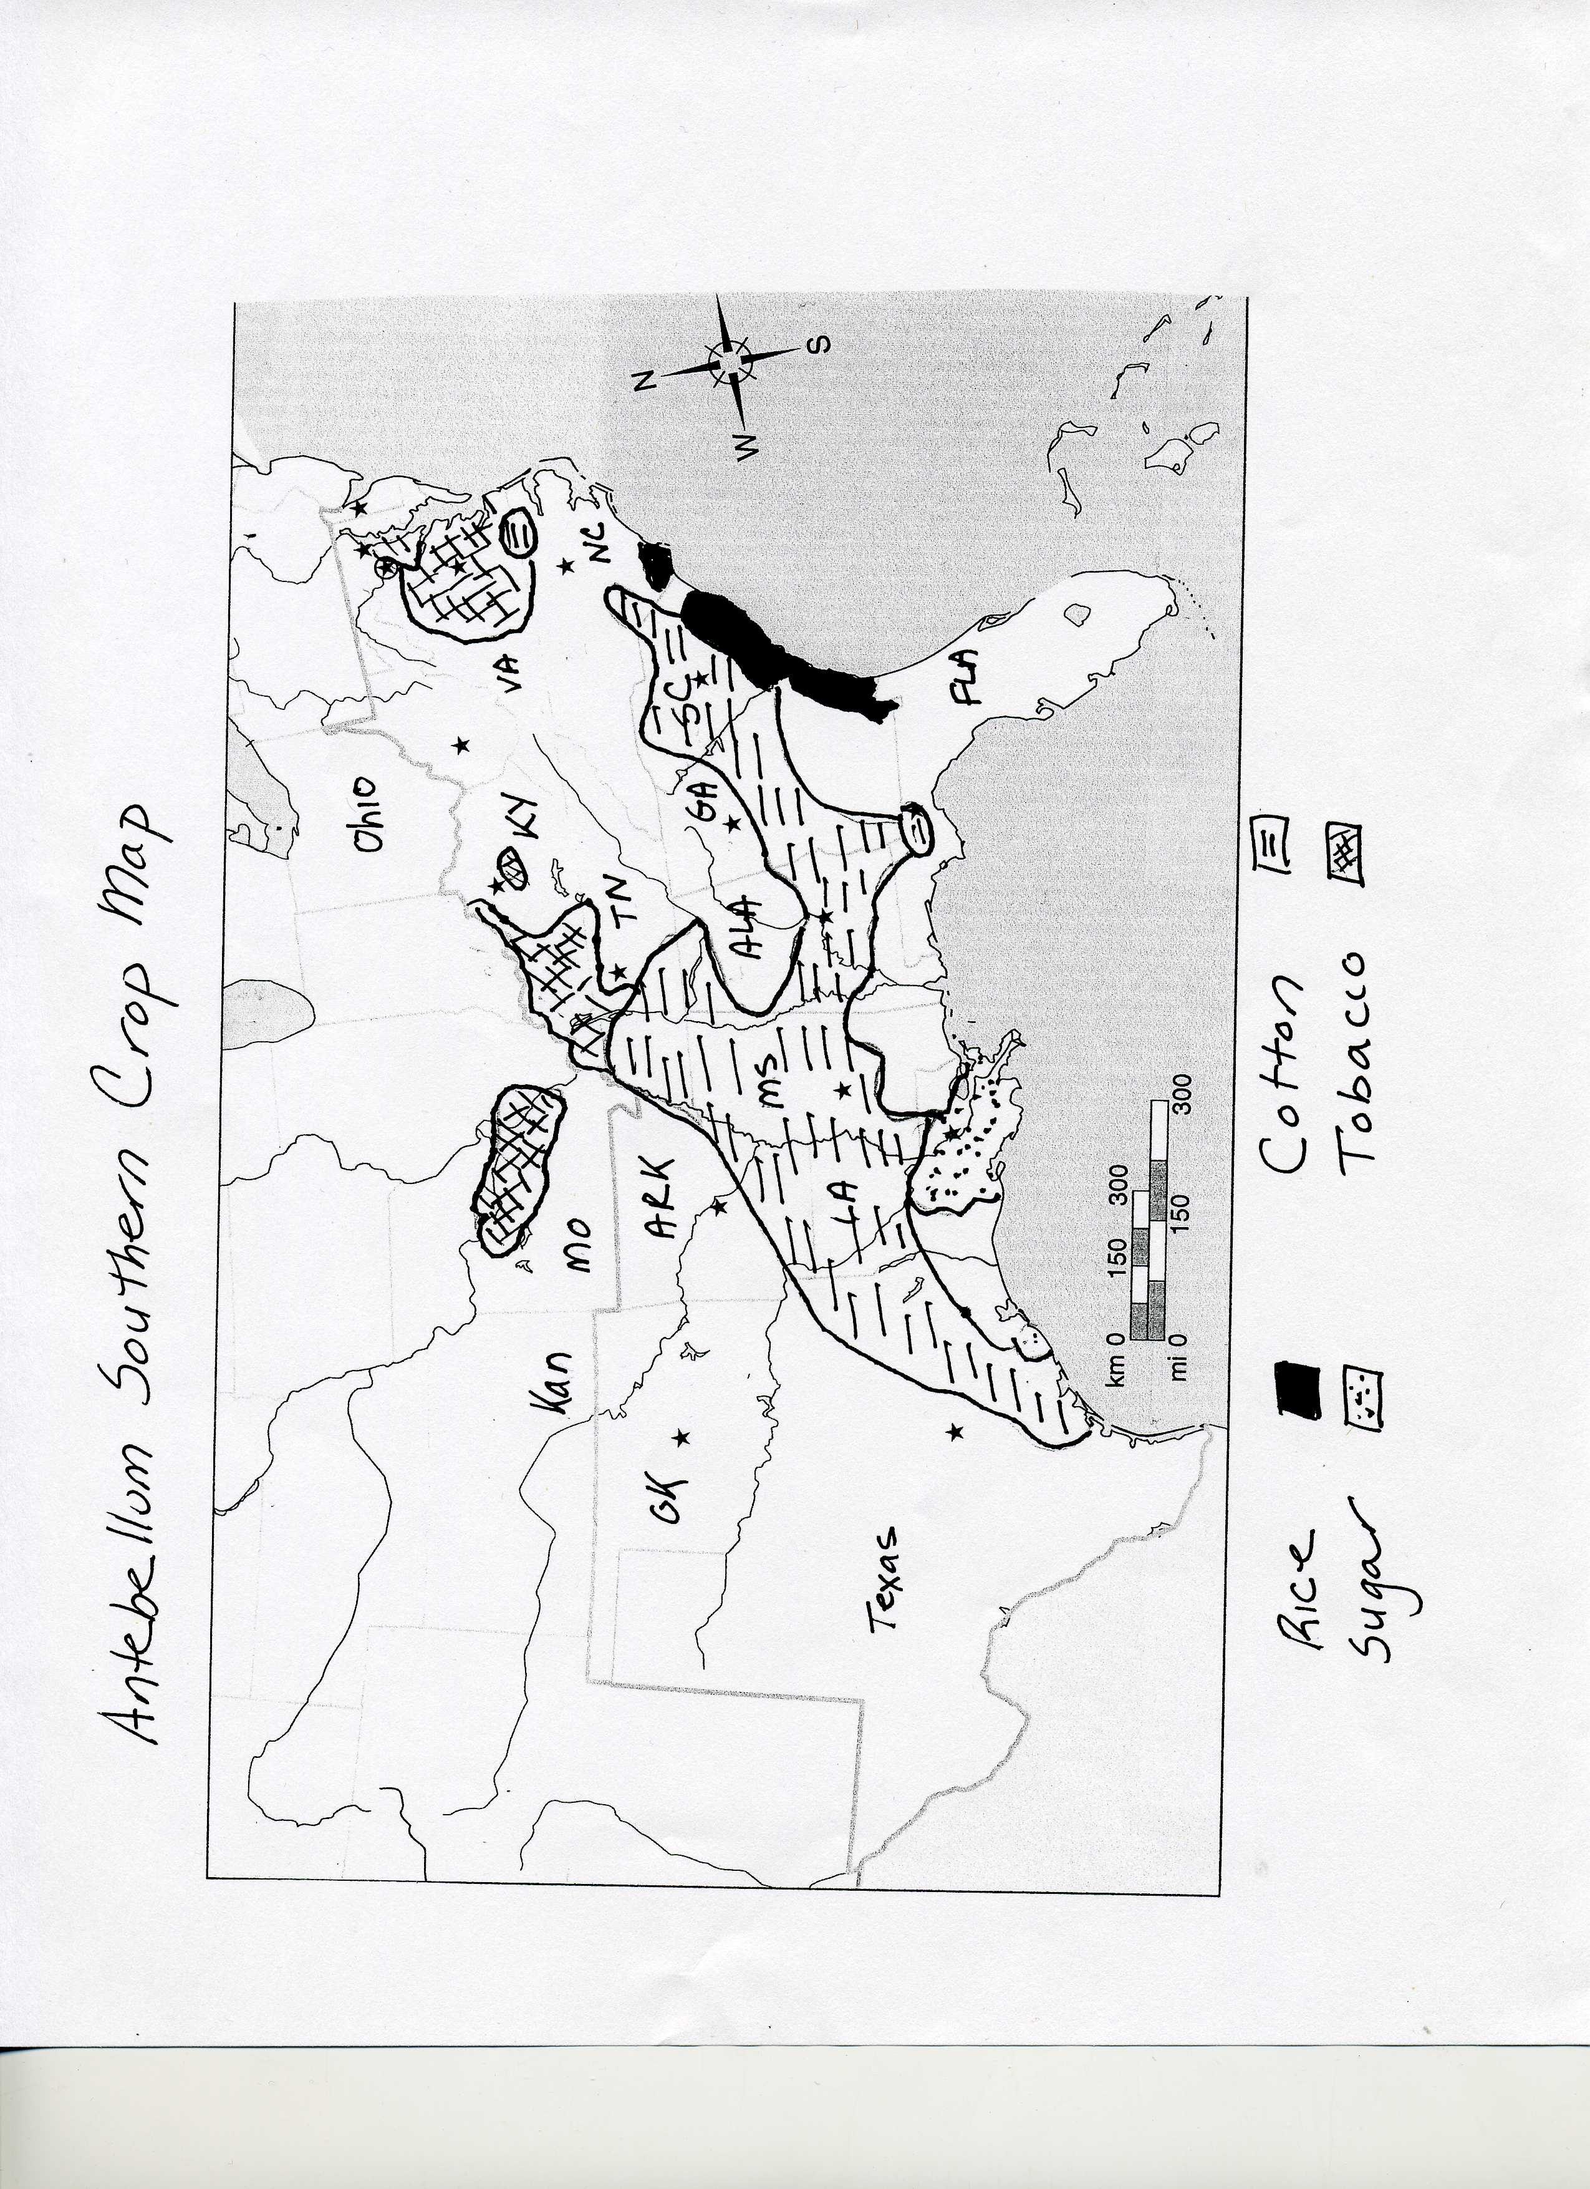

Slave Distribution Map

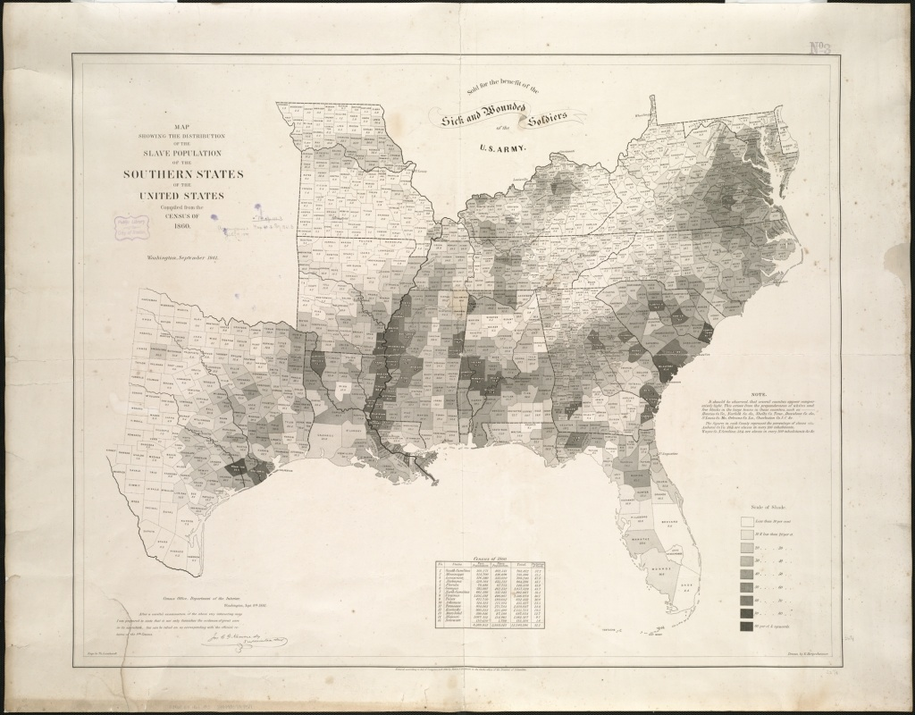

Map of Freedom and Slavery

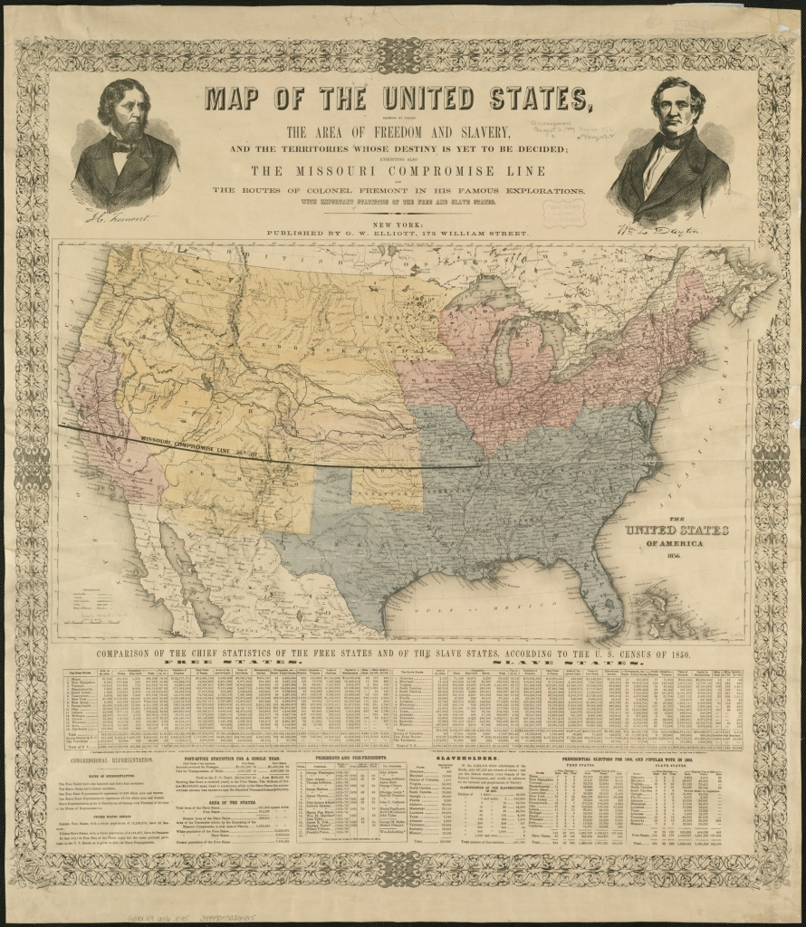

Slave Owner Chart (based on 1850 Census)

Number of Slaves Owned Number of Slave Owners

  - 68,820

between 1-5 105, 683

between 5-10 80, 765

between 10-20 54,595

between 20-50 29,733

between 50-100 6,196

between 100-200 1479

between 200-300 187

between 300-500 56

between 500-1000 9

more than 1000 2

