Part I: What Is Voting?
WHAT IS IT?
1. When do you get to make choices in your life?
2. How is making a choice when you are part of a group different from choices you make as an individual? How are they the same?
3. Think about choices you make when you are part of a group. Is it always best for everyone to have an equal say? When might it best for just one person to make a choice for a group? When is it important to have everyone involved in the decision?
4. How does casting a vote for the President like other choices you make? How is it different?

AND ONCE THE VOTE IS CAST???
A group has held a vote. For which of the following, must you go along with the group’s decision?
1. Three friends decide to order a pizza. Two want sausage. Does the third who ‘voted’ for mushrooms
· Have to eat the pizza?
· Have to pay for the pizza?
Would your answer change if you learned that the third person doesn’t eat meat because she doesn’t like it? How about if her religion forbade her from eating pork?

2. Your town has a school tax increase of 3%. Do you have to pay the School Tax if
You don’t have children who attend the town’s schools?
Your children attend a private school?

3. The US Congress declares war on Mexico and reinstates the draft.
Do I have to pay taxes for a war I don’t believe in?
Do I have to fight in a war I don’t believe in?

4. The State Board of Health mandates that all children receive a vaccine against disease X. Proof of vaccination is required for school attendance. Do I have to get my child vaccinated?

META QUESTION: What is the difference between politics and government??

Part II: WHAT IS THE JOB OF THE GOVERNMENT?
For each of the following issues, decide if it should be under the authority on the local, state or federal government, If you don’t think the government should get involved, put it in the last column
LOCAL STATE FEDERAL NO GOVERNMENT

1. paying for college
2. determining how much someone earns for a job
3. putting out fires
4. fighting wars against other countries
5. deciding on whether immigrants can enter the country
6. deciding what we learn in school
7. keeping our food safe
8. deciding what we are allowed to eat
9. vaccinating children
10. getting a license for your dog
11. getting a license to drive a car
12. making sure the shows on TV are appropriate
13. punishing criminals
14. determining how much some earns for a job
15. granting permission to listen to song lyrics
16. permission to drink alcohol/smoke marijuana
17. permission to sell alcohol/marijuana
18. whom an individual is allowed to marry
19. street repairs in front of your house

When do we want the government in our lives?
What is the distinction between Government and Politics????

Part III: PRESIDENTIAL JOB DESCRIPTION:
Please complete the following
WANTED: President of the United States
JOB DESCRIPTION:
QUALIFICATIONS:
RESPONSIBILITIES:

Compare what you wrote to what is outlined in Article II, US Constitution:

Section 1.
The executive power shall be vested in a President of the United States of America. He shall hold his office during the term of four years, and, together with the Vice President, chosen for the same term, be elected, as follows:
Each state shall appoint, in such manner as the Legislature thereof may direct, a number of electors, equal to the whole number of Senators and Representatives to which the State may be entitled in the Congress: but no Senator or Representative, or person holding an office of trust or profit under the United States, shall be appointed an elector.
The electors shall meet in their respective states, and vote by ballot for two persons, of whom one at least shall not be an inhabitant of the same state with themselves. And they shall make a list of all the persons voted for, and of the number of votes for each; which list they shall sign and certify, and transmit sealed to the seat of the government of the United States, directed to the President of the Senate. The President of the Senate shall, in the presence of the Senate and House of Representatives, open all the certificates, and the votes shall then be counted. The person having the greatest number of votes shall be the President, if such number be a majority of the whole number of electors appointed; and if there be more than one who have such majority, and have an equal number of votes, then the House of Representatives shall immediately choose by ballot one of them for President; and if no person have a majority, then from the five highest on the list the said House shall in like manner choose the President. But in choosing the President, the votes shall be taken by States, the representation from each state having one vote; A quorum for this purpose shall consist of a member or members from two thirds of the states, and a majority of all the states shall be necessary to a choice. In every case, after the choice of the President, the person having the greatest number of votes of the electors shall be the Vice President. But if there should remain two or more who have equal votes, the Senate shall choose from them by ballot the Vice President.
The Congress may determine the time of choosing the electors, and the day on which they shall give their votes; which day shall be the same throughout the United States.
No person except a natural born citizen, or a citizen of the United States, at the time of the adoption of this Constitution, shall be eligible to the office of President; neither shall any person be eligible to that office who shall not have attained to the age of thirty five years, and been fourteen Years a resident within the United States.
In case of the removal of the President from office, or of his death, resignation, or inability to discharge the powers and duties of the said office, the same shall devolve on the Vice President, and the Congress may by law provide for the case of removal, death, resignation or inability, both of the President and Vice President, declaring what officer shall then act as President, and such officer shall act accordingly, until the disability be removed, or a President shall be elected.
The President shall, at stated times, receive for his services, a compensation, which shall neither be increased nor diminished during the period for which he shall have been elected, and he shall not receive within that period any other emolument from the United States, or any of them.
Before he enter on the execution of his office, he shall take the following oath or affirmation:--"I do solemnly swear (or affirm) that I will faithfully execute the office of President of the United States, and will to the best of my ability, preserve, protect and defend the Constitution of the United States."

Section 2.
The President shall be commander in chief of the Army and Navy of the United States, and of the militia of the several states, when called into the actual service of the United States; he may require the opinion, in writing, of the principal officer in each of the executive departments, upon any subject relating to the duties of their respective offices, and he shall have power to grant reprieves and pardons for offenses against the United States, except in cases of impeachment.
He shall have power, by and with the advice and consent of the Senate, to make treaties, provided two thirds of the Senators present concur; and he shall nominate, and by and with the advice and consent of the Senate, shall appoint ambassadors, other public ministers and consuls, judges of the Supreme Court, and all other officers of the United States, whose appointments are not herein otherwise provided for, and which shall be established by law: but the Congress may by law vest the appointment of such inferior officers, as they think proper, in the President alone, in the courts of law, or in the heads of departments.
The President shall have power to fill up all vacancies that may happen during the recess of the Senate, by granting commissions which shall expire at the end of their next session.

Section 3.
He shall from time to time give to the Congress information of the state of the union, and recommend to their consideration such measures as he shall judge necessary and expedient; he may, on extraordinary occasions, convene both Houses, or either of them, and in case of disagreement between them, with respect to the time of adjournment, he may adjourn them to such time as he shall think proper; he shall receive ambassadors and other public ministers; he shall take care that the laws be faithfully executed, and shall commission all the officers of the United States.

Section 4.
The President, Vice President and all civil officers of the United States, shall be removed from office on impeachment for, and conviction of, treason, bribery, or other high crimes and misdemeanors.

PART IV: AN INFORMED CITIZENRY
A. An early meditation on Truth(iness)
http://www.cc.com/video-clips/63ite2/the-colbert-report-the-word---truthiness
- Whether or not you find this clip funny, what is its point?
- Colbert suggested a loose relationship with the facts when he presented this in October 2005.
- How have things gotten worse?

B. Convinced that the people are the only safe depositories of their own liberty, and that they are not safe unless enlightened to a certain degree, I have looked on our present state of liberty as a short-lived possession unless the mass of the people could be informed to a certain degree. --Thomas Jefferson to Littleton Waller Tazewell, 1805

Read Googling Is Believing and consider the following question
What does it mean to be informed in 2016?
http://opinionator.blogs.nytimes.com/2016/03/09/googling-is-believing-trumping-the-informed-citizen/?smprod=nytcore-iphone&smid=nytcore-iphone-share

C. The Power of Narrative
http://www.nytimes.com/2016/02/18/opinion/how-to-win-an-election.html?smprod=nytcore-iphone&smid=nytcore-iphone-share
1. Who is the person speaking in the video? Why is he a good source to learn about presidential campaigns and stories?
2. How do stories shape/affect campaigns?
3. What is the story Secretary Clinton is trying to tell about herself? About Mr. Trump?
4. What is the story Mr. Trump is trying to tell about himself? About Secretary Clinton?
5. Who else participates in the telling of these stories for and against the candidates?
6. How do we know whom to believe?

Part V: THE MATH OF PARTISANSHIP
- THE RED, WHITE, AND BLUE SCHOOL
These are the number of students at the Red, White and Blue School:
Kindergarten-75 Students
Grade 1-100 students
Grade 2 50 students
Grade 3 200 student
Grade 4-100 students
Grade 5-25 students

Each class at Red, White and Blue (R,W, & B) has 25 students.

Answer the following questions. Be sure to be able to explain your answer
1. What are two different ways the students could elect a president of the R,W & B school?
2. How could the students of these students form a school government? Be sure to answer:
How many people should each grade send to student government?
How should each grade decide whom to send?

3. Suppose the school was giving out pencils to its students—should each grade get the number of pencils—why or why not?
4. The school is choosing a new flag. How might an election for that choice be set up?
5. Grade 3 holds a bake sale and raises $60. Should all of the students in the school decide how to spend the money? Why or why not?
6. One of the classrooms in Grade 4 has a flood and it will take 200 hours to clean it up. Who should spend the time cleaning up the classroom? Would your answer change if those students had to use the gym for class until their room was clean and all gym classes were canceled until the classroom was cleaned?
7. The school’s budget for field trips is $5000. It costs $2.00 per student to take a field trip. How would you give out the money for field trips—by grade, by class, by scores on a test? What would be the most fair? If everyone goes on one field trip,
what would you do with the extra money?
8. Write you own question about the R,W, and B school.

Part V: THE MATH OF PARTISANSHIP
2. THE CENSUS
Article I, Section 2, US Constitution:
Representatives and direct Taxes shall be apportioned among the several States which may be included within this Union, according to their respective Numbers, which shall be determined by adding to the whole Number of free Persons, including those bound to Service for a Term of Years, and excluding Indians not taxed, three fifths of all other Persons. (Note: changed by section 2 of the Fourteenth Amendment.) The actual Enumeration shall be made within three Years after the first Meeting of the Congress of the United States, and within every subsequent Term of ten Years, in such Manner as they shall by Law direct. The Number of Representatives shall not exceed one for every thirty Thousand, but each State shall have at Least one Representative

1. Why do we count the people in this country?
2. How many representatives are each state guaranteed?
3. Why do you think the framers created this system of representation?
4. Below is a chart based on the most recent census.
a) What information does it provide?
b) What do the first 31 states on the list have in common?
c) Where would your rather vote for President—Wyoming
d) Does our current system of electoral votes represent a democratic process? Justify your response using the data in the chart below.

STATE PERCENT OF ELECTORAL AND POPULAR VOTE CHART

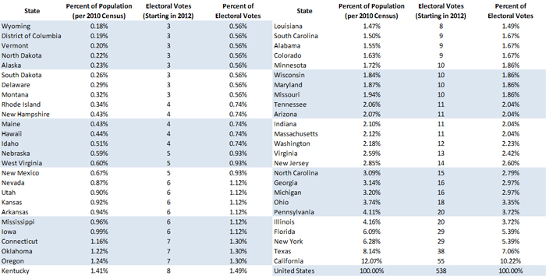

Part V: THE MATH OF PARTISANSHIP
3. What Happened in 2010?

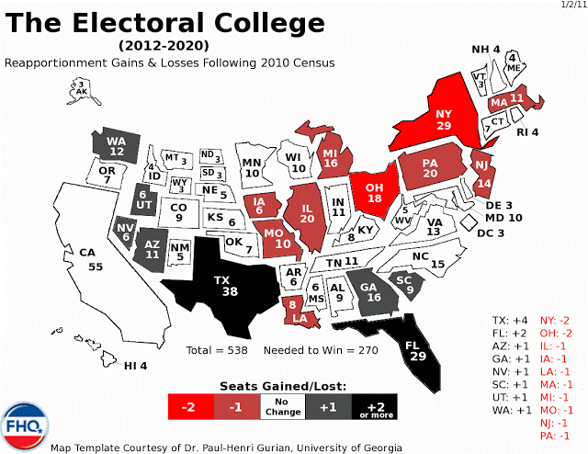

1. Which states were the big winners? Losers?
2. Why do you think the numbers changed, i.e. why did some states gain and others lose?

Part V: THE MATH OF PARTISANSHIP

4. One State, Over Time
Now look at the following graph:

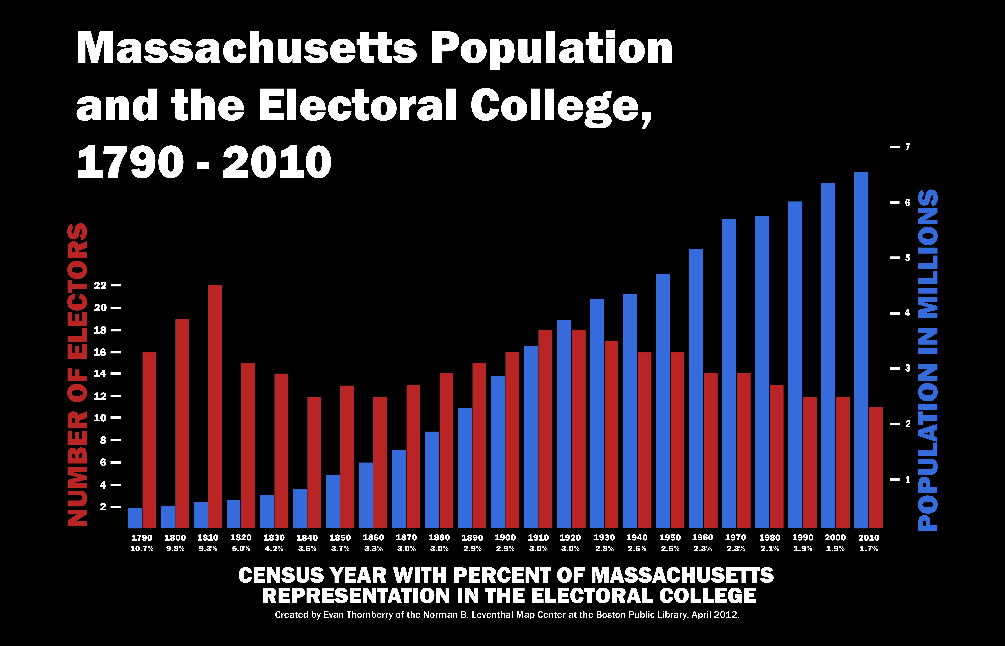

1. What do the Red Lines show? The Blue?
2. How is it possible that the Blue lines have risen while the Red lines have shortened?
3. What has happened to Massachusetts’ political power over time?
4. To compare the history of voting in Massachusetts with that of another state, go to
http://www.270towin.com/states/

Part V: THE MATH OF PARTISANSHIP
5. Within the States
1. What does this image remind you of?
2. What features dominate the ‘creature’?
3. As you look at it more closely, what words are also on this picture?

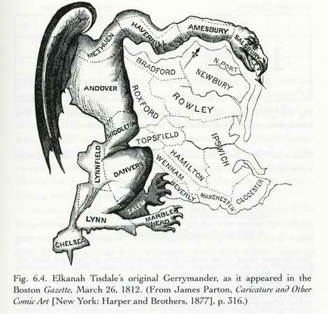

5. Look at the current cartoon and map from Texas (on the next page). What is the cartoonist’s point about the current redistricting process in Texas?
6. What conclusions can you draw about the history of redistricting from these two cartoons? Do you think it is a fair assessment?

TEXAS REDISTRICTS

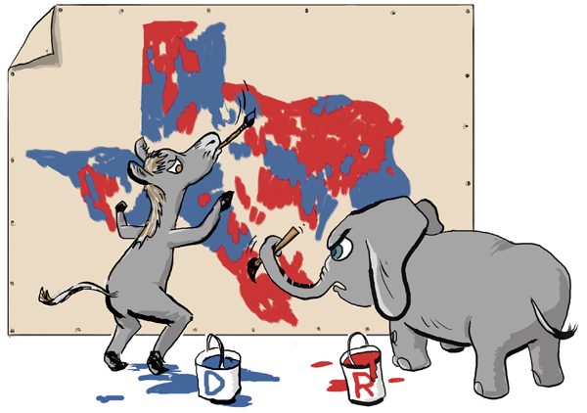

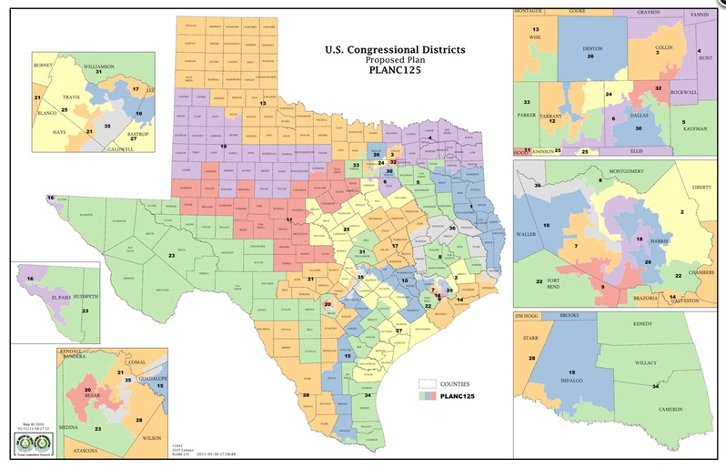
Part V: THE MATH OF PARTISANSHIP
6. Is It Fair??
Consider the case of Pennsylvania, http://www.270towin.com/states/Pennsylvania
1. How has Pennsylvania Voted in the last 3 presidential elections? By how many percentage points did the candidate carry the state?
2. Based on that data alone, what would expect the Congressional delegation (18 to the House of Representatives and 2 the Senate) from the state to look like?
3. Now look at the state’s current representatives: http://www.270towin.com/elected-officials/pennsylvania
What might explain the discrepancy?

Now look at Rhode Island: http://www.270towin.com/states/Rhode_Island
1. How has it voted in the last 3 presidential elections? By what percent did the candidate carry the state??
2. Look at the state’s current representatives: http://www.270towin.com/elected-officials/rhode-island
3. Is everyone in the state being fairly represented in Congress?

Suggest a better system that would more fair.

