Differences Between North and South, pre 1860
The climate and topography of the North and South led to important differences from the beginning stages of our nation’s founding. The types of crops and economy resulted in part from these geographic differences. As different as the regions were though, they were also connected. Raw materials from the South provided the supplies for the growing manufacturing of the factories of the North. Planters in the South often purchased items manufactured in the North.

Procedure

- Provide them with a map of the United States showing the states prior to 1861.
- Introduce and review the concepts of crops and raw materials, emphasizing the stages of growth.
- Have them complete Part I of the Student Sheet and review their results.
- Show them the Climate Map. Have them predict what types of crops they might expect to see in which areas. Then show them the Crop Map and have them complete Part II of the Student Sheet. You may do this as a class, as a homework assignment or in small groups.
- Review their results. In addition to farming, what other work became important in each part of the country? Discuss how the different parts of the country might help one another, i.e. what might they get from one another?
- Have students add these items to the CONNECTIONS section of their Regional Economic Chart.

Time Allocation: Part I: 10 minutes Part II: 20 minutes

Materials Needed

Regional Economic Chart
Map of United States prior 1861
Crop Map United States 1860
Climate Map

Assessment Criteria

Did students learn about the geography and resulting economy of the North?
Did students learn about the geography and resulting economy of the South?
Did students learn about the differences and connections between the North and South?

Enrichment Activities

- Imagine a meeting of farmers from the thirteen colonies. What topics might they discuss? What common concerns might they have? What differences would they have?
- Have Students look at, the Map of Lowell.
http://maps.bpl.org/details_11051/?srch_query=lowell&srch_fields=all&srch_style=exact&srch_fa=save
How were the factories in this town connected to the farmlands in the South?

Common Core Curriculum Standards
Mathematics: Measurement and Data: Grades 3-5
Represent and Interpret Data

English Language Arts: Reading: Informational Text: Grades 3-4
RI.3.7. Use information gained from illustrations (e.g., maps, photographs) and the words in a text to demonstrate understanding of the text (e.g., where, when, why, and how key events occur).
RI.3.9. Compare and contrast the most important points and key details presented in two texts on the same topic.
RI.4.7. Interpret information presented visually, orally, or quantitatively (e.g., in charts, graphs, diagrams, time lines, animations, or interactive elements on Web pages) and explain how the information contributes to an understanding of the text in which it appears.

English Language Arts: Reading: Integration of Ideas and Information, Grades 3-5

Integration of Knowledge and Ideas
7. Integrate and evaluate content presented in diverse media and formats, including visually and quantitatively, as well as in words.

National Geography Standards
Standard 1: How to Use Maps and Other Geographic Representations, Tools, and Technologies to Acquire, Process, and Report Information From a Spatial Perspective
Standard 17: How to Apply Geography to Interpret the Past

Farming was very important in the early years of our country. Different weather and types of soil led to different crops growing in different parts of the country.

Part I: The Cycle of a Crop

There are 5 steps to growing crops. Using the Circle Diagram below, put them in the order you think they would go best. [we’ll need a basic circular diagram here with five lines for writing]

Prepare the Soil Planting the Seeds Selling the Crops
Buying More Seeds Harvesting the Crop

1. ___________________________________

5.

2.

4.

3.

What problem might happen at any of the 5 steps? What could a farmer do?

Part II

The land and weather was very different in parts of the country. Look at the two maps your teacher has given you.
On the Regional Economic Chart, list the Crops you would find in the New England States, the Mid-Atlantic States and the Southern States

Do you think it was good or bad for the colonies that different things grew in different parts of the country?

The chart lists the difference among the different parts of the country. But how could they also help one another? How might they also be connected?

Regional Economic Chart

 | NEW ENGLAND | MID-ATLANTIC | SOUTH
CROPS

INDUSTRY
CONNECTIONS

Climate Map

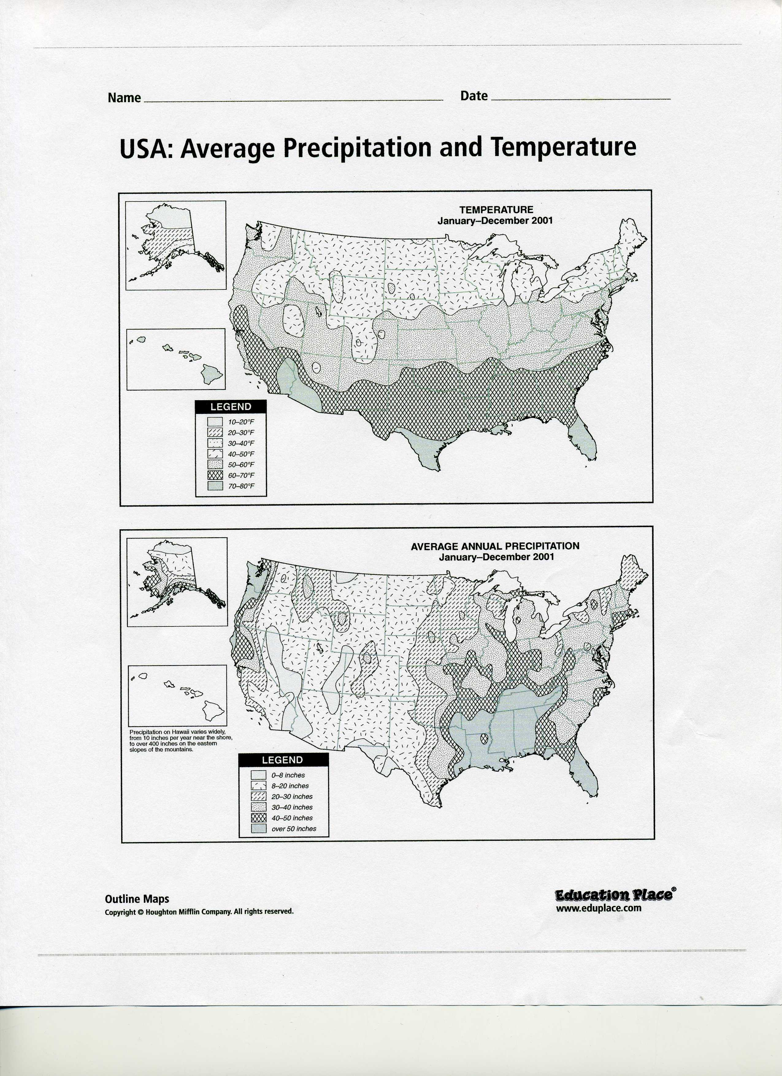

Map of the United States prior to 1861

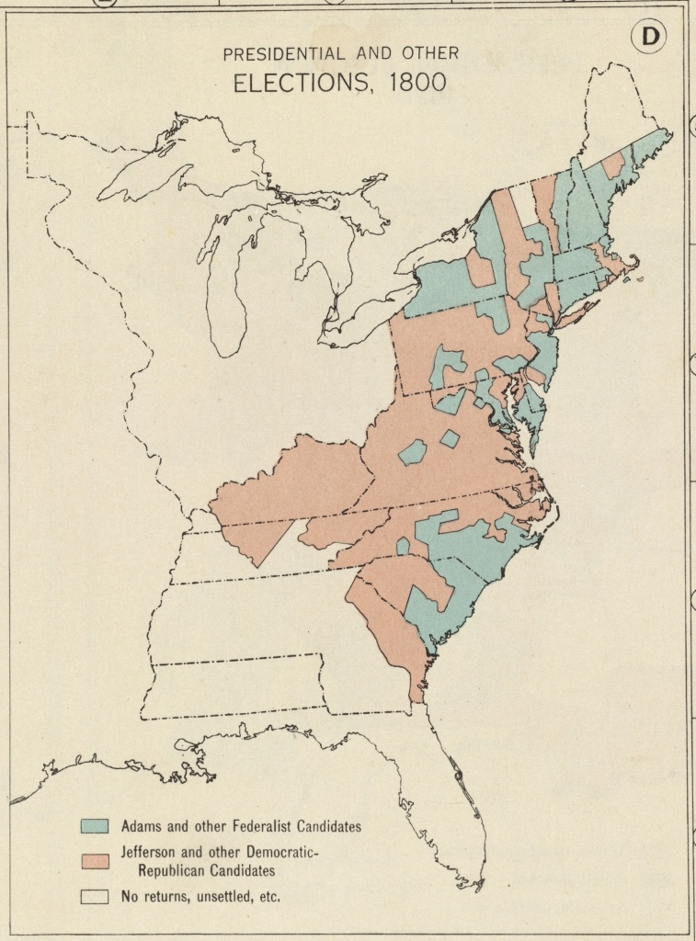

Crop Map United States 1860

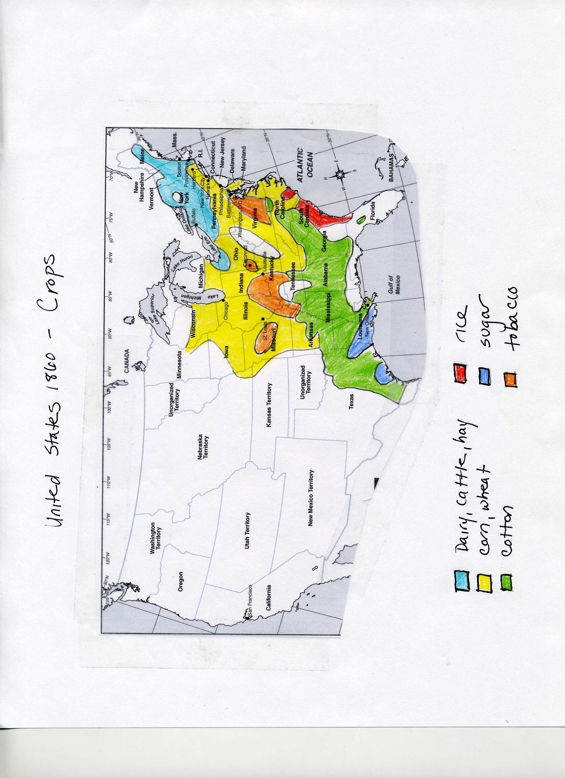
Climate Map

