

No Joke: The Value of Political Cartoons

Location: US Date: 1800-Present Grades 8-12

Essential Question: How have cartoons conveyed and even influenced political discourse in American history?

Objectives:
Students will begin to identify major elements of political cartoons at key moments in US history.
Students will note the ability of cartoons to affect the American political lexicon.
Students will explore political redistricting and extension of the franchise of blacks and women through political cartoons.

Curriculum Standards:
COMMON CORE
English and Language Arts, Grades 11 and 12, Integration of Knowledge and Ideas
RI.11-12.9. Analyze seventeenth-, eighteenth-, and nineteenth-century foundational U.S. documents of historical and literary significance (including The Declaration of Independence, the Preamble to the Constitution, the Bill of Rights, and Lincoln’s Second Inaugural Address) for their themes, purposes, and rhetorical features.

English/Language Arts; History/Social Studies, Grades 9-12
Key Ideas and Details
RH.9-10-11-12.2. Determine the central ideas or information of a primary or secondary source; provide an accurate summary of how key events or ideas develop over the course of the text.
Integration of Knowledge and Ideas
RH.9-12.7. Integrate and evaluate multiple sources of information presented in diverse formats and media (e.g., visually, quantitatively, as well as in words) in order to address a question or solve a problem.

MASSACHUSETTS CURRICULUM FRAMEWORKS
US History 1: The Revolution through Reconstruction, 1763-1877
The Formation and Framework of American Democracy
Political Democratization, 1800-1860
Civil War and Reconstruction
US History 2: Reconstruction to the Present, 1877-Present
The Age of Reform, 1900-1940
Cold War America at Home, 1945-1980
Contemporary America, 1980-Present
American Government Elective


Cartoons are highly effective ways to convey an opinion. In some cases, they become part of our lexicon. With an expanding electorate, often they were deployed to sway voters through emotional appeal. But one thing is certain—they were rarely something to joke about. Use this lesson to supplement your regular curriculum materials in a US History Survey Course.

Procedure:
- With no background information, show students the Gerrymander cartoon, included on the Student Sheet. Have them complete Part I, Q 1-3 of Student Sheet. Discuss their results. The topic is covered in most history texts. But here is a case where the cartoon influenced our language and political practice. The cartoonist combined the name of the governor, Elbridge Gerry with the benign animal, salamander, and the term for creating political districts designed for one party’s gain, gerrymandering, was born.
- Now have students look at Map and Cartoon, as well as the current Map and Cartoon from Texas and complete the rest of Part I.
- Many other issues in US history have drawn the pens of cartoonists, both to promote the cause and lament implementation. One example was the extension of the franchise to blacks and women, both topics again covered in standard US history textbooks. When relevant, please look at these two cartoons with your students and have them complete Section II.

Time Allocation:
Part 1: 20 to 30 minutes
Part 2: 15-20 minutes

Materials Needed:
Gerrymander image, included on Student Sheet
Gerrymander Map and Cartoon, http://maps.bpl.org/id/14867
Texas Map and Cartoon, included below, also located at http://tcgop.org/proposed-texas-congressional-map/
http://www.laits.utexas.edu/txp_media/html/leg/features/0401_01/slide1.html
Woman’s Suffrage Cartoon, included below and also at
http://content.lib.washington.edu/exhibits/suffrage/
[click on tab five]

Voting Access Cartoon, included below
Assessment Criteria:
Did students begin to identify major elements of political cartoons at key moments in US history?
Did students note the impact of cartoons on the American political lexicon?
Did students explore political redistricting and extension of the franchise of blacks and women through political cartoons?

Enrichment Opportunities:
Have students look at cartoons from other time periods/topics. Sources include:
Harpers Weekly, http://loc.harpweek.com/
Presidential Elections, http://elections.harpweek.com/
Thomas Nast, http://www.thomasnast.com/



Political cartoons are an important part of American history.

Part I
- What does this image remind you of?
- What features dominate the ‘creature’?
- As you look at it more closely, what words are also on this picture?

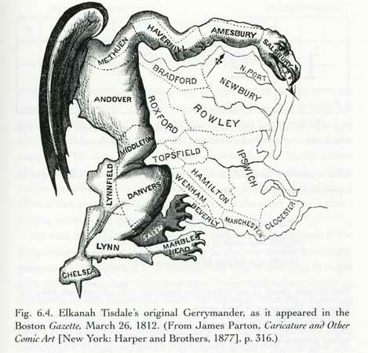

- Now that you have seen the actual map, does the creature generate the same impression as it did before? Why or why not?
- Look at the current cartoon and map from Texas. What is the cartoonist’s point about the current redistricting process in Texas?
- What conclusions can you draw about the history of redistricting from these two cartoons? Do you think it is a fair assessment?

Part II

According to the US Constitution,
Amendment 15 Ratified February 3, 1870.

1. The right of citizens of the United States to vote shall not be denied or abridged by the United States or by any State on account of race, color, or previous condition of servitude.
2. The Congress shall have power to enforce this article by appropriate legislation.

Amendment 19 Ratified August 18, 1920.

The right of citizens of the United States to vote shall not be denied or abridged by the United States or by any State on account of sex.
Congress shall have power to enforce this article by appropriate legislation.

- Does either of these Amendments guarantee the right to vote? What do they promise?

- Look at both cartoons. How is one full of promise and the other full of despair?

- Consider the path of voting for women and blacks in America. Which took longer to accomplish? How do both of these cartoons only tell part of the story?

- Look closely at the cartoon for Woman’s Suffrage. Describe the poster on the wall. What is the central image? Whose name and date are included? Why do you think the cartoonist felt these were important to his message?



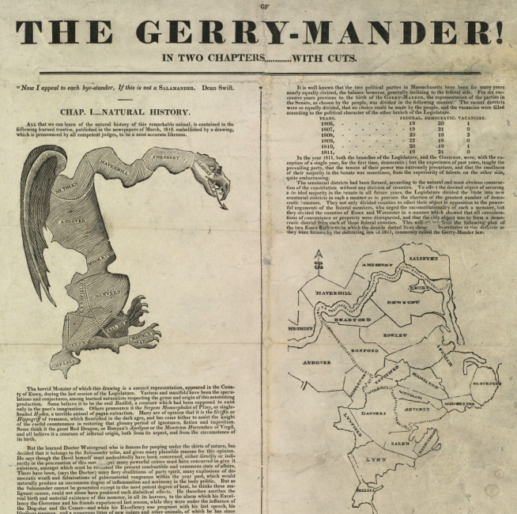

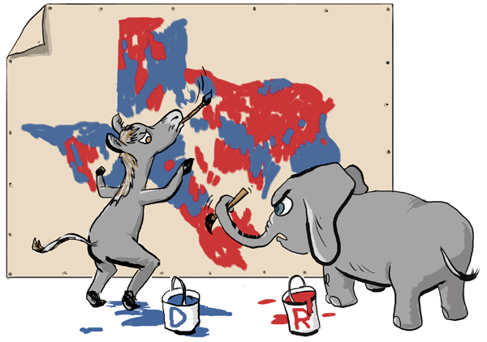

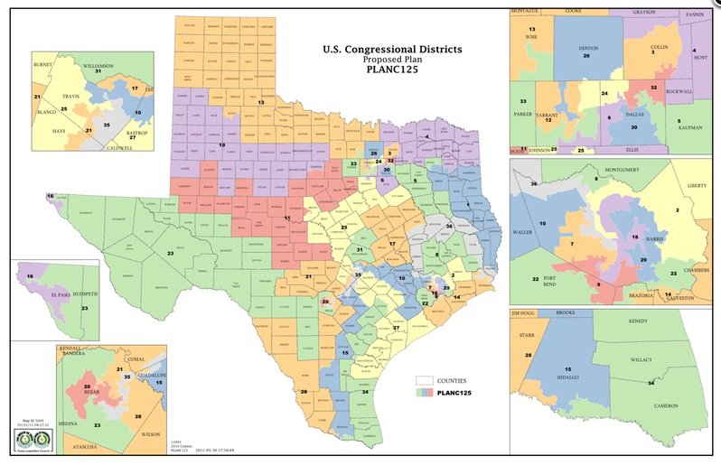

WOMAN’S SUFFRAGE CARTOON

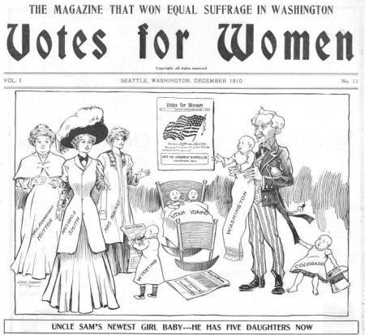

VOTING ACCESS CARTOON


